**CITY UNIVERSITY OF HONG KONG (DONGGUAN)**

Course title : Machine Learning

Session : Semester A 2024/25

Type : Sample Questions

**1.** Describe the similarities and differences for each pair of terms.

**1a)** Multi-layer perceptron (MLP) and convolutional neural network (CNN)

Similarities:

Differences:

**1b)** Principal Component Analysis (PCA) and Kernel Principal Component Analysis (KPCA)

Similarities:

Differences:

**1c)** Dimensionality Reduction and Feature Selection.

Similarities:

Differences:

**2.** Describe the advantages and disadvantages of each method.

**2a)** Ridge Regression.

Advantages:

Disadvantages:

**2b)** Naïve Bayes Classifier.

Advantages:

Disadvantages:

**2c)** Mini-batch Gradient Descent.

Advantages:

Disadvantages:

**3.** Answer each of the following questions.

**3a)** Bob plans to train a binary classifier to filter spam emails using $l_{2}$-norm regularized logistic regression, whose objective function is given by $${\text{argmin}}_{w }λw^{T}w- \sum_{i=1}^{m}{log p{(y^{\left(i\right)}|x^{\left(i\right)};w)}}$$

After training the classifier with gradient descent, he gets an unacceptable high test error. He has also plotted training and test error as a function of training set size

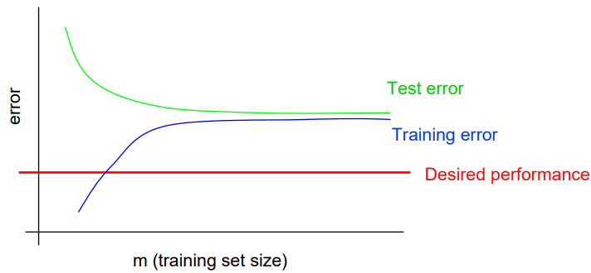

Image courtesy of Andrew Ng

Please help Bob diagnose the problem and suggest possible steps to improve the classification performance.

**3b)** Suppose our training set ${D=\{x}^{(1)},x^{(2)},…,x^{\left(m\right)}\}$ are drawn independently from a uniform distribution $p\left(x;a,b\right)=\frac{1}{b-a}, for a≤x≤b$.

1. Derive the likelihood function of $a and b$ given the training set $D$.
2. Find the maximum likelihood estimate for $a and b$.

**4.** Answer each of the following questions.

**4a)** What is the effect of an unbalanced dataset when training a classifier? Give a real-world example of a classification problem that might have an unbalanced dataset. How do you fix this problem?

**4b)** Consider the following optimization problem

${\text{minimize}}_{w }c^{T}w$

${\text{Subject to}}_{ }Aw≤b,$

where $w$ is an N by 1 parameter vector to be optimized, $A$ is a fixed M by N matrix and $b$ is a fixed M by 1 vector, together imposing M constraints on $w$.

1. Is it a convex optimization problem? Give your reasons.
2. Formulate the dual problem of the above primal problem. Hint: associate the right number of Lagrange multipliers to the constraints.

- END -