

INF1008
Assignment (Part 1)

Student Name | Student ID
Chern Ze Hou | 2303710
Guo You Yan | 2502970
Ang Ben Rong | 2503508
Adil Hadi | 2500499
Ng Jun Yang | 2500406
Mohamad Danish Bin Mohammad | 2501370

Table of Contents
1 Singly Linked List ADT Implementation (Q1) 4
1.1 Requirements/Specifications 4
1.2 User Guide 4
1.3 Design and Analysis 4
1.3.1 Data Structure Design 4
1.3.2 Core Operations 6
1.3.3 Index Map Management 7
1.3.4 Time Complexity Analysis 8
1.4 Limitations 8
1.5 Testing 9
2 Order of Growth (Q2a) 10
2.1 Overview of Asymptotic Notations 10
2.2 Characteristics of Growth Types 10
2.3 Algorithm 1: Singapore Carpark Occupancy Analyzer (O (n lg n)) 11
2.3.1 Requirements/Specification 11
2.3.2 Complexity Analysis 11
2.3.3 Limitations 12
2.3.4 Testing Strategy 12
2.4 Algorithm 2: Singapore Hawker Centre Budget Optimizer (Exponential O(2^n)) 14
2.4.1 Requirements/Specification 14
2.4.2 Design and Analysis 14
2.4.3 Limitations 15
2.4.4 Testing Strategy 16
2.5 Conclusion 17
3 Recursion Implementation (Q2b) 18
3.1 The Problem Statement 18
3.2 Program Specifications and Flow 18
3.3 User Guide 19
3.4 The Grant Support Ratio (GSR) 20
3.5 Breakdown of Solution and Algorithm 21
3.5.1 Recursive Structure $[3.Tn2]$ 21
3.5.2 Basic Operation $[lgn]$ 21
3.5.3 Base Case $[n≤10]$ 22
3.6 Time Complexity Analysis 22
3.6.1 Test Data 22
3.6.2 Substitution Method 23
3.6.3 Recursion Tree Method 24
3.6.4 Master Method 24
3.6.5 Conclusion 24
4 Sorting Algorithm Analysis (Q3a) 25
4.1 Requirements 25
4.1.1 Programme Functionality: 25
4.1.2 Assumptions 25
4.2 User Guide 25
4.3 Design and Analysis 26
4.3.1 Concept: Stability in Sorting 26
4.3.2 Why Stability is Desired 26
4.3.3 Algorithm 1: Merge Sort (Stable) 26
4.3.4 Algorithm 2: Quick Sort (Unstable) 26
4.4 Limitations 27
4.5 Testing 27
4.5.1 Strategy 27
4.5.2 Test Results 27
5 Sorting Algorithm Implementation and Proof (Q3b) 28
5.1 Proof of lower-bound for Comparison-based Sorts 28
5.2 Non-comparison-based Sorting Algorithms 28
5.3 Implementation of Counting Sort 28
5.3.1 Specifications 28
5.3.2 User Guide 29
5.3.3 Design and Analysis 29
5.3.4 Limitations 30
5.3.5 Testing 30
5.3.6 Listing 31
6 Appendix 32

Singly Linked List ADT Implementation (Q1)
Student Name: Ng Jun Yang (2500406) & Adil Hadi (2500499)

Requirements/Specifications
Problem Statement
This report presents a singly linked list implementation that achieves $O(1)$ time complexity for get, insert, and remove operations at any position. The solution augments the standard linked list with a hash map to enable constant-time index-based access.

User Guide
Enter this command to run and compile the code: python q1.py

Design and Analysis

Data Structure Design
The implementation maintains two parallel structures: (1) a singly linked list storing the actual data with proper node linkages, and (2) a hash map (dictionary) that maps integer indices to node references. This dual-structure approach provides the sequential nature of a linked list while enabling array-like random access.
Components Overview
In this section, we will go over the components in out program and the illustrate the structural relationship. The implementation consists of two classes: Node (for individual elements) and AugmentedLinkedList (the main data structure).
Table 1: Data Structure Components
Component | Type | Purpose
head | Node | Reference to the first node in the list
tail | Node | Reference to the last node for O(1) append
size | Integer | Current number of elements
index_map | Dictionary | Hash map: index → node reference

Structural Relationship
The linked list maintains the traditional node chain (each node points to its successor via the next pointer), while the index_map provides a parallel indexing layer. For a list containing elements [A, B, C], the structures appear as follows:
Table 2: Example - List State for [A, B, C]
Linked List Structure | Hash Map (index_map)
head → Node(A) → Node(B) → Node(C) → None | { 0: Node(A), 1: Node(B), 2: Node(C) }
Image 1: Structural relationship representation
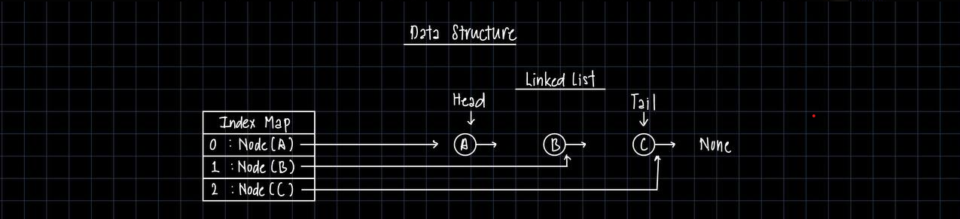

Core Operations
1. Get Operation
The get(i) method retrieves the data at position i.
Algorithm:
- Validate that index $i$is within bounds ($0 ≤ i < size$)
- Access index_map[i] to get the node reference directly
- Return the data attribute of the retrieved node
Time Complexity: $O(1)$ - Direct hash map lookup, no traversal required.

2. Insert Operation
The insert(i, data) method adds a new element at position i. Three cases are handled:
Table 3: Insert Operation Cases
Case | Condition | Linked List Action
Insert at Head | $$i = 0$$ | New node becomes head; points to old head
Insert at Tail | $$i = size$$ | Current tail points to new node; new node becomes tail
Insert at Middle | $$0 < i < size$$ | Node at ($i-1$) points to new node; new node points to old node at $i$
Linked List Complexity: O(1) for node insertion itself (pointer manipulation only).

3. Remove Operation
The remove(i) method deletes the element at position $i$ and returns its data. Three cases are handled:
Table 4: Remove Operation Cases
Case | Condition | Linked List Action
Remove Head | $$i = 0$$ | Head moves to head.next
Remove Tail | $$i = size - 1$$ | Node at $(i-1)$ becomes new tail; its next set to None
Remove Middle | $$0 < i < size - 1$$ | Node at $(i-1)$ points to node at $(i+1)$, bypassing removed node
Linked List Complexity: $O(1)$ for node removal itself (pointer manipulation only).

Index Map Management
After each insert or remove operation, the index_map must be updated to reflect the new positions of elements. This section describes the synchronization strategies.
The Synchronization Challenge
When an element is inserted at position $i$, all elements from position$i$ onward shift to higher indices. Conversely, when an element is removed from position $i$, all elements after it shift to lower indices. The index_map must be updated to reflect these changes.
Table 5: Index Shift Example - Insert at Position 1
State | List Contents | Index Map
Before insert(1, X) | [A, B, C] | {0:A, 1:B, 2:C}
After insert(1, X) | [A, X, B, C] | {0:A, 1:X, 2:B, 3:C}

Rebuild Strategy
The _rebuild_index_map() method reconstructs the entire index map by traversing the linked list from head to tail:
Algorithm:
- Clear the existing index_map
- Start at head with $index = 0$
- For each node: add mapping index → node, increment index, move to next
- Continue until reaching end of list (None)
Time Complexity: $O(n)$ - Must visit every node once.

Partial Update Strategy
The implementation uses an optimization heuristic: if the modification occurs in the first half of the list, a full rebuild is performed. If it occurs in the second half, only the affected indices are shifted.
Rationale: When inserting or removing near the end, fewer indices need updating. Shifting indices iteratively from the end is more efficient than rebuilding in these cases.
Table 6: Update Strategy Selection
Modification Position | Strategy Used | Indices Updated
First half (i < size/2) | Full rebuild | All n indices
Second half (i ≥ size/2) | Partial shift | Only indices i to n

Time Complexity Analysis
Summary Table
Table 7: Time Complexity Summary
Operation | Best Case | Average Case | Worst Case
get(i) | O(1) | O(1) | O(1)
insert(i, data) | O(1)* | O(n) | O(n)
remove(i) | O(1)* | O(n) | O(n)
*Best case occurs when inserting/removing at the tail position.
Justification
get(i): Achieves true O(1) time complexity. The hash map provides direct access to any node via its index key. No traversal of the linked list is required regardless of the position being accessed.
insert(i, data): The node insertion itself (pointer manipulation) is O(1). However, the index map update requires O(n) in the worst case when all indices must be shifted. Best case O(1) is achieved when appending at the tail, where only one new mapping is added.
remove(i): Similar to insert, the node removal is O(1), but index maintenance is O(n) worst case. Best case O(1) occurs when removing the last element.

Limitations
Theoretical Limitation
It is important to acknowledge that achieving true $O(1)$ time complexity for all operations in all cases is theoretically impossible for index-based linked list operations. Traditional linked lists require $O(n)$ traversal to locate elements by index. Our implementation addresses this through an auxiliary data structure, achieving $O(1)$ for access operations while accepting $O(n)$ worst-case for index updates during modifications.

Testing
Insert Test
Input: Insert(index, value)
Output: Array[value]
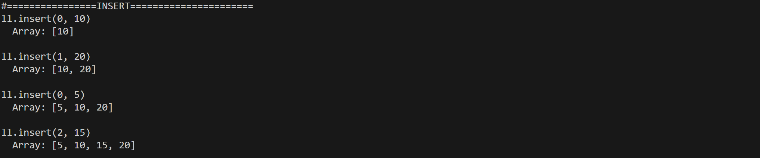

Get Test
Input: get(index)
Output: value
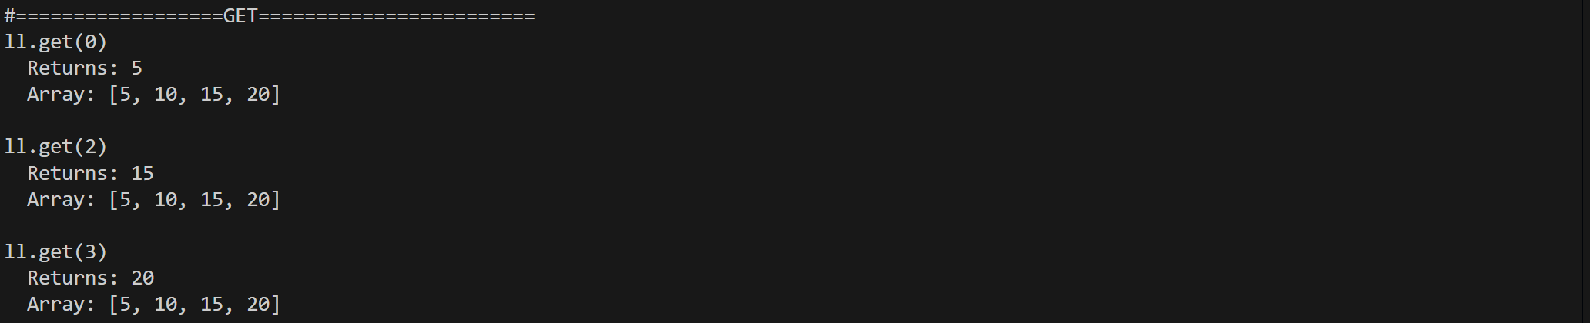

Remove Testing
Input: remove(index)
Output: removed value
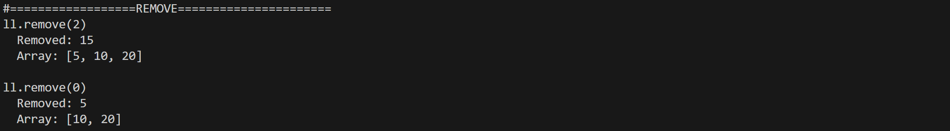

Listing
The source code for the test and algorithm can be found in the following GitHub repository:
https://github.com/NgJunYang/DSA-Assignment1- Q1/blob/7a4cb492c429d2367183b55283877f064e4961f7/q1.py

Order of Growth (Q2a)
Student Name: Guo YouYan (2502970)

Overview of Asymptotic Notations
The efficiency of an algorithm is defined by how its resource requirements (time and space) scale as the input size ($n$) grows. To provide a standardized way to compare algorithms, we use Asymptotic Notations, primarily Big-Oh (O) notation, which characterizes the worst-case upper bound of an algorithm's growth rate.

Characteristics of Growth Types
The following table summarizes the key characteristics of the standard orders of growth, ranked from most efficient to least efficient:
Table 8: Orders of Growth
Type | Notation | Description and Behavioural Characteristics
Constant | $$O(1)$$ | Execution time independent of input size. Same performance for $n=10$ or $n=1,000,000$.
Logarithmic | $$O(lg n)$$ | Extremely efficient. Each step typically halves remaining work.
Linear | $$O(n)$$ | Workload grows proportionally with input size. Optimal for algorithms processing all inputs.
Linearithmic | $$O(n lg n)$$ | Highly efficient for large data. Typical for divide-and-conquer sorting (Merge Sort).
Quadratic | $$O(n^{2})$$ | Poor scalability. Work grows with input squared. Impractical beyond thousands of elements.
Exponential | $$O(2^{n})$$ | Impractical. Execution time doubles with each additional input. Only viable for tiny problems.
Factorial | $$O(n!)$$ | Extreme growth. Represents all possible permutations of a set.

Key Comparison: Linearithmic vs. Exponential
For $n = 20$, the difference in time complexity of Linearithmic and Exponential is huge:
- $O(n lg n)$: ~86 operations
- $O(2^{n})$: 1,048,576 operations (12,000x more work!)

Algorithm 1: Singapore Carpark Occupancy Analyzer (O (n lg n))

Requirements/Specification
- Problem Statement: Singapore drivers waste time finding parking during peak hours. LTA needs to efficiently rank carparks by occupancy from real-time sensor data.
- Input and output: We take in $n$carpark records (ID, available/total lots, occupancy rate)
- Assumptions: Valid sensor data and no division-by-zero error.
User Guide
Enter this command to compile and run the code: python3 carpark_heapsort.py
Menu options
- Small Test & Correctness Verification: Tests with 20 carparks, shows top 5 fullest
- Stress Test:Performance benchmarking for large dataset of 100,000 records
- Scalability Test: Proves O(n log n) growth with empirical testing
- Exit: Terminate the program

Design and Analysis
Design Approach (Divide-and-Conquer)
Heap Sort is a comparison-based sorting algorithm that uses a binary heap data structure. Unlike Merge Sort, Heap Sort operates by building a heap and repeatedly extracting the maximum element.
Step 1: Build Max Heap - $O(n)$
Start from the last non-leaf node, (1) apply heapify operation to all nodes moving upward, and (2) create a max-heap where parent nodes are larger than children.
Step 2: Extract Maximum Elements - $O(n lg n)$
(1) Swap the root (maximum element) with the last element, (2) reduce the heap size by 1, (3) heapify the root to restore max-heap property, and (4) repeat $n$times

Complexity Analysis
The Time Complexity of the program is $O(n\lg{n})$. The composition of this can be broken down as the following:
Max-Heapify - $O(lg n)$
- Recurrence is $T(n) = T(\frac{n}{2}) + O(1)$.
- By Master Theorem (Case 2), since${ n}^{\log_{2}{1}}=1$, $T(n) =θ(lg n)$.

Build-Max-Heap $O(n)$
Nodes at height h require $O(h)$ work. Summing over all nodes:
Image 2: Summation of work over all nodes
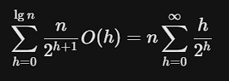
Since the geometric series summation of h/2^{h} converges to 2, the total work is $O(n).$
Total Sorting Time
The total sorting time T(n) can be represented as Sort = Build-Heap + n * Extract-Max.
Hence, $T(n) = O(n) + [n * O(lg n)] = O(n lg n)$
Space Complexity:
Auxiliary: $O(1)$ (In-place swaps).
Stack: $O(lg n)$(Recursive calls for heapify).

Limitations
The following are the limitations of the program:
- Comparison-based bound: Cannot exceed O(n lg n) worst-case (theoretical lower bound)
- Unstable: Doesn't preserve relative order of equal elements (acceptable for this use case)
- Cache performance: Worse than Merge Sort due to non-sequential memory access
- Static ranking: Ranks at single time point; continuous updates require re-sorting
- Single criterion: Ranks by occupancy only; multi-criteria would need complex comparison

Testing Strategy
Test 1: Correctness Verification (Small Test)
This test case has 20 carparks, and the top 10 correctly ranked by occupancy.
Results: Sort order is correct (descending), 118 comparisons done, runtime is 0.0001 seconds.
Image 3: Sample Output:
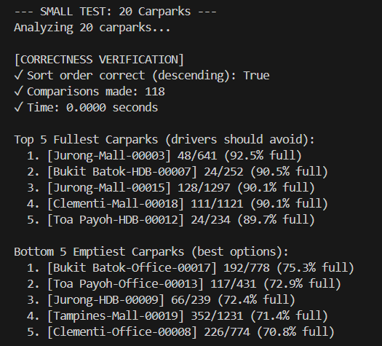
Test 2: Performance Verification
This test case contains 100,000 randomly generated carpark records.
Results: Sort order is correct, 3,017,946 comparisons (1.82 times theoretical), runtime is 0.504 seconds.
Image 4: Stress test results
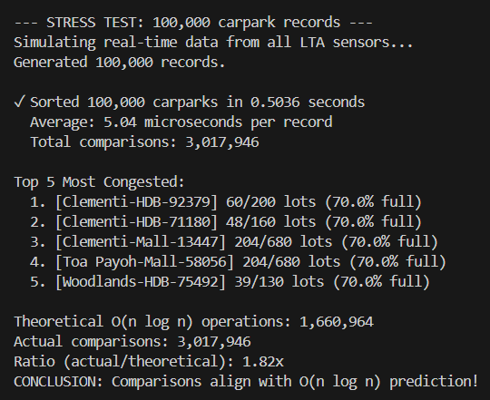

Test 3: Growth Rate Verification (Scalability Test)
This test case progressively doubles the input size to empirically verify $O(n lg n)$ growth.
Results: The growth ratios of 2.03, 2.26, and 2.19 match $O(n log n)$, which expects 2.14 to 2.16 times.
Image 5: Growth rate test results
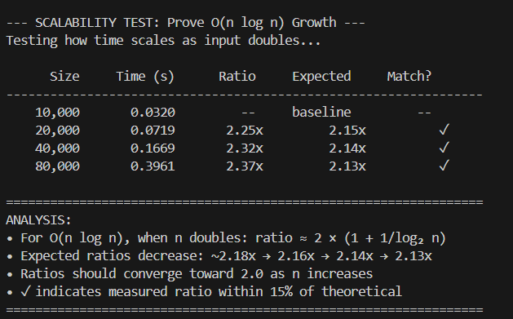

Algorithm 2: Singapore Hawker Centre Budget Optimizer (Exponential O(2^n))

Requirements/Specification
- Problem Statement: With a strict budget, office groups want to find dish combinations at Singapore hawker centres exactly matching their budget. This is a Subset Sum Problem.
- Input and outputs: Target budget and Hawker orders as inputs (stall, dish, price). Program outputs all combinations summing exactly to the budget.
- Assumptions: Assume positive prices only, and that there are no duplicate dishes.

User Guide
Enter this command to run the code: python3 hawker_subsetsum.py
Menu Options:
- Small Verification: Finds all combinations for exact budget with 4 items
- Exponential Growth Proof: Tests $n=10$ to $n=25$ to demonstrate $O\left(2^{n}\right)$
- Exit: Terminate

Design and Analysis
Subset sum is not equivalent to N-Queens backtracking.
Table 9: Subset Sum vs N-Queens
Aspect | Subset Sum | N-Queens
Problem Type | Combination Selection | Constraint Satisfaction
Decision Type | BINARY (include/exclude) | N-ary (N positions/row)
Pruning | Minimal (only when sum > target) | Aggresive  (prunes invalid placements)
Backtracking | NO (never undoes choices) | YES (undoes placements)
State Space | 2ⁿ subsets | N! permutations (heavily pruned)

Key Distinction
Subset Sum uses exhaustive recursion (explores all $2^{n}$combinations), while N-Queens uses constraint backtracking (prunes invalid branches early). They are fundamentally different problem types.

Design Approach: Subset Sum Algorithm
The Subset Sum problem finds all combinations of items that sum exactly to a target value. Our implementation uses exhaustive recursion to explore all $2^{n}$ possible combinations.
At each position, we make a binary decision:
- INCLUDE this dish in our subset
- EXCLUDE this dish from our subset
This creates a binary decision tree with exponential growth.
Image 6: Binary decision tree
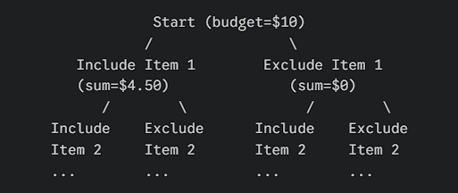
Total nodes: $2^{0} + 2^{1} + 2^{2} +...+ 2^{n} = 2^{n+1} - 1 = O(2^n)$
Recurrence Relation: $T(n) = 2.T(n-1) + O(1) = O(2^{n})$
Backwards Substitution Solution
We substitute $T\left(n-1\right)$ with $T(n-2)$ and so on till $n-k$. Till we find the pattern.
Table 10: Steps for backwards substitution
Step | Equation | Explanation
0 | $$T\left(n\right)=2.T\left(n-1\right)+c$$ | Initial Equation, with O(1) replaced with constant $c$.
1 | $$T\left(n\right)=2\left[2.T\left(n-2\right)+c\right]+c$$ | Substitute $T(n-1)$  with $2.T\left(n-2\right)+c$
2 | $$T\left(n\right)=4.T\left(n-2\right)+3c$$ | Distribute the factor 2
3 | $$T\left(n\right)=2^{k}.T\left(n-k\right)+\left(2^{k}-1\right)c$$ | Equation when substituted $k$ times.
4 | $$T\left(n\right)=2^{n}.T\left(0\right)+\left(2^{n}-1\right)c=O(2^{n})$$ | Let $k=n$. We find that $T(n)$ has a time complexity of $O(n)$.

Space Complexity
Space Complexity: $O(n)$ for recursion stack depth and $O(2^{n})$ for storing all solutions in the worst case.

Limitations
- Scalability: The algorithm becomes impractical for n > 10 groups due to exponential growth. For $n=10$ groups with 10 table choices each, there will be about 10 billion paths.
- Finds all Solutions: The algorithm finds all valid assignments, which may be unnecessary if we only need one valid solution. A variant could stop after finding the first solution.
- Memory Usage: Storing all solutions can consume significant memory for large n.

Testing Strategy
Test 1: Correctness Verification (Small Demo)
This test case contains six hawker dishes, and a $10.00 budget. We will present the input and output of the program in the images below.
Results: Success. Both combinations sum exactly to $10.00. Algorithm explores $2^{6}=64$ subsets.
Image 7: Results of test 1
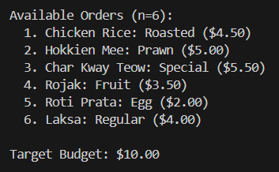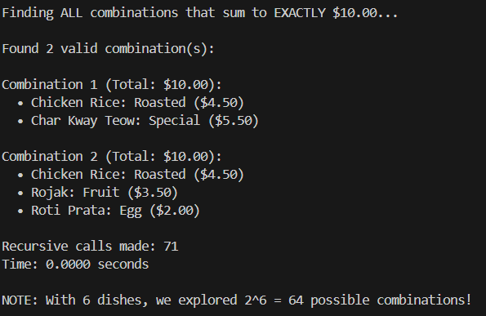

Test 2: Growth Pattern Verification (Exponential Proof)
This test case shows growth factor as the input size $n$ progressively increase from $n=1$ to $n=20$ items.
Results: Growth factors range 1.2-2.3× per item (slight variation due to early termination when sum exceeds target, but still demonstrates exponential O(2^{n}) behaviour)
Image 8: Test output showing exponential proof
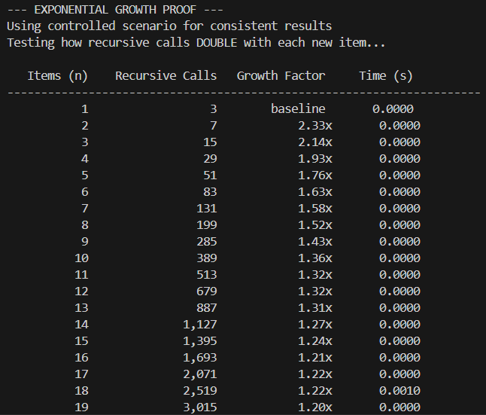
Test 3: Practical Limits (Real Scenario)
This test case uses variable input sizes to demonstrate practical usability.
Results: n=17: 0.7s, n=20: 6.5s. This demonstrates impracticality beyond $n≤15$.
Image 9: Test case output
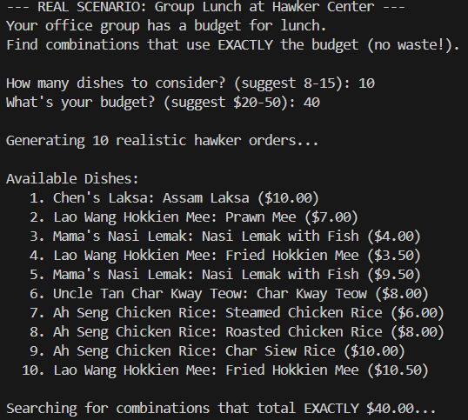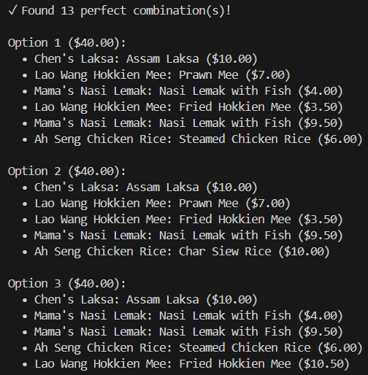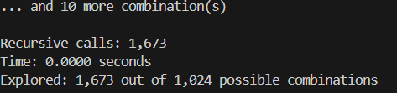

Conclusion
We successfully demonstrated the implementation and analysis of two algorithms representing distinct complexity classes:
- $O(n lg n)$ - Carpark Occupancy Analyzer: Practical, scalable solution for real-time ranking of 100,000+ carparks in under 0.25 seconds. Empirical testing confirmed the theoretical $O(n lg n)$ growth rate with measured time ratios matching predictions.
- $O(2^{n})$ - Hawker Center Budget Optimizer: Demonstrates the fundamental intractability of exponential algorithms. The Subset Sum problem explores all $2^{n}$ possible combinations to find dishes that sum exactly to the target budget. While correct for small inputs ($n≤15$), execution time grows exponentially, rendering it impractical for larger problem sizes, confirming true $O(2^{n})$ exponential complexity.

Recursion Implementation (Q2b)
Student Name: Chern Ze Hou (2303710)
Dataset used: Resale Flat Prices

The Problem Statement
For many young Singaporean couples, the primary barrier to enter the HDB resale market is the initial capital outlay. While the Enhanced CPF Housing Grant (EHG) injected into the CPF Ordinary Account assists with the mandatory 25% downpayment, market price surges often outpaces the government’s “cooling measures” aimed at increasing affordability.

Program Specifications and Flow
Program Purpose
Our presented solution evaluates relative affordability using a Grant Support Ratio (GSR), a gauge for the affordability of flats in different HDB estates, relative to the grant amount, taking into consideration the time of transaction, as the grant amount fluctuates due to policy changes and occasional revisions.
Inputs
The program intakes our dataset: Resale Flat Prices, and also an integer input from the user representing the HDB estate to calculate GSR for.
Outputs
The program outputs a Proof of Time Complexity, and the GSR and advice on getting a flat in the requested HDB estate.
Image 10: Proof of Time Complexity
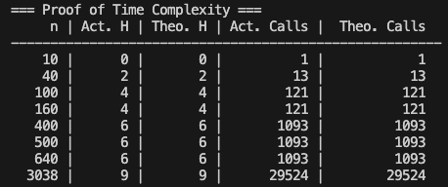
Image 11: Program expected output
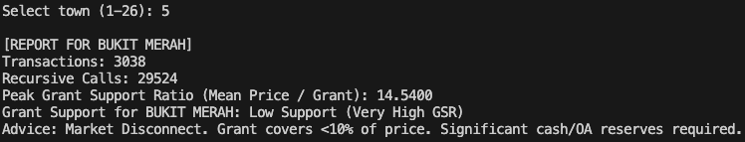

Program Flow
The program flow is outlined as below, further detail in Full Solution Breakdown:
- User inputs estate to check GSR for. (e.g. Bukit Panjang, Sembawang, etc.)
- Program removes unwanted columns from dataset and filters the data to include only 3 Room Flats in the requesting HDB estate.
- Program starts with checking for the base case:
  - The program then continues with the basic operation and recurses into three instances with half the problem size.
    - Basic operation does a binary search to get a shock ratio (explained here), if applicable.
  - This process is repeated until the base case $n≤10$ is hit.
- As the program recurses back up, the maximum GSR is chosen at each level from four choices:
  - GSR of first half
  - GSR of second half
  - GSR of boundary sector
  - GSR of transaction occurring during a ‘Policy Shock’, if applicable
- After obtaining the peak GSR, the program translates it into buyer advice, describing how affordable flats are in the estate, and how much the grant will help with the purchase.

User Guide
These are the instructions to run the program smoothly:
- Ensure that pandas is installed, if not, use “pip install pandas” to install.
- Ensure the dataset CSV file and the python script are in the same directory
- Enter this command in the terminal: “python grant_support_analyzer.py”

The Grant Support Ratio (GSR)
The GSR represents the relative affordability of resale flats in an estate, the lower the better. It comprises two main components, as described below.
Mean Flat Price of n-size group $(n≤10)$
Our Overlapping Divide and Conquer algorithm constantly splits the dataset into smaller groups, till the group size is less than or equal to 10. After which, the mean price of the group is calculated. Our dataset will only include 3-Room flats, and flat transactions segregated into their respective estates (e.g. Woodlands) during processing.
Baseline Grant Amount
The baseline grant amount the grant amount a couple would get if they were earning the 20th percentile of household income (3500-4000 SGD). This amount fluctuates over the years due to policy changes and increases of the grant amount over time.
Calculation and Evaluation of GSR
The GSR is calculated by dividing the Mean Price by the Grant Amount: $\frac{Mean Price}{Grant Amount}$. The GSR can be evaluated to determine the general affordability of the flats in a specific estate, and measure the effectiveness of policies on keeping flats affordable.
Image 11: Interpretation of GSR
GSR | Relative Affordability
GSR <5.0 | Optimal Grant Support: Grant covers more than 80% of downpayment value.
5.0 <= GSR < 8.0 | Significant Grant Support: Expect to fund about half of the downpayment.
8.0 <= GSR < 10 | Moderate Grant Support: Grant subsidises noticeable amount of the downpayment. Market has slightly outpaced grant support.
GSR >= 10 | Poor Grant Support: Market has far outpaced grant support. Flats in this estate are generally not affordable.

Breakdown of Solution and Algorithm
Our solution implements an Overlapping Divide and Conquer algorithm.
Image 12: Interpretation of GSR
Overview of program components (Detailed breakdown below)
Recursive Structure  $$3.T(\frac{n}{2})$$ | Our algorithm splits the data into three other sectors, each half the size of the original the program:  - First half of transactions  - Second half of transactions  - Boundary sector of transactions (25th to 75th Percentile)  The GSR for these are then calculated when the base case is hit.
 | As the problem recurses back up from the base case. The maximum GSR of the three sectors and the transaction made in the month of policy change is returned.
Basic Operation  $$\lg{n}$$ | At every recursive call, a binary search is done against a table mapping months where policy changed to the respective grant amount. The grant amount fluctuates due to policy changes.
Base Case  $$n≤10$$ | At the base case, the mean GSR of the sector is calculated,

Recursive Structure $[3.T\left(\frac{n}{2}\right)]$
Overlapped Divide and Conquer
The Overlapping Divide and Conquer method splits the data into two halves, and adds a third boundary sector containing the 25th to 75th percentile. At each recursion level, the function calls itself recursively three times, one instance for each sector.
Third Boundary Sector
The third boundary sector ensures that significant price increases at the midpoint of the dataset will be captured. If the solution only had two sectors, a significant price movement at the midpoint will be lost when the data is split in half.
Recursing back after base case
As the function recurses back up after hitting the base case, the higher functions returns the maximum result/GSR from its three sub-functions, or the shock ratio (if applicable). The final result is the maximum GSR of the estate.

Basic Operation $[\lg{n]}$
What is a “Shock Ratio”?
A shock ratio is the GSR of an individual transaction which happened on the month where grant policy was changed. There are three months where policy changed in the recent years.
Binary Search for $\lg{n}$ work
At each recursion level, a Binary Search is performed against a list of dates where grant policy changed (e.g. Revision of grant amount). If there is a match, the GSR for the individual transaction is calculated, which is our Shock Ratio. If there are multiple matches, the earliest transaction is taken. If there are no matches, the Shock Ratio is set to zero.

Base Case $[n≤10]$
The base case is hit when the data length is less than or equal to 10. At the base case, a Binary Search is performed against a grant table, in the form of an array of tuples (“yyyy-mm”, grant_amount), this identifies the grant amount relative to the month of the transaction. After which the GSR for the sector is calculated.

Time Complexity Analysis
The equation $T\left(n\right)=3.T\left(\frac{n}{2}\right)+\lg{n}$ is in the form of $T\left(n\right)=a.T\left(\frac{n}{b}\right)+f(n)$; $a=3; b=2$ Our base case is $(n≤10)$, although it would reduce the number of recursive calls at the lower levels, it does not change the Big-O as we are focused on the Asymptotic Growth.
Figure 1: Piecewise representation of Equation
$$T\left(n\right)=\left\{\begin{aligned}1 , &n≤10 \\ 3.T\left(\frac{n}{2}\right)+\lg{n}, &n>10\end{aligned}\right.$$

Test Data
In our implementation, we used test data of size 10, 40, 160, and 640 items to test the growth of complexity as the problem size quadruples.
As our base case is $n≤10$ and the big-O is asymptotically $O(n^{\log_{2}{3}})$, theoretically the recursion depth $k$ will be $\log_{2}{(n/10)}$. Given a branching factor of $a=3$, the total number of recursion calls should be $\sum_{i=0}^{k}{3^{i}}=\frac{3^{k+1}-1}{3-1}$.
Table 13: Theoretical vs Actual Recursion Depth and Calls
No. items $\left(n\right)$ | Recursion Depth  $k$ (Theoretical) | Recursion Depth $k$ (Actual) | Recursion Calls  (Theoretical) | Recursion Calls  (Actual)
10 | $$\log_{2}{\frac{10}{10}}=0$$ | 0 | $$\frac{3^{0+1}-1}{3-1}=2$$ | 1
40 | $$\log_{2}{\frac{40}{10}}=2$$ | 2 | $$\frac{3^{2+1}-1}{3-1}=13$$ | 13
160 | $$\log_{2}{\frac{160}{10}}=4$$ | 4 | $$\frac{3^{4+1}-1}{3-1}=121$$ | 121
640 | $$\log_{2}{\frac{640}{10}}=6$$ | 6 | $$\frac{3^{6+1}-1}{3-1}=1093$$ | 1093
The number of recursion calls made by the program is consistent with the theoretical complexity of the algorithm.

Substitution Method
Guess of the Solution
We guess that the solution is $T\left(n\right)=O(n^{lg3})$.
Reasoning of the Guess
The number of subproblems $\left(a=3\right)$ outpaces the shrinking of the input size $\left(b=2\right)$. Hence the critical value is $n^{\log_{2}{3}}$, which is polynomially larger than $f\left(n\right)=\lg{n}$. Referencing to the Master Method, the time complexity should be similar to the form $θ(n^{\log_{2}{3}})$.
Modification to Substitution T(n)
Our substitution will be in the form $T\left(n\right)≤c.n^{\lg{3}}-d.\lg{n}$for some constants $c>0$ and $d>0$. The additional $-d.\lg{n}$ subtracts the lower order term to account for the $\lg{n}$ overhead at each recursive level.
Table 14: Substitution solution
Step | Equation | Explanation
0 | $$T\left(n\right)=3.T\left(\frac{n}{2}\right)+\lg{n}$$ | This is the initial equation
1 | $$T\left(n\right)≤3.\left[c{\left(\frac{n}{2}\right)}^{\lg{3}}-d.\lg\left(\frac{n}{2}\right)\right]+\lg{n}$$ | Substitute $T(\frac{n}{2})$ with $c.{\left(\frac{n}{2}\right)}^{\lg{3}}-d.\lg{n}$
2 | $$T\left(n\right)≤3\left[c.\frac{n^{\lg{3}}}{3}-d\left(\lg{n}-1\right)\right]+\lg{n}$$ | Simplify using power of a quotient rule
3 | $$T\left(n\right)≤c.n^{\lg{3}}-3d.\lg{n}+3d+\lg{n}$$ | Distribute the factor 3
4 | $$T\left(n\right)≤c.n^{\lg{3}}-d.\lg{n-(2d.\lg{n-3d-\lg{n}})}$$ |  | Rearrange to match guess
For our guess to be true, the extra term $(2d.\lg{n}-3d-lgn)$ must be greater than or equal to zero. We will describe that case in the next step.

Table 15: Proof that substitution works for $d≥1$
Step | Equation | Explanation
1 | $$2d.\lg{n-3d-\lg{n≥0}}$$ | Extra term must be $≥0$.
2 | $$\left(2d-1\right).\lg{n≥3d}$$ | Rearrange for clarity
For a large $n$, the inequality in step 2 is satisfied when $\left(2d-1\right)>0$, which requires
$d≥1.$ This is because for a large $n$, $\left(2\left(1\right)-1\right)\lg{n≥3\left(1\right)}$ ⇒ $\lg{n≥3}$, which holds true for $n≥2^{3}=8.$ Since our recurrence is defined for $n>10$, this works.

Recursion Tree Method
The recursion tree method gives a visual proof of how the Big-O time complexity is determined. We analyse the number of problems/subproblems per level, and the cost of each level, before arriving at our Big-O complexity.
Table 16: Recursion Tree Solution
Height (k) | Number of problems/level | Time/Cost | Big-O Complexity
0 | $$3^{0}=1$$ | $$\lg{n}$$ | Maximum height $(k)=\lg{n}$.  As $3^{k}$ grows exponentially, the bottom-most level (i.e. max-k) contains the most work.  Big-O complexity  $$3^{\log_{2}{n}}=O(n^{\log_{2}{3}})={O(n}^{lg3})$$
1 | $$3^{1}=3$$ | $$3.\lg{\frac{n}{2}}$$
2 | $$3^{2}=9$$ | $$9.\lg{\frac{n}{4}}$$
k | $$3^{k}$$ | $$3^{k}.\lg{\frac{n}{2^{k}}}$$

Master Method
Using the Master Method, we find that $T\left(n\right)=3.T\left(\frac{n}{2}\right)+\lg{n}$ falls into Case 1, and we arrive at $T\left(n\right)=Θ\left(n^{\log_{2}{3}}\right)=Θ\left(n^{\lg{3}}\right)$.
Table 17: Master Method Solution
Step | Equation/Variables | Explanation
0 | $T\left(n\right)=3.T\left(\frac{n}{2}\right)+\lg{n;}$ $a=3, b=2, f\left(n\right)=\lg{n;}$ | Initial Equation and Variables
1 | $$Critical Value (CV)=n^{\log_{2}{3}}=n^{\lg{3}}$$ | Calculating Critical Value
2 | $f\left(n\right)=\lg{n<n^{lg3}}$ [Polynomially Smaller] | f(n) < CV (Case 1)
3 | $$T\left(n\right)={Θ(n}^{\lg{3}})$$ | We derive the Time Complexity.

Conclusion

Sorting Algorithm Analysis (Q3a)
Student Name: Mohamad Danish Bin Mohammad

Requirements
The programme demonstrates the concept of stability in sorting algorithms by processing a large dataset of 1,000,000 records.

Programme Functionality:
- Data Generation: Generates a list of 1,000,000 records. Each record is a dictionary containing a random integer (key) and a value (sequential integer 0 to 999,999). They key will be generated with a limited range to ensure duplicates which is required to test stability.
- Sorting: The programme implements two distinct sorting algorithms manually (without using Python’s built-in sort):
  - Merge Sort: To demonstrate a stable sort.
  - Quick Sort: To demonstrate an unstable sort.
- Validation: After sorting, the programme verifies:
  - Correctness: Are the keys in ascending order?
  - Stability: For records with identical keys, is the record with the lower original value appearing first?

Assumptions
We assume that the system has sufficient RAM to verify the lists.

User Guide
To run the code, do the following:
- Open command prompt or an equivalent software for the OS being used
- Type in “cd” followed by the path to the file in which q3a.py is stored at, then press the Enter key
- Type in “python q3a.py” and press the Enter key

Design and Analysis

Concept: Stability in Sorting
Definition: A sorting algorithm is stable if it preserves the relative order of records with equal keys. If Record A and Record B have the same key and Record A appears before Record B in the original list, a stable sort guarantees that Record A will still appear before Record B in the sorted list.
A simple explanation: A line of people are buying tickets, ask them to sort themselves by age.
- Stable Sort: If Alex (Age 20) was standing in front of John (Age 20) before the sort, Alex will still be in front of John after the sort.
- Unstable Sort: The algorithm might shuffle them around and John might end up in front of Alex. While it is still correct as both are of the same age, this may not be desired in certain situations.

Why Stability is Desired
- Multi-level Sorting: Useful when sorting by multiple criteria. For example, in a spreadsheet of products, you might first sort by “Category” and then by “Price”. A stable sort on “Price” ensures that items with the same price remain grouped by their previous “Category” order.
- Preserving Chronological/Input Order: In a message queue or transaction log, entries often arrive chronologically. If you sort these messages by “Priority”, a stable sort ensures that messages with the same priority are still processed in the order they arrived (FIFO).

Algorithm 1: Merge Sort (Stable)
Approach
Merge sort is a Divide and Conquer algorithm. It recursively splits the list into two halves until single elements remain, then merges the sub-lists back together in sorted order.
Design
When the algorithm merges two lists, it looks at the item on the left and the item on the right. If they are equal, the code is designed to strictly pick the left item first. This rule preserves the original order.
Complexity Analysis (Big-Oh):
Time Complexity: $O(n log n).$ The list is split log n times and merging takes linear time n.
Space Complexity: $O(n)$ for the temporary lists created during slicing and merging.

Algorithm 2: Quick Sort (Unstable)
Approach
Quick Sort selects a “pivot” element and partitions the array such that elements smaller than the pivot go to the left and larger go to the right.
Design
The partitioning involves swapping across long distances. If an element is swapped past another element with an equal key, their relative order changes. We compare strictly less than against the pivot. If a duplicate exists, it might be swapped to the “greater than” side or stay, often losing its original position relative to other duplicates.
Complexity Analysis (Big-Oh)
Time Complexity: Average $O(n log n)$. Worst case $O(n^{2}).$
Space Complexity: $O(log n)$ for recursion stack.

Limitations
Recursive Depth
Quick Sort is recursive. For 1 million records, the recursion depth can exceed Python’s default limit. The codes explicitly increases this limit but extremely unbalanced partitions could still cause a stack overflow.

Testing

Strategy
- Volume Test: We generate 1,000,000 records as per the question’s requirements and to prove efficiency.
- Duplicate Generation: Keys are generated using random.randint(0, 100,000). With 1 million records and only 100,000 distinct keys, there are duplicates which tests the stability.
- Automated Verification: The verify_sort function iterates through the result:
  - Sort Check: if arr[i][‘key’] > arr[i+1][‘key’]: Fail
  - Stability Check: if keys are equal AND arr[i][‘index’] > arr[i+1][‘index’]: Fail

Test Results
Merge Sort
This confirms that Merge Sort is stable. The item that appeared earlier in the original list still comes before the later item in the sorted list.
Image 12: Merge Sort Stability Proof
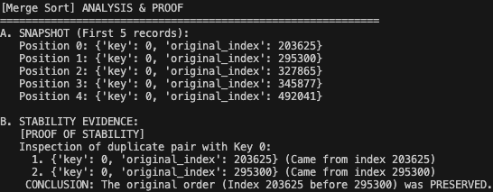
Quick Sort
The image below proves that Quick Sort is unstable. The item that was created later in the original list now comes before the earlier item in the sorted list.
Image 13: Quick Sort Instability Proof
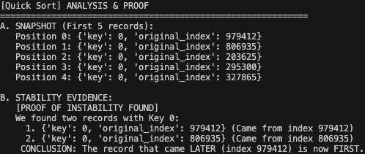

Sorting Algorithm Implementation and Proof (Q3b)
Student Name: Ang Ben Rong

Proof of lower-bound for Comparison-based Sorts
The statement of sorting algorithms can never be better than $O(n\lg{n)}$ is true only for comparison-based sorting algorithms, such as Merge Sort or Quick Sort. Comparison-based sorting algorithms are essentially decision trees, where each node in the tree is a permutation of the original data. The worst-case is when the algorithm has to go through all possible permutations in the tree, which is $n!$. This is based on the permutation formula:
$$nPr=\frac{n!}{\left(n-r\right)!}=\frac{n!}{0!}=n!$$
In the formula, $n$ is the number of data in the input, $r$ is the number of items to be chosen from $n$, but since we need all of the data, thus $n=r$.
To get the height of the tree, we can use:
$$1+ \left\lfloor \log_{b}{n}\right\rfloor$$
For the formula, $n$ is the total number of nodes in the tree and $b$ is the number of sub-inputs the input is split into and $b>1$. The lowest $b$ can be in this case would be 2. In this case, to get the tree height, we can use $1+ \left\lfloor \lg{n}\right\rfloor$. With the formula, we can sub in $n!$ into $1+ \left\lfloor \lg{n}\right\rfloor$, giving $1+ \left\lfloor \lg{(n!)}\right\rfloor$, which, through Stirling’s Approximation which states that:
$$\ln{n!= Ω(n\lg{n)}}$$
We can conclude that the lower bound of comparison-based sorting algorithms would be $O(n\lg{n)}$. Thus, proving that the lower-bound of decision-based algorithms will never be better than $O(n\lg{n)}.$

Non-comparison-based Sorting Algorithms
For algorithms which are not comparison-based, they are not done through decision tree, thus the lower-bound can be better than $O(n\lg{n)}$. Algorithms that are not comparison-based includes algorithms like Counting Sort and Radix Sort.
These algorithms have more limitations as compared to comparison-based sorts, such as requiring additional context before sorting, and some of these sorts require certain data types.

Implementation of Counting Sort

Specifications
The algorithm written is a sorting algorithm known as Counting Sort. This algorithm uses the count of each value to sort the input data. The input data must be an integer, and the range of the values should not be way greater than the number of values in the input data, such that $k≤n$, where $k=\left(\max{-}min\right)$.
The number of data is of a fixed value, which is 1000 in this case. The values are based on using python’s random function, specifically randint, thus using
input = [random.randint(0, max_value) for _ in range(max_value)]
to generate the input data to be sorted.

User Guide
To run the code, do the following:
- From the link below, download the file named “counting_sort_algorithm_only.py”
- Open command prompt or an equivalent software for the OS being used
- Type in “cd ” followed by the path to the file in which counting_sort_algorithm_only.py is stored at, then press the Enter key
- Type in “counting_sort_algorithm_only.py” and press the Enter key

Design and Analysis
The reasoning for choosing Counting Sort compared to the other sorts is when doing through the RAM Model, it has a time of $T\left(n\right)=22n+8$ which can be simplified down to $O(n)$, which is the algorithm’s time complexity.
$O(n)$ is the absolute best for sorting algorithms. $O(1)$ is not possible as sorting algorithms has to go through the input array at least once. $O(\lg{n)}$ is usually for divide-and-conquer, which is just one part of a sorting algorithm, but there needs to be a merge to combine everything. Therefore, the best sorting algorithms can do is $O(n)$, which means that it loops through all the data in the input. And since Counting Sort’s time complexity is $O(n)$, therefore Counting Sort was chosen.
- Counting Sort does the following:
Step | Reasoning | Steps Taken
max_value = max(input) | Get the maximum value of the input data | 1
count = [0] * (max_value + 1) | Create an array of counts, with the length being the highest value of the input data | N
output = [0] * length(input) | Create an output array for the sorted result | N
for value in input:  count[value] += 1 | Increase the value of the element based on the value as the index | 2N+1
for index in range(1, max_value + 1):  count[index] += count[index – 1] | Iterates through the count array to get the sum of the previous counts | 7N + 2
for index in range(len(input)- 1, -1, -1):  value = input[index]  output[count[value] - 1] = value  count[value] -= 1 | - Iterates through the array  - set element of output to the value of the current value in input in index based on the count of the value  - Decrease the count by 1  - Repeat until sorted | 11N + 4

Therefore, the total steps taken according to a RAM model would be $1+N+N+2N+1+5N+2+ 8N+4=22N+8$, which is simplified down to $O(n+k)$, thus the time complexity is $O\left(n\right).$

Limitations
Counting Sort’s time complexity only applies when the maximum range of the values, k, is less or equal to the number of data in the input, simplified to $k≤n$. If, for example, $k=n^{2}$, then the time complexity becomes $O(n+n^{2})$, making the time complexity $O(n^{2})$.

Testing
To test if the algorithm is working, we will be using python’s inbuilt timeit to run multiple rounds of the algorithm, which allows not only running the algorithm multiple rounds, but also record how long it takes on average to run, and we can record down if the algorithm has sorted correctly compared to an inbuilt sorting function too.
In this test, we are testing two things – the average time taken for the algorithm to run when $k≤n$ and $k=n^{2}$, as well the correctness when $k≤n$ and $k=n^{2}$. The values that are to be sorted are pseudorandom, but it will be random enough for this use case. Below is an example of the pseudorandom values for the input.
Image 14: Pseudorandom value inputs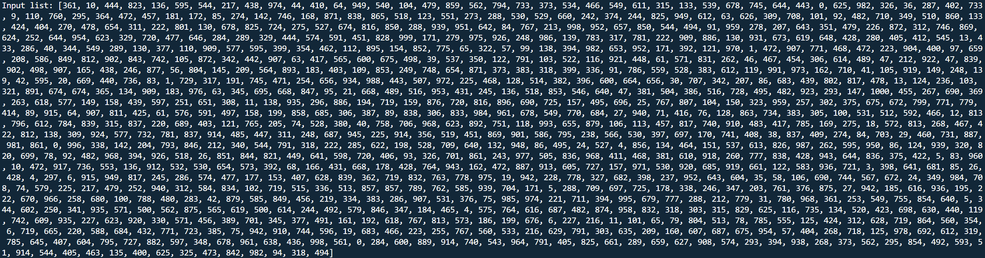
The following code snippet shows how timeit can be implemented to run the algorithms multiple times and get the average timings for both normal and $n^{2}$ runs.
Image 15: timeit Implementation
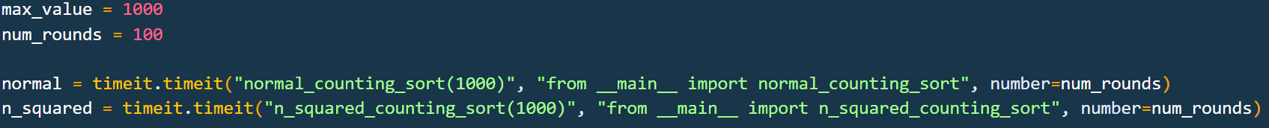
Each time the algorithm runs, it saves the result in an array of dictionaries which can be used to run through and check the correctness of the results. To test the correctness of the algorithm, we can check if the sorted values are the same as if a known working sorting function, which in this case is python’s inbuilt sorting function, Timsort, is the same as what the Counting Sort algorithm has done. Below is the code snippet which contains the code which is used to check the correctness.
Image 16: Test code snippet
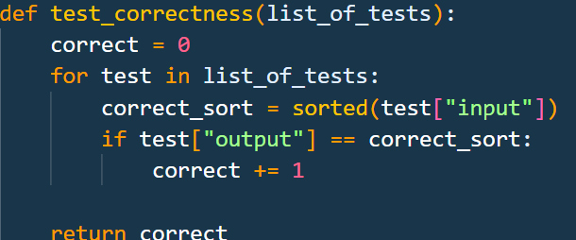
After all that is done, the results will be shown, such as below.
Image 17: Test Result Output
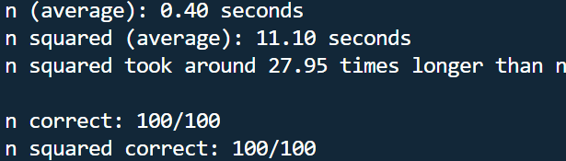
Through this, we tested and proved empirically as well that not only does the Counting Sort that was implemented working, but also that when $k>n$, or in this case $k=n^{2}$, the time taken for Counting Sort to sort the input increases drastically.

Listing
The source code for the test and algorithm can be found in the following GitHub repository:
https://github.com/BenIsRong/DSA_Algo_Assignment_1

