**Project Title**

Asset location using low-cost beacons, smart roaming devices and cloud computing.

This proposal is for a joint project with Orbcomm to investigate the feasibility of using existing truck tracking units to locate trailer assets within a customer’s yard by using simple, low-cost beacons within the trailers, truck units to scan for these beacons, and uploading GPS and beacon information to the cloud using the truck unit for computation.

**Keywords**

Cloud Computing, AWS, IoT (Internet of Things), Electronics, Embedded Systems, Software Development, BLE (Bluetooth Low Energy), GPS, WiFi

**Problem**

Currently if a customer is looking for a trailer tracking solution their only option is to invest in trailer trackers, which come with high purchase and installation costs and maintenance. If a customer simply wants to know if a trailer is in a given yard or where in the yard it is, simple beacons in conjunction with truck units could provide this data at a significantly reduced cost. The truck units could be used to scan for beacon signals, and upon receipt of a beacon signal upload the truck’s latitude, longitude, heading and speed along with the beacon ID to a central server, which would store this information and compute most likely trailer locations based on multiple readings from multiple trucks. The more trucks moving around a yard and scanning for beacons, the more accurate the information could be. This data could provide both dispatchers and drivers with trailer location, saving time finding trailers in a yard.

**Project Summary**

Figure 1 shows proposed architecture. As this project is an investigation into the feasibility of such a solution, Truck and Trailer units will be as simple as possible – rather than using Orbcomm specific hardware, generic devices (e.g. Arduinos with shields for Truck Units, generic beacons for Trailer Units) will be used. The Trailers contain beacons that broadcast their identity. The Trucks are roaming throughout the yard, scanning for beacon signals and reporting beacon IDs and GPS data to the Cloud. Computation is done in the Cloud to figure out the most likely location for a given trailer, and this can be displayed to a user using a mobile device or a computer.

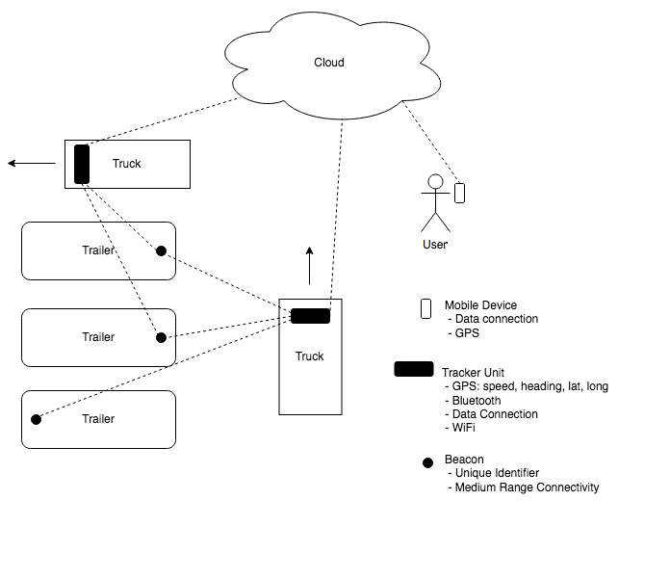

Figure 1

Multiple technologies could be used for the beacons, including BLE (Bluetooth Low Energy), WiFi, RFID (Active) and Zigbee. A signal with a medium range is desirable. Currently BLE looks most promising, as it has a reported range of up to 100m, is low cost, has low power requirements and BT500’s have Bluetooth on-board.

The following stages outline the proposed project roadmap. Stage 1 could prove that a solution based on BLE or similar is not viable.

**Stage 1:**

* Investigation of detection range, accuracy and limitations
* Detection of nearby beacons by truck unit

**Stage 2:**

* Reporting of nearby beacons and telematics data to cloud service

**Stage 3:**

* Triangulation of trailer locations using multiple readings from multiple Trucks and computation of most likely location

**Stage 4:**

* Display data to user using web interface and/or mobile device application

**Stage 5:**

* Tuning of variables
* Testing in a real-life truck yard