PROJECT REPORT ON
STOCK MOVEMENT PREDICTION AND TRADING SIGNAL API
Submitted to
Department of Computer Applications
in partial fulfillment for the award of the degree of
MASTER OF COMPUTER APPLICATIONS

Submitted By | Under the Guidance of
Name of the Student  Enrollment Number | Name of the Guide

GRAPHIC ERA DEEMED TO BE UNIVERSITY, DEHRADUN
May 2026

Candidate Declaration
I hereby declare that the mini project report entitled "Stock Movement Prediction and Trading Signal API" has been prepared by me as part of the academic requirements of the Master of Computer Applications. The work presented in this report is original to the best of my knowledge and has been completed using the source files, code, results, visualizations and documentation available in the project folder.
The report content is based on project-specific implementation details including the data processing pipeline, feature engineering, model training, API implementation, testing artifacts, generated Excel reports and visualizations.
Signature of the Student: ____________________
Name: Name of the Student
Date: ____________________

Internal Guide Certificate
This is to certify that the project report entitled "Stock Movement Prediction and Trading Signal API" submitted to Graphic Era Deemed to be University, Dehradun in partial fulfillment of the requirements for the award of the degree of Master of Computer Applications is an authentic project work carried out by Name of the Student under my supervision and guidance.
The project demonstrates a machine learning based approach for predicting next-day directional stock movement and presenting actionable trading signals through a Flask REST API and supporting dashboards.
Signature of the Guide: ____________________
Name: Name of the Guide
Date: ____________________

Acknowledgement
I express my sincere gratitude to Department of Computer Applications, Graphic Era Deemed to be University, Dehradun, for providing the opportunity to undertake this mini project. I am thankful to my guide for guidance, feedback and encouragement during the analysis, development, testing and documentation stages.
I also acknowledge the usefulness of open-source Python libraries such as pandas, NumPy, scikit-learn, Flask, yfinance, matplotlib, seaborn, joblib and openpyxl, which supported the implementation and evaluation of this work.

Preface
This report presents the design and implementation of a mini project for stock movement prediction. The system uses historical OHLCV stock data, derives technical indicators, trains multiple classification models, stores trained pipelines, exposes prediction functionality through a REST API and produces reports and visualizations for interpretation.
The report follows the supplied MCA report guidelines by including introduction, system analysis, requirement specification, design, implementation, testing, results, project management, future scope, bibliography and appendices.

Table of Contents
- 1. Introduction
- 2. System Analysis and Requirement Specification
- 3. System Design
- 4. Project Management
- 5. Implementation and Coding
- 6. Results, Reports and User Interface
- 7. Testing, Implementation and Maintenance
- 8. Summary and Future Scope
- References / Bibliography
- Appendices

List of Tables and Figures
Type | Title
Table 1.1 | Project overview
Table 2.1 | Functional requirements
Table 2.2 | Non-functional requirements
Table 3.1 | Feature dictionary
Table 4.1 | Risk management plan
Table 5.1 | Module inventory
Table 6.1 | Model comparison
Table 7.1 | Test cases
Figure 2.1 | System context / Level 0 DFD
Figure 3.1 | Logical architecture
Figure 3.2 | Prediction request sequence
Figure 4.1 | Gantt chart

Chapter 1: Introduction
Stock market movement prediction is a challenging classification problem because market prices are affected by trends, volatility, volume behavior, investor sentiment and external events. This mini project focuses on predicting whether the next trading day's closing price will move upward or downward for selected Indian NSE stocks.
The implemented project is a Python based machine learning pipeline named Stock Movement Prediction and Trading Signal API. It uses historical data for TCS.NS, INFY.NS, RELIANCE.NS and HDFCBANK.NS, generates technical indicators, trains classification models and serves predictions using a Flask REST API.
Table 1.1: Project overview
Item | Description
Project domain | Machine learning, financial analytics and web API development
Primary objective | Predict next-day stock direction as UP or DOWN
Supported outputs | Prediction label, confidence, BUY/SELL/HOLD signal and feature values
Models used | Random Forest, Decision Tree and Logistic Regression
Data source | Yahoo Finance via yfinance
Main deliverables | Training pipeline, saved models, API, dashboards, Excel reports and documentation

1.1 Motivation
Investors and learners often need a compact decision-support tool that can combine recent price behavior with interpretable model outputs. The project does not claim to guarantee market profit; instead, it demonstrates a structured software engineering approach to data collection, feature engineering, model evaluation and API delivery.

1.2 Objectives
- Collect historical OHLCV data for selected NSE stocks.
- Clean and transform raw market records into machine learning features.
- Train and compare Random Forest, Decision Tree and Logistic Regression models.
- Generate BUY, SELL and HOLD signals from prediction probabilities.
- Provide a Flask API for single and batch predictions.
- Create dashboards, charts and Excel reports for result interpretation.

1.3 Scope
The scope is limited to directional movement prediction using daily historical market data. The project supports any valid Yahoo Finance ticker at API runtime, but the bundled trained models were trained on four Indian NSE stocks. The work includes analysis, design, implementation, testing and documentation but excludes live trading execution, brokerage integration and financial advisory certification.

1.4 Hardware and Software Requirements
Table 1.2: Hardware and software requirements
Category | Requirement
Hardware | Standard laptop/desktop with 4 GB RAM or above and internet connectivity
Operating system | Windows or any OS capable of running Python 3
Language | Python
Libraries | pandas, numpy, scikit-learn, yfinance, Flask, Flask-CORS, joblib, openpyxl, matplotlib, seaborn, TextBlob, NewsAPI Python
Tools | Jupyter Notebook, browser, spreadsheet viewer and code editor

Chapter 2: System Analysis and Requirement Specification

2.1 Existing System
A manual stock analysis workflow usually requires users to download prices, calculate indicators, compare models and interpret probabilities separately. Such a process is time consuming and prone to inconsistent calculations. Existing online tools may provide charts, but they often do not expose the full model workflow or reusable API endpoints for project-level experimentation.

2.2 Proposed System
The proposed system automates the core workflow from data collection to prediction delivery. Historical data is collected using yfinance, transformed into indicators, passed through trained scikit-learn pipelines and served through REST endpoints. The dashboard and Excel reports make the predictions easier to review.
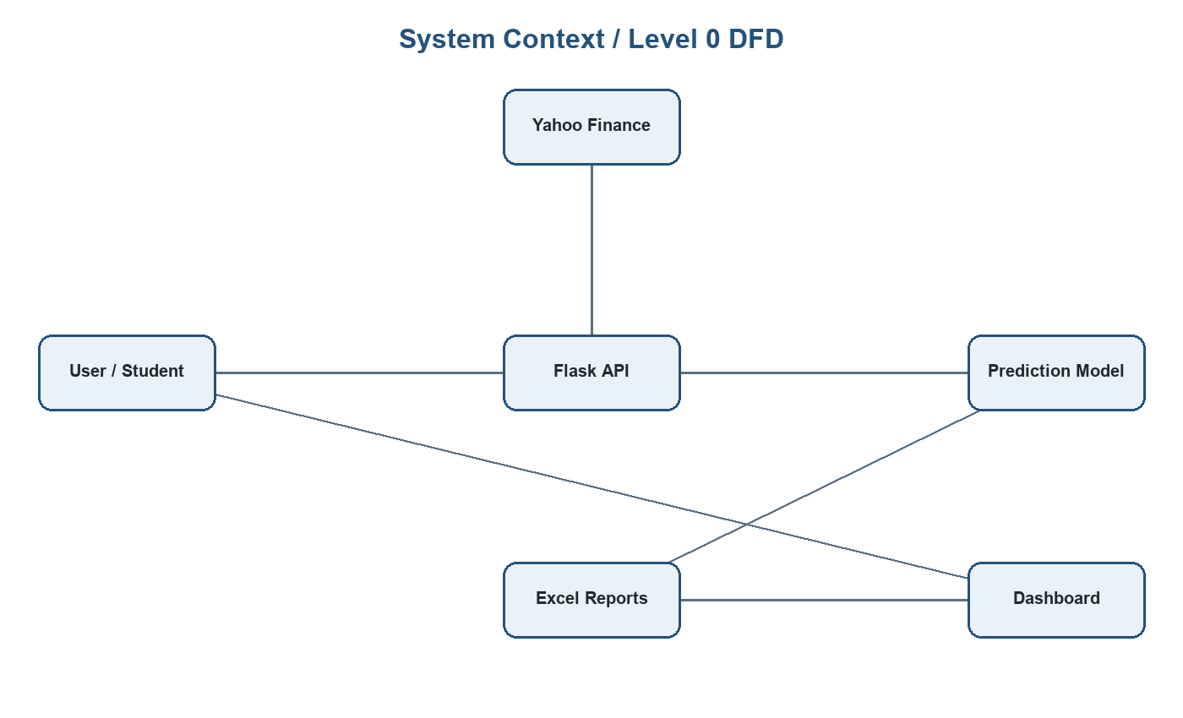
Figure 2.1: System context / Level 0 DFD

2.3 Functional Requirements
Table 2.1: Functional requirements
Req. ID | Requirement | Implemented Through
FR-01 | Download recent and historical stock data | yfinance in mainn.py, train_model.py and api.py
FR-02 | Engineer technical indicators | clean_and_engineer() and compute_features()
FR-03 | Train multiple classification models | train_models() in train_model.py
FR-04 | Persist trained models and metadata | joblib pickle files and metadata.json
FR-05 | Expose prediction API endpoints | Flask routes in api.py
FR-06 | Generate result reports | final.xlsx and model_comparison.xlsx
FR-07 | Generate charts and dashboards | visualize.py, dashboard.html and api_docs.html

2.4 Non-Functional Requirements
Table 2.2: Non-functional requirements
Quality | Requirement
Usability | The API documentation page should allow users to test predictions easily.
Reliability | The system must validate tickers, model names and input payloads.
Maintainability | Training, API and visualization concerns are separated into different files.
Performance | Saved models avoid retraining during API prediction requests.
Portability | Dependencies are listed in requirements.txt for reproducible setup.
Security | The API validates request bodies and limits batch prediction size to 10 tickers.

2.5 Feasibility Study
Technical feasibility is strong because all major components are implemented with stable Python libraries. Operational feasibility is appropriate for academic demonstration because the system can be run locally and used through browser pages or API clients. Economic feasibility is favorable because the implementation uses open-source tools and public data access rather than paid infrastructure.

Chapter 3: System Design

3.1 Architectural Design
The project follows a layered architecture. The data layer obtains raw OHLCV records, the feature layer computes model inputs, the machine learning layer trains and stores pipelines, the service layer exposes predictions and the presentation layer displays documentation, dashboards and reports.
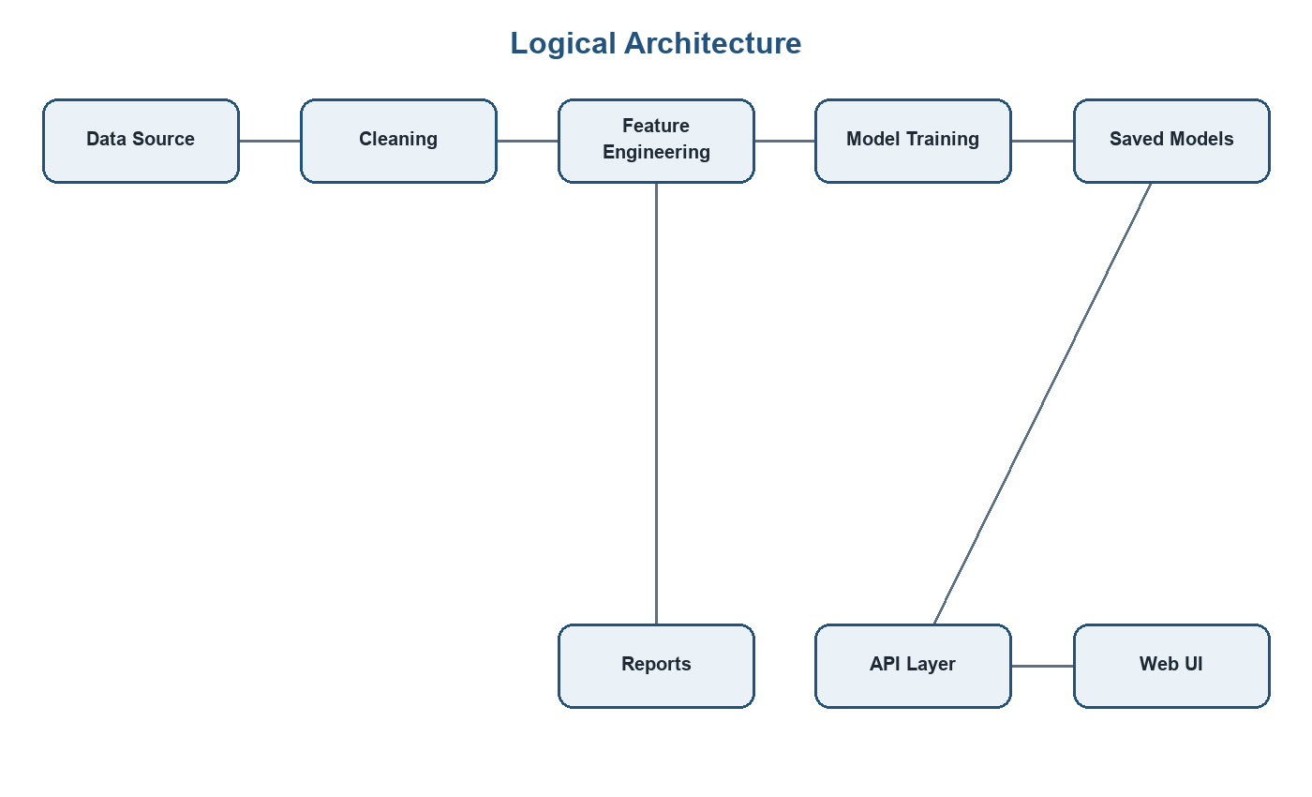
Figure 3.1: Logical architecture of the project

3.2 Data Flow and Processing
The data flow begins with daily stock records containing Date, Open, High, Low, Close, Volume and Stock. The system sorts records chronologically, removes null values, derives rolling features and constructs the target label. In training, the target is binary: 1 when the next day's close is greater than the current close, otherwise 0.

3.3 Feature Dictionary
Table 3.1: Feature dictionary
Feature | Definition | Purpose
MA_5 | 5-day moving average of closing price | Short-term trend
MA_10 | 10-day moving average of closing price | Medium-term trend
Lag_1 | Previous day close | Recent memory
Lag_2 | Close from two days earlier | Short lag memory
Volatility | 5-day rolling standard deviation | Risk and fluctuation
Return | Daily percentage change | Momentum
Volume_MA | 5-day moving average of volume | Trading activity
MA_diff | MA_5 minus MA_10 | Trend strength
Price_Change | Close minus previous close | Absolute movement
Volume_Change | Daily percentage volume change | Volume momentum

3.4 Sequence Design
For a prediction request, the client sends a ticker and optional model name. The API downloads recent records, computes features, extracts the latest feature vector, invokes the selected pipeline and returns prediction metadata in JSON format.
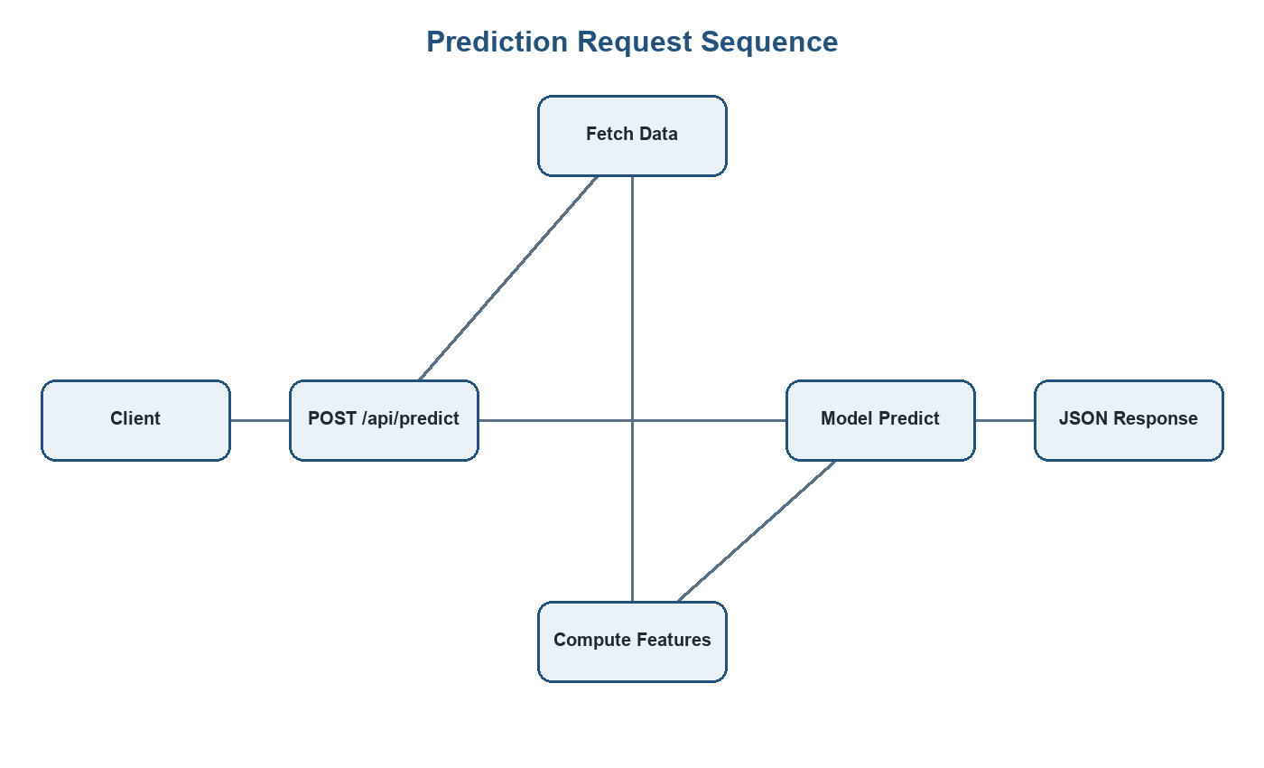
Figure 3.2: Prediction request sequence diagram

3.5 User Interface Design
The project contains two HTML interfaces. The API documentation page provides a prediction panel, model selector, quick stock buttons and result cards. The benchmark dashboard displays model comparison metrics, ranking and visual interpretation. These pages make the API outputs accessible without requiring a separate API client.

Chapter 4: Project Management

4.1 Development Approach
An iterative prototyping approach was suitable because the project required experimentation before finalizing the production pipeline. The notebook and mainn.py captured exploration, while train_model.py converted the successful workflow into a reusable training pipeline. api.py then integrated the trained models into a service layer.
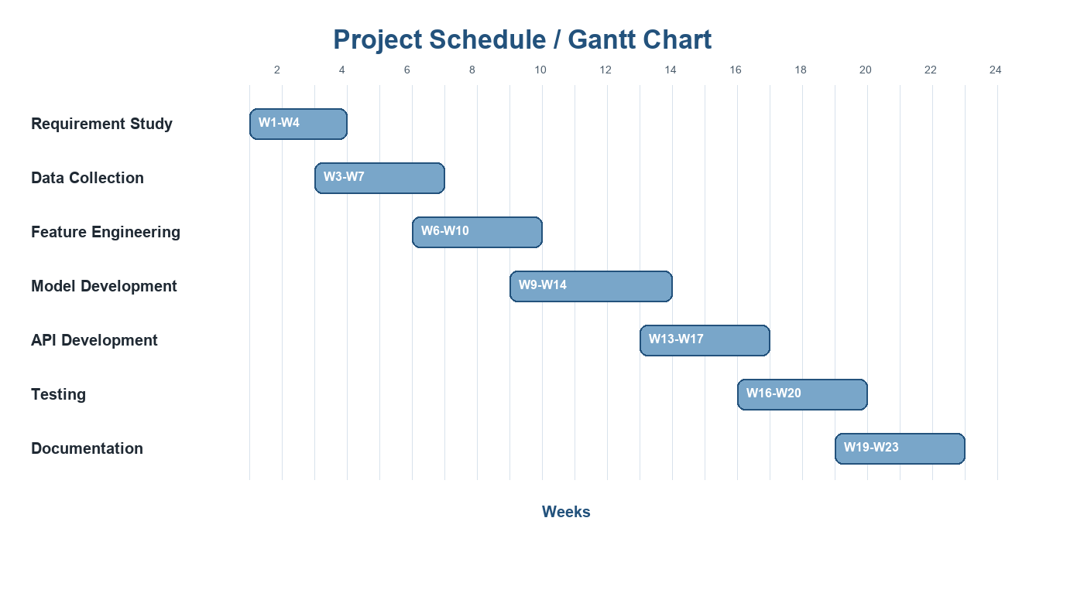
Figure 4.1: Project schedule / Gantt chart

4.2 Milestones and Deliverables
Table 4.1: Milestones and deliverables
Milestone | Deliverable | Dependency
Requirement study | Problem statement and scope | Guidelines and project idea
Data collection | Stock dataset from 2022 to 2025 | Internet and yfinance
Feature engineering | Ten technical indicators | Clean OHLCV records
Model training | Three trained model pipelines | Prepared feature matrix
API development | Flask endpoints | Saved model files
Reporting | Excel sheets, charts and dashboard | Prediction results
Documentation | Mini project report | All project artifacts

4.3 Risk Management
Table 4.2: Risk management plan
Risk | Probability | Impact | Mitigation
Yahoo Finance data unavailable | Medium | High | Validate responses and allow retry with valid tickers.
Model overfitting | Medium | High | Use train/test evaluation and time-series split in production script.
Data leakage | Medium | High | Prefer chronological split in train_model.py.
Low confidence predictions | High | Medium | Use HOLD signal and confidence quality labels.
Dependency mismatch | Medium | Medium | Maintain requirements.txt.
API misuse | Low | Medium | Validate JSON payloads and cap batch size.

4.4 Cost Estimation
Table 4.3: Effort-based cost estimation
Area | Estimated Effort | Cost Basis
Analysis and design | 30 hours | Student development effort
Data preparation | 25 hours | Student development effort
Model development | 45 hours | Student development effort
API and UI | 35 hours | Student development effort
Testing and debugging | 25 hours | Student development effort
Documentation | 30 hours | Student development effort

Chapter 5: Implementation and Coding
The implementation is divided into notebook experimentation, production training, API serving, visualization generation and reporting artifacts. This modular structure improves maintainability and allows each part of the pipeline to be run independently.

5.1 Project File Inventory
Table 5.1: Extracted project folder inventory
File / Folder | Size
.vscode\settings.json | 188 bytes
api.py | 15,180 bytes
api_docs.html | 24,934 bytes
confidence_distribution.png | 50,159 bytes
dashboard.html | 22,212 bytes
feature_importance.png | 81,802 bytes
final.xlsx | 28,042 bytes
LICENSE | 1,097 bytes
mainn.ipynb | 598,051 bytes
mainn.py | 12,732 bytes
mainn.pyi | 62 bytes
model_comparison.xlsx | 4,941 bytes
model_comparison_chart.png | 34,579 bytes
models\decision_tree.pkl | 49,763 bytes
models\logistic_regression.pkl | 2,017 bytes
models\metadata.json | 654 bytes
models\random_forest.pkl | 6,536,850 bytes
prob | 0 bytes
project_code_explanation.md | 24,928 bytes
README.md | 4,408 bytes
requirements.txt | 250 bytes
signal_distribution.png | 72,346 bytes
test_notebook.ipynb | 589 bytes
train_model.py | 10,088 bytes
visualizations\feature_correlation.png | 154,890 bytes
visualizations\feature_importance.png | 106,389 bytes
visualizations\model_performance.png | 116,130 bytes
visualize.py | 5,659 bytes

5.2 Main Modules
Table 5.2: Module responsibility matrix
Module | Responsibility
mainn.ipynb / mainn.py | Original experiment, data cleaning, feature engineering, sentiment attempt, model comparison and Excel export.
train_model.py | Production-style training with time-series split, metrics, backtesting and saved models.
api.py | Flask server that loads models and exposes health, model, stock, feature, single prediction and batch prediction endpoints.
visualize.py | Generates model comparison, feature importance and feature correlation visualizations.
dashboard.html | Benchmark dashboard for model comparison and interpretation.
api_docs.html | Interactive API documentation and prediction interface.

5.3 Training Pipeline
The training script downloads records from 2022-01-01 to 2025-01-01 for TCS.NS, INFY.NS, RELIANCE.NS and HDFCBANK.NS. After cleaning and feature engineering, records are sorted by date and split chronologically. This design is important because future data should not be used to train a model that is supposed to predict later movement.

5.4 API Implementation
The API loads metadata.json and model pickle files from the models folder. It exposes JSON endpoints for health checking, model listing, supported stock listing, feature descriptions, single prediction and batch prediction. The predict_stock function performs input validation, fetches recent stock data, computes features, predicts direction and returns a structured response.

5.5 Validation Checks
- Missing ticker requests return a 400 error with an example payload.
- Unknown model names return an informative error.
- Insufficient stock data is rejected before prediction.
- Batch prediction requires a non-empty list and is limited to 10 tickers.
- Prediction dates skip weekends when computing the next trading day.

Chapter 6: Results, Reports and User Interface

6.1 Model Performance
Table 6.1: Model comparison from model_comparison.xlsx
Model | Accuracy
Decision Tree | 75.42%
Random Forest | 80.00%
Logistic Regression | 75.42%

The Random Forest model achieved the best exported comparison accuracy of 80.00%. The final prediction workbook contains 590 prediction rows with an observed correctness ratio of 80.00% based on the Correct column.

6.2 Signal Distribution
Table 6.2: Trading signal distribution from final.xlsx
Signal | Count
BUY | 253
HOLD | 141
SELL | 196

6.3 Prediction Statistics
Table 6.3: Prediction summary statistics
Metric | Value
Total prediction rows | 590
Correct predictions | 472
Accuracy from final.xlsx | 80.00%
Minimum UP probability | 0.0000
Maximum UP probability | 0.9980
Average UP probability | 0.5101

6.4 Sample Prediction Records
Table 6.4: Sample rows from final.xlsx
Date | Stock | Prediction | Signal | Confidence | Actual | Correct
2022-07-29 | INFY.NS | 0 | SELL | 0.1751 | 0 | 1
2023-03-28 | HDFCBANK.NS | 1 | BUY | 0.9199 | 1 | 1
2023-09-13 | HDFCBANK.NS | 1 | BUY | 0.9356 | 1 | 1
2023-08-08 | TCS.NS | 0 | SELL | 0.1107 | 0 | 1
2024-11-19 | TCS.NS | 0 | SELL | 0.0025 | 0 | 1
2024-10-09 | HDFCBANK.NS | 1 | BUY | 0.7583 | 1 | 1
2023-11-09 | TCS.NS | 0 | SELL | 0.0400 | 0 | 1
2024-12-31 | RELIANCE.NS | 1 | HOLD | 0.5543 | 0 | 0
2024-07-30 | HDFCBANK.NS | 1 | BUY | 0.7791 | 1 | 1
2023-03-13 | TCS.NS | 0 | SELL | 0.0108 | 0 | 1

6.5 Generated Visual Outputs
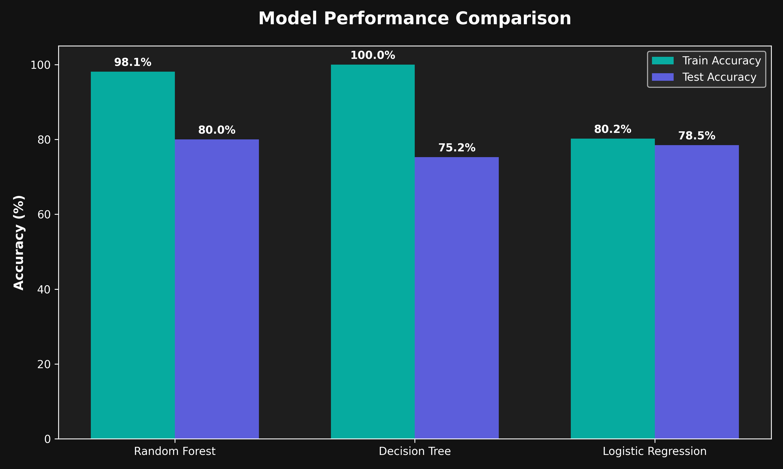
Figure 6.1: Model performance visualization
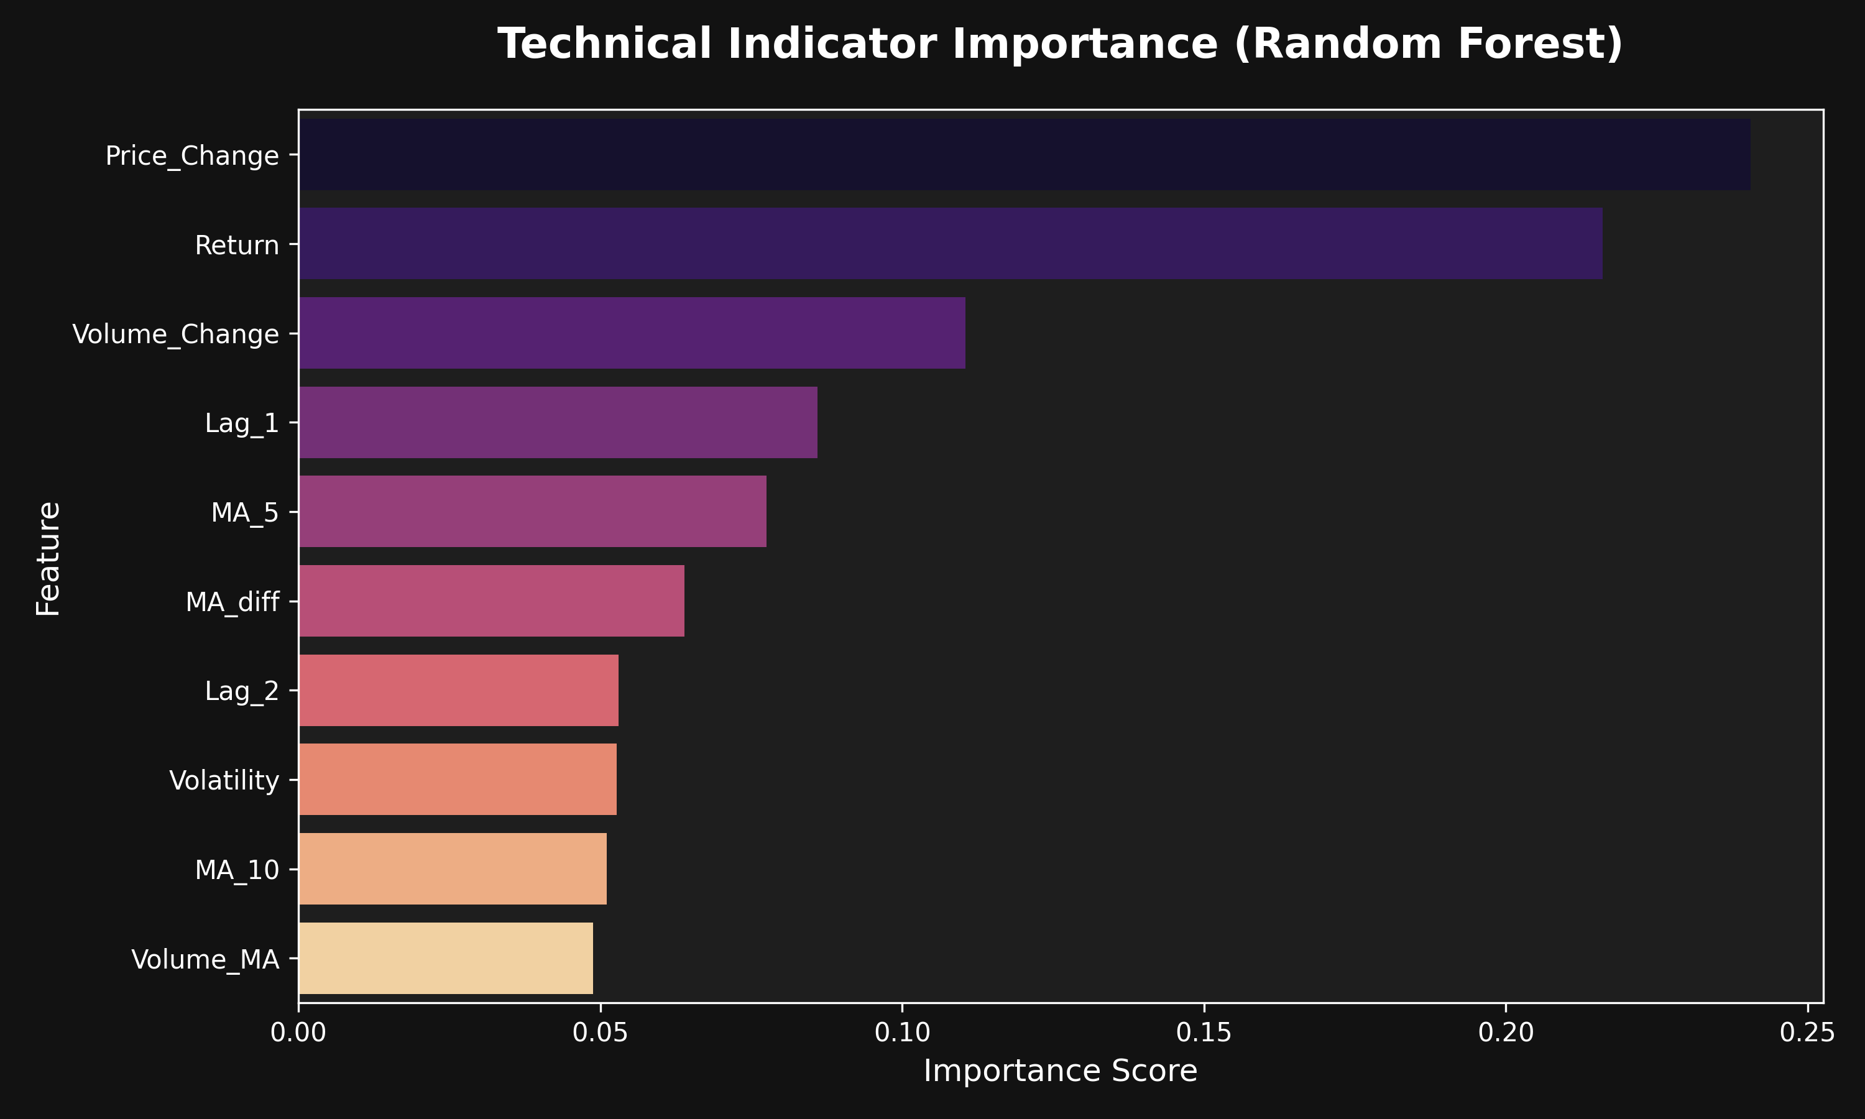
Figure 6.2: Random Forest feature importance
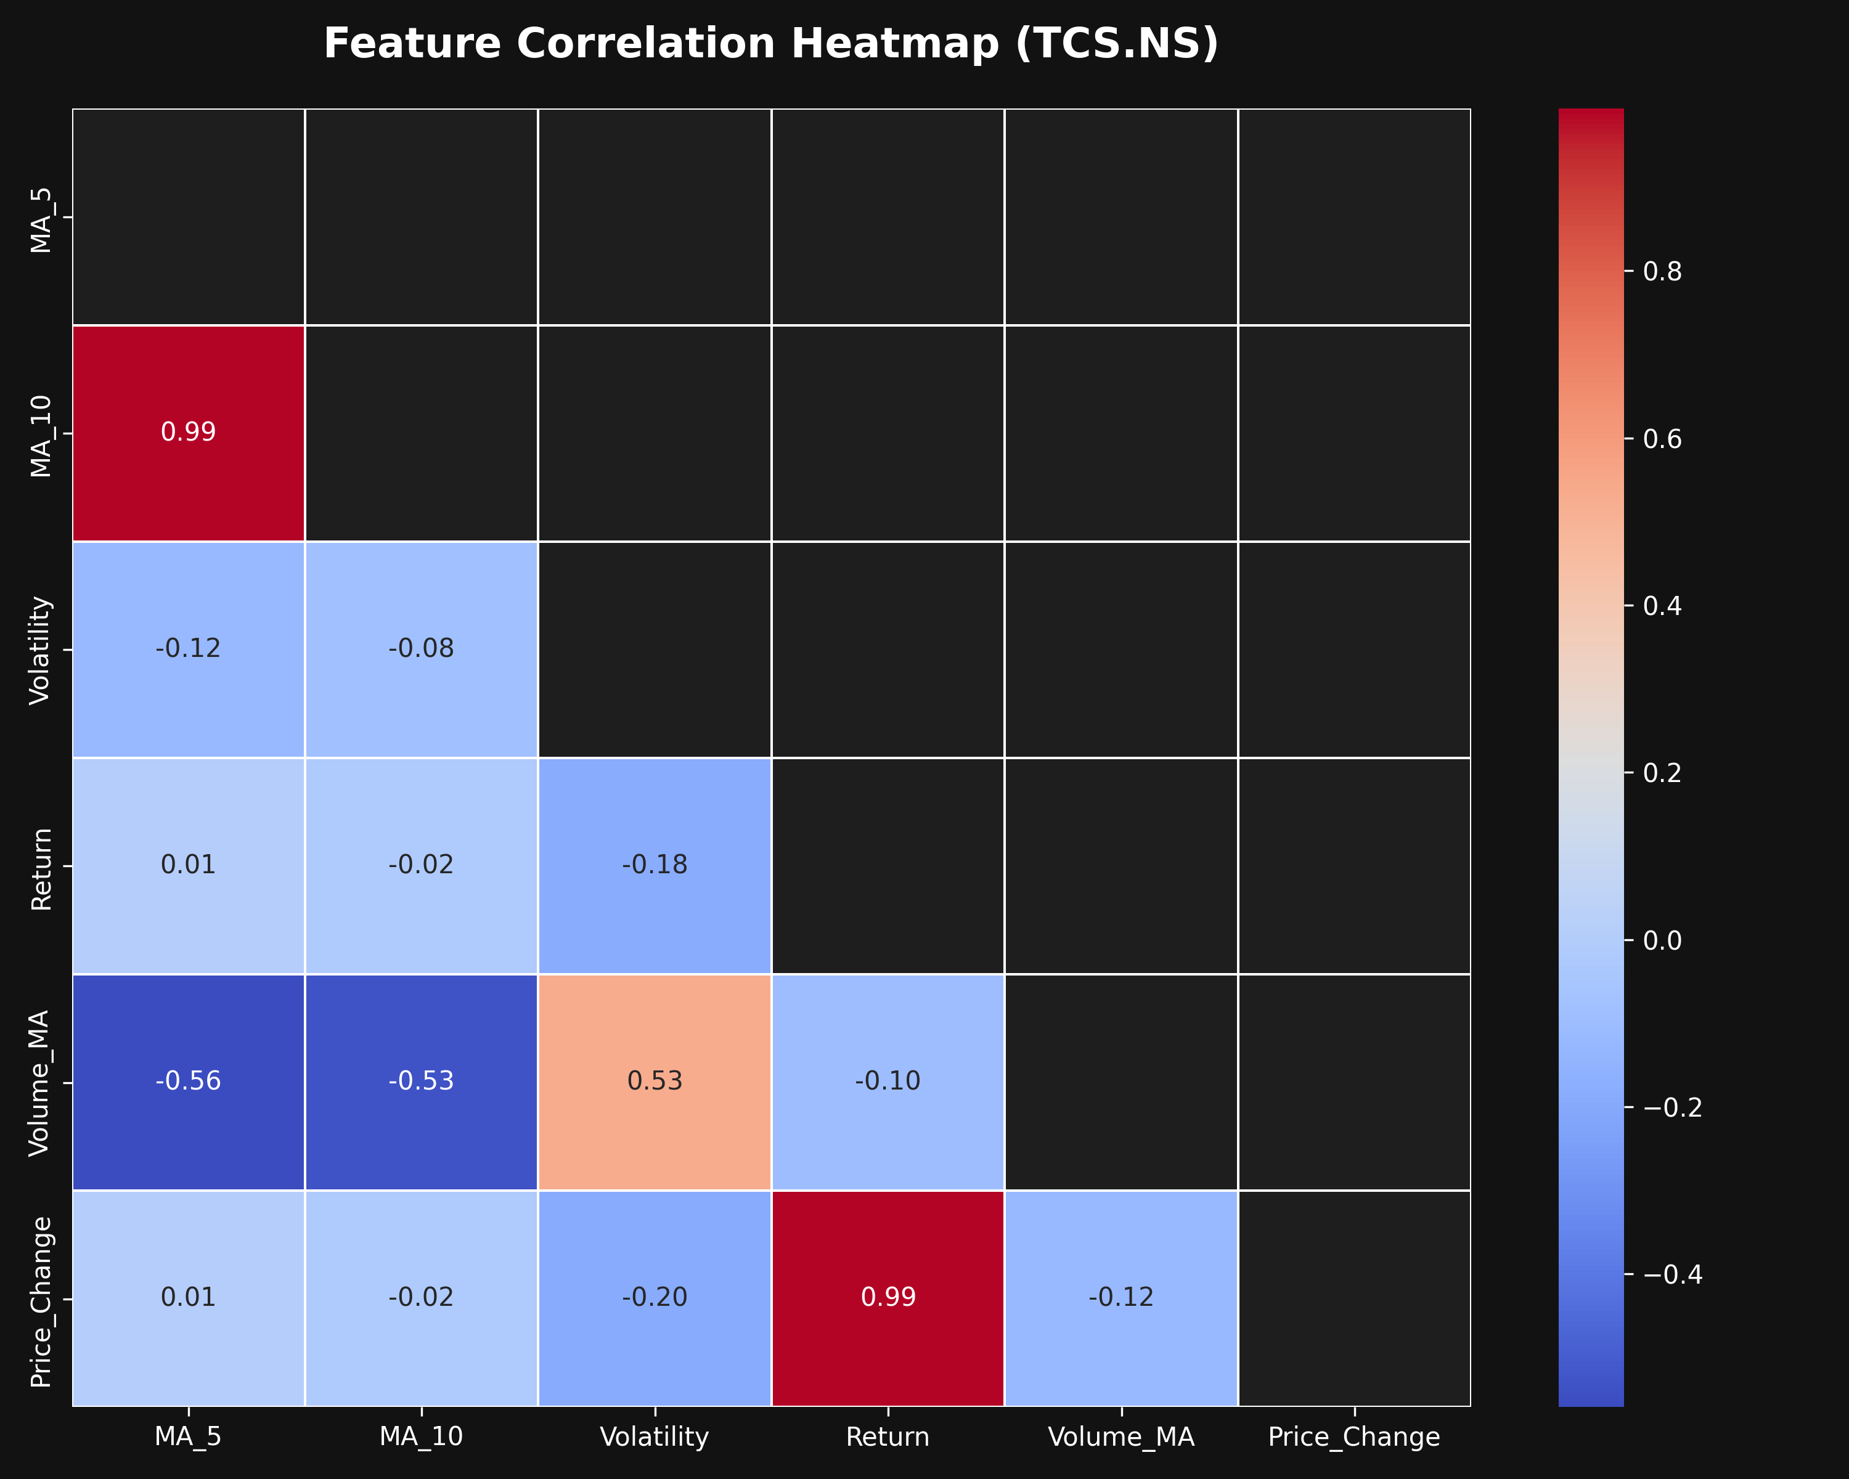
Figure 6.3: Feature correlation heatmap
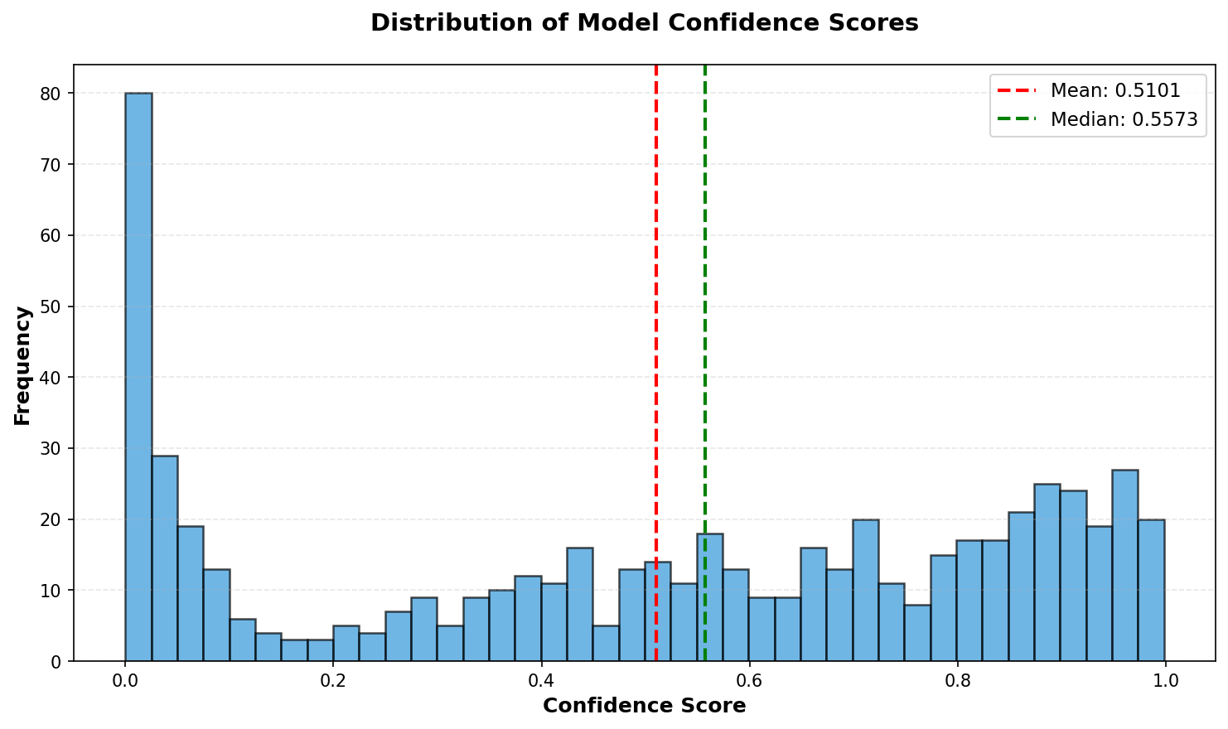
Figure 6.4: Prediction confidence distribution
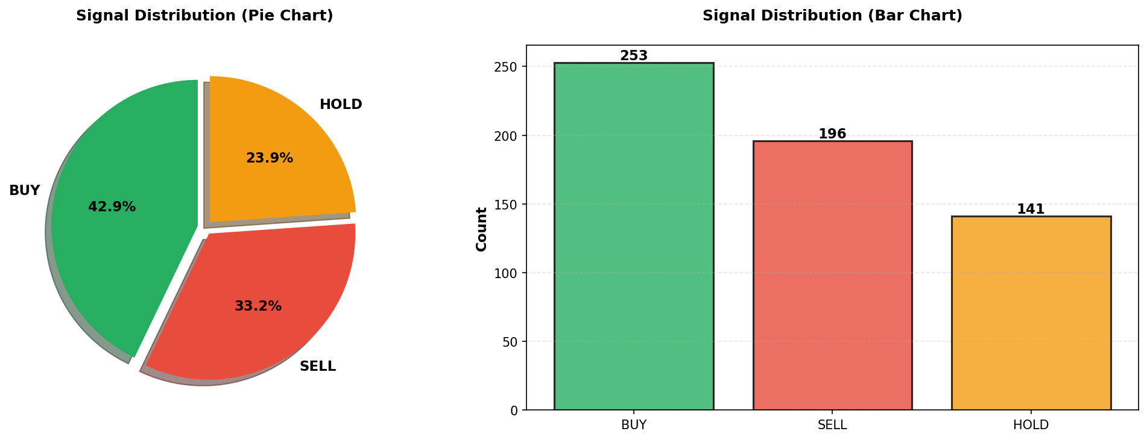
Figure 6.5: Signal distribution chart

Chapter 7: Testing, Implementation and Maintenance

7.1 Testing Strategy
Testing was considered at data, model and API levels. Data testing confirms that expected columns are available and null values are removed. Model testing compares predictions against held-out data. API testing verifies endpoint behavior for normal and invalid request payloads.
Table 7.1: Test cases
Test ID | Scenario | Expected Result | Status
TC-01 | Run training pipeline | Models and metadata saved in models folder | Designed
TC-02 | Open /api/health | Healthy JSON response with loaded model count | Designed
TC-03 | POST /api/predict with TCS.NS | Prediction response with signal and confidence | Designed
TC-04 | POST /api/predict without ticker | 400 error with example body | Designed
TC-05 | POST /api/predict/batch with more than 10 tickers | 400 error for batch size limit | Designed
TC-06 | Generate visualizations | PNG charts saved in visualizations folder | Designed
TC-07 | Open final.xlsx | Prediction rows and formatted headers visible | Designed

7.2 Implementation Notes
The system should be implemented by first installing dependencies from requirements.txt, then running train_model.py to refresh the trained models, then starting api.py. The dashboard and documentation pages can be opened in a browser, while API clients can call JSON endpoints directly.

7.3 Maintenance
- Retrain models periodically so that recent market data is reflected.
- Monitor API errors for invalid tickers and unavailable data source responses.
- Update requirements.txt when library versions change.
- Review feature importance before adding or removing indicators.
- Keep API documentation synchronized with endpoint behavior.

Chapter 8: Summary and Future Scope
The mini project successfully demonstrates a complete machine learning software workflow for stock movement prediction. It includes data collection, cleaning, feature engineering, multiple model training, model persistence, API delivery, dashboard presentation and spreadsheet reporting.

8.1 Key Outcomes
- A working classification pipeline predicts next-day stock direction.
- Random Forest, Decision Tree and Logistic Regression were compared.
- Random Forest produced the strongest exported accuracy result.
- The API supports single and batch prediction workflows.
- Excel reports and visualization charts support result interpretation.

8.2 Limitations
- The model uses historical technical indicators and cannot capture every market-moving event.
- The bundled model was trained on four NSE stocks, so generalization should be evaluated before wider use.
- Sentiment analysis is exploratory and depends on external news API availability.
- The project is for academic decision-support demonstration and not financial advice.

8.3 Future Enhancements
- Add LSTM, GRU or Transformer-based time-series models for deeper sequential learning.
- Integrate robust sentiment features using reliable news sources.
- Add authentication and rate limiting for deployed API use.
- Store prediction history in a database for audit and monitoring.
- Add automated scheduled retraining and model drift detection.
- Build a richer frontend with charts for individual ticker trends and prediction history.

References / Bibliography
- scikit-learn documentation for classification models and pipelines.
- pandas documentation for dataframe cleaning and transformation.
- NumPy documentation for numerical computation.
- Flask documentation for REST API development.
- Yahoo Finance data access through the yfinance Python package.
- matplotlib and seaborn documentation for visualization.
- openpyxl documentation for Excel report generation.
- Project source files: README.md, project_code_explanation.md, mainn.py, train_model.py, api.py and visualize.py.

Appendix A: API Endpoint Summary
Endpoint | Method | Purpose
/ | GET | Serve interactive API documentation page
/api/health | GET | Return server and model health
/api/models | GET | List models and metrics
/api/stocks | GET | List trained stock tickers
/api/features | GET | List feature descriptions
/api/predict | POST | Predict one ticker
/api/predict/batch | POST | Predict up to 10 tickers

Appendix B: Important Code Excerpts

Feature Engineering
df['MA_5'] = df['Close'].rolling(5).mean()
df['MA_10'] = df['Close'].rolling(10).mean()
df['Target'] = (df['Close'].shift(-1) > df['Close']).astype(int)

Signal Generation
if confidence > 0.60:
return 'BUY'
elif confidence < 0.40:
return 'SELL'
else:
return 'HOLD'

Model Persistence
joblib.dump(data['pipeline'], model_path)
json.dump(metadata, f, indent=2)

Glossary
Term | Meaning
OHLCV | Open, High, Low, Close and Volume market data
Feature | Input variable used by a machine learning model
Target | Expected output label used for supervised learning
Random Forest | Ensemble classifier made from multiple decision trees
API | Application Programming Interface
Confidence | Model probability used to qualify prediction strength
Backtesting | Testing trading logic on historical data

