**Entreprise Management and Entrepreneurship**

**M.EIC**

**Financial Accounting Exercises**

# Exercise 1

Suppose that you collected the following information regarding the company OCTANS, LDA.

|  |  |  |  |  |
| --- | --- | --- | --- | --- |
| **Movements** | **(in euros)** | **Assets** | **Liabilities** | **Other (including Income Statement)** |
| Debt from a customer | 55.000 | x |  |  |
| Small car | 15.000 | x |  |  |
| Sales of goods | 120.000 |  |  | x |
| Computer software | 5.000 | x |  |  |
| Debt to a supplier | 30.000 |  | x |  |
| Cost of goods sold | 85.000 |  |  | x |
| Factory building | 65.000 | x |  |  |
| Coins and notes | 300 | x |  |  |
| 3 year bank loan | 100.000 |  | x |  |
| Stock of raw materials | 18.000 | x |  |  |
| Electricity consumption already paid | 150 |  |  | x |
| Value of the heavy duty van that is in service and that was rented at "Car Rent, Lda" | 20.000 |  |  |  |
| Stock of finished goods | 8.000 | x |  |  |
| Portfolio of customer orders | 28.000 |  |  |  |
| Bank deposits | 7.000 | x |  |  |
| Debts related to taxes and Social Security | 6.000 |  | x |  |
| Furniture and administrative equipment | 12.700 | x |  |  |
| TOTAL |  | 186000 |  |  |

1. **Classify the movements presented, distinguishing those that represent a change in the company patrimony (that go to the balance sheet) from those that go to the income statement. Regarding the changes in patrimony, classify them as Assets or Liabilities.**

1. **Calculate the value of the Assets, Liabilities and Equity of this company.**

1. **Prepare the balance sheet of this company after the presented movements.**

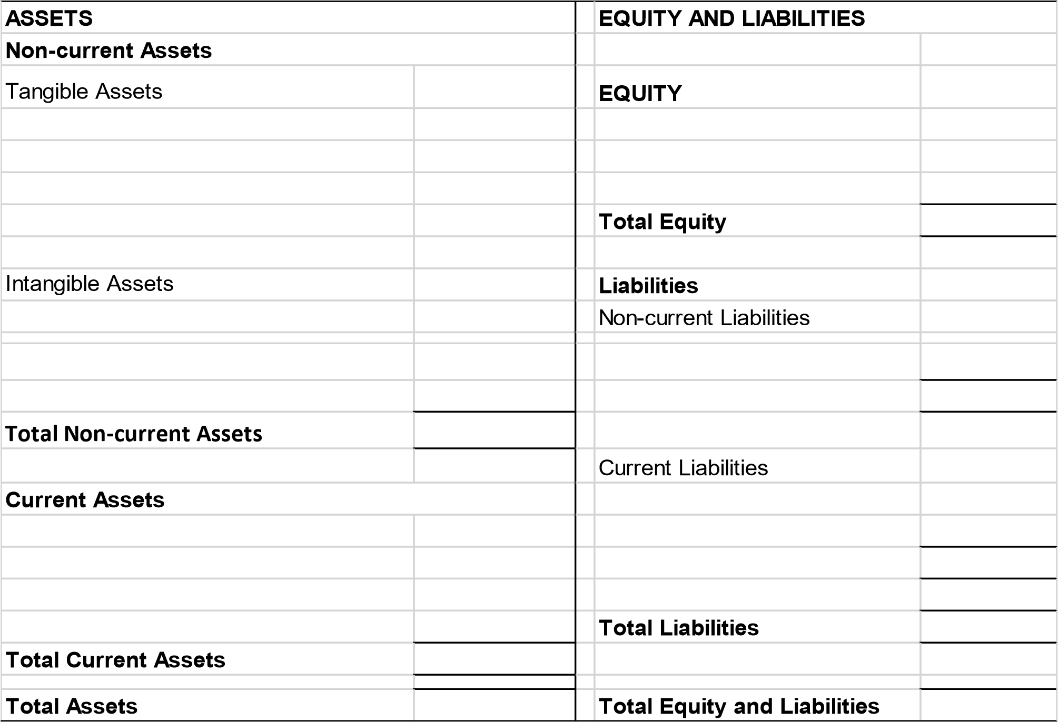

# Exercise 2

1. Identify the positive and the negative componentes of the income:  **Transactions**

**Value**

* 1. Staff wages 10.000 -
  2. Electricity bill 1.500 -
  3. Sales to customers 50.000 +
  4. Cost of goods sold 32.500 -
  5. Cash discounts granted 300 -
  6. Company headquartes rent 500 -
  7. Interests received from bank deposits 80 +
  8. Journals and magazines bought 50 -
  9. Interests paid to the bank from credit obtained 200 -
  10. Depreciation and amortization 300 -

1. Prepare the income statment of this company, using the template below:

|  |  |  |
| --- | --- | --- |
| **Revenue and expenses** |  | **Period 31-12-N** |
| Sales | + |  |
| Cost of goods sold | - |  |
| Suppliers and external services | - |  |
| Employee expenses | - |  |
| Other income | + |  |
| Other expenses | - |  |
| **EBITDA – Earnings before Interest, Taxes, Depreciation and Amortization** | = |  |
| Depreciation and Amortization | -/+ |  |
| **Operating Income (EBIT – Earnings before Interests and Taxes)** | = |  |
| Interests and financial revenues | + |  |
| Interests and financial expenses | - |  |
| **Earnings before taxes** | = |  |
| Taxes (17%) | -/+ |  |
| **Net Income** | = |  |