FE2

1. A program is a set of instructions and associated data that resides on the disk and is loaded by the operating system to perform some task. An executable file or a python script file are examples of programs. In order to run a program, the operating system’s kernel is first asked to create a new process, which is an environment in which a program executes.
A process is a program in execution. A process is an execution environment that consists of instructions, user-data and system-data segments, as well as lots of other resources such as CPU, memory, adress-space, disk and network I/O acquired at runtime. A progam can have several copies of it running at the same time, but a process necessarily belongs to only one program.
Thread is the smallest unit of execution in a process. A thread simply executes instructions serially. A process can have multiple threads running as part of it. Usually, there would be some state associated with the process ( global state ) that is shared among all the threads and in turn, each thread would have some state private to itself ( local state ). The globally shared state amongst the threads of a process is visible and accessible to all the threads, and special attention needs to be paid when any thread tries to read or write to this global shared state. There are several constructs offered by various programming languages to guard and discipline the access to this global state.

2.
a) Each process has data associated with it that differentiates them, such as :
  - PID – Process Identifier
  - PPID – Parent Process Identifier
  - real U/GID – User/Group Identifier of who initiated the process
  - current dir – Directory to where names of files are referenced by default
  - file descriptor table – info on open files; descriptor is table index
  - environment – initially inherited from parent process
  - text space – memory where program instructions lie; read only
  - stack space – memory automatically managed
  - heap space – memory managed by the user at runtime
  - priority – info for process scheduling
  - signal disposition – masks for delivery or blocking of signals
  - unmask – mask that restrains files’ permissions on creation
b) Each thread has data associated with it that differentiates them, such as:
- Program Counter
- Registers
- Stack
- State
- Threads from the same process, also share:
  - Address space
  - Global Variables
  - … more
c)
 | Process | Thread
PID | TBD
PPID
Real U/GID
Current dir

3. Run: “ps a u x”
- Different values for the process state (STAT)
D uninterruptible sleep (usually IO)
R running or runnable (on run queue)
S interruptible sleep (waiting for an event to complete)
T stopped by job control signal
t stopped by debugger during the tracing
W paging (not valid since the 2.6.xx kernel)
X dead (should never be seen)
Z defunct ("zombie") process, terminated but not reaped by
its parent

For BSD formats and when the stat keyword is used, additional
characters may be displayed:

< high-priority (not nice to other users)
N low-priority (nice to other users)
L has pages locked into memory (for real-time and custom IO)
s is a session leader
l is multi-threaded (using CLONE_THREAD, like NPTL pthreads
do)
+ is in the foreground process group
- ps -ejHC ps ?
- ? Use pstree command to do smth

4.

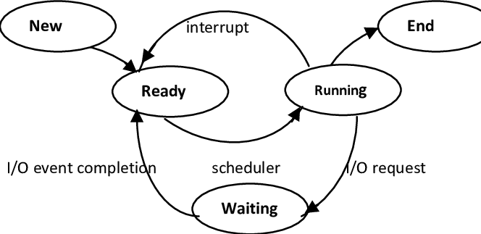
5. Done in code

6.
Architecture of a program | Processes | Threads
Advantage | Date is not shared between processes, hence there is no risk of corruption | Less overhead to start and terminate a thread. Also, faster task-switching and data sharing with other threads enable for a faster execution.
Disadvantage | Overhead (tempo) significantly superior to start and terminate processes, relative to threads. To start a process, the whole process area must be duplicated . | System relies on shared memory, so if something goes wrong in a thread and causes data corruption, this affects all the threads

7. Signals are intended to provide a rudimentary form of communication between processes, as such, they have several issues such as:
- A lot of system calls will be interrupted by a signal and need special handling
- Accordingly, a lot of code in the wild is not signal-safe
- Signals do not have any kind of data content, except for themselves, making them useless as a message passing method
- There is only so much you can do with a signal handler
- Most importantly, subsequent signals of the same type are not queued – they are merged into one instance
- Even more important, there is no guarantee that signals are delivered in the same order as they were generated.
After taking these issues into account, we can understand the problem with signals and an example where they could bring some serious issues would be the example of sending a signal to run a program followed by another to terminate it. Since the order is not guaranteed, the program might terminate before even running.

8. The sigaction() system call is used to change the action taken by a process on receipt of a specific signal.
9. Done in code
10. Done in code
11. A pipe is a method of connecting the standard output of a process to the standard input of another. Normal (anonymous) pipes can only be used to communicate between a parent and child processor, while the named pipes (FIFOs) allow the communication of any process, as long as it has rights to read/write on that fifo. Another difference is that anonymous pipes do not exist in the file system, while named pipes do exist.
12.
- With named pipes, any 2 processes can communicate as long as they have the reference to the file. So, the process A sends the color informations and B receives it.
- with normal pipes, the processes may only communicate if they are parent and child. Consequentially, the parent process shall send the color information and the child process will receive it the same way.
- With signals, since you need to know the process ID you are sending the signal to, the best way would be to connect a parent to a child process once again. Furthermore, since signals carry no information on the message, ony the signal itself and there is a limited number of colors (7), we can create a dictionary where different signals point to different colors and that way we can communicate one color to another process.

