JPA HIBERNATE EXERCISE 3

- Create a class Address for Author with instance variables streetNumber, location, State.
//address entity
package com.example.exercise.q1to2.entity;
import javax.persistence.Embeddable;
@Embeddable
public class Address {
private String streetNumber;
private String location;
private String state;
public String getStreetNumber() {
return streetNumber;
}
public void setStreetNumber(String streetNumber) {
this.streetNumber = streetNumber;
}
public String getLocation() {
return location;
}
public void setLocation(String location) {
this.location = location;
}
public String getState() {
return state;
}
public void setState(String state) {
this.state = state;
}
}

- Create instance variable of Address class inside Author class and save it as embedded object.
// AUTHOR ENTITY
package com.example.exercise.q1to2.entity;
import javax.persistence.Embeddable;
@Embeddable
public class Address {
private String streetNumber;
private String location;
private String state;
public String getStreetNumber() {
return streetNumber;
}
public void setStreetNumber(String streetNumber) {
this.streetNumber = streetNumber;
}
public String getLocation() {
return location;
}
public void setLocation(String location) {
this.location = location;
}
public String getState() {
return state;
}
public void setState(String state) {
this.state = state;
}
}

// creating author in Q1To4Tests test.java with address as embedded object
@SpringBootTest
class Q1To4Tests {
@Autowired
Author1to2Repository author1to2Repository;
@Test
void contextLoads() {
}
// Q1 to 4
@Test // creating a new author with address as embedded object
// Persist 3 subjects for each author.
void testCreateAuthor1(){
Author author=new Author();
author.setAuthorName("mason");
author.setAuthorAge(45);
Address address=new Address();
address.setStreetNumber("565");
address.setState("york shire");
address.setLocation("hobbiton");
author.setAddress(address);
author1to2Repository.save(author);
}

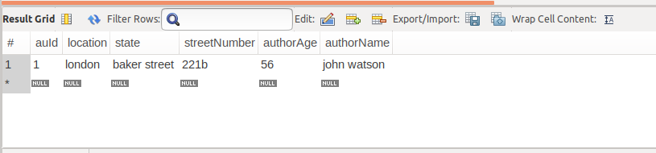
- Introduce a List of subjects for author.
// SUBJECTS ENTITY

@Entity
public class Subjects {
@Id
private int subId;
private String subjectName;
@ManyToOne(cascade = CascadeType.ALL)
@JoinColumn(name = "auId")
private Author author;
public int getSubId() {
return subId;
}
public void setSubId(int subId) {
this.subId = subId;
}
public String getSubjectName() {
return subjectName;
}
public void setSubjectName(String subjectName) {
this.subjectName = subjectName;
}
public Author getAuthor() {
return author;
}
public void setAuthor(Author author) {
this.author = author;
}
}

// Updated Author Entity
package com.example.exercise.q1to4.entity;
import javax.persistence.*;
import java.util.HashSet;
import java.util.List;
import java.util.Set;
@Entity
public class Author {
@Id
@GeneratedValue(strategy = GenerationType.AUTO)
private int auId;
private String authorName;
private int authorAge;
@Embedded
private Address address;
@OneToMany(mappedBy = "author",cascade = CascadeType.ALL,fetch = FetchType.EAGER)
private Set<Subjects> subjectsList;
public int getAuId() {
return auId;
}
public void setAuId(int auId) {
this.auId = auId;
}
public String getAuthorName() {
return authorName;
}
public void setAuthorName(String authorName) {
this.authorName = authorName;
}
public int getAuthorAge() {
return authorAge;
}
public void setAuthorAge(int authorAge) {
this.authorAge = authorAge;
}
public Address getAddress() {
return address;
}
public void setAddress(Address address) {
this.address = address;
}
public Set<Subjects> getSubjectsList() {
return subjectsList;
}
public void setSubjectsList(Set<Subjects> subjectsList) {
this.subjectsList = subjectsList;
}
public void addSubject(Subjects subject){
if(subjectsList==null){
subjectsList= new HashSet<>();
}
subject.setAuthor(this);
subjectsList.add(subject);
}
}

- Persist 3 subjects for each author.
// creating the author with 3 subjects in Q1To4Tests test
@SpringBootTest
class Q1To4Tests {
@Autowired
Author1to2Repository author1to2Repository;
@Test
void contextLoads() {
}
// Q1 to 4
@Test // creating a new author with address as embedded object
// Persist 3 subjects for each author.
void testCreateAuthor1(){
Author author=new Author();
author.setAuthorName("mason");
author.setAuthorAge(45);
Address address=new Address();
address.setStreetNumber("565");
address.setState("york shire");
address.setLocation("hobbiton");
author.setAddress(address);
Subjects sub1=new Subjects();
sub1.setSubId(1);
sub1.setSubjectName("friction");
Subjects sub2=new Subjects();
sub2.setSubId(2);
sub2.setSubjectName("non-friction");
Subjects sub3=new Subjects();
sub3.setSubId(3);
sub3.setSubjectName("thriller");
author.addSubject(sub1);
author.addSubject(sub2);
author.addSubject(sub3);
author1to2Repository.save(author);
}

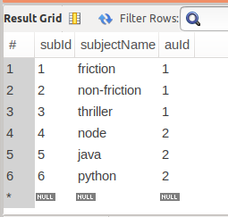
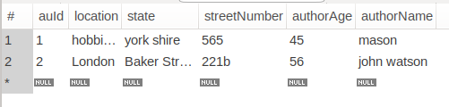

- Create an Entity book with an instance variable bookName.
// BOOK ENTITY
package com.example.exercise.q1to6.entity;
import javax.persistence.Entity;
import javax.persistence.Id;
import javax.persistence.JoinColumn;
import javax.persistence.OneToOne;
@Entity
public class Book {
@Id
private int bId;
private String BookName;
private String PublisherName;
@OneToOne
@JoinColumn(name = "auId")
Author author;
public int getbId() {
return bId;
}
public void setbId(int bId) {
this.bId = bId;
}
public String getBookName() {
return BookName;
}
public void setBookName(String bookName) {
BookName = bookName;
}
public String getPublisherName() {
return PublisherName;
}
public void setPublisherName(String publisherName) {
PublisherName = publisherName;
}
public Author getAuthor() {
return author;
}
public void setAuthor(Author author) {
this.author = author;
}
}

- Implement One to One mapping between Author and Book.
// UPDATED AUTHOR
package com.example.exercise.q1to6.entity;
import javax.persistence.*;
import java.util.HashSet;
import java.util.Set;
@Entity
public class Author {
@Id
@GeneratedValue(strategy = GenerationType.AUTO)
private int auId;
private String authorName;
private int authorAge;
@OneToOne(mappedBy = "author",cascade = CascadeType.ALL,fetch = FetchType.EAGER)
private Book book;
@Embedded
private Address address;
@OneToMany(mappedBy = "author",cascade = CascadeType.ALL,fetch = FetchType.EAGER)
private Set<Subjects> subjectsList;
public int getAuId() {
return auId;
}
public void setAuId(int auId) {
this.auId = auId;
}
public String getAuthorName() {
return authorName;
}
public void setAuthorName(String authorName) {
this.authorName = authorName;
}
public int getAuthorAge() {
return authorAge;
}
public void setAuthorAge(int authorAge) {
this.authorAge = authorAge;
}
public Address getAddress() {
return address;
}
public void setAddress(Address address) {
this.address = address;
}
public Set<Subjects> getSubjectsList() {
return subjectsList;
}
public void setSubjectsList(Set<Subjects> subjectsList) {
this.subjectsList = subjectsList;
}
public Book getBook() {
return book;
}
public void setBook(Book book) {
this.book = book;
}
public void addSubject(Subjects subject){
if(subjectsList==null){
subjectsList= new HashSet<>();
}
subject.setAuthor(this);
subjectsList.add(subject);
}
public void addBook(Book book){
this.setBook(book);
book.setAuthor(this);
}
}
// creating the author
@Test
void contextLoads() {
}
// Q1 to 4
@Test // creating a new author with address as embedded object
// Persist 3 subjects for each author.
void testCreateAuthor1(){
Author author=new Author();
author.setAuthorName("mason");
author.setAuthorAge(45);
// embedding address
Address address=new Address();
address.setStreetNumber("565");
address.setState("york shire");
address.setLocation("hobbiton");
author.setAddress(address);
Subjects sub1=new Subjects();
sub1.setSubId(1);
sub1.setSubjectName("friction");
Subjects sub2=new Subjects();
sub2.setSubId(2);
sub2.setSubjectName("non-friction");
Subjects sub3=new Subjects();
sub3.setSubId(3);
sub3.setSubjectName("thriller");
// adding subject to the list
author.addSubject(sub1);
author.addSubject(sub2);
author.addSubject(sub3);
// adding book to author
//adding book to the author
Book b1=new Book();
b1.setbId(12);
b1.setBookName("rd sharma");
b1.setPublisherName("sharma publications");
author.addBook(b1);
author1To6Repository.save(author);
}
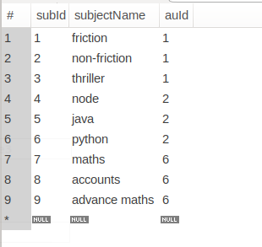
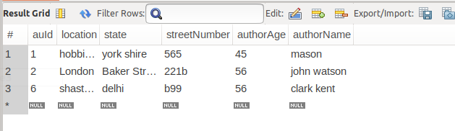

- Implement One to Many Mapping between Author and Book(Unidirectional, BiDirectional and without additional table ) and implement cascade save.

1. Unidirectional
// Author.java
package com.example.mapping.one2many.unidirectional;
import javax.persistence.*;
import java.util.ArrayList;
import java.util.List;
@Entity
@Table(name = "author")
public class Author {
@Id
@GeneratedValue(strategy = GenerationType.AUTO)
@Column(name = "author_id")
private int aId;
@Column(name = "author_name")
private String authorName;
@Column(name = "author_age")
private int authorAge;
@OneToMany(cascade = CascadeType.ALL,fetch = FetchType.EAGER)
// @JoinColumn(name = "a_id")
private List<Book> bookList;
public Author(){}
public Author(String authorName, int authorAge, List<Book> bookList) {
this.authorName = authorName;
this.authorAge = authorAge;
this.bookList = bookList;
}
public int getaId() {
return aId;
}
public void setaId(int aId) {
this.aId = aId;
}
public String getAuthorName() {
return authorName;
}
public void setAuthorName(String authorName) {
this.authorName = authorName;
}
public int getAuthorAge() {
return authorAge;
}
public void setAuthorAge(int authorAge) {
this.authorAge = authorAge;
}
public List<Book> getBookList() {
return bookList;
}
public void setBookList(List<Book> bookList) {
this.bookList = bookList;
}
}

// Book.java
package com.example.mapping.one2many.unidirectional;
import javax.persistence.*;
@Entity
@Table(name = "book")
public class Book {
@Id
@GeneratedValue(strategy = GenerationType.AUTO)
@Column(name = "book_id")
private int id;
@Column(name = "book_name")
private String bookName;
public Book(){}
public Book(String bookName) {
this.bookName = bookName;
}
public int getId() {
return id;
}
public void setId(int id) {
this.id = id;
}
public String getBookName() {
return bookName;
}
public void setBookName(String bookName) {
this.bookName = bookName;
}
}

// AuthorService.java
package com.example.mapping.one2many.unidirectional;
import org.springframework.beans.factory.annotation.Autowired;
import org.springframework.stereotype.Service;
import java.util.Arrays;
import java.util.List;
@Service
public class AuthorService {
@Autowired
UniRepository uniRepository;
public void addAuthor(){
List<Book> bookList= Arrays.asList(new Book("bam"),new Book("kabam"),
new Book("sazam"));
Author author=new Author("yani",56,bookList);
uniRepository.save(author);
List<Book> bookList1= Arrays.asList(new Book("teenage"),new Book("wasteland"),
new Book("this is"));
Author author1=new Author("baba o riley",76,bookList1);
uniRepository.save(author1);
}
}

// UniRepository.java
package com.example.mapping.one2many.unidirectional;
import org.springframework.data.repository.CrudRepository;
public interface UniRepository extends CrudRepository<Author,Integer> {
}

//package com.example.mapping.one2many.unidirectional;
import org.springframework.boot.SpringApplication;
import org.springframework.boot.autoconfigure.SpringBootApplication;
import org.springframework.context.ApplicationContext;
@SpringBootApplication
public class UnidirectionalApplication {
//RUNNING THE SCRIPT RUN FOLOWING COMMANDS IN DATABASE
//BEFORE
//SET foreign_key_checks = 0;
//drop table author;
//drop table book;
//SET foreign_key_checks = 1;
public static void main(String[] args) {
ApplicationContext applicationContext=SpringApplication.run(UnidirectionalApplication.class, args);
AuthorService as=applicationContext.getBean(AuthorService.class);
as.addAuthor();
}
}

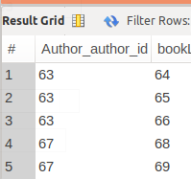
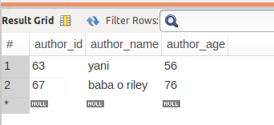
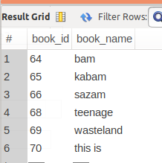

2. Bidirectional without additional table
// Author.java
package com.example.mapping.one2many.bidirectional;
import javax.persistence.*;
import java.util.ArrayList;
import java.util.List;
@Entity
@Table(name = "author")
public class Author {
@Id
@GeneratedValue(strategy = GenerationType.IDENTITY)
@Column(name = "author_id")
private int aId;
@Column(name = "author_name")
private String authorName;
@Column(name = "author_age")
private int authorAge;
@OneToMany(mappedBy = "author",cascade = CascadeType.ALL,fetch = FetchType.EAGER)
private List<Book> bookList;
public int getaId() {
return aId;
}
public void setaId(int aId) {
this.aId = aId;
}
public String getAuthorName() {
return authorName;
}
public void setAuthorName(String authorName) {
this.authorName = authorName;
}
public int getAuthorAge() {
return authorAge;
}
public void setAuthorAge(int authorAge) {
this.authorAge = authorAge;
}
public List<Book> getBookList() {
return bookList;
}
public void setBookList(List<Book> bookList) {
this.bookList = bookList;
}
public void addBook(Book book){
if(bookList==null){
bookList=new ArrayList<Book>();
}
book.setAuthor(this);
bookList.add(book);
}
}

// Book.java
package com.example.mapping.one2many.bidirectional;
import com.example.mapping.one2many.bidirectional.Author;
import javax.persistence.*;
@Entity
@Table(name = "book")
public class Book {
@Id
@GeneratedValue(strategy = GenerationType.IDENTITY)
@Column(name = "book_id")
private int id;
@Column(name = "book_name")
private String bookName;
@ManyToOne(cascade = CascadeType.ALL)
@JoinColumn(name = "a_id")
private Author author;
public int getId() {
return id;
}
public void setId(int id) {
this.id = id;
}
public String getBookName() {
return bookName;
}
public void setBookName(String bookName) {
this.bookName = bookName;
}
public Author getAuthor() {
return author;
}
public void setAuthor(Author author) {
this.author = author;
}
}

// AuthorService.java
package com.example.mapping.one2many.bidirectional;
import org.springframework.beans.factory.annotation.Autowired;
import org.springframework.boot.SpringApplication;
import org.springframework.stereotype.Service;
@Service
public class AuthorService {
@Autowired
BiRepository biRepository;
public void createAuthor(){
Author author = new Author();
author.setAuthorName("regina");
author.setAuthorAge(34);
Book book1 = new Book();
book1.setBookName("ikigai");
author.addBook(book1);
Book book2 = new Book();
book2.setBookName("ying-yang");
author.addBook(book2);
biRepository.save(author);
}
}
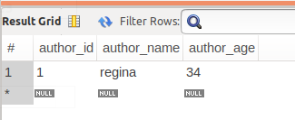
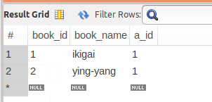

- Implement Many to Many Mapping between Author and Book.

// Author.java
package com.example.mapping.many2many;
import javax.persistence.*;
import java.util.ArrayList;
import java.util.List;
@Entity
@Table(name = "author")
public class Author {
@Id
@Column(name = "author_id")
@GeneratedValue(strategy = GenerationType.IDENTITY)
private int aId;
@Column(name = "author_name")
private String authorName;
@Column(name = "author_age")
private int authorAge;

@ManyToMany(cascade = CascadeType.ALL)
@JoinTable(name = "author_booklist",
joinColumns = @JoinColumn(name = "a_id",referencedColumnName = "author_id"),
inverseJoinColumns = @JoinColumn(name = "b_id",referencedColumnName = "book_id"))
private List<Book> bookList;
public Author() {
}
public int getaId() {
return aId;
}
public void setaId(int aId) {
this.aId = aId;
}
public String getAuthorName() {
return authorName;
}
public void setAuthorName(String authorName) {
this.authorName = authorName;
}
public int getAuthorAge() {
return authorAge;
}
public void setAuthorAge(int authorAge) {
this.authorAge = authorAge;
}
public List<Book> getBookList() {
return bookList;
}
public void setBookList(List<Book> bookList) {
this.bookList = bookList;
}
public void addBook(Book book){
if(bookList==null){
bookList=new ArrayList<>();
}
bookList.add(book);
book.getAuthors().add(this);
}
}

// BOOKS.JAVA

package com.example.mapping.many2many;
import javax.persistence.*;
import java.util.ArrayList;
import java.util.List;
@Entity
@Table(name = "book")
public class Book {
@Id
@GeneratedValue(strategy = GenerationType.IDENTITY)
@Column(name = "book_id")
private int id;
@Column(name = "book_name")
private String bookName;
@ManyToMany(mappedBy = "bookList")
private List<Author> authors;
public Book() {
}
public int getId() {
return id;
}
public void setId(int id) {
this.id = id;
}
public String getBookName() {
return bookName;
}
public void setBookName(String bookName) {
this.bookName = bookName;
}
public List<Author> getAuthors() {
return authors;
}
public void setAuthors(List<Author> authors) {
this.authors = authors;
}
}

// ManyRepository.java
package com.example.mapping.many2many;
import org.springframework.data.repository.CrudRepository;
import org.springframework.stereotype.Repository;
@Repository
public interface ManyRepository extends CrudRepository<Author,Integer> {
}

// AuthorService.java

package com.example.mapping.many2many;
import org.springframework.beans.factory.annotation.Autowired;
import org.springframework.stereotype.Service;
import com.example.mapping.many2many.Author;
import java.util.*;
@Service
public class AuthorService {
@Autowired
ManyRepository manyRepository;
public void insertAuthor(){
Book b1=new Book();
b1.setBookName("alpha");
Book b2=new Book();
b2.setBookName("beta");
Book b3=new Book();
b3.setBookName("omega");
Author author=new Author();
author.setAuthorName("hoax");
author.setAuthorAge(23);
author.setBookList(Arrays.asList(b1,b3));
Author author1=new Author();
author1.setAuthorName("xavier");
author1.setAuthorAge(23);
author1.setBookList(Arrays.asList(b2,b3));
manyRepository.saveAll(Arrays.asList(author,author1));
}
}

// Many2ManyApplication.java
package com.example.mapping.many2many;
import org.springframework.boot.SpringApplication;
import org.springframework.boot.autoconfigure.SpringBootApplication;
import org.springframework.context.ApplicationContext;
@SpringBootApplication
public class Many2ManyApplication {
public static void main(String[] args) {
ApplicationContext applicationContext=SpringApplication.run(Many2ManyApplication.class, args);
AuthorService as=applicationContext.getBean(AuthorService.class);
as.insertAuthor();
}
}
