# Q-WAP to show different String Functions in java?

package java_lab;

public class Java_lab {

public static void main(String[] args) {

System.out.println("welcome");

Strings_class s1=new Strings_class()

}

}

public class Strings_class {

Strings_class(){

System.out.println("Inside Strings class \n");

System.out.println("Testing Various string class function\n");

char ch1[]={'a','b','c','d','e','f','g'};

String s1=new String(ch1);

System.out.println("creating a string out of charater array");

System.out.println(s1);

String s2=new String(ch1,2,4);

System.out.println("creating a substring out of charater array");

System.out.println(s2);

byte b1[]={67,68,69,70,71};

String s3=new String(b1);

System.out.println("creating a string out of byte array\n"+s3);

String s4=new String(b1,2,3);

System.out.println("creating a substring out of charater array\n"+s4);

char ch2[]=new char[s2.length()];

byte b2[]=new byte[s2.length()];

s2.getChars(0, 3, ch2, 0);

b2=s2.getBytes();

System.out.println("converting string into character array\n");

for(int i=0;i<ch2.length;i++)

{

System.out.println(ch2[i]);

}

System.out.println("converting string into bytes array\n");

for(int i=0;i<b2.length;i++)

{

System.out.println(b2[i]);

}

String l1="Collateral";

String l2="Damage";

String l3="damage";

System.out.println("lentgh of a string \t"+l1.length());

System.out.println("concatination of two strings\n"+l1+l2);

System.out.println(l1.charAt(0)+"\t char at 0 index using charat function");

if(l2.equals(l3))

{

System.out.println("two strings are eqaual with case senstivity\n");

}

else if(l2.equalsIgnoreCase(l3))

{

System.out.println("two strings are eqaual without case senstivity\n");

}

else

{

System.out.println("two strings are not equal");

}

System.out.println("comparing of two strings with compare to function \t"+l1.compareTo(l2));

System.out.println("converting string into upper case \t"+l1.toUpperCase());

System.out.println("converting string into lower case \t"+l1.toLowerCase());

}

}

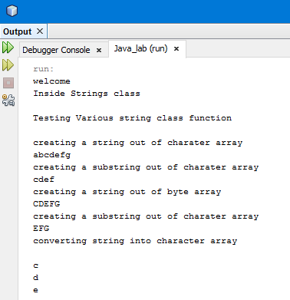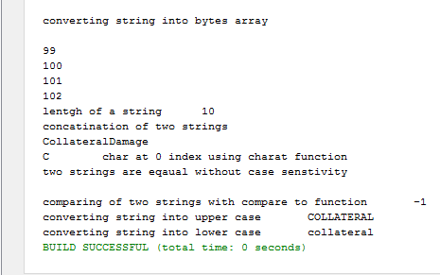

**Q-WAP to show Stack Operation in Java?**

package java_lab;

public class Java_lab {

public static void main(String[] args) {

System.out.println("welcome");

Stack_class st1=new Stack_class();

st1.create_stack();

st1.pop_stack();

st1.push_stack(99);

st1.print_stack();

}

}

public class Stack_class {

int top;

int[] stack=new int[10];

Stack_class(){

top=-1;

}

void create_stack(){

System.out.println("Creation of stack\n");

for(int i=0; i<stack.length-1; i++)

{

stack[i]=i;

++top;

}

}

void pop_stack(){

System.out.println("Pop operation on Stack");

if(top<=-1){

System.out.println("underflow\n");

}

else{

int del=stack[top];

System.out.println("element poped out of stack is "+del);

--top;

}

}

void push_stack(int ele){

System.out.println("push operation on Stack");

if(top>stack.length){

System.out.println("overflow\n");

}

else{

++top;

stack[top]=ele;

}

}

void print_stack(){

System.out.println("printing of stack");

for(int i=0; i<=top; i++){

System.out.println(stack[i]);

}

}

}

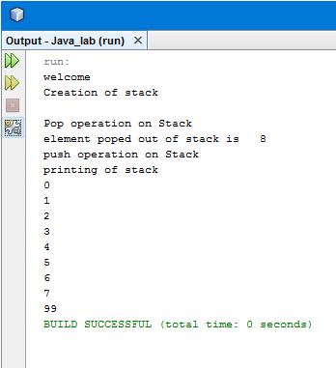

**Q-WAP to show inheritance from same and different package from in Java?**

package java_lab;

public class Java_lab {

public static void main(String[] args) {

System.out.println("welcome");

Call_class alpha=new Call_class();

Call_class beta=new Call_class();

}

}

package java_lab;

public class Alpha_class {

public Alpha_class(){

System.out.println("calling of class from same package java_lab");

}

}

package java_lab.package0;

public class Beta_class {

public Beta_class(){

System.out.println("calling of class from diffrent package java_lab.package0");

}

}

package java_lab;

public class Call_class extends Alpha_class {

Call_class(){

super();

}

}

public class Call_class extends java_lab.package0.Beta_class{

Call_class(){

super(); }}

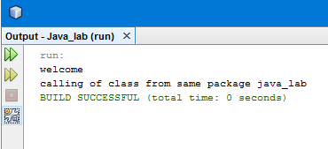

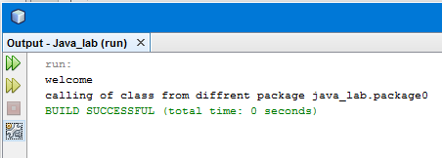

# Q-wap in java to show factorial of a no. using recursion?

Ans:-

package lab1;

public class Lab1 {

public static void main(String[] args) {

// TODO code application logic here

Factorial_class f1= new Factorial_class();

int result=f1.fact(5);

System.out.println("factorial of 5 is\n"+result);

}

}

package lab1;

public class Factorial_class {

int fact(int n)

{

if(n==1 || n==0)

{

return 1;

}

return( n * fact(n-1));

}}

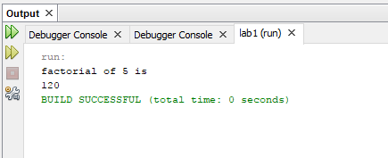

# Q-wap in java to override ToString() function in java?

ANS-

package java_lab;

public class Java_lab {

public static void main(String[] args) {

Box_Tostring b1=new Box_Tostring(5,4);

System.out.println(b1);

}

}

package java_lab;

public class Box_Tostring {

int length;

int breadth;

Box_Tostring(int l,int b){

length=l;

breadth=b;

}

/**

*

* @return

*/

@Override

public String toString(){

return String.format("length = " + this.length + " bredth = "+ this.breadth);

}

}

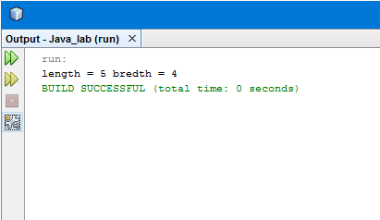

Q-wap in java to show Integer number wrapper class?

Ans-

package java_lab;

/**

*

* @author monks_mojo

*/

public class Java_lab {

public static void main(String[] args) {

double b=3.145763;

char c='A';

int a=10;

String str1="777";

String str2="hello";

Wrapper_class w1=new Wrapper_class(a,str1);

}

}

package java_lab;

public class Wrapper_class {

Wrapper_class(int i, String str)

{

System.out.println("integer no. wrapper class \n");

Integer i1=new Integer(i);

Integer i2=new Integer(str);

Integer i3=Integer.valueOf("76");

System.out.println("the INT value "+i2.intValue());

System.out.println("the FLOAT value "+i1.floatValue());

System.out.println("the INT to String value "+i1.toString());

System.out.println("the BYTE value "+i2.byteValue());

System.out.println("the doubleValue value "+i2.doubleValue());

System.out.println("the longValue value "+i3.longValue());

System.out.println("the shortValue value "+i3.shortValue());

System.out.println("Invoking object :"+i1+" Called Object :"+i2);

System.out.println(i1.compareTo(i2));

System.out.println("Calling Integer object i1:"+i1+" Called Integer Object i2:"+i1);

System.out.println(i1.equals(i1));

System.out.println("Returning simple data type");

System.out.println(Integer.parseInt(str));

}

}

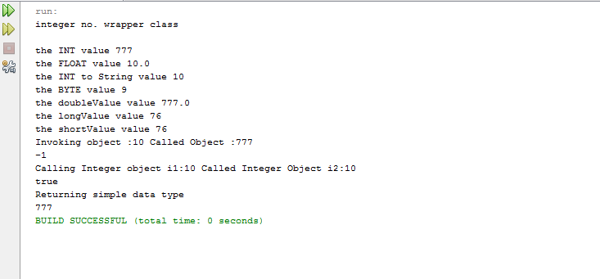

Q-wap in java to show Double number wrapper class?

Ans-

package java_lab;

/**

*

* @author monks_mojo

*/

public class Java_lab {

public static void main(String[] args) {

double b=3.145763;

char c='A';

int a=10;

String str1="777";

String str2="hello";

Wrapper_class w1=new Wrapper_class(b,str1);

}

}

package java_lab;

public class Wrapper_class {

Wrapper_class(double d, String str){

Double d1=new Double(d);

Double d2=new Double(str);

Double d3=Double.valueOf("76.88");

System.out.println("The DOUBLE value "+d2.doubleValue());

System.out.println("The INT value "+d1.intValue());

System.out.println("The BYTE value "+d1.byteValue());

System.out.println("The FLOAT value "+d2.floatValue());

System.out.println("The LONG value "+d2.longValue());

System.out.println("The SHORT value "+d3.shortValue());

System.out.println("The STRING "+d3.toString());

System.out.println("Invoking object :"+d1+" Called Object :"+d2);

System.out.println(d1.compareTo(d2));

System.out.println("Invoking object :"+d1+" Called Object :"+d2);

System.out.println(d1.equals(d2));

System.out.println("Returning simple data type");

System.out.println(Double.parseDouble(str));

}

}

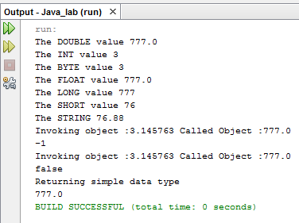

Q-wap in java to show Character wrapper class?

Ans-

package java_lab;

/**

*

* @author monks_mojo

*/

public class Java_lab {

public static void main(String[] args) {

double b=3.145763;

char c='A';

int a=10;

String str1="777";

String str2="hello";

Wrapper_class w1=new Wrapper_class(b,str1);

}

}

package java_lab;

Wrapper_class(char ch, String str){

Character ch1=new Character(ch);

char[] ch2= str.toCharArray();

System.out.println("Is it a letter"+Character.isLetter(ch1));

System.out.println(ch2);

System.out.println("Is it a Digit"+Character.isDigit(ch1));

System.out.println("Is it a uppercase"+Character.isUpperCase(ch1));

System.out.println("Is it a lowercase"+Character.isLowerCase(ch1));

System.out.println("To uppercase"+Character.toUpperCase(ch1));

System.out.println("To lowercase"+Character.toLowerCase(ch1));

}

}

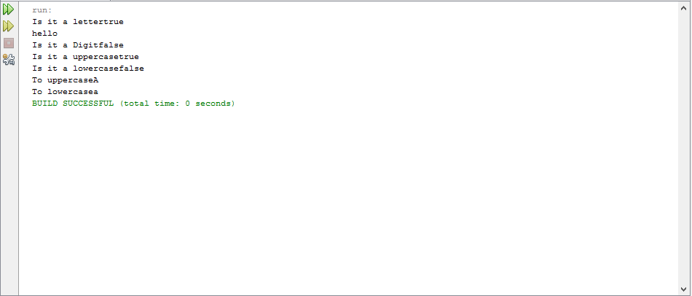

**Q-wap in java to implement a MoneyChanger Interface which converts your currency into dollars and vice-versa?**

package java_lab;

public class Java_lab {

public static void main(String[] args) {

MoneyConvertor i2d=new MoneyConvertor(700);

i2d.To_dollar();

MoneyConvertor d2=new MoneyConvertor(8);

d2.Dollar_to();

}

}

package java_lab;

public interface MoneyChanger {

void To_dollar();

void Dollar_to();

}

package java_lab;

public class MoneyConvertor implements MoneyChanger {

float Currency;

MoneyConvertor( int c){

Currency=c;

}

@Override

public void To_dollar(){

System.out.println("your currency into dollar is = "+Currency/70);

}

@Override

public void Dollar_to(){

System.out.println("Dollar to inr = "+Currency*70);

System.out.println("Dollar to nepalese rupee = "+Currency*100);

System.out.println("Dollar to bangladeah daka = "+Currency*111);

}

}

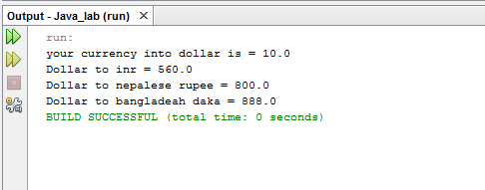

**Q-wap in java to implement a Stack Interface which shows stack push and pop operation using static and dynamic array?**

package java_lab;

public class Java_lab {

public static void main(String[] args) {

DynamicArray da=new DynamicArray(4);

da.push(10);

da.push(20);

da.push(30);

da.push(40);

da.push(50);

da.pop();

da.pop();

da.stack_print();

FixedArray f1=new FixedArray(5);

f1.push(10);

f1.push(20);

f1.push(30);

f1.push(40);

f1.push(50);

f1.pop();

f1.pop();

f1.stack_print();

}

}

package java_lab;

public interface StackInterface {

void push(int ele);

void pop();

}

package java_lab;

public class FixedArray implements StackInterface{

int[] st;

int top;

int size=0;

FixedArray(int s){

size=s;

top=-1;

st= new int[size];

}

@Override

public void push(int ele) {

if(top >= size){

System.out.println("OVERFLOW");

st= new int[size*2];

}

else{

System.out.println("element pushed into stack"+ele);

++top;

st[top] = ele;

}

}

@Override

public void pop() {

if(top<=-1){

System.out.println("UNDERFLOW");

}

else{

System.out.println("element poped out of stack is "+st[top]);

--top;

}

}

void stack_print(){

System.out.println("Printing of stack");

for(int i=0; i <= top;i++){

System.out.println(st[i]);

}

}

}

package java_lab;

public class DynamicArray {

int[] st;

int top;

int size=0;

DynamicArray(int s){

size=s;

top=-1;

st= new int[size];

}

public void push(int ele) {

if(top >= (size-1) ){

System.out.println("OVERFLOW");

System.out.println("INCREASING THE SIZE OF ARRAY");

int temp[];

temp = new int[size*2];

for(int i=0; i <= top; i++)

{

temp[i]=st[i];

}

st=temp;

++top;

st[top]=ele;

System.out.println("element pushed into stack"+ele);

}

else{

++top;

st[top] = ele;

System.out.println("element pushed into stack"+ele);

}

}

public void pop() {

if(top<=-1){

System.out.println("UNDERFLOW");

}

else{

System.out.println("element poped out of stack is "+st[top]);

--top;

}

}

void stack_print(){

for(int i=0; i<= top;i++){

System.out.println(st[i]);

}

}

}

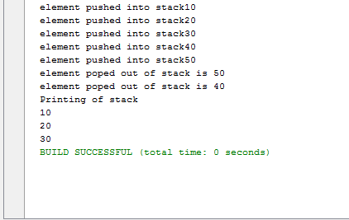 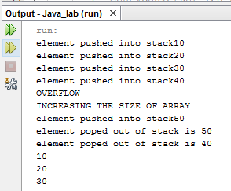

**Q-wap in java to implement a IntrestRate Interface which different interest rate on savings and fixed deposit amount and return interest after 1 year?**

package java_lab;

public class Java_lab {

public static void main(String[] args) {

MyAccount a1=new MyAccount(20000,50000,2);

a1.passbook();

a1.calculate_amnt();

MyAccount a2=new MyAccount(40000,80000,8);

a2.passbook();

a2.calculate_amnt();

}

}

package java_lab;

public interface IntrestRate {

final static double SBR = 0.46;

final static double FDR1 = 0.62;

final static double FDR2 = 0.72;

void calculate_amnt();

}

package java_lab;

public class MyAccount implements IntrestRate {

int sa_amount;

int time;

int fd_amount;

float si_sa;

float si_fda;

MyAccount(int sa,int fda, int t){

sa_amount=sa;

time=t;

fd_amount=fda;

}

void passbook(){

System.out.println("Amount in saving account ="+sa_amount);

System.out.println("fixed amount of "+fd_amount+" is done for "+time+" time");

}

@Override

public void calculate_amnt() {

si_sa=(float) ((sa_amount*SBR*1)/100);

System.out.println("intrest on savings acount amount after 1 year is ="+si_sa);

if(time >= 5){

si_fda=(float) ((fd_amount*FDR2*1)/100);

System.out.println("intrest on fixed acount amount after 1 year is ="+si_fda);

}

else{

si_fda=(float) ((fd_amount*FDR1*1)/100);

System.out.println("intrest on fixed acount amount after 1 year is ="+si_fda);

}

}

}

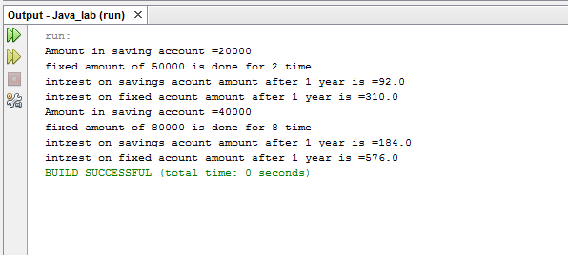

# Q-WAP to Exception Handling in java?

Ans-

package java_lab;

public class Java_lab {

public static void main(String[] args) {

try {Passbook p1=new Passbook(800,7);

p1.deposit(1000);

System.out.println(p1);

p1.withdrawl(1200);

System.out.println(p1);

p1.withdrawl(200);

}

catch(PassbookException pe){

System.out.println(pe);

}

}

package java_lab;

/**

*

* @author monks_mojo

*/

public class Passbook {

double acc_bal;

final double min_bal=500;

int acc_id;

Passbook(double bal, int id){

acc_bal=bal;

acc_id=id;

}

void deposit(double d_amount ){

acc_bal+=d_amount;

}

void withdrawl(double w_amount)throws PassbookException {

double temp_bal=acc_bal- w_amount;

if(temp_bal<=min_bal){

throw new PassbookException(temp_bal);

}

else{

acc_bal-=w_amount;

}

}

/**

*

* @return

*/

@Override

public String toString(){

return String.format("current balance is "+this.acc_bal+"of account id"+this.acc_id);

}

}

package java_lab;

/**

*

* @author monks_mojo

*/

public class PassbookException extends Exception {

double low_bal;

PassbookException(double a){

low_bal=a;

}

/**

*

* @return

*/

@Override

public String toString(){

return String.format("cannot withdrawl this much amount\n leads to low balance of"+low_bal);

}

}

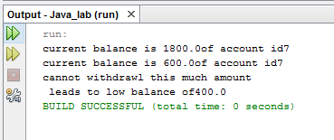

# Q-WAP to show Nested Exception Handling in java?

Ans-

**case-1 : outer try throw exception**

package java_lab;

@author monks_mojo

public class Java_lab {

public static void main(String[] args) {

int a=8,b=0;

int arr[]={10,8,7,6};

double result;

try{

result=a/b;

System.out.println("Devision Result="+result);

try{

System.out.println("Array element"+arr[4]);

}finally{

System.out.println("nested try dosen't have its catch so going for outer try catch");

}

}

catch(ArithmeticException ae){

System.out.println("Cannot devide by 0");

}

catch(Exception e){

System.out.println("Array out of index or no. is devided by zero");

}

}

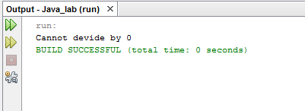

**case-2 : inner try throw exception with appropriate catch**

package java_lab;

* @author monks_mojo

public class Java_lab {

/**

* @param args the command line arguments

*/

public static void main(String[] args) {

int a=8,b=0;

int arr[]={10,8,7,6};

double result;

try{

result=a/b;

System.out.println("Devision Result="+result);

try{

System.out.println("Array element"+arr[4]);

}

catch(ArrayIndexOutOfBoundsException ae){

System.out.println("Array out of Index");

}

}

catch(ArithmeticException ae){

System.out.println("Cannot devide by 0");

}

catch(Exception e){

System.out.println("Array out of index or no. is devided by zero");

}

}

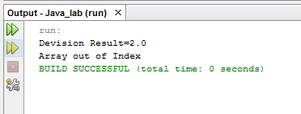

**case-3 : inner try throw exception witjout catch defined with inner try**

/*

* To change this license header, choose License Headers in Project Properties.

* To change this template file, choose Tools | Templates

* and open the template in the editor.

*/

package java_lab;

/**

*

* @author monks_mojo

*/

public class Java_lab {

/**

* @param args the command line arguments

*/

public static void main(String[] args) {

int a=8,b=0;

int arr[]={10,8,7,6};

double result;

try{

result=a/b;

System.out.println("Devision Result="+result);

try{

System.out.println("Array element"+arr[4]);

}finally{

System.out.println("nested try dosen't have its catch so going for outer try catch");

}

}

catch(ArrayIndexOutOfBoundsException ae){

System.out.println("Array out of Index");

}

catch(ArithmeticException ae){

System.out.println("Cannot devide by 0");

}

catch(Exception e){

System.out.println("Array out of index or no. is devided by zero");

}

}

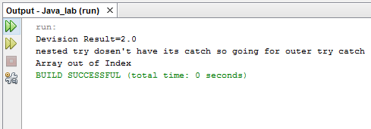

# Q-WAP to show Custom Exception Handling in java?

Ans-

package java_lab;

* @author monks_mojo

public class Java_lab {

public static void main(String[] args) {

try{

Ride r1=new Ride("Roller Coster",300,2.0);

System.out.println(r1);

Person p1=new Person(23,"monks mojo",3.5);

System.out.println(p1);

r1.check_height(p1);

Person p2=new Person(22,"freddy mercury",1.5);

System.out.println(p2);

r1.check_height(p2);

}catch(Height_exception he){

System.out.println(he);

}

}

package java_lab;

public class Person {

int age;

String name;

double height;

Person(int a,String n, double h){

age=a;

name=n;

height=h;

}

public double get_height(){

return height;

}

public String get_name(){

return name;

}

@Override

public String toString(){

return String.format("name is "+name+" age= "+age+" & hieght= "+height);

}}\

package java_lab;

class Height_exception extends Exception {

String rider_name;

double rider_height;

double min_height;

Height_exception(Person p0,double temp_height,double height_required ){

rider_name=p0.get_name();

rider_height=temp_height;

min_height=height_required;

}

public String toString(){

return String.format("Rider "+rider_name+"with height "+rider_height+" cannot ride becuase minimum height is "+min_height);

}

}

package java_lab;

public class Ride {

String ride_name;

int cost;

double height_required;

Ride(String rn,int c,double hr){

ride_name=rn;

cost=c;

height_required=hr;

}

void check_height(Person p0) throws Height_exception{

double temp_height=p0.get_height();

if(temp_height<height_required){

throw new Height_exception(p0,temp_height,height_required);

}

else{

System.out.println(p0.get_name()+" can go on this ride");

}

}

@Override

public String toString(){

return String.format("Ride = "+ride_name +" cost= "+cost+" & hieght required= "+height_required);

}

}

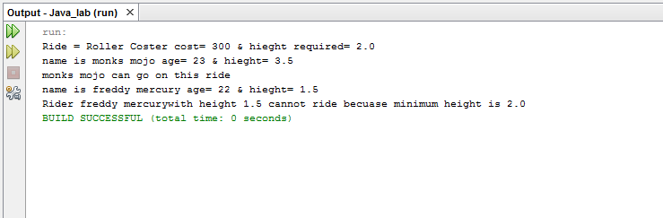

# Q-WAP to show main thread in java by implementing runnable class?

Ans-

package java_lab;

* @author monks_mojo

public class Java_lab {

public static void main(String[] args) {

Thread t1=Thread.currentThread();

System.out.println(t1);

t1.setName("Main Thread");

System.out.println("name of the thread is--"+t1.getName());

}

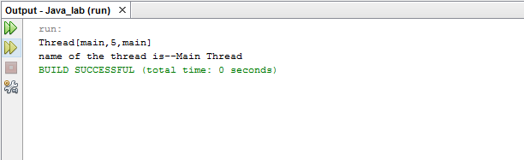

# Q-WAP to show main thread and a child thread in java by implementing runnable class?

Ans-

package java_lab;

* @author monks_mojo

public class Java_lab {

* @param args the command line arguments

public static void main(String[] args) {

One_Thread ot1 = new One_Thread();

Thread t1=Thread.currentThread();

System.out.println(t1);

t1.setName("String Length Thread");

String r=ot1.return_string();

System.out.println("Executing "+t1.getName());

System.out.println("Lenght of String "+r.length());

System.out.println("termination "+t1.getName());

}

package java_lab;

* @author monks_mojo

*/

public class One_Thread implements Runnable {

String a="hello";

String b="world";

One_Thread(){

Thread t1= new Thread(this,"concatinator");

System.out.println(t1+" is born");

t1.start();

}

String return_string(){

String c;

c=a+b;

return c;

}

@Override

public void run() {

System.out.println(Thread.currentThread());

String c=a+b;

System.out.println("Concatination of two strings "+ a +" "+ b+" " +c);

System.out.println("Termination of "+Thread.currentThread());

}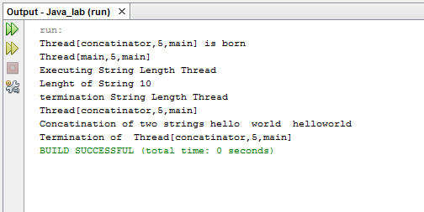

# Q-WAP to show main thread and a multi child thread in java by implementing runnable class?

Ans-

package java_lab;

public class Three_Thread implements Runnable {

int no=9;

Three_Thread(){

Thread tt1=new Thread(this,"even_thread");

Thread tt2=new Thread(this,"odd_thread");

Thread tt3=new Thread(this,"prime_thread");

tt1.start();

tt2.start();

tt3.start();

}

public int return_no(){

return no;

}

@Override

public void run() {

Thread tt0=Thread.currentThread();

String tn=tt0.getName();

if(tn.equals("even_thread")) {

System.out.println("Excution of-> "+tn);

if(no%2==0){

System.out.println(no+" Is Even");

}

else{

System.out.println(no+" Is Not Even");

}

System.out.println("temination of-> "+tn);

}

else if(tn.equals("odd_thread")){

System.out.println("Excution of-> "+tn);

if(no%2!=0){

System.out.println(no+" Is odd");

}

else{

System.out.println(no+" Is Not odd");

}

System.out.println("temination of-> "+tn);

}

else{

int flag=0;

System.out.println("Excution of-> "+tn);

for(int i=2; i<no; i++){

if(no%i == 0){

flag=1;

}

}

if(flag==1){

System.out.println(no+" Is Not Prime");

}

else{

System.out.println(no+" Is Prime");

}

System.out.println("temination of-> "+tn);

}

}

}

package java_lab;

* @author monks_mojo

public class Java_lab {

public static void main(String[] args) {

Three_Thread obj1=new Three_Thread();

Thread mt=new Thread();

mt.setName("mainThread");

String mt_name=mt.getName();

System.out.println("excution of ->"+mt_name);

int no=obj1.return_no();

if(no>=10){

System.out.println(no+" Greater than 10");

}

else{

System.out.println(no+" less than 10");

}

System.out.println("termination of ->"+mt_name);

}

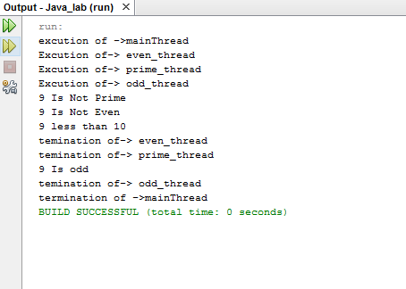

# Q-WAP to show multi child thread in java by extending thread class?

Ans-

package java_lab;

* @author monks_mojo

public class Java_lab {

public static void main(String[] args) {

T_threechild tc1=new T_threechild("even_thread");

T_threechild tc2=new T_threechild("odd_thread");

T_threechild tc3=new T_threechild("prime_thread");

}

package java_lab;

public class T_threechild extends Thread{

int no=6;

T_threechild(String name){

super(name);

System.out.println("Creation of thread child by extending thread class");

start();

}

@Override

public void run(){

Thread tt0=Thread.currentThread();

String tn=tt0.getName();

if(tn.equals("even_thread")) {

System.out.println("Excution of-> "+tn);

if(no%2==0){

System.out.println(no+" Is Even");

}

else{

System.out.println(no+" Is Not Even");

}

System.out.println("temination of-> "+tn);

}

else if(tn.equals("odd_thread")){

System.out.println("Excution of-> "+tn);

if(no%2!=0){

System.out.println(no+" Is odd");

}

else{

System.out.println(no+" Is Not odd");

}

System.out.println("temination of-> "+tn);

}

else{

int flag=0;

System.out.println("Excution of-> "+tn);

for(int i=2; i<no; i++){

if(no%i == 0){

flag=1;

}

}

if(flag==1){

System.out.println(no+" Is Not Prime");

}

else{

System.out.println(no+" Is Prime");

}

System.out.println("temination of-> "+tn);

}

}

}

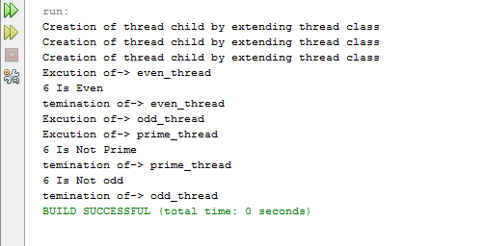

# Q-WAP to show setPriority and thread.sleep thread class function in java by extending thread class?

Ans-

package java_lab;

* @author monks_mojo

public class FN_thread1 extends Thread {

String s1="Hello";

String s2="Darkness";

static int p=3;

public Thread t1;

FN_thread1(String name){

super(name);

System.out.println("creating thread by extending the thread class");

start();

}

@Override

public void run(){

t1=Thread.currentThread();

String to_name=t1.getName();

if(to_name.equals("concatinator")){

t1.setPriority(++p);

System.out.println(to_name+"execution started with prioroty"+ p);

String s3=s1+s2;

System.out.println("concatination of "+ s1+" "+s2+" is "+s3);

}

else{

t1.setPriority(++p);

System.out.println(to_name+"execution started with priority"+ p);

String s3=s1+s2;

System.out.println("length of string"+ s3+" is "+s3.length());

}

}}

package java_lab;

* @author monks_mojo

public class Java_lab {

public static void main(String[] args) {

Thread mt=Thread.currentThread();

mt.setName("main Thread");

FN_thread1 fn1=new FN_thread1("concatinator");

try{

System.out.println(mt.getName()+"->started execution with priotity->"+mt.getPriority());

Thread.sleep(200);

System.out.println(mt.getName()+"->has been put to sleep");

}catch(InterruptedException e1){

System.out.println("Cant put main thread to sleep ");

}

System.out.println(mt.getName()+"->has woken up");

FN_thread1 fn2=new FN_thread1("length_calculator");

System.out.println(mt.getName()+"->has terminated");

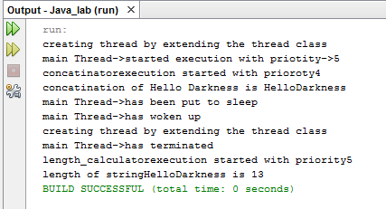

# Q-WAP to show join thread class function in java by extending thread class?

Ans-

package java_lab;

* @author monks_mojo

public class FN_thread2 implements Runnable {

int no=6;

public Thread tf;

FN_thread2(String name){

tf=new Thread(this,name);

tf.start();

}

@Override

public void run() {

String tf_name=tf.getName();

if(tf_name.equals("odd_thread")) {

System.out.println("Excution of-> "+tf_name);

if(no%2!=0){

System.out.println(no+" Is odd");

}

else{

System.out.println(no+" Is Not odd");

}

System.out.println("Temination of-> "+tf_name);

}

if(tf_name.equals("even_thread")) {

System.out.println("Excution of-> "+tf_name);

if(no%2==0){

System.out.println(no+" Is Even");

}

else{

System.out.println(no+" Is Not Even");

}

System.out.println("temination of-> "+tf_name);

}

}

}

package java_lab;

* @author monks_mojo

public class Java_lab {

* @param args the command line arguments

public static void main(String[] args) {

Thread mt=Thread.currentThread();

mt.setName("main Thread");

System.out.println(mt.getName()+"->started execution ");

FN_thread2 fn2=new FN_thread2("even_thread");

String tf_name = fn2.tf.getName();

if(tf_name.equals("even_thread")){

try{

fn2.tf.join();

System.out.println(mt.getName()+"->is on hold ");

}catch(InterruptedException e1){

System.out.println("Cant put main thread to wait");

}

FN_thread2 fn22=new FN_thread2("odd_thread");

System.out.println(mt.getName()+"->is terminated");

}

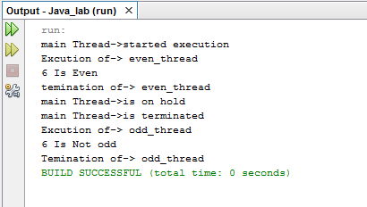

# Q-WAP to show synchronized public void method by implementing Runnable class in java by extending thread class?

Ans-

package java_lab;

* @author monks_mojo

public class Call_me {

synchronized public void call(String name){

System.out.println("[ we are starting"+name +"but going to sleep");

try{

Thread t1=Thread.currentThread();

System.out.println("we are making->"+t1.getName()+"-> to sleep");

Thread.sleep(500);

}catch(InterruptedException e1){

Thread t1=Thread.currentThread();

System.out.println(t1.getName()+"-> cant go to sleep");

}

System.out.println(name +"->just woke up GOODBYE ALL MY FRNDS ]");

}

}

package java_lab;

public class Caller implements Runnable {

Call_me target;

String name;

Thread t1;

Caller(Call_me t,String n){

target=t;

name=n;

t1=new Thread(this,name);

System.out.println(t1.getName()+"-> is born");

t1.start();

}

@Override

public void run() {

System.out.println(t1.getName()+"-> is executing");

target.call(name);

System.out.println(t1.getName()+"-> is terminated");

}

}

package java_lab;

/**

*

* @author monks_mojo

*/

public class Java_lab {

/**

* @param args the command line arguments

*/

public static void main(String[] args) {

Call_me target=new Call_me();

Caller c1=new Caller(target,"c1.child");

Caller c2=new Caller(target,"c2.child");

}

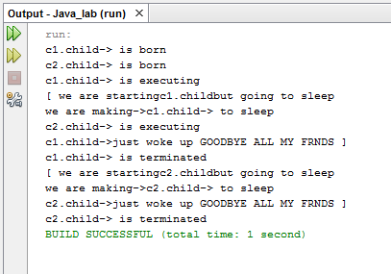

# Q-WAP to show booking and cancellation of tickets simultaneously?

Ans-

package java_lab;

* @author monks_mojo

public class Train {

final int total_ticket=40;

static int occupied=10;

synchronized public int check(int ticket){

String thread_name=Thread.currentThread().getName();

System.out.println(thread_name);

if(thread_name.equals("BookTicket")){

System.out.println("total tickets "+total_ticket);

System.out.println("you want to book"+ticket);

if(ticket+occupied<=total_ticket){

System.out.println("seats left "+(total_ticket-occupied));

occupied+=ticket;

return 1;

}

}

else if(thread_name.equals("CancelTicket")){

System.out.println("total tickets "+total_ticket);

System.out.println("occupied seats "+occupied);

System.out.println("you want to cancel"+ticket);

if(ticket <= occupied){

occupied-=ticket;

System.out.println("seats left "+(total_ticket-occupied));

return 1;

}

}

return 0;

}

}

package java_lab;

public class Booking implements Runnable {

String p_name;

int age;

int bticket=0;

int cticket=0;

Train seat;

Booking(String pn, int a){

p_name=pn;

age=a;

seat=new Train();

}

@Override

public String toString(){

return String.format("Passenger name = " + this.p_name + " age= "+ this.age +" has booked"+bticket+" tickets and has cancelled "+ cticket+" tickets");

}

void book_seat(int pess){

bticket=pess;

Thread bt= new Thread(this,"BookTicket");

bt.start();

}

void cancel_seats(int pess){

System.out.println("Cancillation of ticket");

cticket=pess;

Thread ct= new Thread(this,"CancelTicket");

ct.start();

}

@Override

public void run() {

Thread current=Thread.currentThread();

String ct_name=current.getName();

if(ct_name.equals("BookTicket")){

System.out.println("Booking in progress");

int res = seat.check(bticket);

if(res==1){

System.out.println("Your"+bticket+"tickets have been booked" );

}

else{

System.out.println("Your"+bticket+"cannot be booked");

System.out.println("no vacant seats available");

}

}

else{

System.out.println("Cancillation in progress");

if(cticket < bticket){

int res=seat.check(cticket);

if(res==1){

System.out.println("Your"+cticket+"tickets have been cancelled" );

}

}

else{

System.out.println("Your"+cticket+"cannot be cancelled");

System.out.println("cancillation more than booking seats");

}

}

}

package java_lab;

* @author monks_mojo

public class Java_lab {

public static void main(String[] args) {

Booking gratel=new Booking("gratel",55);

gratel.book_seat(10);

gratel.cancel_seats(8);

}

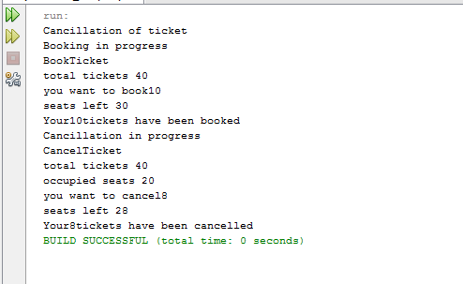

# Q-WAP to show Integer Arraylist collection class in java?

Ans-

package java_lab;

* @author monks_mojo

public class Java_lab {

public static void main(String[] args) {

Collection_classes cc=new Collection_classes();

cc.Integer_ArrayList();

}

package java_lab;

import java.util.ArrayList;

import java.util.HashSet;

import java.util.Iterator;

import java.util.LinkedList;

import java.util.TreeSet;

public class Collection_classes {

ArrayList <String> al1 = new ArrayList();

void Integer_ArrayList(){

ArrayList <Integer> ai1 = new ArrayList();

System.out.println("adding 4 element into Integer arraylist 1");

ai1.add(2);

ai1.add(4);

ai1.add(6);

ai1.add(8);

System.out.println("Size of ArrayList 1= "+ai1.size());

System.out.println("printing content of arraylist 1");

System.out.println(ai1);

System.out.println("adding element at perticular index");

ai1.add(1,1);

System.out.println("Size of ArrayList 1= "+ai1.size());

System.out.println("printing content of arraylist 1");

System.out.println(ai1);

System.out.println("Creating a second ArrayList same size as first ArrayList");

ArrayList <Integer> ai2 = new ArrayList(ai1.size());

System.out.println("adding 4 element into Integer arraylist 2");

ai2.add(12);

ai2.add(14);

ai2.add(16);

ai2.add(18);

System.out.println("Size of ArrayList 2= "+ai2.size());

System.out.println("printing content of arraylist 2");

System.out.println(ai2);

System.out.println("Converting first ArrayList into array to find sum of element");

Integer[] arr= new Integer[ai1.size()];

arr=ai1.toArray(arr);

int sum=0;

System.out.println("elements of array");

for (Integer arr1 : arr) {

System.out.println(arr1);

sum += arr1;

}

System.out.println("Sum of Elements");

System.out.println(sum);

}

}

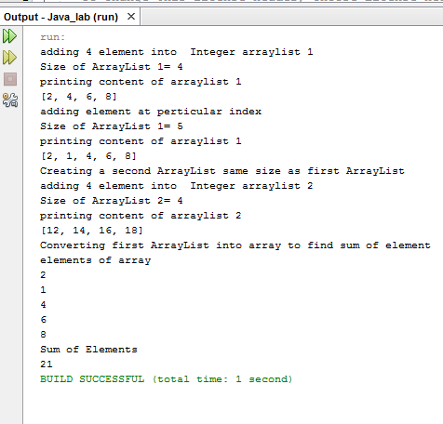

# Q-WAP to show String Arraylist collection class in java and print element using iterator and for each loop?

Ans-

package java_lab;

* @author monks_mojo

public class Java_lab {

public static void main(String[] args) {

Collection_classes cc=new Collection_classes();

cc.String_ArrayList();

cc.iterator_print();

cc.foreach_print();

}

package java_lab;

import java.util.ArrayList;

import java.util.HashSet;

import java.util.Iterator;

import java.util.LinkedList;

import java.util.TreeSet;

public class Collection_classes {

ArrayList <String> al1 = new ArrayList();

void String_ArrayList(){

System.out.println("adding 5 element into arraylist");

al1.add("jhon");

al1.add("watson");

al1.add("mayer");

al1.add("trovolta");

al1.add("kennedy");

System.out.println("Size of ArrayList= "+al1.size());

System.out.println("printing content of arraylist");

System.out.println(al1);

System.out.println("adding element at perticular index");

al1.add(1,"sherlock");

System.out.println("Size of ArrayList= "+al1.size());

System.out.println("printing content of arraylist");

System.out.println(al1);

System.out.println("removing the element from ArrayList");

al1.remove("kennedy");

al1.remove("trovolta");

System.out.println("Size of ArrayList= "+al1.size());

System.out.println("printing content of arraylist");

System.out.println(al1);

}

void iterator_print(){

Iterator it=al1.iterator();

System.out.println("printing elements of arraylist with the help of iterator");

while(it.hasNext()!=false){

System.out.println(it.next());

}

}

void foreach_print(){

System.out.println("printing element of arraylist with the help of foreach loop");

for(String o: al1){

System.out.println(o);

}

}

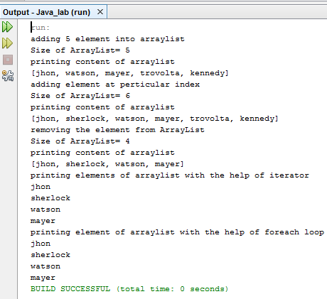

# Q-WAP to show Likedlist, Hashset & Treeset collection class in java ?

Ans-

void String_LinkedList(){

System.out.println("creating a linkedlist");

LinkedList <String> ll1=new LinkedList();

System.out.println("adding 5 elemennts to linkedlist");

ll1.addFirst("Kurt");

ll1.push("eminem");

ll1.add("jimmy");

ll1.add(0,"JIMI");

ll1.addLast("Robert");

System.out.println("elements in the list");

System.out.println(ll1);

System.out.println("first element"+ ll1.getFirst());

System.out.println("last element"+ll1.getLast());

System.out.println("size of linked list"+ll1.size());

System.out.println("Removing of second element");

ll1.remove(2);

System.out.println("size of linked list after removing 1 element"+ll1.size());

System.out.println("elements in the final list");

System.out.println(ll1);

}

void Integer_Hashset(){

HashSet<Integer> hs= new HashSet();

System.out.println("A HashSet");

System.out.println("inserting 5 elements");

hs.add(2);

hs.add(4);

hs.add(6);

hs.add(8);

hs.add(10);

System.out.println("printing value of hashset");

System.out.println(hs);

System.out.println("Floor function");

}

void Integer_Treeset(){

TreeSet<Integer> ts= new TreeSet();

System.out.println("A treeSet");

System.out.println("inserting 5 elements");

ts.add(1);

ts.add(3);

ts.add(5);

ts.add(7);

ts.add(9);

System.out.println("printing value of Treeset");

System.out.println(ts);

System.out.println("Floor function "+ ts.floor(8));

System.out.println("higher function "+ ts.higher(8));

System.out.println("lower function "+ ts.lower(8));

System.out.println("Pollfirst function "+ ts.pollFirst());

System.out.println("Polllast function "+ ts.pollLast());

System.out.println("printing value of Treeset after functions");

System.out.println(ts);

}

}

package java_lab;

/**

*

* @author monks_mojo

*/

public class Java_lab {

/**

* @param args the command line arguments

*/

public static void main(String[] args) {

Collection_classes cc=new Collection_classes();

cc.String_LinkedList();

cc.Integer_Hashset();

cc.Integer_Treeset();

}  
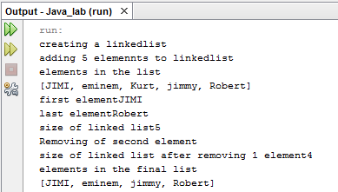

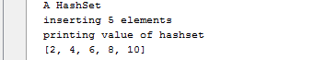

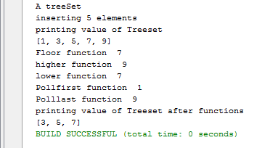

# Q-WAP to show Hashmap, Treemap & Hashtable collection class in java ?

Ans-

package java_lab;

import java.util.*;

* @author monks_mojo

public class Collection_classes {

void String_Hashmap(){

System.out.println("creating a HashMap <String,Double> ");

HashMap hm =new HashMap();

System.out.println("Inserting data into hashmap");

hm.put("clark",15000.35);

hm.put("bruce",20000.30);

hm.put("steven",10000.85);

hm.put("kendric",45000.15);

hm.put("tupac",78000.25);

System.out.println("key and value of hashmap"+hm);

System.out.println("geting only the key values");

Set <String> se1=hm.keySet();

for(String s: se1){

System.out.println(s);

}

System.out.println("getting account balance of tupac");

double bal=(double) hm.get("tupac");

bal+=15000;

System.out.println("updating account balance of tupac");

hm.put("tupac", bal);

System.out.println("hashmap elements are updating value");

System.out.println(hm);

}

void String_Treemap(){

System.out.println("creating a TreeMap <String,Double> ");

TreeMap tm =new TreeMap();

System.out.println("Inserting data into treemap");

tm.put("david",15000.35);

tm.put("jimmi",20000.30);

tm.put("dan",10000.85);

tm.put("alex",45000.15);

tm.put("matt",78000.25);

System.out.println("key and value of treemap"+tm);

System.out.println("geting only the key values");

Set <String> s2=tm.keySet();

for(String s: s2){

System.out.println(s);

}

System.out.println("getting account balance of matt");

double bal=(double) tm.get("matt");

bal+=15000;

System.out.println("updating account balance of matt");

tm.put("matt", bal);

System.out.println("treemap elements are updating value");

System.out.println(tm);

}

void String_Hashtable(){

System.out.println("creating a HashTable <String,Double> ");

Hashtable ht =new Hashtable();

System.out.println("Inserting data into Hashtable ");

ht.put("paul",16000.35);

ht.put("lenon",21000.30);

ht.put("ringo",12000.85);

ht.put("jon",41000.15);

ht.put("robert",74000.25);

System.out.println("key and value of hashmap"+ht);

System.out.println("geting only the key values in the enumeration");

Enumeration <String> en=ht.keys();

while(en.hasMoreElements()){

System.out.println(en.nextElement());

}

System.out.println("getting account balance of robert");

double bal;

bal = (double) ht.get("robert");

System.out.println("old balance of robert"+bal);

bal+=15000;

System.out.println("new balance of robert"+bal);

System.out.println("updating account balance of robert");

ht.put("tupac", bal);

System.out.println("hashmap elements are updating value");

System.out.println(ht);

}

}

}

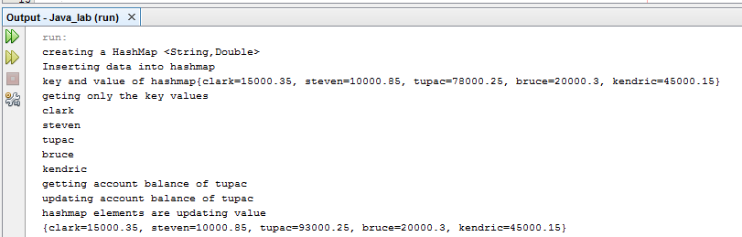

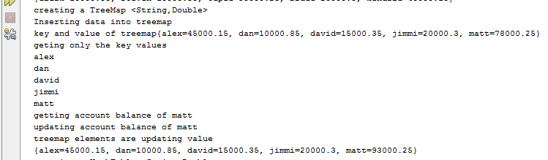

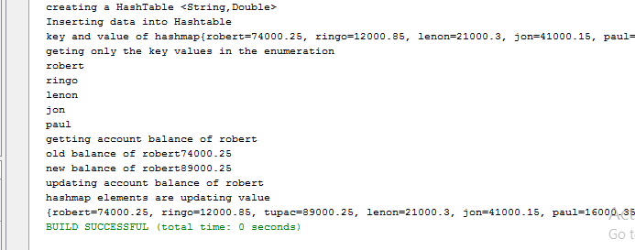

# Q-WAP to show Properties class in java ?

Ans-

public class Java_lab {

public static void main(String[] args) {

Collection_classes cc=new Collection_classes();

cc.state_property();

}

package java_lab;

import java.util.*;

@author monks_mojo

public class Collection_classes {

void state_property(){

Properties pr = new Properties();

System.out.println("creating a Properties object");

System.out.println("Inserting data into properties <States,Capital> ");

pr.put("punjab","chandigarh");

pr.put("rajisthan","jaipur");

pr.put("madhya pradesh","jaipur");

pr.put("sikkim","gangtok");

pr.put("tamil nadi","chennai");

System.out.println("key and value of hashmap"+pr);

System.out.println("geting only the key values in the enumeration");

Enumeration en=pr.propertyNames();

while(en.hasMoreElements()){

System.out.println(en.nextElement());

} }}

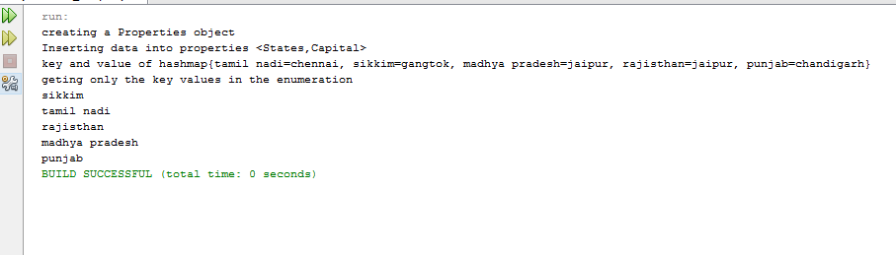

# Q-WAP to show File and Directory list in a Directory in java ?

Ans-

package java_lab;

import java.io.File;

public class File_Creation {

public void filecreation(){

System.out.println("creating files and directores");

File f1 = new File("D:\\directory0");

File f2=new File(f1.getPath(),"file1.txt");

File f3=new File(f1.getPath(),"file2.txt");

File f4=new File(f1.getPath(),"/directory1");

System.out.println("all the directories and file in"+ f1.getName()+"parent directory");

System.out.println("path of "+ f1.getName()+ " is "+f1.getPath());

System.out.println("Absolute path of "+ f1.getName()+ " is "+f1.getAbsolutePath());

System.out.println("path of "+ f2.getName()+ " is "+f2.getPath());

System.out.println("Absolute path of "+ f2.getName()+ " is "+f2.getAbsolutePath());

System.out.println("all the directories and file in"+ f1.getName()+"parent directory");

File[] filesList = f1.listFiles();

for(File f : filesList){

if(f.isDirectory())

System.out.println("Is a Directory "+f.getName());

if(f.isFile()){

System.out.println("Is a file "+f.getName());

}

}}

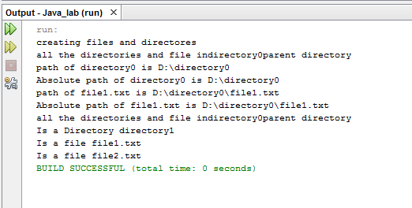

# Q-WAP to show FileInputStream Functions in java ?

Ans-

package java_lab;

mport java.io.File;

import java.io.FileInputStream;

import java.io.FileNotFoundException;

import java.io.FileOutputStream;

import java.io.IOException;

public class Filefunction {

void fis_function0() throws FileNotFoundException{

System.out.println("creating files and directores");

try{

File f1 = new File("

FileInputStream fis=new FileInputStream("D:\\directory0\\file1.txt");

System.out.println("using the Fileinputstream constructor to read from file");

System.out.println("1. read();");

int read0=fis.read();

System.out.println("no. of characters that are readed from the filr are"+read0);

System.out.println("2. read(byte b[]);");

int nobyte=fis.available();

byte[] text=new byte[nobyte];

int read1 = fis.read(text);

for(byte b: text){

System.out.print((char)b);

}

}catch(Exception e){

System.out.println(e);

}

}

void fis_function1() throws FileNotFoundException, IOException{

File f1 = new File("

FileInputStream fis=new FileInputStream("D:\\directory0\\file1.txt");

int no=fis.read();

int size=fis.available();

System.out.println("part1");

System.out.println("no. of character in file"+no);

System.out.println("size of file"+size);

System.out.println("part 2");

System.out.println("save part of file in byte array");

int part=size/4;

byte[] text0=new byte[part];

int r=fis.read(text0);

System.out.println("part of file saved in byte array which is");

for(byte b : text0){

System.out.print((char)b);

}

System.out.println("\n part 3");

System.out.println("skip a part of file");

fis.skip(part);

System.out.println("part of a file skipped");

System.out.println("part 4");

System.out.println("print a part on screen");

byte[] text1=new byte[part];

int r1=fis.read(text1);

for(byte b : text1){

System.out.print((char)b); }}

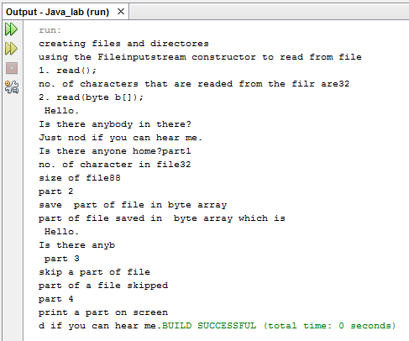

# Q-WAP to write and read from a file in java?

Ans-

package java_lab;

import java.io.File;

import java.io.FileInputStream;

import java.io.FileNotFoundException;

import java.io.FileOutputStream;

import java.io.IOException;

void file_copy() throws FileNotFoundException, IOException{

try(FileOutputStream fos = new FileOutputStream("D:\\directory0\\\\file2.txt")) {

System.out.println("writing into a file");

String s="God is woman.";

byte text1[]=s.getBytes();

fos.write(text1);

fos.flush();

fos.close();

System.out.println("data written into file");

FileInputStream fis=new FileInputStream("D:\\directory0\\file2.txt");

System.out.println("Reading from a file");

int size=fis.available();

byte[] text2=new byte[size+5];

fis.read(text2);

for(byte b: text2){

System.out.print((char)b);

}

}catch(Exception e){

System.out.println(e);

}

System.out.println("\nsuccess...");

}

}

