DepenDancy Managment usig Gradel

- Add a gradle dependency and its related repository url.
Step-1 open the project
Step-2 in intellij idea in terminal run command- $ gradle build

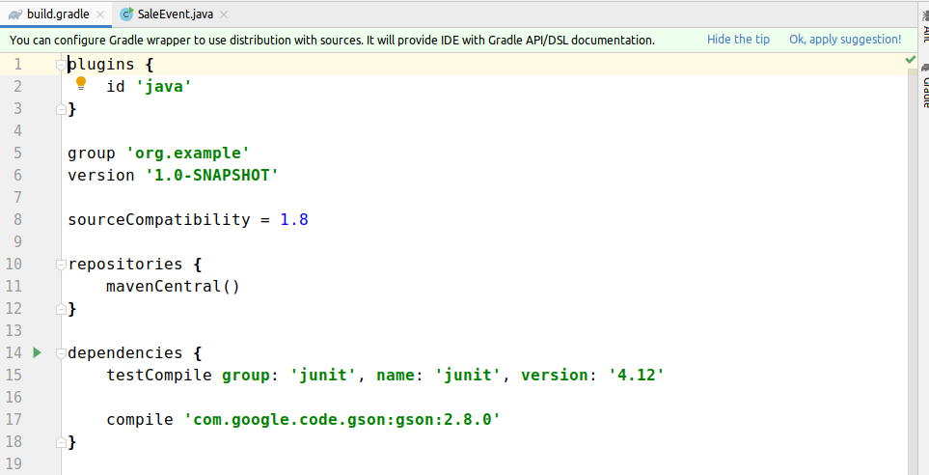
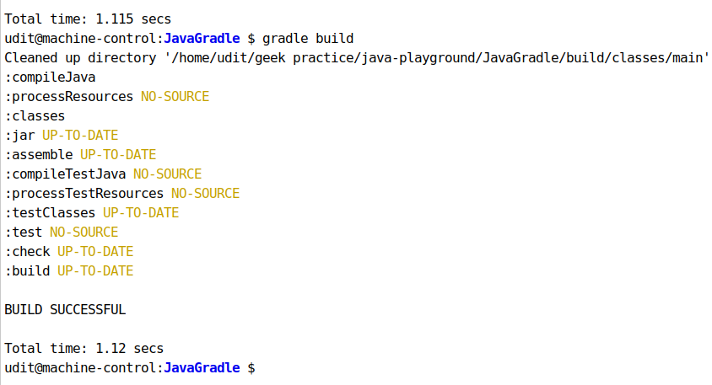

- Using java plugin, make changes in the manifest to make the jar executable. Using java -jar JAR_NAME, the output should be printed as "Hello World"

step1-add a java class demo in src>main>java

public class Demo {
public static void main(String[] args){
System.out.println("hello world");
}
}
step-2 override sourceSets

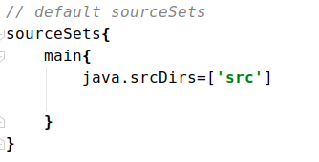

Step-3 make jar executable to run demo class

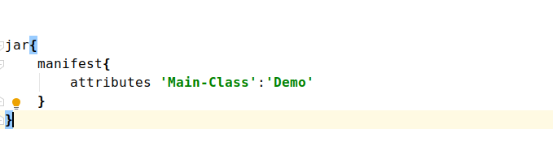

Step-4- switch to jar directory run the jar by running the command
java -jar <jar-name>
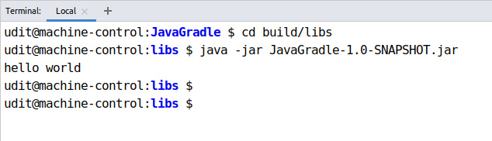

- Differentiate between the different dependency scopes: compile, runtime, testCompile, testRuntime using different dependencies being defined in your build.gradle.

compile-->Dependencies required at compile time but never required at runtime, such as source-only annotations or annotation processors. Compile dependencies are available in all classpaths of a project.these dependencies are also transitive available to sub projects:

runtime-->The dependencies with this scope are required at runtime, but they're not needed for compilation of the project code. Because of that, dependencies marked with the runtime scope will be present in runtime and test classpath, but they will be missing from compile classpath.
testCompile--> testCompile is a group of dependencies that might be needed only for testing while compile is the group of dependencies that might be needed to build the application . The testCompile configuration contains the dependencies which are required to compile the tests of the project. This configuration contains the compiled classes of the project and the dependencies added to the compile configuration.
runCompile: The testRuntime contains the dependencies which are required when our tests are run. This configurations contains the dependencies added to compile, runtime, and testCompile configurations.

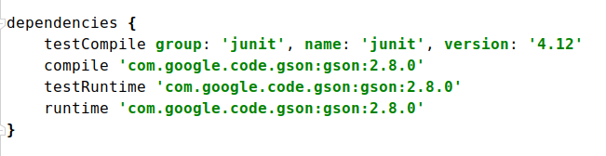

- Create a custom plugin which contains a custom task which prints the current date-time. Using that plugin in your project, execute that task after the jar task executes.

Step -1 create a module inside root module
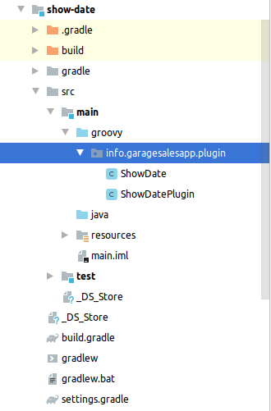

step-2 write the plugin ShowDate ShowDatePlugin
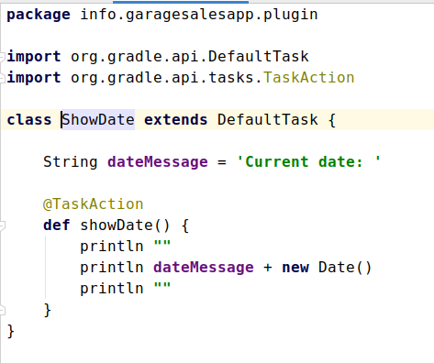
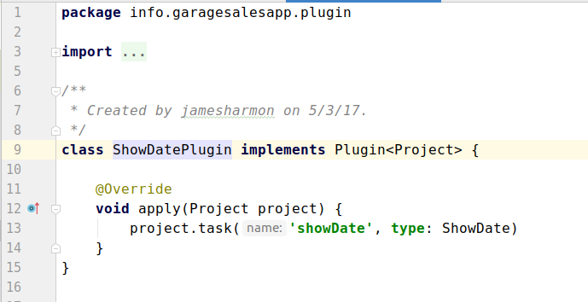

step 3- make changes build.gradle(:show-date) and build.gradle(JavaGradle)
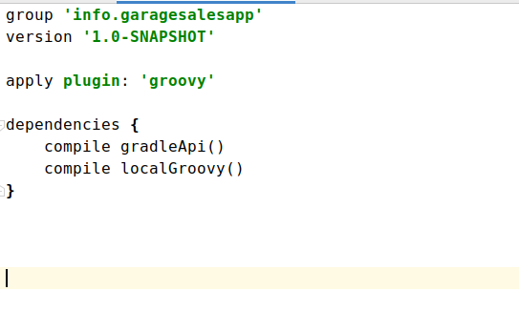

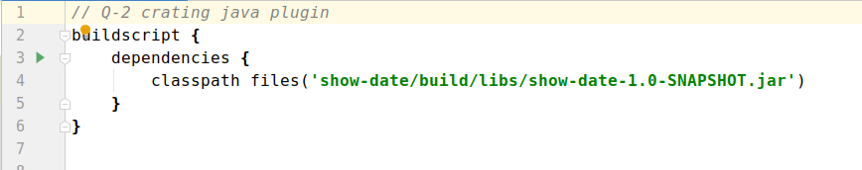
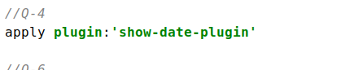

step 4- Run plugin with command $gradle showDate

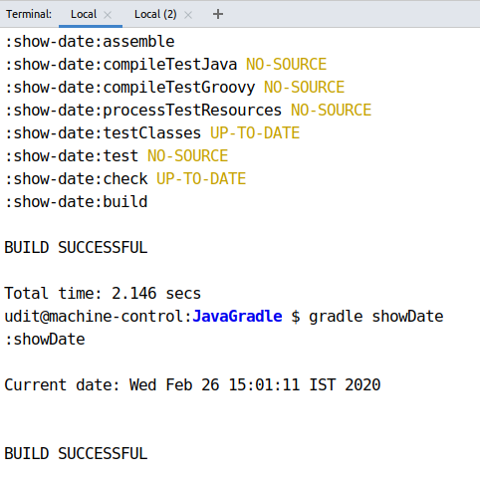

- Instead of using default source set, use src/main/javaCode1, src/main/javaCode2 to be taken as code source. Make sure that the JAR created contains files from both the directories and not from src/main/java.

Step-1 create directories javaCode1 and java Code2 in src/main
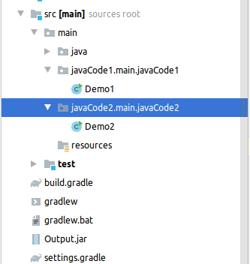

Step-2 overwrite the default source set
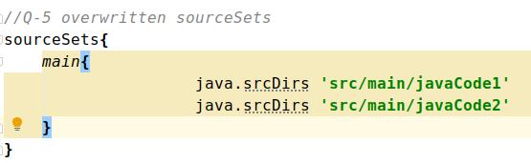

Step-3 clean build the gradle with $./gradlew clean build
Step-4 see the content of the jar file with command

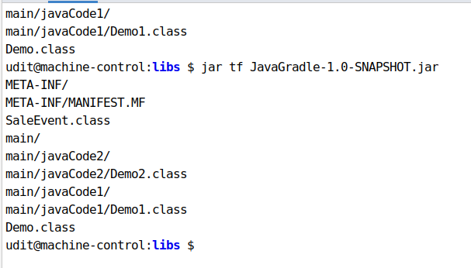

- Override the Gradle Wrapper task to install a different version of gradle. Make sure that the task written in Q4 also executes with it.

Step-1 create a wrapper task to overwrite the default wrapper task
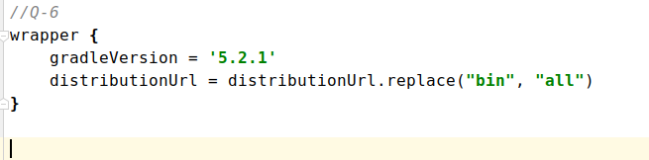
Step-2 check the gradle version in gradle>wrapper>gradle-wrapper.properties

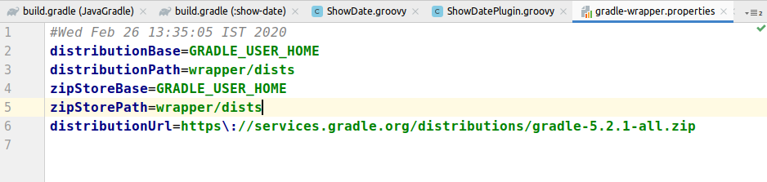

step-3 after gradle build. Run custom plugin showDate with command $gradle showDate
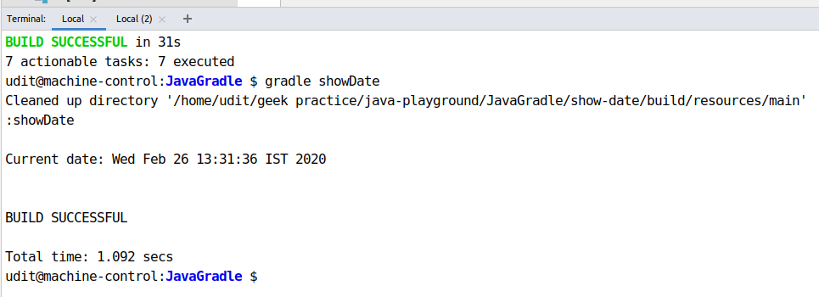

- Run the gradle profile command and attach the resulting files.
Step-1 run the command $gradle buld --profile to crate profile of the project
