Which method on the session object can be used to remove an object from the cache?

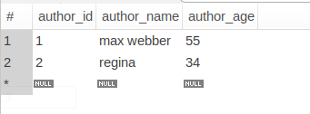
@Autowired
EntityManager entityManager;
@Test
@Transactional
public void testCaching(){
org.hibernate.Session session =entityManager.unwrap(Session.class);
Author author=biRepository.findById(1).get();// run the query from database
biRepository.findById(1);// run the query from level 1 cache
session.evict(author); // remove the object from cache
biRepository.findById(1); // run the query from database
}
