# **Midterm Sample Problems on FP Computation (Aj. Suthep’s Problem)**

# ABC Co., Ltd. sells shoes at wholesale (ขายส่ง). It uses SAP ERP software to manage all stock and finance. It now wishes to open a retail (ขายปลีก) store at the company’s ground floor to sell directly to consumers. You are asked to develop the Point of Sales (POS) software (ระบบบริหารการขายหน้าร้าน) with the following features:

* + When goods arrive (สินค้าเข้า) at Retail Store, the store manager will enter “Transfer No.: ___” to link and import data from SAP to update POS’s 1) New product codes 2) Stock In data 3) Product Specification Sheet for new products as PDF files saved in POS folder “D:\Shoe_Spec” as product code + “.PDF” (eg. “233310031.PDF”).
  + A MySQL database keeps all the information of product, sales, stock, and starting cash for each day at the Retail Store. The product specification sheets are stored in the hard disk.
  + The login screen at the POS system accepts user name and password, but will actually verify it through the SAP authentication system. No user master data is kept in the POS system.
  + At start of each day, the store manager enters the starting cash put into cash register as the day’s beginning Cash On Hand. The cash is used so customers can get change (เงินทอน).
  + At the end of each day, the sales clerk and/or store manager will view the Daily Sales Report which will ask “For Date: ____” and then shows the total cash on hand (including starting cash + cash received during day via invoices), number credit card slips, total credit card sales amount in baht for that day. This information is used to manually check that the cash is not lost and all credit card slips are accounted for.
  + The invoice form can be used by sales clerk only. Although, the invoice accepts product code input from the barcode scanner, it works through the keyboard port, so the POS software does not communicate with the barcode machine at all.
  + For each invoice, the customer can pay by cash or credit card. If by credit card a separate credit card machine (เครื่องรูดบัตร) will be used where the POS will send invoice amount to the machine. The credit card will be swiped (รูดบัตร) at the machine, and the machine will return the credit card’s last 4 digits number/ owner name / bank name/ and approval number to the POS system. The card machine will print the credit card slip for customer to sign. The invoice is then printed by the Print Button (it can also be previewed) on any regular printer.
  + Each saved sales invoice data is immediately sent to SAP to update sales information etc. there.
  + The “Product Return Form” is used by manager to return goods to head office. Once entered, this will update stock at POS system. It will also immediately link to SAP and update the stock there as well.
  + Store manager and sales clerk can see the entire Stock Balance report by entering the “Stock Balance until Date: ____” to get the report.
  + Store manager and sales clerk can view the sales report by entering the “Date From: ____” and “Date To: _____” to see all invoice + line item per day along with total sales quantity and baht amount per day.

## *20 points.* Draw the architectural context diagram such as shown below. Label each arc as EI, EQ, EO, EIF, or ILF. *Hint*: Each Send Data to SAP is 1 EIF; each Get Data from SAP into POS is 1 EI.

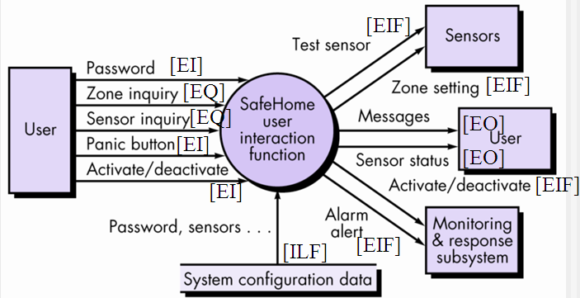

Answer:

Grading will be based on how well students appear to understand how to draw this diagram correctly. General idea is query screen (for report or view) is called EQ, external software interfaces are called EIF, reports and views are EO’s, user interface forms or data sent from another application for data saved here are called EI, and stored data are called ILF. Students should at least have the diagram shown in solution below, but may have more if they get too creative with the details of the application, in which case points should not be deducted. Points will be deducted if any of the following explicitly stated components is missing or incorrectly labeled EIF/EQ/EO etc. Arrow directions should be correct for type: EI/ILF/EQ points into circle, EO/EIF points out of circle. Students who are just drawing garbage and don’t understand much should get 0 points.

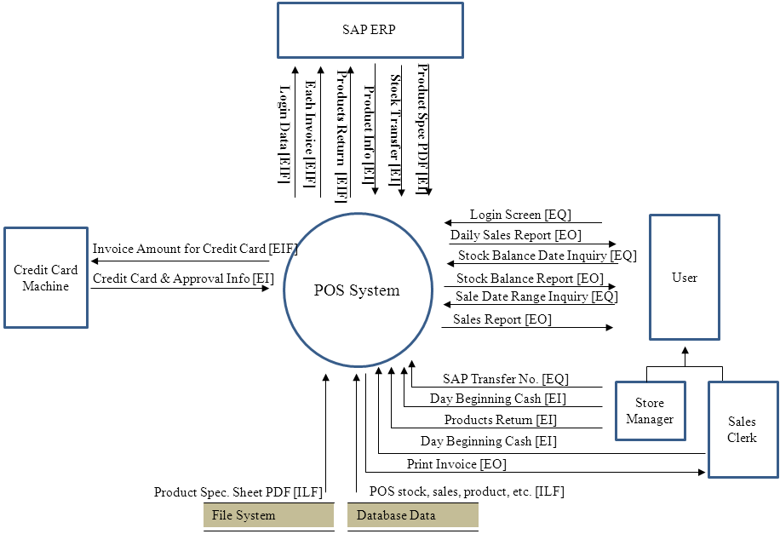

## *5 points.* Assume we have the following from above, compute the FP for this project:

* 3 complex EI’s, 1 average EI, and 2 simple EI’s,
* 3 complex EO’s, 1 average EO
* 1 average EQ, 4 simple EQ
* 1 complex ILF, 2 simple ILF
* 1 complex EIF’s, 2 average EIF

Note: 

Weighting Factor Table:

|  |  |  |  |
| --- | --- | --- | --- |
| **Information Domain Value** | **Weighting Factor** | | |
| **Simple** | **Average** | **Complex** |
| External Inputs (EI’s) | 3 | 4 | 6 |
| External Outputs (EO’s) | 4 | 5 | 7 |
| External Inquiries (EQ’s) | 3 | 4 | 6 |
| Internal Logical Files (ILF’s) | 7 | 10 | 15 |
| External Interface Files (EIF’s) | 5 | 7 | 10 |

|  |
| --- |
| 1. Requires backup and recovery? 2 2. Need specialized data communication? 5 3. Has distributed processing functions? 4 4. Is Performance critical? 2 5. Run in an existing, heavily utilized operational environment? 2 6. Requires online data entry? 4 7. Online data entry requires input over multiple screens / operations / tabs (line items)? 4 8. Are the ILF’s (database) updated online? 5 9. Inputs, outputs, files, or inquiries complex? 3 10. Internal processing complex? 3 11. Code designed to be reusable? 2 12. Conversion and installation included in the design? 2 13. System designed for multiple installations in different organizations? 0 14. Application designed to facilitate change and ease of use by user? 4 |

Answer:

|  |  |  |  |  |  |
| --- | --- | --- | --- | --- | --- |
| **Information Domain Value** | **Count** | × | **Weight Factor** | **=** | **Total** |
|
| Complex EI | 3 | × | 6 | **=** | 18 |
| Average EI | 1 | × | 4 | **=** | 4 |
| Simple EI | 2 | × | 3 | **=** | 6 |
| Complex EO | 3 | × | 7 | **=** | 21 |
| Average EO | 1 | × | 5 | **=** | 5 |
| Average EQ | 4 | × | 4 | **=** | 16 |
| Simple EQ | 1 | × | 3 | **=** | 3 |
| Complex ILF | 1 | × | 15 | **=** | 15 |
| Simple ILF | 2 | × | 7 | **=** | 14 |
| Complex EIF | 1 | × | 10 | **=** | 10 |
| Average EIF | 2 | × | 7 | **=** | 14 |
|  |  |  | Complexity Count | Total: | 126 |

Sum Fi is 42. FP = 126 x (0.65 +0.01*42) = 134.82 ≈ 135.

# Your Bangmod Cineplex movie theater wishes to display movies that are playing for each date for customer users to view the Movie Show Times (รอบหนัง ตารางเวลาภาพยนต์). The following are the requirements:

* + Administrator can enter data into forms: login, user name/password, movie information (includes youtube.com link to view movie preview video), theater information (Bangmod Cineplex has 4 theaters inside), show time information (at each date/time, what movie is showing in each of the 4 theaters).
  + There is a link to Google maps to view the map to Bangmod Cineplex
  + Each movie information has link to youtube.com to watch the movie’s preview (ตัวอย่างภาพยนตร์).
  + User can ask system for: Enter date to see list of movie show times per theater, Enter date + movie to see list of theater show times for the movie on that date, Click on the movie name to get movie information screen, in movie information screen click on preview button to see a preview of the movie (linked to youtube.com video), first page show cineplex map by link to Google maps.

## *20 points.* Draw the architectural context diagram such as the one shown below. Label each arc as EI, EQ, EIF, or ILF.



Answer:

Grading will be based on how well students appear to understand how to draw this diagram correctly. General idea is query screen (for report or view) is called EQ, external software interfaces are called EIF, reports and views are EO’s, user interface forms or data sent from another application for data saved here are called EI, and stored data are called ILF. The Login form should be considered an EQ form, since no data is saved. Students should at least have the diagram shown in solution below, but may have more if they get too creative with the details of the application, in which case points should not be deducted. Points will be deducted if any of the following explicitly stated components is missing or incorrectly labeled EIF/EQ/EO etc.. The components can be named something other than that shown below, if it has same meaning. Some students may have subclass of “Admin User” and “General User” as subclass of User, which is a better solution actually. “Google Maps” and “You Tube” are definitely EIF’s. If the component is incorrectly labeled as, say EQ instead of EI, points will be deducted as it clearly shows a lack of understanding. Arrow directions should be correct for type: EI/ILF/EQ points into circle, EO/EIF points out of circle. Students who are just drawing garbage and don’t understand much should get 0 points.

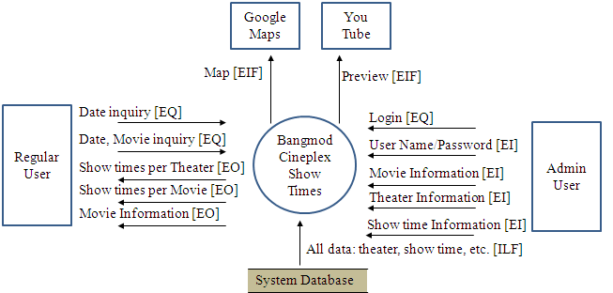

## *5 points.* Assume we have the following from part A above, use the information below to compute the FP:

* 2 simple EIF’s
* 1 simple EQ and 1 average EQ
* 3 complex EO’s
* 2 simple EI’s, 2 average EI’s, and 1 complex EI
* 1 complex ILF

Note: 

Weighting Factor Table:

|  |  |  |  |
| --- | --- | --- | --- |
| **Information Domain Value** | **Weighting Factor** | | |
| **Simple** | **Average** | **Complex** |
| External Inputs (EI’s) | 3 | 4 | 6 |
| External Outputs (EO’s) | 4 | 5 | 7 |
| External Inquiries (EQ’s) | 3 | 4 | 6 |
| Internal Logical Files (ILF’s) | 7 | 10 | 15 |
| External Interface Files (EIF’s) | 5 | 7 | 10 |

|  |
| --- |
| 1. Requires backup and recovery? 4 2. Need specialized data communication? 2 3. Has distributed processing functions? 3 4. Is Performance critical? 2 5. Run in an existing, heavily utilized operational environment? 4 6. Requires online data entry? 5 7. Online data entry requires input over multiple screens / operations / tabs (line items)? 3 8. Are the ILF’s (database) updated online? 4 9. Inputs, outputs, files, or inquiries complex? 3 10. Internal processing complex? 3 11. Code designed to be reusable? 4 12. Conversion and installation included in the design? 0 13. System designed for multiple installations in different organizations? 2 14. Application designed to facilitate change and ease of use by user? 1 |

Answer:

|  |  |  |  |  |  |
| --- | --- | --- | --- | --- | --- |
| **Information Domain Value** | **Count** | × | **Weight Factor** | **=** | **Total** |
|
| External Inputs (EI’s) | 2 | × | 3 | **=** | 6 |
| External Inputs (EI’s) | 2 | × | 4 | **=** | 8 |
| External Inputs (EI’s) | 1 | × | 6 | **=** | 6 |
| External Outputs (EO’s) | 3 | × | 7 | **=** | 21 |
| External Inquiries (EQ’s) | 1 | × | 3 | **=** | 3 |
| External Inquiries (EQ’s) | 1 | × | 4 | **=** | 4 |
| Internal Logical Files (ILF’s) | 1 | × | 15 | **=** | 15 |
| External Interface Files (EIF’s) | 2 | × | 5 | **=** | 10 |
|  |  |  | Complexity Count | Total: | 73 |

Sum Fi is 40. FP = 73 x (0.65 +0.01*40) = 76.7 ≈ 77.

# Consider the payroll processing system described below:

* + User enters data into following screens: login, user information, user set/change password, employee information (includes active/inactive), type of income/deductions, daily late/absent reasons for employees, setup work time schedule per date (to know what is on time and what is late), each employee new monthly income/deductions information starting at a particular month/year (enter data here for month when employee gets new salary), employee pay-slip form for each month/year with late/absent data in the slip.
  + Fingerprint reader sends data of employee time in/time out after you send it what date range (from date: ___ to date to: ___ ) you want this data.
  + User should have a screen to edit daily time in / time out data read from fingerprint reader.
  + System prints monthly pay-slip with late/absent data from print button in pay-slip form, late/absent summary report given the month range, absent reports by type given the month range, withholding tax report given the month range, and social security deduction report given the month range.
  + Door access control system is updated daily based on today’s active employees for employees to come into the office using keycard at the door.
  + Employee photograph data is kept in the file server as a JPG file (as ###.JPG where ### is employee ID) that appears in the employee information form.

## *20 points.* Draw the architectural context diagram such as the one shown below. Label each arc as EI, EQ, EIF, or ILF.



Answer:

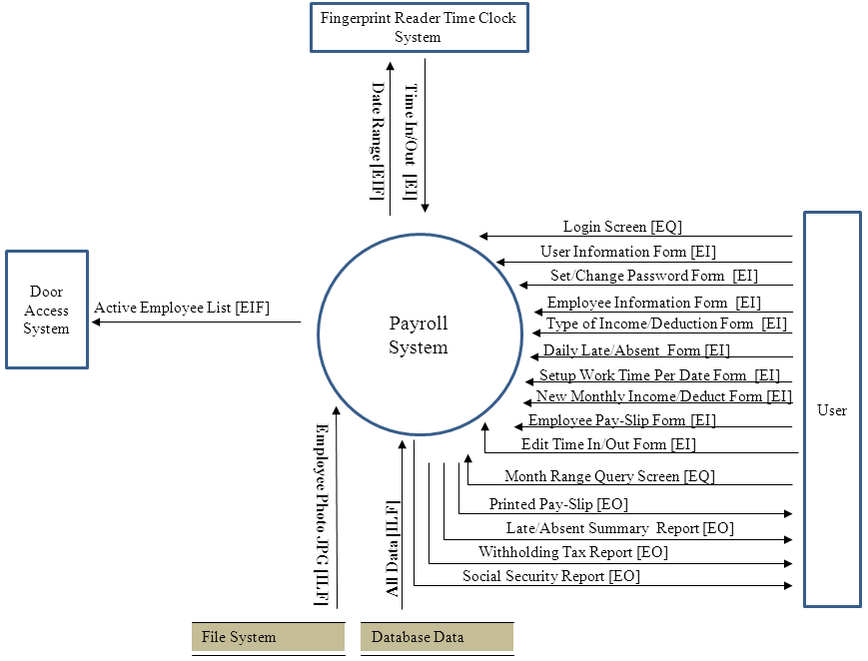

Above also correct if you have 3 Month Range Query Screens instead of just 1 (assuming you use one each for late/absent summary, withholding tax report, and social security report. Note that printed pay-slip (report) has no query screen because it is printed from the pay-slip form.

## *10 points.* Classify each EI, EO, EQ, EIF, ILF as simple, average, or complex. Then find the FP for this system.

Note: 

Weighting Factor Table:

|  |  |  |  |
| --- | --- | --- | --- |
| **Information Domain Value** | **Weighting Factor** | | |
| **Simple** | **Average** | **Complex** |
| External Inputs (EI’s) | 3 | 4 | 6 |
| External Outputs (EO’s) | 4 | 5 | 7 |
| External Inquiries (EQ’s) | 3 | 4 | 6 |
| Internal Logical Files (ILF’s) | 7 | 10 | 15 |
| External Interface Files (EIF’s) | 5 | 7 | 10 |

|  |
| --- |
| 1. Requires backup and recovery? ___ 2. Need specialized data communication? ___ 3. Has distributed processing functions? ___ 4. Is Performance critical? ___ 5. Run in an existing, heavily utilized operational environment? ___ 6. Requires online data entry? ___ 7. Online data entry requires input over multiple screens / operations / tabs (line items)? ___ 8. Are the ILF’s (database) updated online? ___ 9. Inputs, outputs, files, or inquiries complex? ___ 10. Internal processing complex? ___ 11. Code designed to be reusable? ___ 12. Conversion and installation included in the design? ___ 13. System designed for multiple installations in different organizations? ___ 14. Application designed to facilitate change and ease of use by user? ___ |

Answer (Each person will assess complexity rating differently. This is just an example of my rating):

External Inputs (EI’s): User Information – Average, Change Password Form – simple, Employee Information Form – Complex, Type of Income/Deduction Form – Simple, Daily Late/Absent Form – Average, Setup Work Time Per Date Form – Average, New Monthly Income/Deduct Form – Average, Employee Pay-Slip Form – Complex, Edit Time In/Out Form – Complex, Time In/Out from Time Clock – Average.

External Outputs (EO’s): Printed Pay-Slip – Complex, Late/Absent Summary – Average, Withholding Tax – Simple, Social Security Report – Simple.

External Inquiries (EQ’s): Month Range – Simple.

Internal Logical Files (ILF’s): Database Data – Complex, Employee Photo – Simple.

External Interface Files (EIF’s): Date Range to Time Clock System – Simple, Active Employee List to Door Access Control System – Average.

|  |  |  |  |  |  |
| --- | --- | --- | --- | --- | --- |
| **Information Domain Value** | **Count** | × | **Weight Factor** | **=** | **Total** |
|
| External Inputs (EI’s). Simple | 2 | × | 3 | **=** | 6 |
| External Inputs (EI’s). Average. | 5 | × | 4 | **=** | 20 |
| External Inputs (EI’s). Complex. | 3 | × | 6 | **=** | 18 |
| External Outputs (EO’s). Simple. | 2 | × | 4 | **=** | 8 |
| External Outputs (EO’s). Average. | 1 | × | 5 | **=** | 5 |
| External Outputs (EO’s). Complex. | 1 | × | 7 | **=** | 7 |
| External Inquiries (EQ’s). Simple. | 1 | × | 3 | **=** | 3 |
| Internal Logical Files (ILF’s). Simple. | 1 | × | 7 | **=** | 7 |
| Internal Logical Files (ILF’s). Complex | 1 | × | 15 | **=** | 15 |
| External Interface Files (EIF’s). Simple. | 1 | × | 5 | **=** | 5 |
| External Interface Files (EIF’s). Average. | 1 | × | 7 | **=** | 7 |
|  |  |  | Complexity Count | Total: | 101 |

|  |
| --- |
| (Each person will answer this differently as well):   1. Requires backup and recovery? 4 2. Need specialized data communication? 2 3. Has distributed processing functions? 2 (for the file system) 4. Is Performance critical? 4 5. Run in an existing, heavily utilized operational environment? 3 6. Requires online data entry? 4 7. Online data entry requires input over multiple screens / operations / tabs (line items)? 4 8. Are the ILF’s (database) updated online? 4 9. Inputs, outputs, files, or inquiries complex? 3 10. Internal processing complex? 3 11. Code designed to be reusable? 4 12. Conversion and installation included in the design? 3 13. System designed for multiple installations in different organizations? 3 14. Application designed to facilitate change and ease of use by user? 4 |

Sum Fi is 47. FP = 101 x (0.65 +0.01*47) = 113.12 ≈ 113.