|  |  |
| --- | --- |
|  | King Mongkut’s University of Technology  **CPE 333 Software Engineering**  Suthep Madarasmi, Ph.D**.**  **Metrics Overview Lecture In-Class Practice Problems** |

* + 1. Based on the data below from past projects at the KMUTT’s Computer Center, find the 5 metrics below. Show your work.

|  |  |  |  |  |  |
| --- | --- | --- | --- | --- | --- |
| **Project Name** | **KLOC** | **Effort (p-months)** | **Baht** | **Errors** | **Defects** |
| Student Registration System | 200 | 60 | 6,000,000 | 6,500 | 120 |
| University Accounts | 150 | 40 | 5,000,000 | 5,400 | 100 |
| Student Information System | 70 | 20 | 2,000,000 | 2,600 | 70 |
| LMS System | 180 | 30 | 2,000,000 | 2,500 | 110 |
| TOTAL: | **600** | **150** | **15,000,000** | **17,000** | **400** |

1. Defects per LOC

Answer: Defects Total = 400. KLOC = 600. Defects / KLOC = 400/ 600 = 0.67.

1. Cost per LOC

Answer: 15,000,000 baht/ 600,000 LOC = 25 baht/ LOC.

1. Errors per person-day, assuming 22 person-days in one person-month.

Answer: 17,000 errors/ (150 p-month*22 p-days/p-month) = 5.15 errors/p-day

1. LOC per person-month

Answer: 600x1000 LOC/150 p-month = 4,000 LOC/p-month

1. Defect Removal Efficiency 

Answer: E =17000. D = 400. DRE = 17000/(17400) = 0.98.

* + 1. Your Bangmod Cineplex movie theater wishes to display movies that are playing for each date for customer users to view the Movie Show Times (รอบหนัง ตารางเวลาภาพยนต์). The following are the requirements:
  + Administrator can enter data into forms: login, change password, movie information (includes youtube.com link to view movie preview video), theater information (Bangmod Cineplex has 4 theaters inside), show time information (at each date/time, what movie is showing in each of the 4 theaters).
  + There is a link to Google maps to view the map to Bangmod Cineplex
  + Each movie information has link to youtube.com to watch the movie’s preview (ตัวอย่างภาพยนตร์).
  + User can ask system for: Enter date to see list of movie show times per theater, Enter date + movie to see list of theater show times for the movie on that date, Click on the movie name to get movie information screen, in movie information screen click on preview button to see a preview of the movie (linked to youtube.com video), first page show cineplex map by link to Google maps.

1. Draw the architectural context diagram such as the one shown below. Label each arc as EI, EQ, EIF, or ILF.

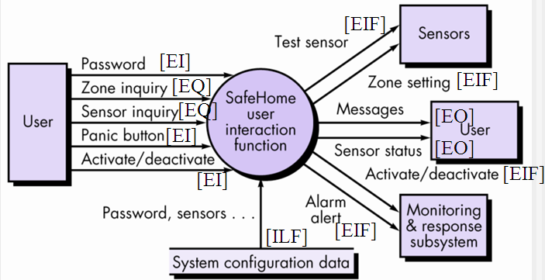

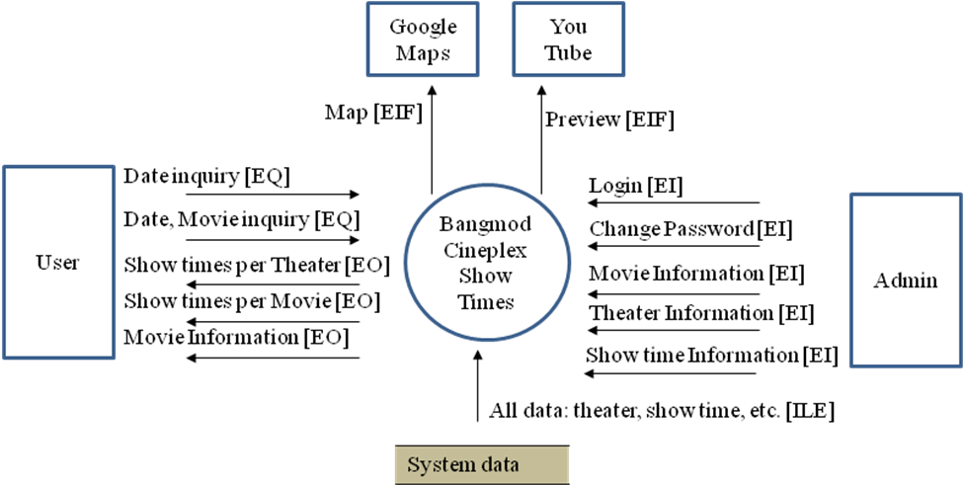

1. Fill data in the table below to compute the Count Total for the above Movie Show Times problem. Assume we have the following from part A above:

* 2 simple EIF’s
* 1 simple EQ and 1 average EQ
* 3 complex EO’s
* 2 simple EI’s, 2 average EI’s, and 1 complex EI
* 1 complex ILF

|  |  |  |  |  |  |  |  |
| --- | --- | --- | --- | --- | --- | --- | --- |
| **Information Domain Value** | **Count** | × | **Weighting Factor** | | | **=** | **Total** |
| **Simple** | **Average** | **Complex** |
| External Inputs (EI’s) | 2 | × | 3 | 4 | 6 | **=** | 6 |
| External Inputs (EI’s) | 2 | × | 3 | 4 | 6 | **=** | 8 |
| External Inputs (EI’s) | 1 | × | 3 | 4 | 6 | **=** | 6 |
| External Outputs (EO’s) | 3 | × | 4 | 5 | 7 | **=** | 21 |
| External Inquiries (EQ’s) | 1 | × | 3 | 4 | 6 | **=** | 3 |
| External Inquiries (EQ’s) | 1 | × | 3 | 4 | 6 | **=** | 4 |
| Internal Logical Files (ILF’s) | 1 | × | 7 | 10 | 15 | **=** | 15 |
| External Interface Files (EIF’s) | 2 | × | 5 | 7 | 10 | **=** | 10 |
|  |  |  |  |  | Count | Total: | 73 |

1. Compute the FP for this problem given the 14 adjustment factors below.



|  |
| --- |
| 1. Requires backup and recovery? 4 2. Need specialized data communication? 2 3. Has distributed processing functions? 3 4. Is Performance critical? 2 5. Run in an existing, heavily utilized operational environment? 4 6. Requires online data entry? 5 7. Online data entry requires input over multiple screens / operations / tabs (line items)? 3 8. Are the ILF’s (database) updated online? 4 9. Inputs, outputs, files, or inquiries complex? 3 10. Internal processing complex? 3 11. Code designed to be reusable? 4 12. Conversion and installation included in the design? 0 13. System designed for multiple installations in different organizations? 2 14. Application designed to facilitate change and ease of use by user? 1 |

Answer: Sum Fi is 40. FP = 73 x (0.65 +0.01*40) = 76.7 ≈ 77.

* + 1. If a Project’s estimated FP is 150. If effort in Java-programming is given by person-months and effort in VB-programming is given by  person-months. If you charge based on 100,000 baht per person-month, what would be the estimated effort E and the estimated price for a program in Java and VB for this project? You must show your work to get credit.

|  |  |
| --- | --- |
| **Programming Language** | **Average LOC per FP** |
|
| Ada | 150 |
| C | 160 |
| C++ | 70 |
| COBOL | 80 |
| Java | 60 |
| Perl | 60 |
| Visual Basic (VB) | 50 |

Answer:

Java:

KLOC = 150 FP*60 LOC/FP / (1000 LOC/KLOC) = 9 KLOC;

E = 2(9)^1.5 = 2 * 9 * 3 = 54 person-months.

Price = 54 x 100,000 baht.

VB:

KLOC = 150 FP *50/1000 = 7.5 KLOC ;

E = 1 + 4*(7.5) = 31 person-months.

Price = 31 x 100,000 baht.