Manual for Scheduler assignment

Implemented by:

Name: Mona Hussiny Mohamed Sec: 3

Name: Mona Ahmed Abu El-ella Sec: 3

Delivered to:

Eng. Mai Said

1. Launching the Program

DoubleClick Form1.exe

1. 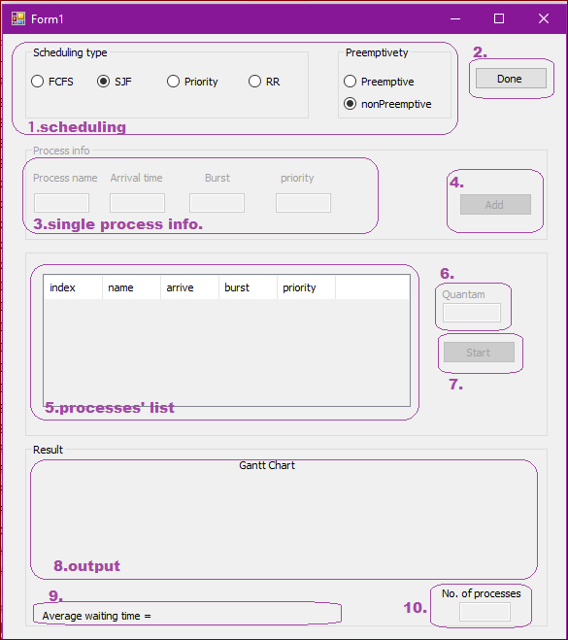Program Interface
2. **Scheduling**

Choose the scheduling type whether FCFS (first come first serve), SJF (shortest job first) preemptive or non-preemptive, Priority preemptive or non-preemptive, or RR (round robin)

1. Finished/Edit choosing the type of scheduling
2. **Single process info**

Specify the information of a process

Process name, arrival time, burst, and priority (only for priority scheduling)

1. Add a process to the processes’ list
2. **Processes’ list**

Shows the list of added processes to schedule

1. Quantum of time for round robin scheduling
2. Start/restart the scheduling and drawing the Gantt chart
3. **Output**

Shows the Gantt chart of the processes scheduled

1. Average waiting time
2. Number of processes added
3. Steps:
   1. **Choosing the type of scheduling**

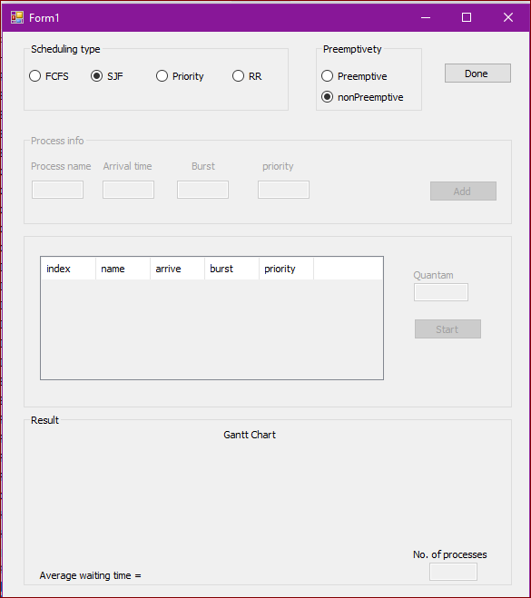Choose the type of scheduling from Scheduling Type group box then if its preemptive or non-preemptive. Then press done.

3.1

* 1. **Adding processes**

Write name, arrival time, burst and priority (for priority scheduling) then press add. Add as much processes as you want.

If you want to change the scheduling type press modify.

Notice: if you press modify, all the processes you added will be deleted.

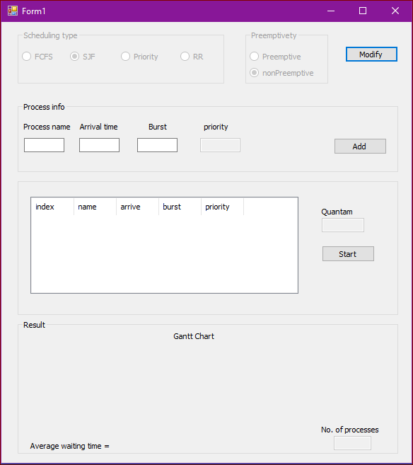Notice: arrival, burst and priority must be non-negative number and must not be empty or it’s an invalid input.

3.2

* 1. **Ensure processes**

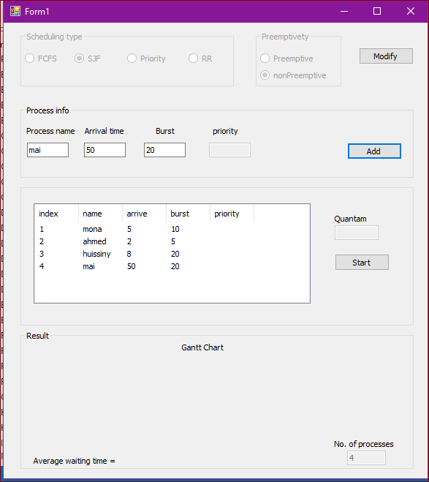Review the processes you entered and their information, specify the quantum for round robin scheduling then press start.

3.3

* 1. **Output**

Draws the Gantt chart, displays the average waiting time and the number of processes you entered.

If you want to enter more processes you may press restart.

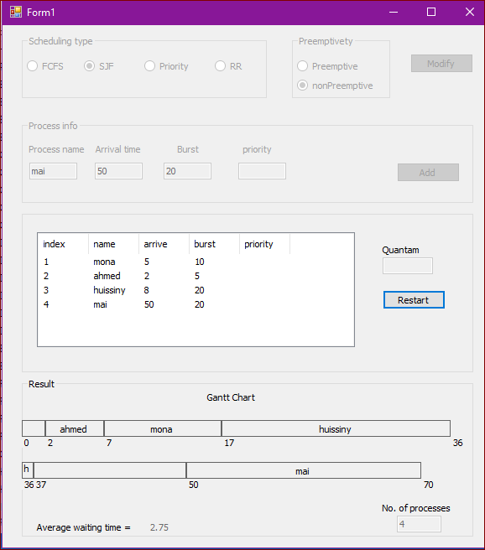If you want to start from scratch (from the scheduling type), press modify after pressing restart.

3.4