# Infant Cry Detector Project Report

## Introduction

The Infant Cry Detector is a smart device designed to help parents and caregivers monitor their baby’s needs. Babies cry to communicate, but sometimes it’s hard for parents to hear or respond immediately, especially if they’re in another room or busy with other tasks. This project uses an Arduino-based system to detect a baby’s cry and provide visual and auditory alerts to notify the guardian. Additionally, it plays soothing lullabies to calm the baby down.

## Objective

The goal of this project is to:

1. Detect a baby’s cry using a sound sensor (or simulate it using a potentiometer).

2. Notify the guardian using LEDs and an LCD display.

3. Calm the baby by playing soothing lullabies through a buzzer.

## Components Used

• Arduino Uno - The brain of the project that controls all the components.

• Potentiometer: Simulates the sound sensor by adjusting the input value.

• LCD Display i2C (16x2): Shows the intensity of the cry and system status.

• LEDs (Green, Yellow, Red) - Indicate the intensity of the cry (low, medium, high).

• Buzzer - Plays lullabies to calm the baby.

• Resistors - Protect the LEDs from excessive current.

• Breadboard and Jumper Wires - Connect all the components together.

## How It Works

1. Sound Detection: The potentiometer simulates the sound sensor by providing a value between 0 and 1023.

2. Intensity Levels:

- Low Intensity (Green LED): The baby is calm or making soft sounds.

- Medium Intensity (Yellow LED): The baby is crying moderately.

- High Intensity (Red LED): The baby is crying loudly.

3. Notifications:

- The LCD display shows the intensity level and the potentiometer value.

- The LEDs light up to indicate the intensity level.

4. Lullabies: Different lullabies are played for medium and high-intensity cries.

## Circuit Diagram

The following is the circuit diagram for the Infant Cry Detector:

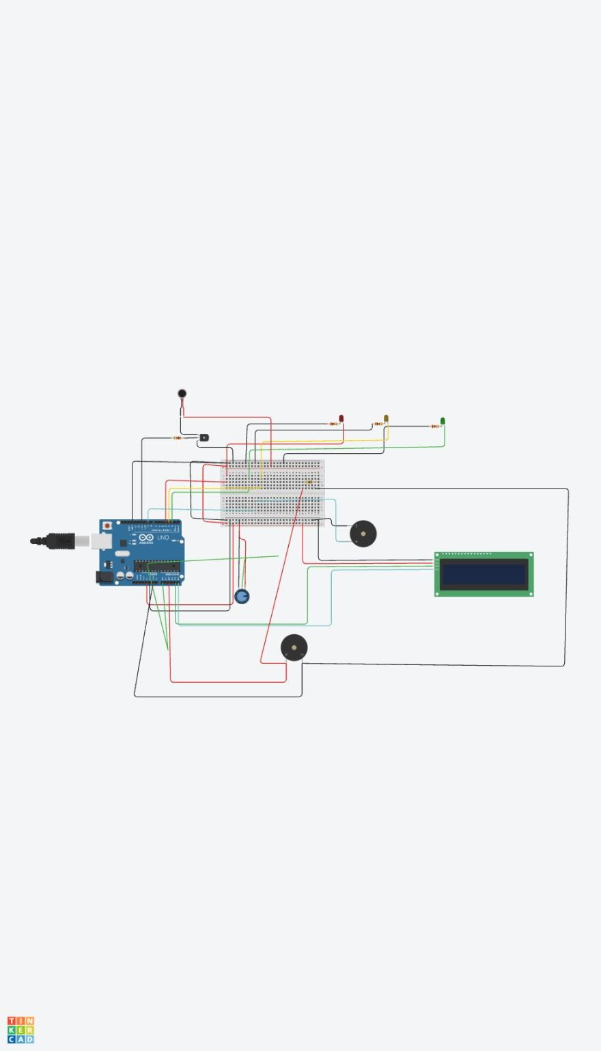

## System in Action

Below are images of the system running under different conditions:

[Insert image of baby sleeping - low intensity]

[Insert image of baby crying moderately - medium intensity]

[Insert image of baby crying loudly - high intensity]

## Technical Details

1. Arduino Code: The Arduino reads the potentiometer value to determine the cry intensity, controls the LEDs, LCD, and buzzer based on the intensity level, and plays different lullabies accordingly.

2. Circuit Connections: The components are connected in a manner that allows the Arduino to interpret sound intensity and trigger appropriate outputs.

## Challenges and Solutions

• Challenge: Simulating sound detection without a real sound sensor.  
 Solution: Used a potentiometer to adjust the input value and simulate different cry intensities.

• Challenge: Playing different lullabies for different cry intensities.  
 Solution: Used arrays to store the notes and durations of each lullaby and played them using the `tone()` function.

• Challenge: Ensuring the LCD displays the correct information.  
 Solution: Used the `LiquidCrystal` library to control the LCD and update the display dynamically.

## Future Improvements

• Use a real sound sensor instead of a potentiometer.

• Add Wi-Fi or Bluetooth capabilities to send alerts to a smartphone.

• Allow parents to upload their own lullabies or soothing sounds.

• Make the device portable by powering it with a battery.

## Conclusion

The Infant Cry Detector is a simple yet effective device that helps parents and caregivers monitor their baby’s needs. By combining an Arduino board with basic electronic components, this project provides visual and auditory alerts and plays soothing lullabies to calm the baby. It’s a great example of how technology can make parenting a little easier and more convenient.