|  |  |
| --- | --- |
| How is your result ? | |
| sad-emoji-24oz4yx.png | &MaxW=640&MaxH=427&AR-307149990.jpgC:\Users\PC\AppData\Local\Microsoft\Windows\Temporary Internet Files\Content.IE5\E3SLIG17\images_(4)[1].jpg |

Name : …………………………… Class : ………………

worksheet : ( 15 )

Color :

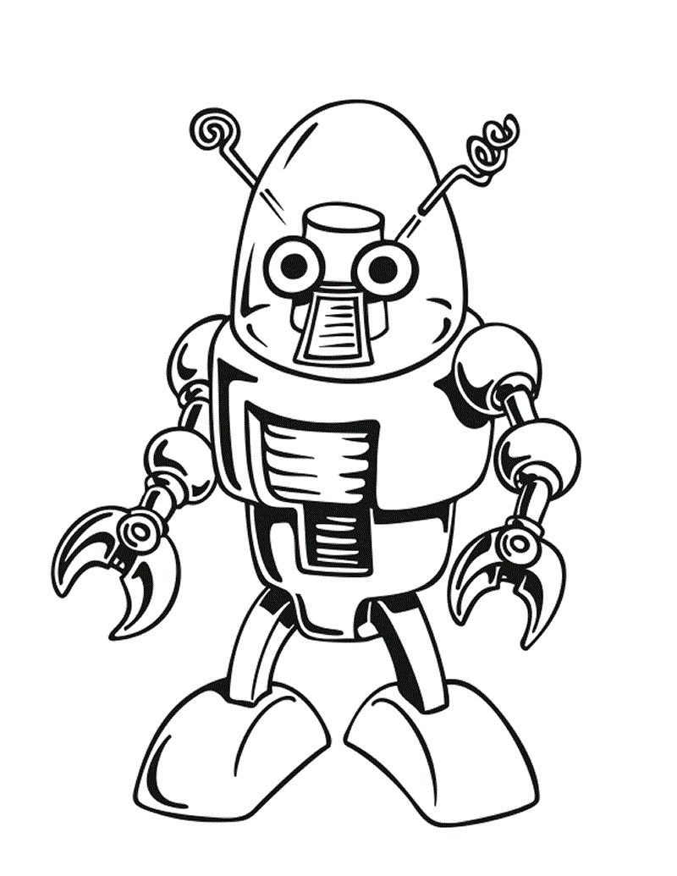

Fill in the blanks :

playing - watching - eating - making

* He is \_\_\_\_\_\_\_ dinner .
* She is \_\_\_\_\_\_\_ orange juice .
* We are \_\_\_\_\_\_\_\_ computer games .
* They are \_\_\_\_\_\_\_\_ TV .