|  |  |
| --- | --- |
| How is your result ? | |
| sad-emoji-24oz4yx.png | &MaxW=640&MaxH=427&AR-307149990.jpgC:\Users\PC\AppData\Local\Microsoft\Windows\Temporary Internet Files\Content.IE5\E3SLIG17\images_(4)[1].jpg |

Name : …………………………… Class : ………………

worksheet : ( 16 )

Fill in with the missing letters :

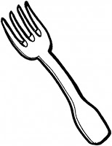

C \_ \_ F \_ \_ k

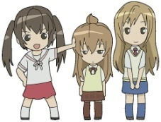

Doct \_ \_ Sist \_ \_ s

Spell these words :



\_ \_ \_ \_ \_ \_ \_



   