Hany Ragheb Abou El Ezz  23 Zaki El Sisy st. – Haram – Giza – Egypt.  Tel: (M) (+2) 0120711006  E-Mail: h.ragheb.elezz@gmail.com  ------------------------------------------------------------------------- | 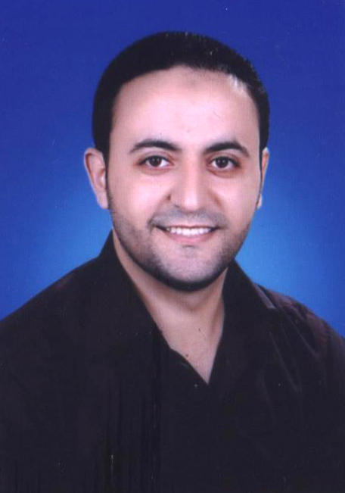

Objective

Seeking a challenging position in a dynamic professional environment, requiring versatile and extensive
experience to perform analysis, design, development for both Desktop and web applications using the latest methods and technologies.

Education

- B.Sc. Computers and information, Faculty of Computers and Information - Cairo University.
- Year 2006.
- Graduation project: Human Computer Interface for E-Learning System.
- Graduation project grade: Excellent.

Work Experience

November 2008 till Present
Victory Link®
www.victroylink.com
Projects:
VFN Stock Trader:
- Overview: VFN Stock Trader is a multi user interface for stock exchanging using Windows communication foundation,windows presentation foundation and multi threading
My Roles:-
Server side :
- Data Access Layer:
- Design Data Access Layer for Stock Trader Entities
- Implement Data Base Manager for different providers (Oracle, SQL)
- Business Service Layer:
- Implement WCF service with Duplex communication
- Implement Stock Trader Contracts and Data Contracts
- Stock Trader Service Manager:
- Implement Security features for Stock Trader service .
- Utilities:
- Implement Encryption and Decryption.
5. Data management module
- Implement custom data transfer channel to compress and data serialization

Client side :
- Implement set of client requirements for Desktop and Web application using MVP
design pattern and WPF .

Admin Panel:
- Implement web application for admin part to manage Stock Exchange Calenadar ,
user subscription and expiration and reports module

April 2008 till October 2008
Nebras® Technologies
www.nebrastech.com
Projects:
ERIS:
- Overview: ERIS is an internal website manage medical centers operation and transactions
- My Roles:
1. I have participated as a software developer for Inventory Module and Examination Module.
2. I have participated as a quality assurance engineer, I have tested all its business process
including front-end and administration backend.
Web Ray Viewer:
- Overview: Manipulate patient information collected from medical area and Dicom objects,
online viewing of (Media, Images, and Reports) for patients and communication channel
with PACS used in medical area
- My Roles:-
I have participated as a software developer for Web Ray Viewer architecture and functionality.

Technical Skills
Programming Languages
- C#
- ADO.NET
- ASP.NET
- WCF
- WPF
- Java
- C/C++
- Java Script
- AJAX
- Web Services
- Mono - Mac
UML Tools
- Sybase PowerDesigner 7.0
- MS Visio
Operating Systems
- Windows 98 /2000/ME/2003/XP
- Windows 7
- Linux
- Mac OS X
Tools and IDEs
- Microsoft Visual Studio 2005,2008,2010
- Sybase Power Builder 7.0
- Mono Develop For Mac OS
Database Management Systems DBMS
- Microsoft SQL Server (2000-2005-2008)
- Microsoft SQL Server Reporting Services

Conceptual knowledge
- Solid understanding of Object Orientation concepts.
- Solid understanding Database designing concepts.
- Good understanding of software Engineering concepts
- Good understanding of design pattern techniques

Soft Skills

- Interactive and fast enough to learn new technologies and sciences.
- Advanced Research Abilities.
- Highly Communications Skills.
- Self Motivated.
- Ability to work under pressure and good team work player.

Personal Information
- Date of Birth: 12th of September 1984
- Marital status: Single
- Nationality: Egyptian
- Military Status: Completed
- Language: Arabic: Mother tongue
English: Very good (spoken & written)
- Hobbies and Interest: Football, Ping-Pong, Reading, and travelling abroad.

