Week’s Theme:

1st week: Fortress

2nd week: Replication

3rd week: You only have one

Name of Game:

Fortalice

Link to game:

Included in file

Photo/Picture:

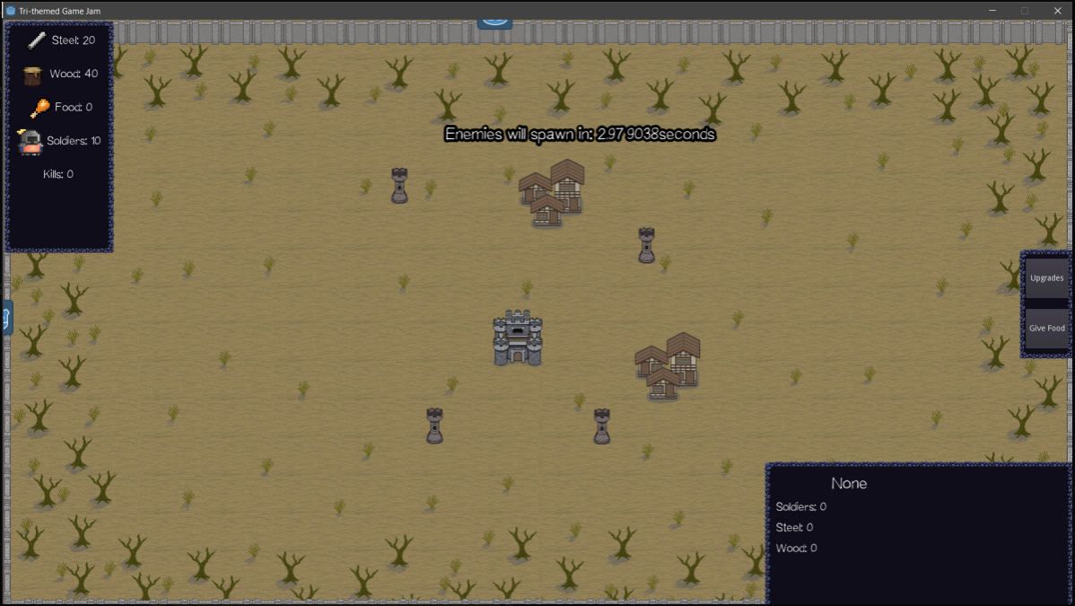

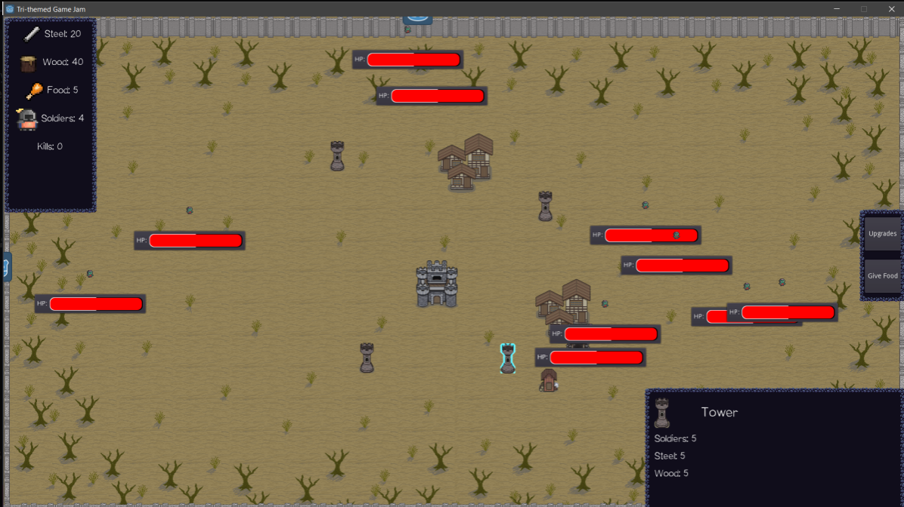

How does the game fit the themes:

For the first theme is “*Fortress”,* the game starts off already with a fortress containing soldiers where you can use those same soldiers to capture buildings such as towers and villages in order to reproduce resources that will aid in obtaining upgrades which is technically part of the second week’s theme “*Replication*”. Lastly, for the final theme namely "You Only Have One", it is more of a reference with Attack on Titan where there are three walls and the player will have to rebuild the walls inside and out in order to create one huge wall.

Team:

Makxi Ursua(Sicarius214) - Designer

Jasmine Zabala(Viahnimo) – Sprite/Building Artist

Eleen Gonzales(MonoAi) – Head Programmer

Jose Locsin(JayAiJoe) – Co-Programmer

Phoebe Ong(PBJs_31) – Background Artist