***FOCAS IFU***

Reduction software manual

February 13, 2020

# Installation

FOCAS IFU reduction software uses Python. It is confirmed to work under both Python 2 and 3.

## Required Linux libraries

Before installing PyRAF, you need to install following Linux libraries.

* Xlib
* Tcl
* Tk
* Tkinter.

For Ubuntu, you can install the following command.

apt install libx11-dev tcl-dev tk-dev python-tk

## Required python modules

The reduction software has been confirmed to work well under the environments shown in Table 1.

Table Python versions and the module versions.

|  |  |  |
| --- | --- | --- |
| Python | 2.7.12 | 3.6.7 |
| [NumPy](http://www.numpy.org/) | 1.14.2 | 1.13.3 |
| [SciPy](https://www.scipy.org/) | 1.0.1 | 0.19.1 |
| [matplotlib](https://matplotlib.org/) | 2.2.2 | 2.1.1 |
| [Astropy](http://www.astropy.org/) | 2.0.5 | 3.0 |
| [Astro-SCRAPPY](https://github.com/astropy/astroscrappy) | 1.0.8 | 1.0.5 |
| [stsci.tools](https://stscitools.readthedocs.io/en/latest/) | 3.4.11 | 3.4.12 |
| [PyRAF](http://www.stsci.edu/institute/software_hardware/pyraf/) | 2.1.14 | 2.1.14 |
| [Photutils](https://photutils.readthedocs.io/en/stable/) | 0.4 | 0.4 |

In Ubuntu 16.04, PyRAF for Python 3 cannot be installed, but it for Python 2 can be install with the following command.

pip install numpy, scipy, matplotlib, astropy, astro-scrappy, stsci.tools==3.4.11, photoutils

Note: In Ubuntu 16.04, stsci.tools can be installed only for 3.4.11, and not for >=3.4.12. So, you have to install the specific version like above.

In Ubuntu 18.04, all of the modules for both Python 2 and 3 can be installed from the Ubuntu package manager. But their versions tend to be slightly older than those installed with pip.

To improve smoothness of the PyRAF graphics, set the following environment variable.

setenv PYRAFGRAPHICS matplotlib

## IRAF

[IRAF](http://iraf.noao.edu/) is also needed for the software.

In Ubuntu 18.04, it is also available as a part of Ubuntu packages. Note that the IRAF install directory is “/usr/lib/iraf/” in this case, and the environment variable of “iraf” should be set to the directrory.

setenv iraf /usr/lib/ira/

## Installation of FOCAS IFU reduction software

* Download FOCASIFU.tar.gz from the following URL.

<https://www2.nao.ac.jp/~shinobuozaki/focasifu/software.html>

* Decompress it in a desired directory. The directory tree is shown in Figure 1.

FOCASIFU

scripts

lib

doc

maintenance

Figure 1 Directory tree

* + “scripts” directory contains python scripts for the reduction.
  + “lib” directory contains some data referred by the reduction scripts.
  + “doc” directory contains this manual.
  + “maintenance” directory contains some scripts for maintenance of this reduction software. Users usually do not need to use them.
* Add the path of “FOCASIFU/scripts” to the “PATH” environment variable.

# Data

FOCAS has two CCDs, and each data consists of two FITS files for the two CCDs. These two files have the name with odd and even frame ID numbers (for example, FCSA01234567.fits and FCSA01234568.fits). In this manual, FCSA01234567 or FCSA01234568 is called as the frame ID.

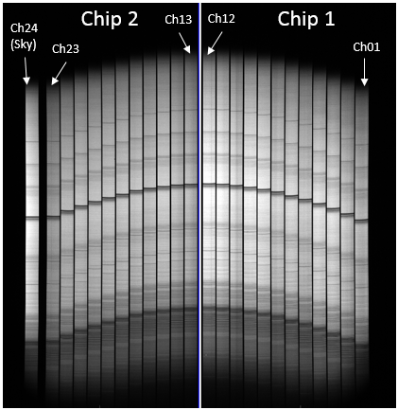

Figure 2 Obtained image with FOACS IFU.

Data cube FITS files created by this software have the following format.

NAXIS1: slice length direction  
NAXIS2: another spatial direction perpendicular to NAXIS1  
NAXIS3: wavelength direction

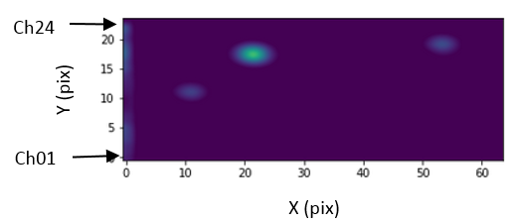

Figure 3 Reconstructed image.

# Reduction flow

Reduction flow is shown in **エラー! 参照元が見つかりません。**. Typical procedure is as follows.

1. First of all, create template bias images using mkbiastemplate.py.
2. Reduce dome flat images using domeflat.py.
3. Reduce CAL flat images for both object and standard star using calflat.py.
4. Reduce comparison images for both object and standard star using comparison.py.
5. Reduce standard star images using standardstar.py.
6. Reduce object images using object.py.

Examples of the commands

# Bias template

mkbiastemplate.py FCSA00200797.fits -d ../20180302/

# Dome flat

domeflat.py FCSA00200723.fits,FCSA00200725.fits,FCSA00200727.fits,FCSA00200729.fits,FCSA00200731.fits -d ../20180302/

# CAL flat for object

calflat.py FCSA00201317.fits,FCSA00201319.fits,FCSA00201321.fits -d ../20180302/

# CAL flat for standard star

calflat.py FCSA00200939.fits,FCSA00200941.fits,FCSA00200943.fits -d ../20180302/

# Comparison for object

comparison.py FCSA00201315.fits FCSA00201317 -d ../20180302/

# Comparison for standard star

comparison.py FCSA00200987.fits FCSA00200939 -d ../20180302/

# Standard star

standardstar.py FCSA00200903.fits FCSA00200723 FCSA00200939 FCSA00200987 -d ../20180302/

# Object

object.py FCSA00201303.fits FCSA00200723 FCSA00201317 FCSA00201315 FCSA00200903 -d ../20180302/

# Scripts

All scripts have two same options, “-h” and “-o”.

-h : Display a help screen.

-o : Overwritten output files.

All low-level scripts check whether the output files already exit or not. If exits, the scripts are skipped. If you want to apply a certain script again, you must remove or rename the output file beforehand.

## High-level scripts

### domeflat.py

USAGE: domeflat.py [-h] [-o] [-d RAWDATADIR] <FITS files>

ARGUMENT

FITS files: Comma-separated file names of dome flat images.

OPTION

-d RAWDATADIR: Raw data directory

OUTPUT

XXXX.ov.fits : bias-structed and overscan-region-removed image

XXXX.fcmb.fits : combined flat image

XXXX.fcmb_low.fits: low spatial frequency image

XXXX.fcmb_high.fits : high spatial frequency image

(XXXXX is the frame ID of the input file.)

This script is for dome-flat images and applies the following low-level scripts; bias_overscan.py, flat_combine.py, and divhighlow.py. You have only to input FITS files with odd-number frame IDs. The script deduces FITS file names with even-number frame IDs. See descriptions about each script for more details.

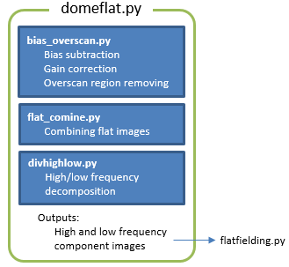

Figure Script structure of domeflat.py.

### calflat.py

USAGE: calflat.py [-h] [-o] [-d RAWDATADIR] <FITS files>

ARGUMENT

FITS files: Comma-separated file names of CAL flat images.

OPTION

-d RAWDATADIR: Raw data directory

OUTPUT

XXXX.ov.fits : bias-structed and overscan-region-removed image

XXXX.fcmb.fits : combined flat image

idXXXX.fcmb : spectrum gap location database in “database” directory

XXXX.fcmb_gapcoef : coefficient database for spectrum gap position

XXXX.chNNedge.fits : edge-enhanced images in “chimages” directrory.

idXXXX.chNNedge : edge location database in “chimages/database” directory.

idXXXX.ch12edge_org : edge location database for Ch12 in “chimages/database” directory only for VPH650 data.

fcXXXX.chNNedge : spatial coordinate transform function database in “chimages/database” directory

(XXXXX is the frame ID of the input file, and NN is the channel number.)

This script is for CAL-flat images and applies the following low-level scripts; bias_overscan.py, flat_combine.py, identify_gap.py, fit_gap_coordinate.py, mkedgeimage.py, identify_edge.py, correct_ch12_edge.py only for VPH650 data, and fitcoord_edge.py. You have only to input FITS files with odd-number frame IDs. The script deduces FITS file names with even-number frame IDs. See descriptions about each script for more details.

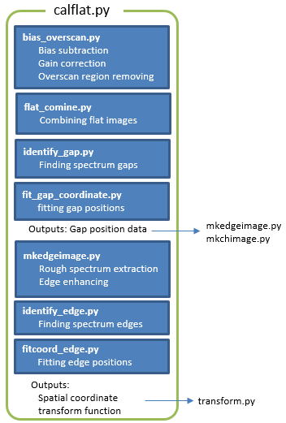

Figure Script structure of calflat.py.

### comparison.py

USAGE: comparison.py [-h] [-o] [d RAWDATADIR] <FITS files> <CAL flat ID>

ARGUMENT

FITS files: Comma-separated file names of comparison images.

CAL flat ID: Frame ID of the CAL flat image created by calflat.py or flat_combine.py.

OPTION

-d RAWDATADIR: Raw data directory

OUTPUT

XXXX.ov.fits : bias-structed and overscan-region-removed image

XXXX.chNN.fits : each spectrum image in “chimages” directrory

idXXXX.chNN : emission line location database in “chimages/database” directory

fcXXXX.chNN : wavelength coordinate transform function in “chimages/database” directory

(XXXXX is the frame ID of the input file, and NN is the channel number.)

This script is for comparison images and applies the following low-level scripts; bias_overscan.py, mkchimage.py, identify_dispersion.py, and fitcoord_dispersion.py. You have only to input FITS files with odd-number frame IDs. The script deduces FITS file names with even-number frame IDs. See descriptions about each script for more details.

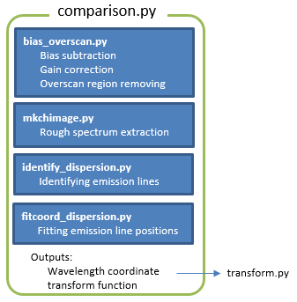

Figure . Script structure of comparison.py.

### standardstar.py

USAGE: standardstar.py [-h] [-o] [-d RAWDATADIR] <FITS file> <Dome flat ID>

<CAL flat ID> <Comparison ID>

ARGUMENT

FITS file: Object image

Dome flat ID: Frame ID of the dome flat image combined by domeflat.py or flat_combine.py.

CAL flat ID: Frame ID of the combined CAL flat image created by calflat.py or flat_combine.py.

Comparison ID: Frame ID of the fc-file created by comparison.py or fitcoord_dispersion.py.

OPTION

-d RAWDATADIR: Raw data directory

OUTPUT

XXXX.ov.fits : bias-structed and overscan-region-removed image

XXXX.cr.fits and XXXX.mask.fits : cosmic-ray-removed image and mask image

XXXX.ff.fits : flat-fielded image

XXXX.chNN.fits : each spectrum image in “chimages” directrory

XXXX.chNN.wc.fits : transformed images in “chimages” directrory

XXXX.xyl.fits : data cube

XXXX.ss.fits : sky-subtracted data cube

XXXX.1dspec.fits : 1D spectrum of the standard star

XXXX.std : standard star database

XXXX.sens.fits : sensitivity function image

This script is for an standard star image and applies the following low-level scripts; bias_overscan.py, cosmicrays.py, flatfielding.py, mkchimage.py, transcorm.py, mkcube.py, skysub.py, std1dspec.py and standard_sens.py. You have only to input a FITS file with an odd-number frame ID. The script deduces a FITS file name with an even-number frame ID. See descriptions about each script for more details.

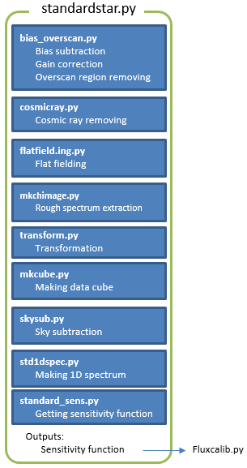

Figure . Script structure of standard.py.

### object.py

USAGE: object.py [-h] [-o] [d RAWDATADIR] <FITS file> <Dome flat ID>

<CAL flat ID> <Comparison ID> <Standard star ID>

ARGUMENT

FITS file: Object image

Dome flat ID: Frame ID of the dome flat image combined by domeflat.py or flat_combine.py.

CAL flat ID: Frame ID of the combined CAL flat image created by calflat.py or flat_combine.py.

Comparison ID: Frame ID of the comparison image.

Standard star ID: Frame ID of the standard star image.

OPTION

-d RAWDATADIR: Raw data directory

OUTPUT

XXXX.ov.fits : bias-structed and overscan-region-removed image

XXXX.cr.fits and XXXX.mask.fits : cosmic-ray-removed image and mask image

XXXX.ff.fits : flat-fielded image

XXXX.chNN.fits : each spectrum image in “chimages” directrory

XXXX.chNN.wc.fits : transformed images in “chimages” directrory

XXXX.xyl.fits : data cube

XXXX.ss.fits : sky-subtracted data cube

XXXX.fc.fits : flux-calibrated data cube

This script is for an object image and applies the following low-level scripts; bias_overscan.py, cosmicrays.py, flatfielding.py, mkchimage.py, transcorm.py, mkcube.py, and skysub.py. You have only to input a FITS file with an odd-number frame ID. The script deduces a FITS file name with an even-number frame ID. See descriptions about each script for more details.

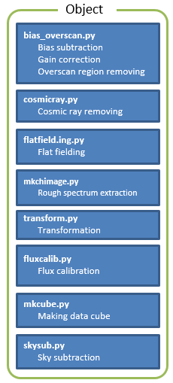

Figure . Script structure of object.py.

## Low-level script

### bias_overscan.py

Usage: bias_overscan.py [-h] [-o] [-d RAWDATADIR] <FITS file>

ARGUMENT

FITS file: Input FITS file with an odd-number frame ID

OPTION

-d RAWDATADIR: Raw data directory

OUTPUT

XXXXX.ov.fits (XXXXX is the frame ID of the input file.)

This script

* subtracts the bias,
* removes the over scan regions,
* converts the unit from ADUs to electrons,
* corrects the bad pixels, and
* merges the two images for two CCDs into one image.

You have only to input one FITS file with an odd-number frame ID. The script deduces another FITS file name with an even-number frame ID. This needs the bias template files created by mkbiastemplate.py.

### correct_ch12_edge.py

USAGE: correct_ch12_edge.py [-h] [-o] <CAL flat ID>

ARGUMENT

CAL flat ID: Frame ID of the CAL flat image combined by flat_combine.py.

OUTPUT

idXXXX.ch12edge and idXXXX.ch12edge_org in “chimages/database” directory

(XXXXX is the frame ID of the input file, and NN is the channel number.)

When VPH650 is used, the left edge of the Ch12 spectrum is in the gap between the two CCDs. This script corrects the left edge position data detected in identify_edge.py. The left edge position is estimated from the spectrum width interpolated from other channels and the detected Ch12 right edge. This renames the old id-file to “idXXXX.ch12edge_org” and creates a new id-file, “idXXXX.ch12edge.” This is not needed for the other grisms.

### cosmicrays.py

USAGE: cosmicrays.py [-h] [-o] [-sigclip SIGCLIP] [-sigfrac SIGFRAC]

[-niter NITER] <FITS file>

ARGUMENT

FITS file: Input FITS file name

OPTION

-sigclip SIGCLIP: Laplacian-to-noise limit for cosmic ray detection.

(default: 5.0)

-sigfrac SIGFRAC: Fractional detection limit for neighboring pixels.

(default: 0.4)

-niter NITER: Number of iterations of the LA Cosmic algorithm to perform.

(default: 4)

OUTPUT

XXXX.cr.fits and XXXX.mask.fits

(XXXXX is the frame ID of the input file)

This script removes cosmic rays and creates a mask image using the Python module, [Astro-SCRAPPY](https://github.com/astropy/astroscrappy), based on the L.A.Cosmic algorithm ([Pieter G. van Dokkum, 2001, PASP, 113, 1420](http://iopscience.iop.org/article/10.1086/323894)). SIGCLIP, SIGFRAC and NITER are the options for Astro-SCRAPPY. For more details about the options, see the [Astro-SCRAPPY](https://github.com/astropy/astroscrappy) web page.

### divhighlow.py

Usage: divhighlow.py [-h] [-o] <FITS file>

ARGUMENT

FITS file: Dome flat files combined using flat_combine.py.

OUTPUT

XXXX.fcmb_low.fits and XXXX.fcmb_high.fits

(XXXXX is the frame ID of the input file.)

The Ch10 slice mirror has chips at the edge. These causes dark lanes in the Ch10 spectrum. The dark lanes move by some pixels due to flexure. To correct the dark lanes as well as pixel-to-pixel efficiency variation in a flat fielding procedure, a flat image must be decomposed into two components; One is a component moving due to the flexure, and the other is a stationary component. The former will be shifted before it is used in a flat fielding process.

This script decomposes a dome flat image into the two components. This takes time. For reducing the time, multi-processing using all CPUs is used. For example, the time is about 8 minutes for one 2x1 binning data with Intel Xeon E5-1650 v3 processor having 6 cores.

### fit_gap_coordinate.py

USAGE: fit_gap_coordinate.py [-h] [-o] <FITS file>

ARGUMENT

FITS file: CAL flat file combined using flat_combine.py.

OUTPUT

XXXX.fcmb_gapcoef　 (XXXXX is the frame ID of the input file.)

For spectrum extraction, gap positions identified using identify_gap.py are fitted with 2nd order Chebyshev polynomial function. In the fitting, 3-sigma clipping is applied. This result is used in mkchimage.py and mkedgeimage.py. The identified positions and the best fit functions are shown in the left panel of Figure 9. The fitting residuals are shown in the right panel of Figure 9. Deviation within 1 pixel is acceptable. The clipped data points are shown by cross marks. Color code shows difference of the gaps (Some cross marks have different color from the assigned color for the gaps. This might be due to a bug in plotting.). After checking the results, close the window to quit this script.

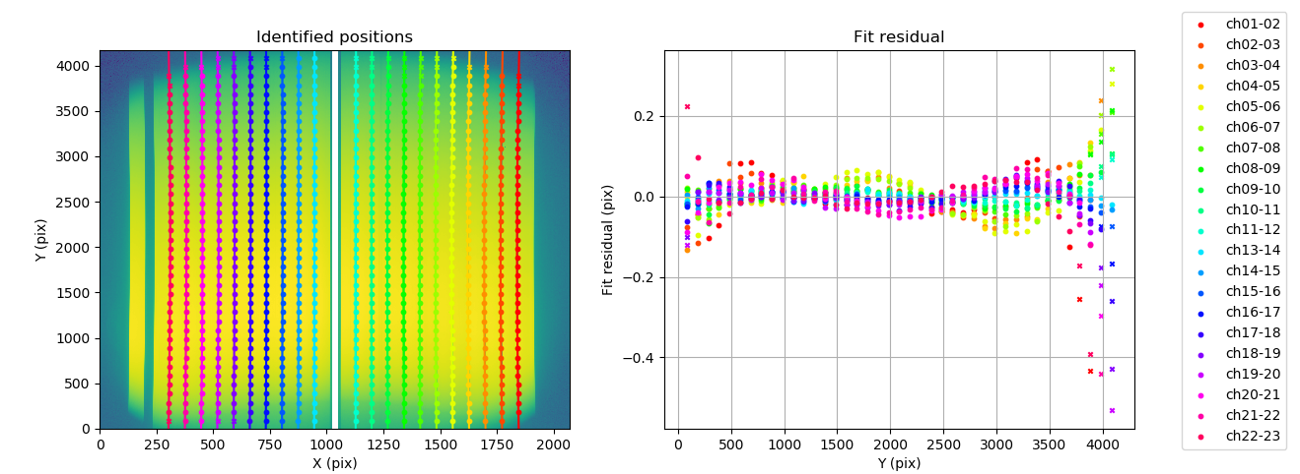

Figure 9

### fitcoord_dispersion.py

USAGE: fitcoord_dispersion.py [-h] [-o] <Frame IDs>

ARGUMENT

Frame IDs: Comma-separated frame IDs of the comparison FITS files.

OUTPUT

fcXXXX.chNN in “chimages/database” directory

(XXXXX is the frame ID of the input file, and NN is the channel number.)

This script creates wavelength coordinate transform functions using the IRAF FITCOORDS task. In the default plot, horizontal axis is Y (dispersion direction). Change it to X (spatial direction) pressing ‘x’, ‘x’, and then ‘r’ in the graphical window. Some data points near the edges might largely deviate (Figure 10). Because those are out of the pseudo slit, eliminate them pressing ‘d’ near one of them and then ‘p’ or ‘x’. To fit again, press ‘f’ key (Figure 11). Go back to the default plow pressing ‘x’, ‘y’, and then ‘r’. If some data points still significantly deviate, they should be also eliminated. To quit, press ‘q’ key. See the IRAF manual for more details.

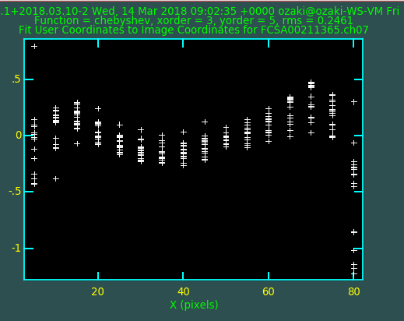

Figure 10

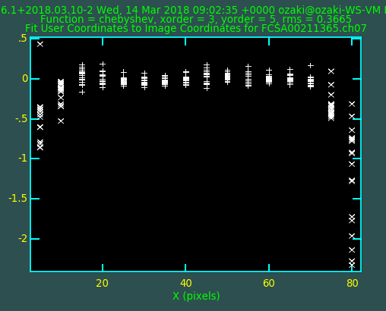

Figure 11

### fitcoord_edge.py

USAGE: fitcoord_edge.py [-h] [-o] <FITS file>

ARGUMENT

FITS file: CAL flat files combined using flat_combine.py.

OUTPUT

fcXXXX.chNNedge in “chimages/database” directory

(XXXXX is the frame ID of the input file, and NN is the channel number.)

This script derives spatial coordinate transform functions using the IRAF FITCOORDS task. In the default plot, horizontal axis is X (spatial direction) (Figure 12). Change it to Y (dispersion direction) pressing ‘x’, ‘y’, and then ‘r’ in the graphical window. Some data points near the Y edges might largely deviate (Figure 13). In that case, eliminate the outermost points even if they do not seem to deviate. pressing ‘d’ near one of them and then ‘y’. To fit again, press ‘f’ key. If there are still largely deviating points, repeat the above elimination procedure (Figure 14). To quit, press ‘q’ key. See the IRAF manual for more details.

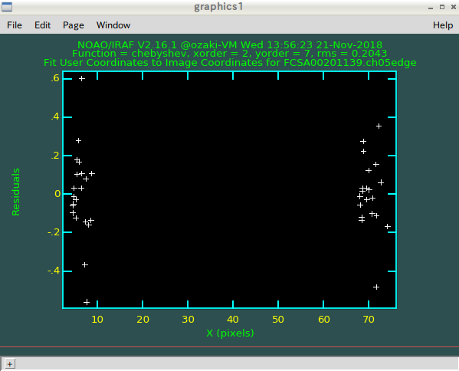

Figure 12

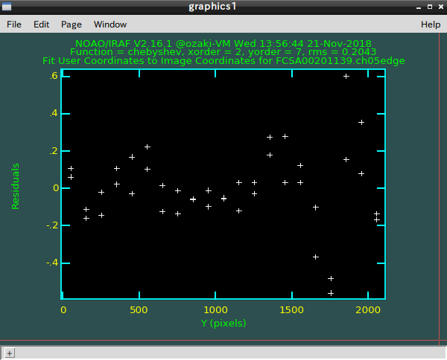

Figure 13

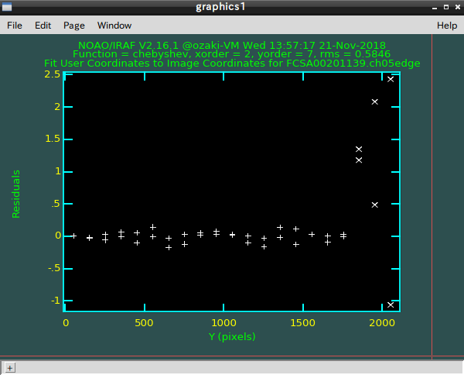

Figure 14

### flat_combine.py

Usage: flat_combine.py [-h] [-o] <FITS files>

ARGUMENT

FITS files: Comma-separated flat FITS files created by bias_overscan.py.

OUTPUT

XXXX.fcmb.fits (XXXX is the frame ID of the first input file.)

This script simply combines either dome or CAL flat images using the IRAS task IMCOMBINE with the combine type of ’median’. See the IRAF manual for the more details.

### flatfielding.py

USAGE: flatfielding.py [-h] [-o] <FITS file> <Dome flat ID> <CAL flat ID>

<Comparison ID for dome flat> <Comparison ID for object>

ARGUMENT

FITS file: Input FITS file name

Dome flat ID: Frame ID of the dome flat image combined by flat_combine.py.

CAL flat ID: Frame ID of the CAL flat image combined by flat_combine.py.

Comparison ID for dome flat: Frame ID of the comparison image for dome flat processed by bias_overscan.py.

Comparison ID for object flat: Frame ID of the comparison image for object processed by bias_overscan.py.

OUTPUT

XXXX.ff.fits (XXXXX is the frame ID of the input file.)

This script performs flat fielding to the input image. An image shift along the X direction is automatically derived from the cross-correlation between the dome flat and the CAL flat (The CAL flat was always taken in the telescope position same as the object). A Y-direction shift is also automatically calculated from the comparison images for the object and the dome flat. The X and Y shifts are shown in plot windows (Figure 15 and Figure 16). After checking, close them.

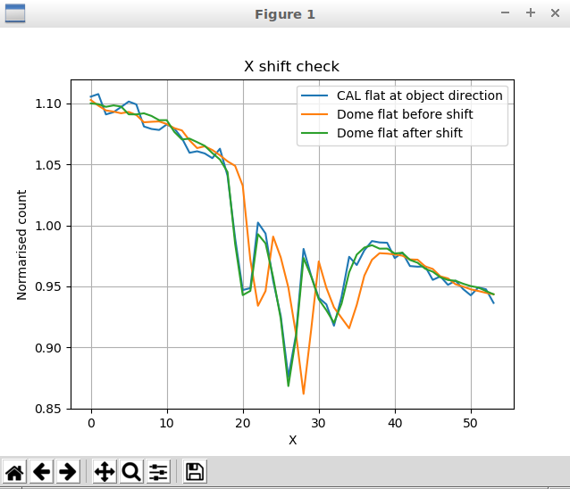

Figure Plot for X shift check.

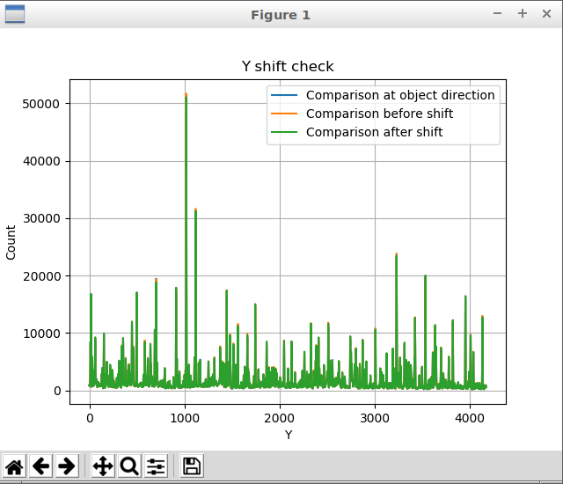 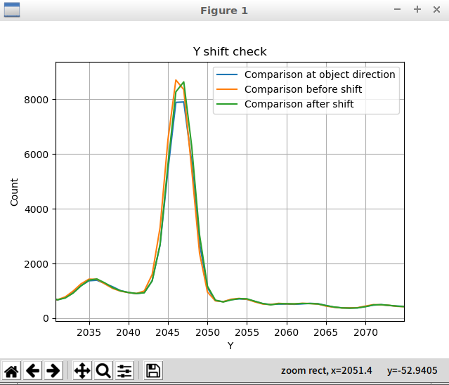

Figure Plot for Y shift check. Right panel shows a magnified view.

### fluxcalib.py

USAGE: fluxcalib.py [-h] [-o] <Input FITS file> <Sensitivity file>

ARGUMENT

Input FITS file: Input FITS file name to be calibrated.

Sensitivity file: Sensitivity function image created by standard_sens.py.

OUTPUT

XXXX.fc.fits (XXXXX is the frame ID)

This script applies flux calibration to the data cube using the sensitivity function derived by standard_sens.py.

### identify_dispersion.py

USAGE: identify_dispersion.py [-h] [-o] <Frame IDs>

ARGUMENT

Frame IDs: Comma-separated frame IDs of the comparison FITS files.

OUTPUT

idXXXX.chNN in “chimages/database” directory

(XXXXX is the frame ID of the input file, and NN is the channel number.)

This script identifies emission line locations using the IRAF IDENTIFY and REIDENTIFY tasks. An object frame with sky emission lines can be used. **When the number of frames except an object frame is 2, then the frame for bright lines is followed by the one for faint lines in the argument.** **An object frame must be at last in the argument.** Emission lines are automatically identified. If some lines are not correctly identified, manually identify them with comparing the reference figure shown in the separated window.

### identify_edge.py

USAGE: identify_edge.py [-h] [-o] <FITS file>

ARGUMENT

FITS file: CAL flat files combined using flat_combine.py.

OUTPUT

idXXXX.chNNedge in “chimages/database” directory.

(XXXXX is the frame ID of the input file, and NN is the channel number.)

This script identifies spectrum-edge locations using the IRAF IDENTIFY and REIDENTIFY tasks for each channel. In the graphical window, press m-key at the two edge-peak locations. In the plot, there are some peaks. You should select the inner peak pair like Figure 17. After identifying two peaks, quite the IDENTIFY task with q-key. The REIDENTIFY task starts right after that. If the data is for VPH650, then the left-edge-position data of the Ch12 spectrum is automatically corrected (see correct_ch12_edge.py).

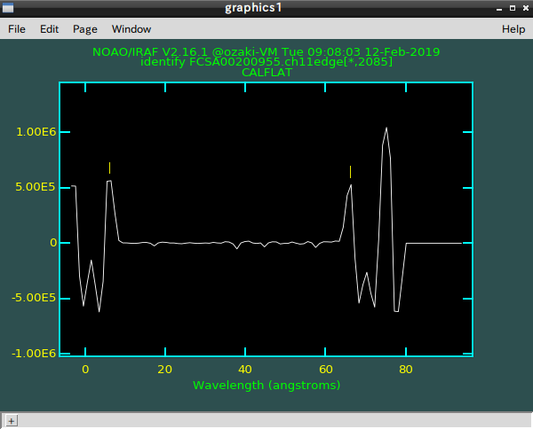

Figure 17

### identify_gap.py

USAGE: identify_gap.py [-h] [-o] <FITS file>

ARGUMENT

FITS file: CAL flat file combined using flat_combine.py.

OUTPUT

id-files in “database” directory

This script identifies spectrum gap locations using the IRAF tasks, IDENTIFY and REIDENTIFY. Figure 18 shows the PyRAF graphic window for identifying gaps. In the window, press l-key to find the gap locations. The IRAF colon command “:label both” shows the gap names in the window. The number of gaps to be found is 21. If some gaps are not found, manually identify the positions using m-key. See the IRAF manual for the details. The gap positions of Ch12-13 and Ch23-24 are not used in the following procedure, so this script does not find these two gaps. After finding all gaps, quit the IRAF IDENTIFY task by pressing q-key. The IRAF REIDENTIFY task automatically starts.

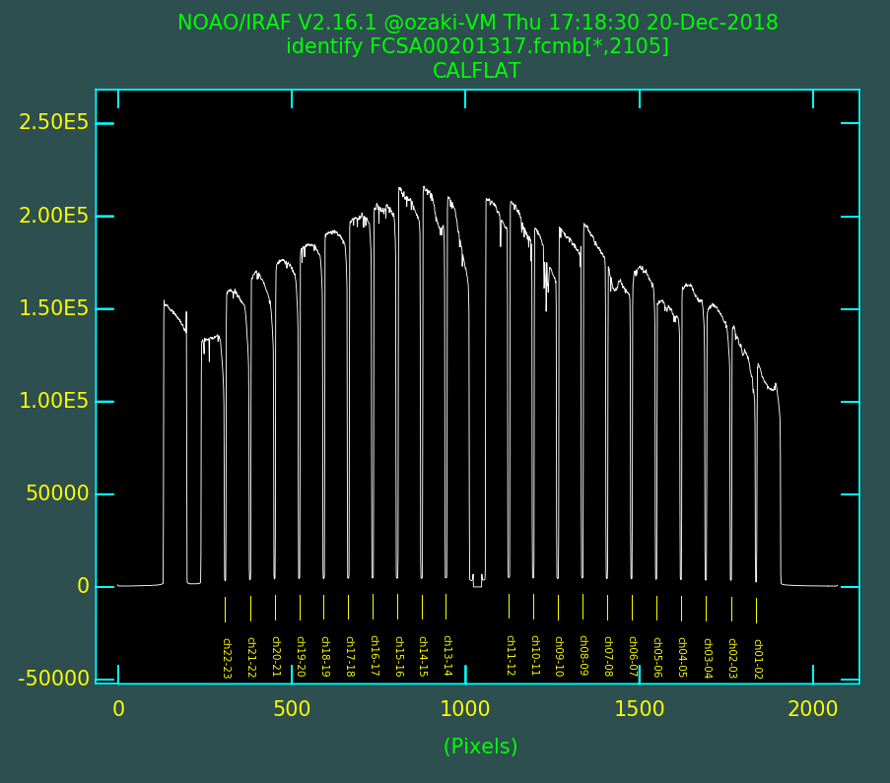

Figure 18

### mkbiastemplate.py

USAGE: mkbiastemplate.py [-h] [-o] [-d RAWDATADIR] <FITS file>

ARGUMENT

FITS file: Input bias file name with an odd-number frame ID

OPTION

-d RAWDATADIR: Raw data directory

OUTPUT

bias_template1.fits and bias_template2.fits

This script creates 1-D bias template integrating the bias image along Y direction. In the integration, 4-sigma clipping is applied. You have only to input one FITS file with an odd-number frame ID. The script deduces another FITS file name with an even-number frame ID. This script must be run before bias subtraction.

### mkchimage.py

USAGE: mkchimage.py [-h] [-o] <FITS file> <CAL flat ID>

ARGUMENT

FITS file: FITS file created by bias_overscan.py

CAL flat ID: Frame ID of the relevant CAL flat image

OUTPUT

XXXX.chNN.fits in “chimages” directrory

(XXXX is the frame ID of the input FITS file, and NN is the channel number.)

This script extracts each channel spectrum, and stores them in separated FITS files in “chimages” directory.

### mkcube.py

USAGE: mkcube.py [-h] [-o] <Frame ID>

ARGUMENT

Frame ID: Frame ID of the object frame.

OUTPUT

XXXX.xyl.fits (XXXXX is the frame ID)

This script creates a data cube from 24 extracted images, and added the WCS headers.

### mkedgeimage.py

USAGE: mkedgeimage.py [-h] [-o] <FITS fits>

ARGUMENT

FITS file: CAL flat files combined using flat_combine.py.

OUTPUT

XXXX.chNNedge.fits in “chimages” directrory.

(XXXXX is the frame ID of the input file, and NN is the channel number.)

This script extracts each channel spectrum and creates edge-strengthen images.

### skysub.py

USAGE: skysub.py [-h] [-o] [-x1 X1] [-x2 X2] [-scale SCALE] <FITS file>

ARGUMENT

FITS file: Input FITS file name of the data cube created by mkcube.py.

OPTIONS

-x1 X1: Start pixel for integrating the sky spectrum. (default: 53)

-x2 X2: End pixel for integrating the sky spectrum. (default: 63)

-scale SCALE: Scale factor applied for the sky spectrum. (default: 1.0)

OUTPUT

XXXX.ss.fits (XXXXX is the frame ID)

This script subtracts the sky spectrum from the data cube. The sky spectrum is created by integrating the Ch24 (sky) spectrum from X1 to X2. The sky slit has graded width. The width is narrower for larger X1 and X2. The sky spectrum is scaled before the subtraction. The scale factor can be changed by specifying the SCALE option. Tuning these parameters, the subtraction residual can be minimized.

### standard_sens.py

USAGE: standard_sens.py [-h] [-o] <FITS file>

ARGUMENT

FITS file: FITS file name of the 1D standard star spectrum made by std1dspec.py.

OUTPUT

XXXX.std and XXXX.sens.fits (XXXXX is the frame ID)

This script derives the sensitivity function using the IRAF STANDARD and SENSFUNC tasks. STANDARD selects the bands used for deriving a sensitivity function (Figure 19). ‘d’ key is for deleting the band. SENSFUNC derives the sensitivity function (Figure 20). Also, ‘d’ key is for deleting the points from the fitting. See the IRAF manual for more details.

Around 9000 – 9500 Å, there is a bump in the sensitivity function. This originates from the absorption feature in the dome flat. To fit this feature, high order function is required in the fitting. In the case of Figure 20, the 50-order spline3 function is used. For such high order fitting, [CALSPEC](http://www.stsci.edu/hst/observatory/crds/calspec.html) is recommended because of the dense spectral sampling. Some data converted to IRAF database format can be found in [the FOCAS web page](https://www.naoj.org/Observing/Instruments/FOCAS/Detail/UsersGuide/Observing/StandardStar/Spec/SpecStandard.html). Please contact to the Subaru telescope for more detail.

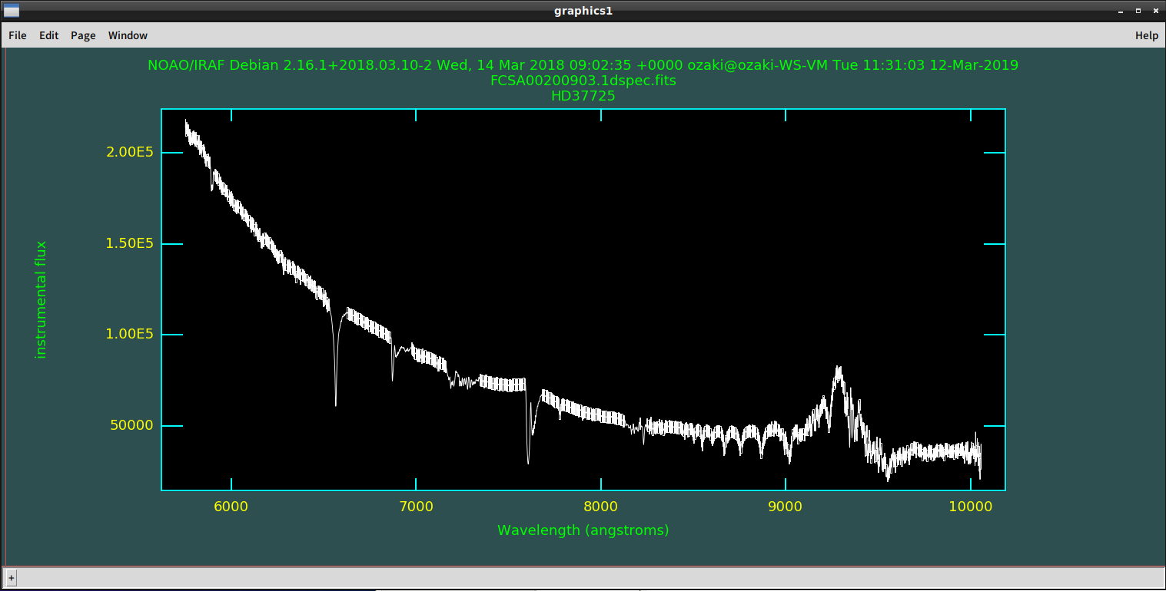

Figure Plot window of the IRAF STANDARD task.

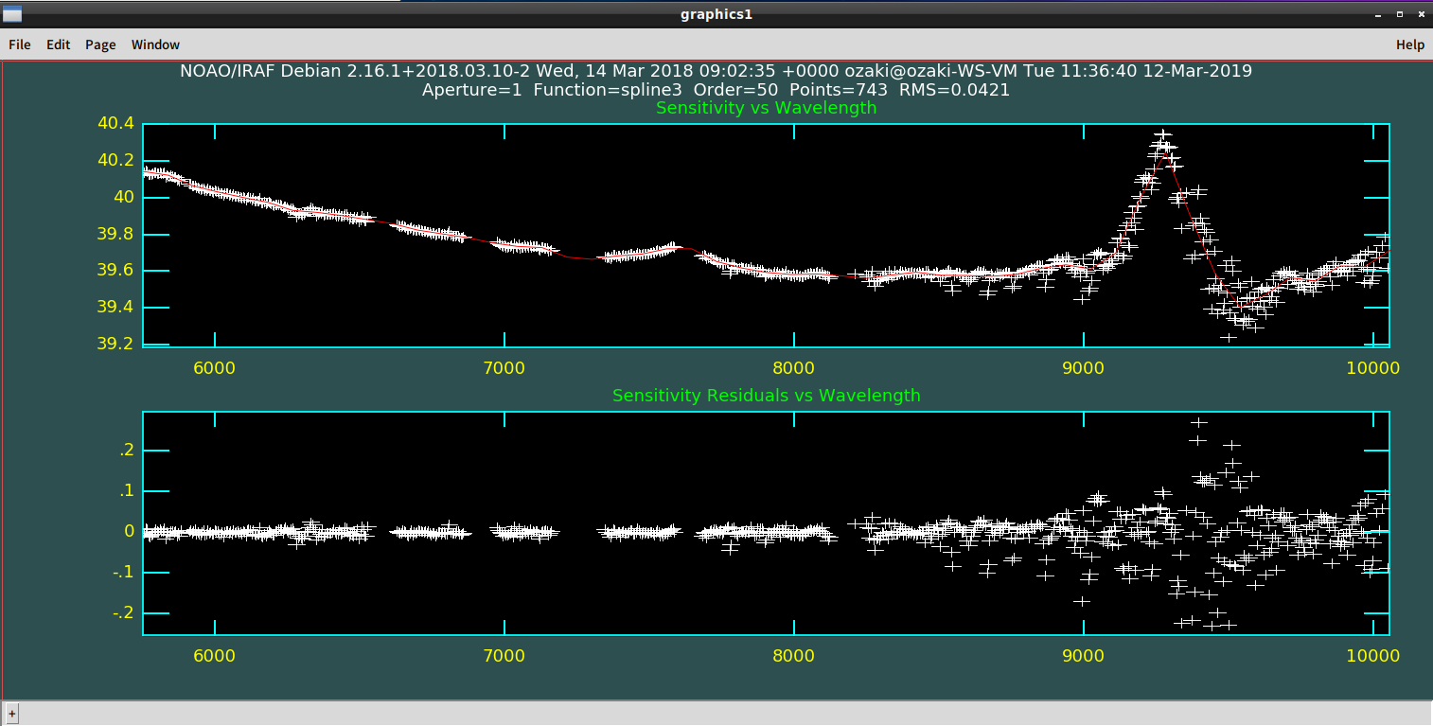

Figure Plot window of the IRAF SENSFUNC task.

### std1dspec.py

USAGE: std1dspec.py [-h] [-o] [-startz STARTZ] [-nsigma NSIGMA] <FITS file>

ARGUMENT

FITS file: FITS file name of the data cube of the standard star.

OPTIONS

-startz STARTZ: Start Z pixel for aperture photometry. (default: 2000)

-nsigma NSIGMA: Number of sigma for the aperture size. (default: 5)

OUTPUT

XXXX.1dspec.fits (XXXXX is the frame ID)

This script makes a 1D spectrum of the standard star. The procedure is as follows.

1. After an image at Z = STARTZ is shown (Figure 21 left), click around the star center.
2. Standard deviations along X and Y directions are obtained applying 2D Gaussian fitting.
3. A photometric aperture radius is set to NSIGMA times larger than the standard deviations. And the aperture center is set at the 2D Gaussian center.

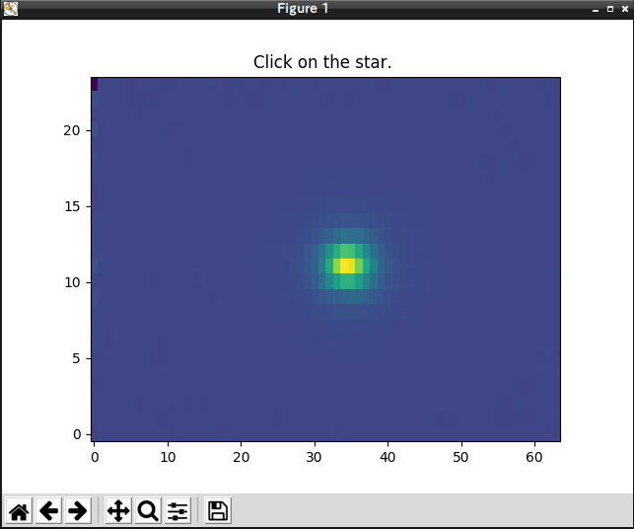 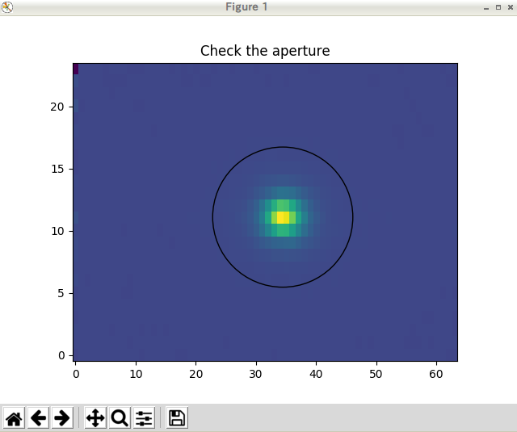

Figure 21

1. The aperture is overlaid on the image (Figure 21 right). Check the aperture, and close the graphic window.
2. The aperture center is recalculated at every wavelength pixel, and count values are integrated within the aperture.
3. The 1D standard star spectrum is shown (Figure 22 left).
4. Specify the required wavelength range by pushing any key except ‘q’ at both ends of the range (Figure 22 right). Including rapidly changing region causes difficulty in deriving sensitivity function.
5. Close the plot window.

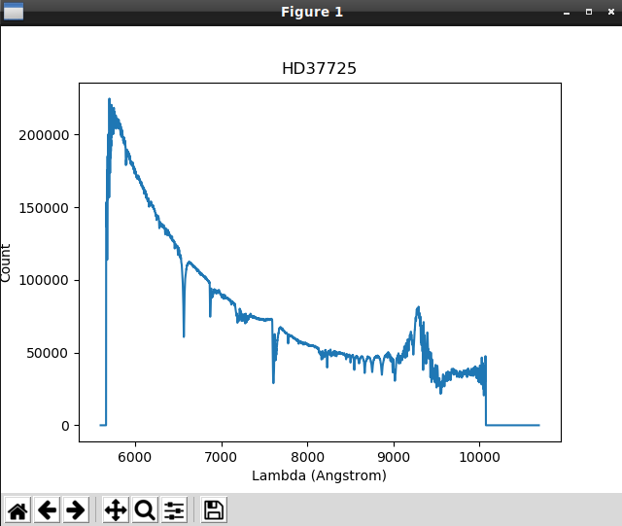 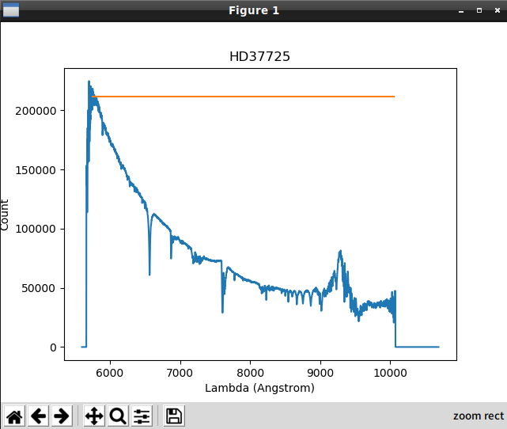

Figure 22

### transform.py

USAGE: transform.py [-h] [-o] <Frame ID> <Comparison ID> <CAL flat ID>

ARGUMENT

Frame ID: Frame ID of the object frame.

Comparison ID: Frame ID of the comparison frame.

CAL flat ID: Frame ID of the CAL flat image combined by flat_combine.py.

OUTPUT

XXXX.chNN.wc.fits

(XXXXX is the object frame ID, and NN is the channel number.)

This script transforms each channel spectrum to user coordinate using the wavelength and spatial coordinate transform functions derived from fitcoord_dispersion.py and fitcoord_edge.py, respectively. This uses the IRAF TRANSFORM task internally. Blank pixels are padded with NaN.

# Citing

A paper on FOCAS IFU is now preparing. If you want to cite before the publication, please cite the following SPIE proceeding.

[Ozaki, S., et al. 2014, Proc. SPIE, 9151, 915149](https://www.spiedigitallibrary.org/conference-proceedings-of-spie/9151/1/Development-of-a-slicer-integral-field-unit-for-the-existing/10.1117/12.2054838.full?SSO=1)

# Contact

If you have any questions, please don't hesitate to ask.

https://www2.nao.ac.jp/~shinobuozaki/focasifu/madd.PNG

# Changelog

## 20200210 => 20200213

* In transform.py, blank pixels are padded with NaN. In the previous version, they are padded with 0.
* After flux calibration, unit has been changed from ergs/s/cm2/A to 1E-20 ergs/s/cm2/A. Because of this change, Auto Plot 3D function of SAO image ds9 works well.

## 20190621 => 20200210

* “os.path.join” has been used to add a path to a file name.
* In fitcoord_dispersion.py, xorder and yorder have been changed from 7,7 to 5,3.
* In terms of WCS, only the CD matrix has been used. In the previous version, both the CD matrix and the CDELT keywords were included in the FITS header.
* Some minor bugs have been fixed.
* In Section 4.2.6, the explanation has been slightly changed, and Figure 10 and Figure 11 have been changed.
* In this manual, figure numbers have been corrected.