**Plan Outline for** *INPLD*

(an Intelligent Networked Personal Listening Device)

**1) Object/Interface:**

- attach comfortably to the head leaving hands and arms free.

- It covers one ear, the second ear is free (to be tested)

- contains a mobile Bluetooth battery-powered speaker (e.g. Dwarf, Dos Asimom etc)

- GSR Sensors connected to 2 fingers on each hand

- It contains a Mini-Computer (BBB), a speaker with some kind of audio amplifier

*Interface Idea is: A flexible singular/collective interface:*

*a) The two-electrodes-for-two-fingers version is the "single player interface".*

*b) If more people ‘hook-up’ i.e., attach electrodes to fingers, and then you have a "multi-player interface". Every node must be in series then: - elecrtrode connects to + electrode...*

*Physics / Electronics: The control values will change according how much pressure is put onto the contact (and also how moist your skin is in that moment). Because of the biology finger tips, palms and feet are best points for measurement / contact*

This “Touch”interface is extended by a microphone to pick up breath, human speech, etc, to be able to input a “human sound character”…

Currently it would be like this:

1 x USB for Soundcard (mic in  / stereo out)

1 x USB for Wireless LAN Adapter

**Lucky Dragon:** *Interface Example and Sound inspiration (perhaps):*

[**http://youtu.be/xFwi1zF5RoQ?t=1m18s**](http://youtu.be/xFwi1zF5RoQ?t=1m18s)**2) Signal Flow Chart**

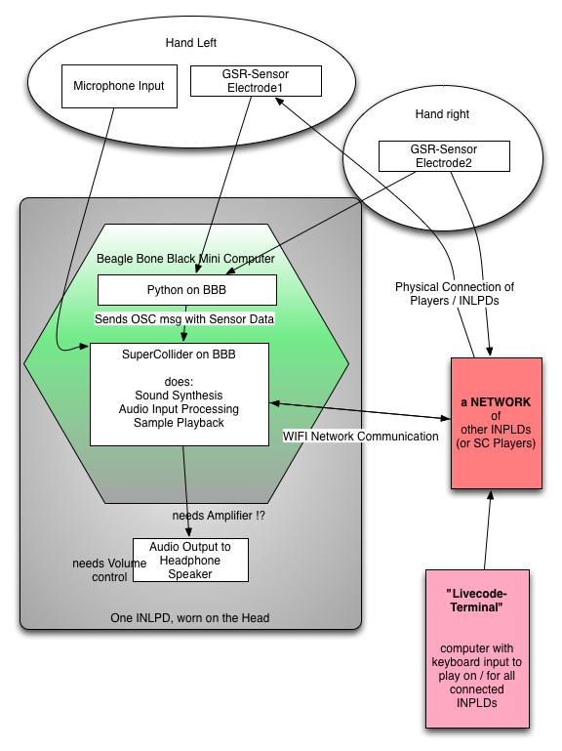

**3) Sound Design**

For the prototype using SC to design sounds.

A mix of textural sounds & noises and simpler tuneable sounds

**4) Performance Strategies / Role Assignment**

One person could have the role of live coding or sound generation, selection of sounds.

People with gsr sensors could be the manipulators of the sounds, so that through a touch interface parameters of sounds are varied and manipulated. These same players can also use a piezo mic for voice etc.

Everyone is listening

The Beagle Board is the central device where sounds are stored and data from sensors is received.

Sould be able to turn the mic on and off.

**5) Tech Specs / Protocols**

- Network Communication goes via WLAN

- Sending OSC msgs for sound control data / SC code

- Building on SuperCollider Republic Structure, ideally working from Version 2.0: [Utopia](https://github.com/muellmusik/Utopia)

*One INLPD:  (we need one per player) consists of*

*- a mini computer (the Beagle Bone Black), battery driven to be able to*

*to read sensors, taking data from the physical environment*

*a GSR electrode set.*

*to participate in a network with other such devices*

***cost:***

*about 50 EUR for the board*

*a USB WIFI stick (4-12 EUR)*

*a small portable Battery (4-30 EUR)*

*a USB audio soundcard (2 EUR)*

*a tiny USB Hub (there is only one port) (2-5 EUR)*

*overall cost of extensions: between 12 - 49 EUR*

*Bluetooth battery operated speakers*

*construction to house it all in*

*listening device construction*

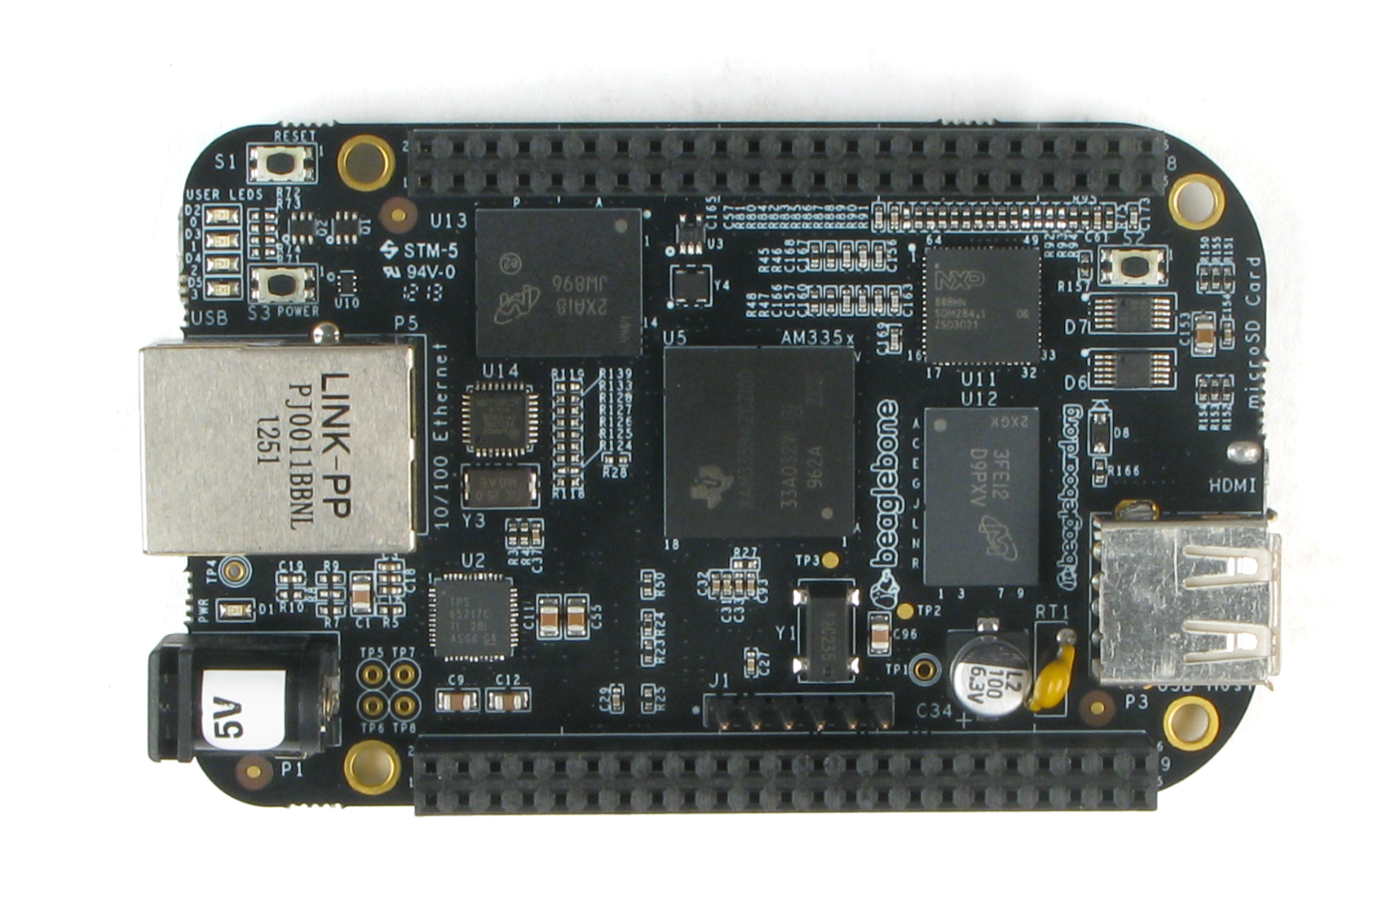

*One Beagle Bone Black Board, nothing attached****HELP WANTED FOR:***

*A) Designing and making boxes for housing the Beagle Bord*

*B) Designing and making listening device – hemispherical shape that can be comfortable attached to the head*

*C) Programming, especially for networking + signal communication, OSC etc*

**LINKS Collection (incomplete)**

**BeagleBone UdK Project:**

<https://github.com/redFrik/udk11-Portable_sonification_projects>

**GSR sensor DIY**

<http://makezine.com/projects/the-truth-meter-2/>

h[ttp://theanthillsocial.co.uk/projects/biosensing](http://theanthillsocial.co.uk/projects/biosensing)

<http://ftmedia.eu/diy-gsr-sensor/>

<http://www.instructables.com/id/Stress-Makes-Art-Galvanic-Skin-Response-and-Visual/>

<http://www.extremenxt.com/blog/?page_id=168>

<http://www.media.mit.edu/galvactivator/faq.html>

<http://www.ledalab.de/>

Conor Barrys Beatback Instrument: <http://conorbarry.me/BeatBack>

<http://www.synthtopia.com/content/tag/galvanic-skin-response/>

His MakeLabProject: <http://electroniclunch.wordpress.com/>

DIY Pulse Sensor: <http://pulsesensor.myshopify.com/>