## Debt Simulator

https://debt-simulator.web.hsctf.com/

Author: Madeleine

After going to this link this page opened :

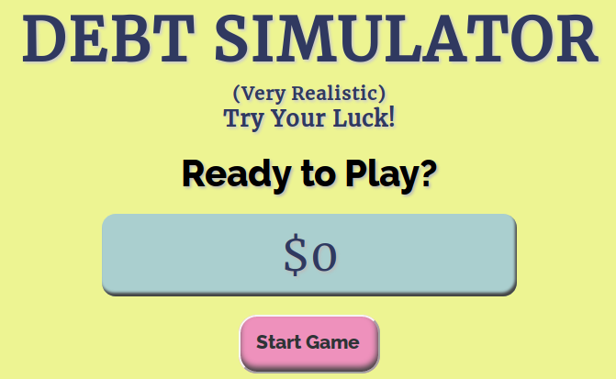

I tried its page source and all sort of stuff but couldn’t get something productive. So I turned to burp suite for further analysis.

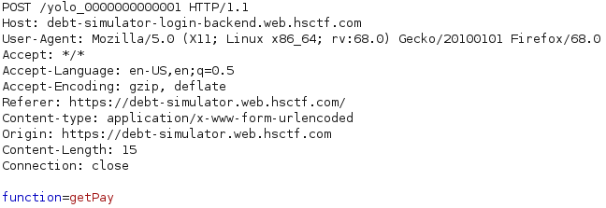

I saw two things .

1. A function named getPay.

2.In the request method there was something yolo_00….1.

I send this request to repeater for further analysis. It showed this :

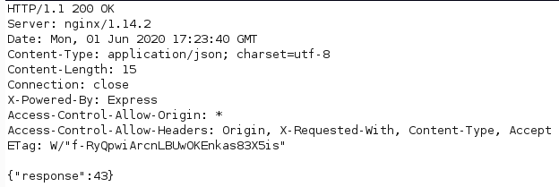

It gave a response code and I send this request to browser and got the following result :

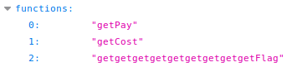

It was clear that flag was in the 2 json response. So I typed this getger...Flag in the above function variable and got the flag :

flag{y0u_f0uND_m3333333_123123123555554322221}.