META MOUNTAINS

It seems that mountains are a great place for hiding secrets. Maybe you could find this one!

Author: wooshi

After downloading png file from the given link in ques I typed strings command to look for some text and I got this.

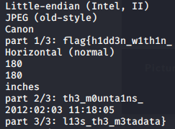

After combining the three parts the flag was clear : flag{h1dd3n_w1th1n_th3_m0unta1ns_l13s_th3_m3tadata}