VERY SAFE LOGIN

Bet you can't log in.

<https://very-safe-login.web.hsctf.com/very-safe-login>

After going on this site it was a basic login page :

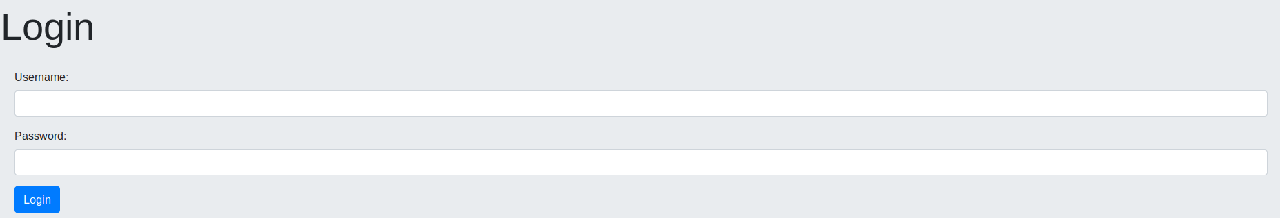

I gave the credentials admin, admin and started burpsuite, intercepted the request and send the request to repeater. Without making any changes I sent the request and received credentials :

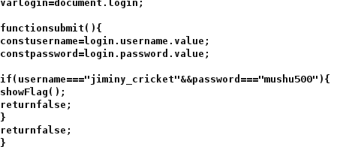

and eventually got the flag : flag{cl13nt_51de_5uck5_135313531}