MIX

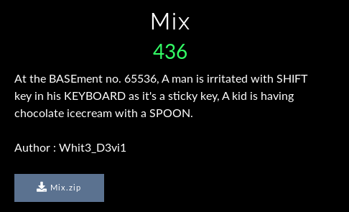

After unzipping the file there were two more additional files.

1. flag.txt 2. chall_encrypted.text

After opening file flag.txt it showed :



After opening file chall_encrypted.txt it was text which was not readable. But after reading the challenge it was pretty clear that this text was base65536. I quickly searched for base65536 decoder online and decoded the text.

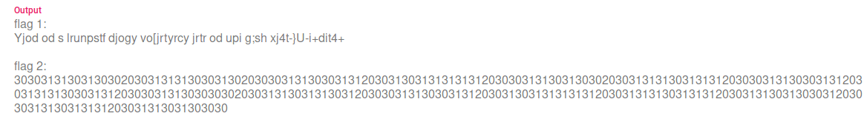

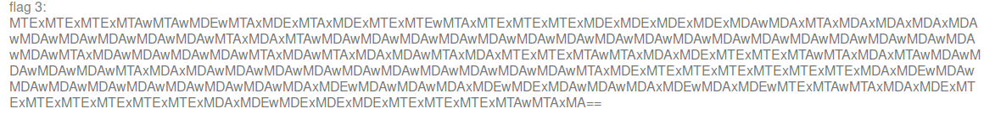

I tried to solve the flag1 first as it was a Keyboard Sift cipher as told in the challenge description . I used decode.fr to solve this and got flag1 as :

flag1 : This is a keyboard shift ciphertext here is you flag zh3r0{Y0u_sur3_

After that I tried to decode flag2. After looking at flag2 I thought of decoding it with hex. After decoding I got another binary string which after decoding gave the second flag .

flag2: 4r3_4w3s0m3_wi7h

We were left with the last flag and from above photo we can see that it is base64 string. But in the question ‘SPOON’ is highlighted so I searched for SPOON cipher and got one. After decoding the SPOON cipher flag3 was clear.

flag3: _411_7h3_ski115}

So the final flag becomes : zh3r0{Y0u_sur3_4r3_4w3s0m3_wi7h_411_7h3_ski115}}