UNCIPHER ME

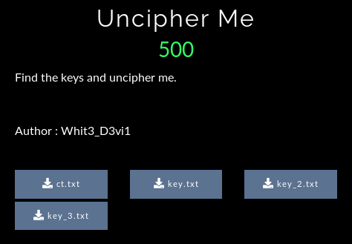

After downloading all the files these were their content.

1. ct.txt gave this text – b'gAAAAABe5zDHy1Vk74P8AspzQ4bqK9dzfI52djZeMbsXRk8G5ng1BtYmDj7v6SCbx7cvnUFu2fDh6XTVtQPQqlJcVVCxGoA0P4L_gtSIGHQPLZysxuoN1E7kP_5lZFbZLo6b6G-YqFxs'

If you regularly play ctf you will guess it right that it is token for Fernet cipher.

2. key.txt gave -



It was pretty clear that this was base64 but after decoding it the output was something different.



e: GY2TKMZX

ct: GB7kTHaRdkH#IRfHZ?RjH8(afGc-0eG&eLbI5IRiHaIplG&VOmGcz+eFf=(ZF)=hYH8D9dH83?ZH#9gnI59LaIW{seGc-9iGBP(YGB7YWIWaafIWspgHa0jnG%z_gIXE~mH90gjIW#yoIXE;iGdDRkI5jspH#jvjIWaRcGc_<ZGdVahH8?jmGB!0bH!?FfG&eUmF*!CdH#9UjHZ?FeFflhaFfceWGcz<bI5RggH!?OfHZwIgI5aXaH83_eG&4ClH#RXfH#IdiFgP?YH#askGBGzaFgQ3fI5{~oF*P<bF*PtTHZe9gI5apkIW#pnHZU|ZIXO5mHaImhHZd_XGBPtUFflYVIW#yqF*i9eH83+XH#apfGc`6gFg7qbHa9piHZ?LgGdVdjGBh+dHZe3gH90dkF*r6iIWaLgIW{&mIWaRbI5s&rI5RdkIWaLgHaIdcGBP(YG&nRjH#IgiGBP$dGc`FjG&nRfGB`3YI5;;lHZnFfG%++VF)}bSH#9UjFgZ9fGB+|XG&DIhGcq+fHa9RhFgP$XIXN;gGBP(bF)%VVFf}wdFf%bVH#9RgH#9aiHaIjeI5jykGc-3jG%+?XH!?IhG%_?YF*!6cF)}eWI59XhIXE#iI5jgfF*!3hH!v_WGB7zZI503WF)=nYHZ(FbHZd|VIW;gfFf}tcFgGwVF*P(bHa9pmGdM6cI5IgfGBh<ZGdVIfF*P(cH#s&mGB+|aF*h|bHZU+ZF*!6eGdVLkIX5{tGdMXnHZ(LhH#IOdI503XFf=hUG5

I wasted 15-20 min on this thing but found nothing. So I moved further to next keys.

So I then moved to key_2.txt and got this text-

Are your rots strong.

<6Ji :"+:;v5@)_96AGaH?u+~&D%(&\GeIJv(JB$2?0Afdrtl

w6C6VD 2?@E96C <6J 7@C E96 6?4CJAE:@?]

:7 J@F 2C6 2 8@@5 4CJAE@8C2A96C J@F 42? :56?E:7J E96 4@>>@? DJ>>6EC:4 6?4CJAE:@?]

It was pretty clear that this was ROT cipher. So I decoded it and got the result

key:iQZijGdoX0hepv2wnFZOUsTWU-v6xyGWyqSan_p75CE=Here'sanotherkeyfortheencryption.ifyouareagoodcryptographeryoucanidentifythecommonsymmetricencryption.

I thought what is the use of key but then I remembered that Fernet cipher requires a key to decode. So I gave this key in the Fernet decoder and got the flag : zh3r0{Symm3tric_3ncrypti0n_i5_5tr0ng}

So I submitted this and got correct answer . But I opened the key_3.txt just to see what was in their.

jlc: OsPCTS98D3eci4cXumo345lOQiRUS4E17UJQXAOG1uM=

Soi cora ovm zuh pct jee un kitfxwxv hgl gzdglv,

zt xvy tctshe'h hkiehhmc kvdu wvs soi jhzyxzbf weih nm xys bptysqaioh,

hm xys clgimoamfbr dmkv soi bsxz hfsru'x ncqr xysm avp fdhviomnmeu soi bsxz.

I didn’t understood this but was happy that I got the flag.