

Operating System (PCC-CS502/ PCC-CS592)

Assignment-I

Name: ………………………………………………………………………………… Monojit Goswami
Roll: ……………………………………………………………………………………………… 16900124112
Semester: ……………………………………………………………………………………………………..…… 5th
Year: ……………………………………………………………………………………………………..…………. 2026

Academy of Technology
G. T. Road (Adisaptagram), Aedconagar
Hooghly-712121 West Bengal, India

Project 1: Snake Game Using Shell Script
Problem statement: Design and implement a Snake Game using a shell script. The game provides an interactive terminal-based interface in which the snake moves in different directions, grows after eating food, and ends when it collides with itself or a boundary. The script handles input, game logic, score tracking, and terminal display updates.
Objective
To implement a playable terminal arcade game using Bash, with keyboard controls, a visible game arena, score tracking, difficulty settings, color themes, and game-state screens.
Features and controls
• Keyboard movement using arrow keys, WASD, and Vim-style HJKL controls.
• Score and high-score tracking, with a persistent high-score file in the user home directory.
• Multiple difficulty levels and color themes, plus selectable wall behavior.
• Pause, instructions, restart, main-menu, and game-over screens.
How to execute
chmod +x snake.sh
./snake.sh
Program output
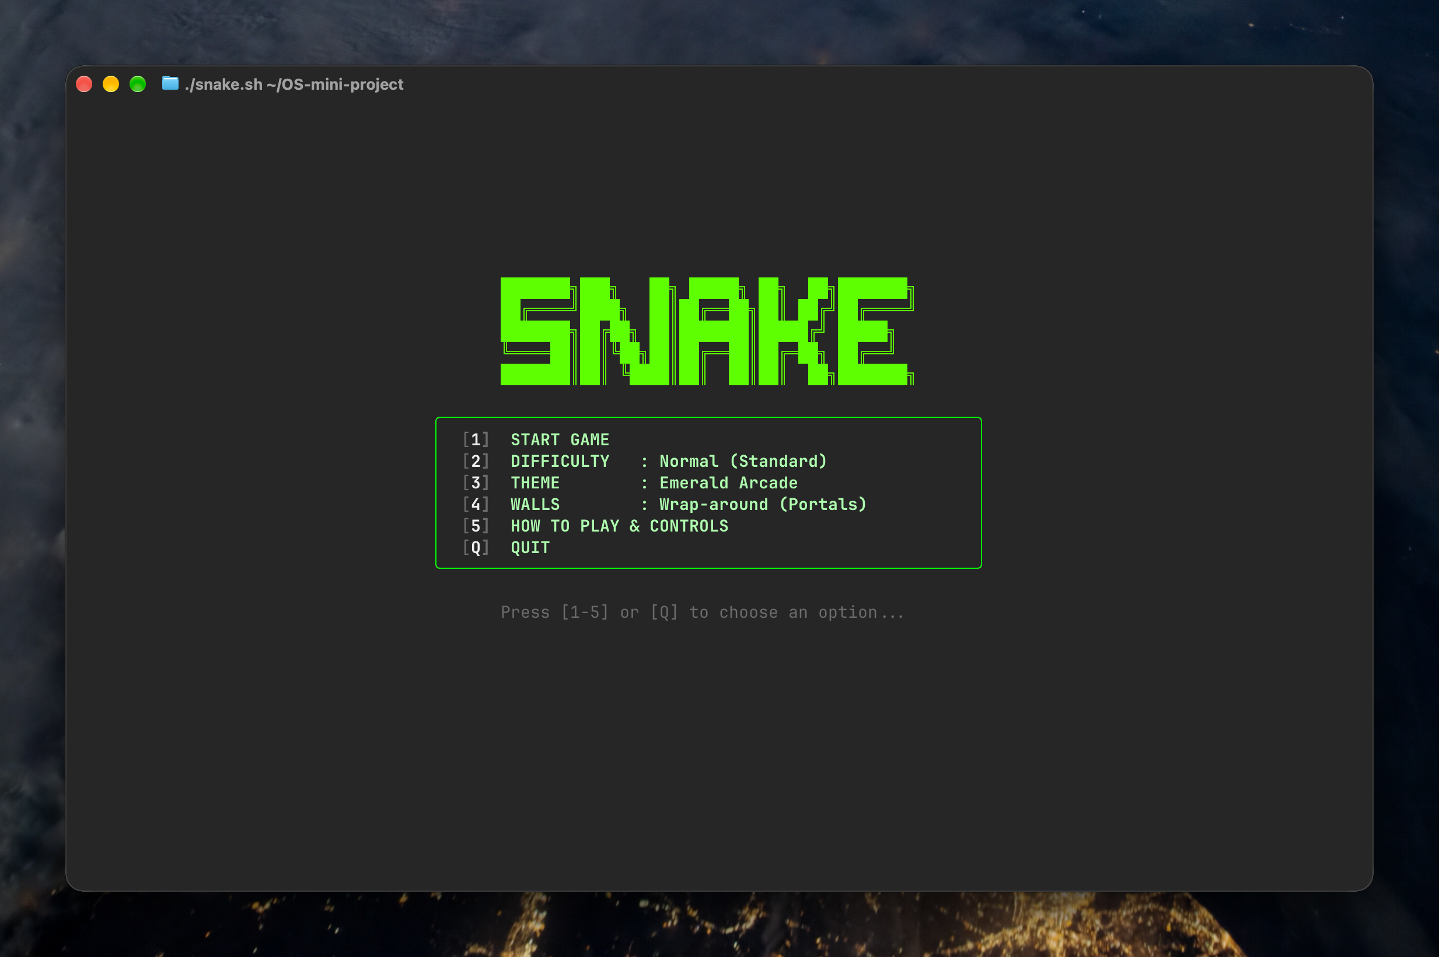
The following screenshots were captured from the program running in an interactive terminal instance.
Figure 1. Terminal output of Project 1, Snake Game main menu.

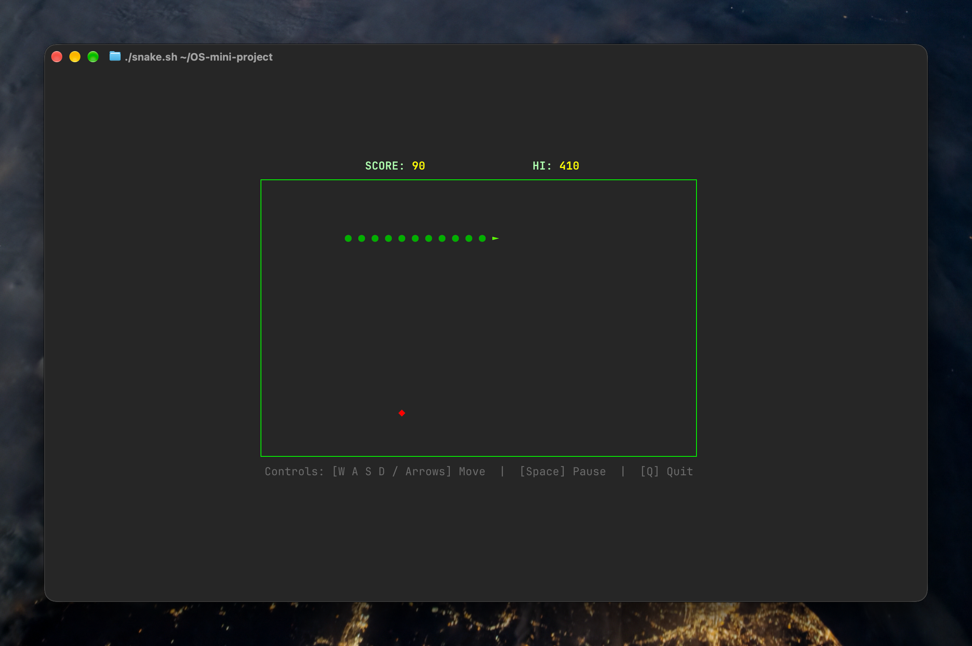
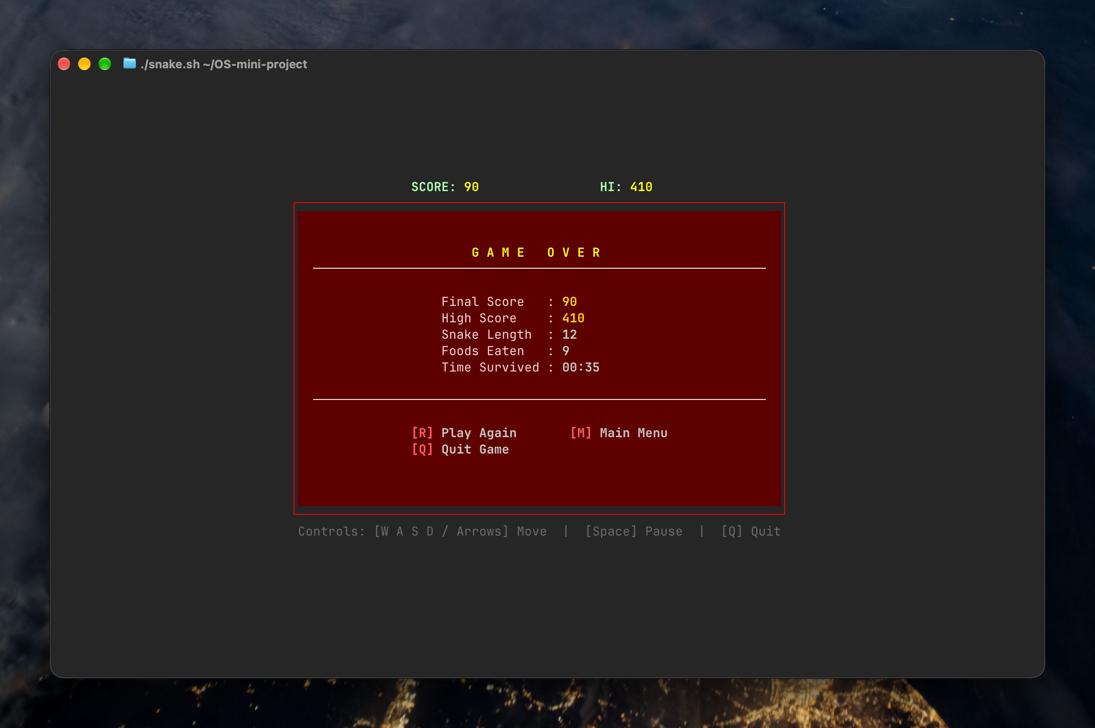
Figure 2. Terminal output of Project 1, Snake Game Live Gameplay
Figure 3. Terminal output of Project 1, Game Over Screen.

Source Code: snake.sh
#!/usr/bin/env bash

set -u

# Single-byte ASCII Escape code for ANSI terminal formatting (compatible with all shells and printf %s)
ESC=$(printf '\033')

# High score file location (prefers user home directory, fallbacks to local)
HIGHSCORE_FILE="${HOME}/.snake_highscore"
if [ ! -w "$(dirname "$HIGHSCORE_FILE")" ]; then
HIGHSCORE_FILE="./snake_highscore"
fi

# Terminal cleanup handler
ORIG_STTY=""
cleanup() {
printf "%s[?25h" "$ESC" # Show cursor
printf "%s[0m" "$ESC" # Reset color styles
printf "%s[2J%s[H" "$ESC" "$ESC" # Clear screen and reset cursor home
if [ -n "$ORIG_STTY" ]; then
stty "$ORIG_STTY" 2>/dev/null || true
fi
exit 0
}

trap cleanup INT TERM EXIT

# Save original terminal settings and enable raw non-blocking mode
ORIG_STTY=$(stty -g 2>/dev/null || true)
stty -echo -icanon min 0 time 0 2>/dev/null || true
printf "%s[?25l" "$ESC" # Hide cursor

# ------------------------------------------------------------------------------
# Game Configuration & Global State
# ------------------------------------------------------------------------------
BOARD_W=32 # Grid cells wide (each cell = 2 terminal columns -> 64 cols)
BOARD_H=18 # Grid cells high (18 rows high -> 16:10 visual aspect ratio)
CELL_WIDTH=2 # 2 characters per cell for square cell geometry

DIFFICULTY=1 # 0 = Casual (0.12s), 1 = Normal (0.08s), 2 = Hard (0.05s), 3 = Insane (0.035s)
WALL_MODE=0 # 0 = Wrap-around (portal walls), 1 = Solid walls (die on crash)
THEME=0 # 0 = Emerald Arcade, 1 = Cyberpunk Neon, 2 = Synthwave, 3 = Ice Blue, 4 = Monochrome

MIN_COLS=68
MIN_ROWS=24

update_term_geometry() {
local size
size=$(stty size 2>/dev/null || echo "24 80")
read -r TERM_ROWS TERM_COLS <<< "$size"
[ -z "$TERM_ROWS" ] || [ "$TERM_ROWS" -le 0 ] && TERM_ROWS=24
[ -z "$TERM_COLS" ] || [ "$TERM_COLS" -le 0 ] && TERM_COLS=80

if [ "$TERM_COLS" -lt "$MIN_COLS" ] || [ "$TERM_ROWS" -lt "$MIN_ROWS" ]; then
printf "\033[2J\033[H"
printf "\033[1;38;5;196m⚠️ TERMINAL WINDOW TOO SMALL\033[0m\n\n"
printf "Current size : %d cols x %d rows\n" "$TERM_COLS" "$TERM_ROWS"
printf "Minimum required: %d cols x %d rows\n\n" "$MIN_COLS" "$MIN_ROWS"
printf "Please resize or zoom out your terminal, then press any key...\n"
dd bs=10 count=1 2>/dev/null || true
fi

# Auto-center game arena on terminal
local total_w=$(( BOARD_W * CELL_WIDTH + 2 ))
local total_h=$(( BOARD_H + 4 )) # 1 HUD + 2 arena borders + 1 controls

OFFSET_X=$(( (TERM_COLS - total_w) / 2 ))
OFFSET_Y=$(( (TERM_ROWS - total_h) / 2 ))
[ "$OFFSET_X" -lt 1 ] && OFFSET_X=1
[ "$OFFSET_Y" -lt 1 ] && OFFSET_Y=1
}

# ------------------------------------------------------------------------------
# Color Palettes
# ------------------------------------------------------------------------------
init_theme() {
case "$THEME" in
0) # Emerald Arcade (Default)
COLOR_BORDER="${ESC}[38;5;46m"
COLOR_HUD_TXT="${ESC}[1;38;5;157m"
COLOR_HUD_VAL="${ESC}[1;38;5;226m"
COLOR_HEAD="${ESC}[1;38;5;82m"
COLOR_BODY="${ESC}[38;5;34m"
COLOR_FOOD="${ESC}[1;38;5;196m"
COLOR_MODAL="${ESC}[1;38;5;46m"
THEME_NAME="Emerald Arcade"
;;
1) # Cyberpunk Neon
COLOR_BORDER="${ESC}[38;5;51m"
COLOR_HUD_TXT="${ESC}[1;38;5;213m"
COLOR_HUD_VAL="${ESC}[1;38;5;226m"
COLOR_HEAD="${ESC}[1;38;5;201m"
COLOR_BODY="${ESC}[38;5;45m"
COLOR_FOOD="${ESC}[1;38;5;196m"
COLOR_MODAL="${ESC}[1;38;5;51m"
THEME_NAME="Cyberpunk Neon"
;;
2) # Synthwave Sunset
COLOR_BORDER="${ESC}[38;5;198m"
COLOR_HUD_TXT="${ESC}[1;38;5;222m"
COLOR_HUD_VAL="${ESC}[1;38;5;208m"
COLOR_HEAD="${ESC}[1;38;5;214m"
COLOR_BODY="${ESC}[38;5;162m"
COLOR_FOOD="${ESC}[1;38;5;51m"
COLOR_MODAL="${ESC}[1;38;5;198m"
THEME_NAME="Synthwave Sunset"
;;
3) # Ice Blue
COLOR_BORDER="${ESC}[38;5;39m"
COLOR_HUD_TXT="${ESC}[1;38;5;153m"
COLOR_HUD_VAL="${ESC}[1;38;5;87m"
COLOR_HEAD="${ESC}[1;38;5;159m"
COLOR_BODY="${ESC}[38;5;32m"
COLOR_FOOD="${ESC}[1;38;5;208m"
COLOR_MODAL="${ESC}[1;38;5;39m"
THEME_NAME="Ice Blue"
;;
4) # Retro Monochrome
COLOR_BORDER="${ESC}[38;5;250m"
COLOR_HUD_TXT="${ESC}[1;38;5;255m"
COLOR_HUD_VAL="${ESC}[1;38;5;255m"
COLOR_HEAD="${ESC}[1;38;5;255m"
COLOR_BODY="${ESC}[38;5;244m"
COLOR_FOOD="${ESC}[1;38;5;255m"
COLOR_MODAL="${ESC}[1;38;5;255m"
THEME_NAME="Monochrome CRT"
;;
esac
COLOR_RESET="${ESC}[0m"
COLOR_DIM="${ESC}[38;5;242m"
COLOR_GOLD="${ESC}[1;38;5;220m"
COLOR_RED="${ESC}[1;38;5;196m"
COLOR_WHITE="${ESC}[1;38;5;255m"
}

# ------------------------------------------------------------------------------
# High Score Management
# ------------------------------------------------------------------------------
get_high_score() {
if [ -f "$HIGHSCORE_FILE" ]; then
local hs
hs=$(tr -cd '0-9' < "$HIGHSCORE_FILE" 2>/dev/null)
if [ -n "$hs" ]; then
echo "$hs"
return
fi
fi
echo "0"
}

save_high_score() {
local score="$1"
local current_hs
current_hs=$(get_high_score)
if [ "$score" -gt "$current_hs" ]; then
echo "$score" > "$HIGHSCORE_FILE" 2>/dev/null || true
fi
}

# ------------------------------------------------------------------------------
# How To Play Screen
# ------------------------------------------------------------------------------
show_instructions() {
printf "\033[2J"
update_term_geometry
init_theme

local box_w=62
local inner_w=60
local start_c=$(( (TERM_COLS - box_w) / 2 ))
[ "$start_c" -lt 1 ] && start_c=1
local row=$(( (TERM_ROWS - 17) / 2 ))
[ "$row" -lt 1 ] && row=1

local hline=""
for ((i=0; i<inner_w; i++)); do hline="${hline}─"; done

printf "%s[%d;%dH%s╭%s╮%s" "$ESC" "$row" "$start_c" "$COLOR_BORDER" "$hline" "$COLOR_RESET"; row=$((row+1))
printf "%s[%d;%dH%s│%s HOW TO PLAY & CONTROLS %s│%s" "$ESC" "$row" "$start_c" "$COLOR_BORDER" "$COLOR_WHITE" "$COLOR_BORDER" "$COLOR_RESET"; row=$((row+1))
printf "%s[%d;%dH%s├%s┤%s" "$ESC" "$row" "$start_c" "$COLOR_BORDER" "$hline" "$COLOR_RESET"; row=$((row+1))
printf "%s[%d;%dH%s│%s MOVEMENT: %s│%s" "$ESC" "$row" "$start_c" "$COLOR_BORDER" "$COLOR_GOLD" "$COLOR_BORDER" "$COLOR_RESET"; row=$((row+1))
printf "%s[%d;%dH%s│%s • Arrow Keys (Up, Down, Left, Right) %s│%s" "$ESC" "$row" "$start_c" "$COLOR_BORDER" "$COLOR_HUD_TXT" "$COLOR_BORDER" "$COLOR_RESET"; row=$((row+1))
printf "%s[%d;%dH%s│%s • WASD Keys (W=Up, A=Left, S=Down, D=Right) %s│%s" "$ESC" "$row" "$start_c" "$COLOR_BORDER" "$COLOR_HUD_TXT" "$COLOR_BORDER" "$COLOR_RESET"; row=$((row+1))
printf "%s[%d;%dH%s│%s • Vim Keys (K=Up, H=Left, J=Down, L=Right) %s│%s" "$ESC" "$row" "$start_c" "$COLOR_BORDER" "$COLOR_HUD_TXT" "$COLOR_BORDER" "$COLOR_RESET"; row=$((row+1))
printf "%s[%d;%dH%s│%s %s│%s" "$ESC" "$row" "$start_c" "$COLOR_BORDER" "$COLOR_RESET" "$COLOR_BORDER" "$COLOR_RESET"; row=$((row+1))
printf "%s[%d;%dH%s│%s OBJECTIVES & ITEMS: %s│%s" "$ESC" "$row" "$start_c" "$COLOR_BORDER" "$COLOR_GOLD" "$COLOR_BORDER" "$COLOR_RESET"; row=$((row+1))
printf "%s[%d;%dH%s│%s • %s◆%s Fruit : +10 pts, grows snake by 1 unit %s│%s" "$ESC" "$row" "$start_c" "$COLOR_BORDER" "$COLOR_HUD_TXT" "$COLOR_FOOD" "$COLOR_HUD_TXT" "$COLOR_BORDER" "$COLOR_RESET"; row=$((row+1))
printf "%s[%d;%dH%s│%s • Avoid hitting your own body or boundary walls! %s│%s" "$ESC" "$row" "$start_c" "$COLOR_BORDER" "$COLOR_HUD_TXT" "$COLOR_BORDER" "$COLOR_RESET"; row=$((row+1))
printf "%s[%d;%dH%s│%s %s│%s" "$ESC" "$row" "$start_c" "$COLOR_BORDER" "$COLOR_RESET" "$COLOR_BORDER" "$COLOR_RESET"; row=$((row+1))
printf "%s[%d;%dH%s│%s ACTIONS: %s│%s" "$ESC" "$row" "$start_c" "$COLOR_BORDER" "$COLOR_GOLD" "$COLOR_BORDER" "$COLOR_RESET"; row=$((row+1))
printf "%s[%d;%dH%s│%s • [Space] Pause Game | [Q] Quit / Return %s│%s" "$ESC" "$row" "$start_c" "$COLOR_BORDER" "$COLOR_HUD_TXT" "$COLOR_BORDER" "$COLOR_RESET"; row=$((row+1))
printf "%s[%d;%dH%s├%s┤%s" "$ESC" "$row" "$start_c" "$COLOR_BORDER" "$hline" "$COLOR_RESET"; row=$((row+1))
printf "%s[%d;%dH%s│%s Press any key to return... %s│%s" "$ESC" "$row" "$start_c" "$COLOR_BORDER" "$COLOR_DIM" "$COLOR_BORDER" "$COLOR_RESET"; row=$((row+1))
printf "%s[%d;%dH%s╰%s╯%s" "$ESC" "$row" "$start_c" "$COLOR_BORDER" "$hline" "$COLOR_RESET"; row=$((row+1))

while true; do
local in
in=$(dd bs=10 count=1 2>/dev/null || true)
if [ -n "$in" ]; then break; fi
sleep 0.05
done
}

# ------------------------------------------------------------------------------
# Arena & HUD Rendering
# ------------------------------------------------------------------------------
draw_static_arena() {
printf "\033[2J" # Clear entire screen
update_term_geometry
init_theme

local total_w=$(( BOARD_W * CELL_WIDTH + 2 ))
local high_score
high_score=$(get_high_score)

# 1. Clean Borderless Top HUD Line: Only current score and HI score
local cur_y=$OFFSET_Y
local cur_x=$OFFSET_X

# Width: "SCORE: " (7) + 5 + " " (13) + "HI: " (4) + 5 = 34 columns
local hud_line
hud_line=$(printf "%sSCORE: %s%-5d %sHI: %s%-5d" \
"$COLOR_HUD_TXT" "$COLOR_HUD_VAL" 0 \
"$COLOR_HUD_TXT" "$COLOR_HUD_VAL" "$high_score")

local hud_col=$(( OFFSET_X + (total_w - 34) / 2 ))
[ "$hud_col" -lt 1 ] && hud_col=1
printf "\033[%d;%dH%s%s" "$cur_y" "$hud_col" "$hud_line" "$COLOR_RESET"
cur_y=$((cur_y + 1))

# 2. Game Arena Box
# Top Arena Border
local arena_tl="┌" arena_tr="┐" arena_bl="└" arena_br="┘" arena_h="─" arena_v="│"
local arena_top_line=""
for ((i=0; i<BOARD_W * CELL_WIDTH; i++)); do arena_top_line="${arena_top_line}${arena_h}"; done

printf "\033[%d;%dH%s%s%s%s%s" "$cur_y" "$cur_x" "$COLOR_BORDER" "$arena_tl" "$arena_top_line" "$arena_tr" "$COLOR_RESET"
cur_y=$((cur_y + 1))

# Empty Arena Rows
local empty_row=""
for ((i=0; i<BOARD_W * CELL_WIDTH; i++)); do empty_row="${empty_row} "; done
for ((r=0; r<BOARD_H; r++)); do
printf "\033[%d;%dH%s%s%s%s%s%s%s" "$cur_y" "$cur_x" "$COLOR_BORDER" "$arena_v" "$COLOR_RESET" "$empty_row" "$COLOR_BORDER" "$arena_v" "$COLOR_RESET"
cur_y=$((cur_y + 1))
done

# Bottom Arena Border
printf "\033[%d;%dH%s%s%s%s%s" "$cur_y" "$cur_x" "$COLOR_BORDER" "$arena_bl" "$arena_top_line" "$arena_br" "$COLOR_RESET"
cur_y=$((cur_y + 1))

# Controls Helper Footer (only space will pause)
local hint="Controls: [W A S D / Arrows] Move | [Space] Pause | [Q] Quit"
local hint_x=$(( (TERM_COLS - ${#hint}) / 2 ))
[ "$hint_x" -lt 1 ] && hint_x=1
printf "\033[%d;%dH%s%s%s" "$cur_y" "$hint_x" "$COLOR_DIM" "$hint" "$COLOR_RESET"
}

update_hud() {
local score="$1"
local high_score="$2"

local cur_y=$OFFSET_Y
local total_w=$(( BOARD_W * CELL_WIDTH + 2 ))
local hud_col=$(( OFFSET_X + (total_w - 34) / 2 ))
[ "$hud_col" -lt 1 ] && hud_col=1

printf "\033[%d;%dH%sSCORE: %s%-5d %sHI: %s%-5d%s" \
"$cur_y" "$hud_col" \
"$COLOR_HUD_TXT" "$COLOR_HUD_VAL" "$score" \
"$COLOR_HUD_TXT" "$COLOR_HUD_VAL" "$high_score" \
"$COLOR_RESET"
}

# ------------------------------------------------------------------------------
# Cell Coordinate Conversions
# ------------------------------------------------------------------------------
# Arena content starts at row (OFFSET_Y + 2) and col (OFFSET_X + 1)
get_screen_row() {
local gy="$1"
echo $(( OFFSET_Y + 2 + gy ))
}

get_screen_col() {
local gx="$1"
echo $(( OFFSET_X + 1 + gx * CELL_WIDTH ))
}

# ------------------------------------------------------------------------------
# Pause Dialog
# ------------------------------------------------------------------------------
show_pause_overlay() {
local box_w=28
local inner_w=26
local start_c=$(( (TERM_COLS - box_w) / 2 ))
local start_r=$(( (TERM_ROWS - 7) / 2 ))

local hline=""
for ((i=0; i<inner_w; i++)); do hline="${hline}─"; done

printf "%s[%d;%dH%s╭%s╮%s" "$ESC" "$start_r" "$start_c" "$COLOR_MODAL" "$hline" "$COLOR_RESET"
printf "%s[%d;%dH%s│%s P A U S E D %s│%s" "$ESC" "$((start_r+1))" "$start_c" "$COLOR_MODAL" "$COLOR_WHITE" "$COLOR_MODAL" "$COLOR_RESET"
printf "%s[%d;%dH%s├%s┤%s" "$ESC" "$((start_r+2))" "$start_c" "$COLOR_MODAL" "$hline" "$COLOR_RESET"
printf "%s[%d;%dH%s│%s [Space] Resume %s│%s" "$ESC" "$((start_r+3))" "$start_c" "$COLOR_MODAL" "$COLOR_HUD_TXT" "$COLOR_MODAL" "$COLOR_RESET"
printf "%s[%d;%dH%s│%s [Q] Quit %s│%s" "$ESC" "$((start_r+4))" "$start_c" "$COLOR_MODAL" "$COLOR_HUD_TXT" "$COLOR_MODAL" "$COLOR_RESET"
printf "%s[%d;%dH%s╰%s╯%s" "$ESC" "$((start_r+5))" "$start_c" "$COLOR_MODAL" "$hline" "$COLOR_RESET"

while true; do
local in
in=$(dd bs=10 count=1 2>/dev/null || true)
case "$in" in
" ") break ;;
q|Q|$'\e') return 1 ;;
esac
sleep 0.05
done

# 3-2-1 Countdown before resuming
for num in 3 2 1; do
printf "%s[%d;%dH%s│%s Resuming in %d... %s│%s" "$ESC" "$((start_r+3))" "$start_c" "$COLOR_MODAL" "$COLOR_GOLD" "$num" "$COLOR_MODAL" "$COLOR_RESET"
sleep 0.4
done

return 0
}

# ------------------------------------------------------------------------------
# Game Over Dialog & Score Recording
# ------------------------------------------------------------------------------
show_game_over() {
local score="$1"
local snake_len="$2"
local foods_eaten="$3"
local time_sec="$4"
local high_score="$5"

local is_new_record=0
if [ "$score" -gt "$high_score" ]; then
is_new_record=1
high_score="$score"
fi

# Save high score
if [ "$score" -gt 0 ]; then
save_high_score "$score"
fi

local min=$(( time_sec / 60 ))
local sec=$(( time_sec % 60 ))
local time_fmt
time_fmt=$(printf "%02d:%02d" "$min" "$sec")

local inner_w=$(( BOARD_W * CELL_WIDTH ))

local BG_OVERLAY="${ESC}[48;5;52m"
local FG_BORDER="${ESC}[1;38;5;196m"
local FG_TITLE="${ESC}[1;38;5;226m"
local FG_LABEL="${ESC}[38;5;224m"
local FG_VAL="${ESC}[1;38;5;220m"
local FG_TXT="${ESC}[1;37m"
local FG_BTN="${ESC}[1;38;5;203m"

render_game_over_overlay() {
local title="G A M E O V E R"
if [ "$is_new_record" -eq 1 ]; then
title="NEW HIGH SCORE!"
fi
local t_len=${#title}
local t_pad=$(( inner_w - t_len ))
local t_pad_l=$(( t_pad / 2 ))
local t_pad_r=$(( t_pad - t_pad_l ))

# Top border in bright red
printf "%s[%d;%dH%s┌" "$ESC" "$((OFFSET_Y + 1))" "$OFFSET_X" "$FG_BORDER"
for ((i=0; i<inner_w; i++)); do printf "─"; done
printf "┐%s\n" "$COLOR_RESET"

for ((r=0; r<BOARD_H; r++)); do
local cur_y=$(( OFFSET_Y + 2 + r ))
printf "%s[%d;%dH%s│%s" "$ESC" "$cur_y" "$OFFSET_X" "$FG_BORDER" "$COLOR_RESET"
printf "%s" "$BG_OVERLAY"

case "$r" in
0|1)
printf "%64s" ""
;;
2)
printf "%*s%s%s%s%*s" "$t_pad_l" "" "$FG_TITLE" "$title" "$COLOR_RESET$BG_OVERLAY" "$t_pad_r" ""
;;
3)
printf " "
for ((d=0; d<60; d++)); do printf "─"; done
printf " "
;;
4)
printf "%64s" ""
;;
5)
printf " %sFinal Score : %s%-10d%s " "$FG_LABEL" "$FG_VAL" "$score" "$COLOR_RESET$BG_OVERLAY"
;;
6)
printf " %sHigh Score : %s%-10d%s " "$FG_LABEL" "$FG_VAL" "$high_score" "$COLOR_RESET$BG_OVERLAY"
;;
7)
printf " %sSnake Length : %s%-10d%s " "$FG_LABEL" "$FG_TXT" "$snake_len" "$COLOR_RESET$BG_OVERLAY"
;;
8)
printf " %sFoods Eaten : %s%-10d%s " "$FG_LABEL" "$FG_TXT" "$foods_eaten" "$COLOR_RESET$BG_OVERLAY"
;;
9)
printf " %sTime Survived : %s%-10s%s " "$FG_LABEL" "$FG_TXT" "$time_fmt" "$COLOR_RESET$BG_OVERLAY"
;;
10)
printf "%64s" ""
;;
11)
printf " "
for ((d=0; d<60; d++)); do printf "─"; done
printf " "
;;
12)
printf "%64s" ""
;;
13)
printf " %s[R]%s Play Again %s[M]%s Main Menu%*s" "$FG_BTN" "$FG_TXT" "$FG_BTN" "$FG_TXT" 15 ""
;;
14)
printf " %s[Q]%s Quit Game%*s" "$FG_BTN" "$FG_TXT" 36 ""
;;
15|16|17)
printf "%64s" ""
;;
esac
printf "%s%s│%s" "$COLOR_RESET" "$FG_BORDER" "$COLOR_RESET"
done

# Bottom border in bright red
printf "%s[%d;%dH%s└" "$ESC" "$((OFFSET_Y + 2 + BOARD_H))" "$OFFSET_X" "$FG_BORDER"
for ((i=0; i<inner_w; i++)); do printf "─"; done
printf "┘%s" "$COLOR_RESET"
}

render_game_over_overlay

while true; do
local in
in=$(dd bs=10 count=1 2>/dev/null || true)
case "$in" in
r|R) return 0 ;; # Restart
m|M) return 2 ;; # Main menu
q|Q|$'\e') return 3 ;; # Quit
esac
sleep 0.05
done
}

# ------------------------------------------------------------------------------
# Core Game Loop
# ------------------------------------------------------------------------------
run_game() {
init_theme
draw_static_arena

local high_score
high_score=$(get_high_score)

# Snake state (dynamically centered on board)
local cx=$(( BOARD_W / 2 ))
local cy=$(( BOARD_H / 2 ))
local snake_len=3
local snake_x=( $((cx)) $((cx - 1)) $((cx - 2)) )
local snake_y=( $((cy)) $((cy)) $((cy)) )

# Occupancy tracking: 1D array indexed by y * BOARD_W + x
local grid=()
local total_cells=$(( BOARD_W * BOARD_H ))
for ((i=0; i<total_cells; i++)); do grid[i]=0; done
grid[$(( cy * BOARD_W + cx ))]=1
grid[$(( cy * BOARD_W + cx - 1 ))]=1
grid[$(( cy * BOARD_W + cx - 2 ))]=1

# Direction: UP, DOWN, LEFT, RIGHT
local dir="RIGHT"
local next_dir="RIGHT"

# Score & Counters
local score=0
local foods_eaten=0
local start_time
start_time=$(date +%s)

# Base tick speed based on difficulty
local base_delay=0.08
case "$DIFFICULTY" in
0) base_delay=0.12 ;;
1) base_delay=0.08 ;;
2) base_delay=0.05 ;;
3) base_delay=0.035 ;;
esac
local current_delay="$base_delay"

# Spawning food helper
local food_x=0
local food_y=0
spawn_food() {
while true; do
food_x=$(( RANDOM % BOARD_W ))
food_y=$(( RANDOM % BOARD_H ))
local idx=$(( food_y * BOARD_W + food_x ))
if [ "${grid[idx]:-0}" -eq 0 ]; then
break
fi
done
local s_row
s_row=$(get_screen_row "$food_y")
local s_col
s_col=$(get_screen_col "$food_x")
printf "\033[%d;%dH%s◆ %s" "$s_row" "$s_col" "$COLOR_FOOD" "$COLOR_RESET"
}

# Initial draw of snake
for ((i=1; i<snake_len; i++)); do
local r
r=$(get_screen_row "${snake_y[i]}")
local c
c=$(get_screen_col "${snake_x[i]}")
printf "\033[%d;%dH%s● %s" "$r" "$c" "$COLOR_BODY" "$COLOR_RESET"
done
local hr
hr=$(get_screen_row "${snake_y[0]}")
local hc
hc=$(get_screen_col "${snake_x[0]}")
printf "\033[%d;%dH%s► %s" "$hr" "$hc" "$COLOR_HEAD" "$COLOR_RESET"

spawn_food

# Main active play loop
while true; do
# 1. Non-blocking input reading
local raw_input
raw_input=$(dd bs=10 count=1 2>/dev/null || true)

if [ -n "$raw_input" ]; then
# Check arrow keys first
case "$raw_input" in
*"[A"*|*"OA"*) [ "$dir" != "DOWN" ] && next_dir="UP" ;;
*"[B"*|*"OB"*) [ "$dir" != "UP" ] && next_dir="DOWN" ;;
*"[C"*|*"OC"*) [ "$dir" != "LEFT" ] && next_dir="RIGHT" ;;
*"[D"*|*"OD"*) [ "$dir" != "RIGHT" ] && next_dir="LEFT" ;;
*[wWkK]*) [ "$dir" != "DOWN" ] && next_dir="UP" ;;
*[sSjJ]*) [ "$dir" != "UP" ] && next_dir="DOWN" ;;
*[aAhH]*) [ "$dir" != "RIGHT" ] && next_dir="LEFT" ;;
*[dDlL]*) [ "$dir" != "LEFT" ] && next_dir="RIGHT" ;;
" "*)
show_pause_overlay || return 2
# Redraw arena after unpausing
draw_static_arena
# Redraw food
local fr fc
fr=$(get_screen_row "$food_y")
fc=$(get_screen_col "$food_x")
printf "\033[%d;%dH%s◆ %s" "$fr" "$fc" "$COLOR_FOOD" "$COLOR_RESET"
# Redraw snake body
for ((i=1; i<snake_len; i++)); do
local sr sc
sr=$(get_screen_row "${snake_y[i]}")
sc=$(get_screen_col "${snake_x[i]}")
printf "\033[%d;%dH%s● %s" "$sr" "$sc" "$COLOR_BODY" "$COLOR_RESET"
done
# Redraw snake head
local shr shc
shr=$(get_screen_row "${snake_y[0]}")
shc=$(get_screen_col "${snake_x[0]}")
printf "\033[%d;%dH%s%s%s" "$shr" "$shc" "$COLOR_HEAD" "$head_symbol" "$COLOR_RESET"
update_hud "$score" "$high_score"
;;
*[qQ]*|$'\e'*)
return 2 # Back to menu
;;
esac
fi

dir="$next_dir"

# 2. Compute new head position
local cur_hx="${snake_x[0]}"
local cur_hy="${snake_y[0]}"
local new_hx="$cur_hx"
local new_hy="$cur_hy"
local head_symbol="● "

case "$dir" in
UP)
new_hy=$((cur_hy - 1))
head_symbol="▲ "
;;
DOWN)
new_hy=$((cur_hy + 1))
head_symbol="▼ "
;;
LEFT)
new_hx=$((cur_hx - 1))
head_symbol="◄ "
;;
RIGHT)
new_hx=$((cur_hx + 1))
head_symbol="► "
;;
esac

# 3. Wall collision or Wrap-around
if [ "$WALL_MODE" -eq 1 ]; then
# Solid walls: collision kills
if [ "$new_hx" -lt 0 ] || [ "$new_hx" -ge "$BOARD_W" ] || \
[ "$new_hy" -lt 0 ] || [ "$new_hy" -ge "$BOARD_H" ]; then
# Crash!
break
fi
else
# Wrap-around portal mode
if [ "$new_hx" -lt 0 ]; then new_hx=$((BOARD_W - 1)); fi
if [ "$new_hx" -ge "$BOARD_W" ]; then new_hx=0; fi
if [ "$new_hy" -lt 0 ]; then new_hy=$((BOARD_H - 1)); fi
if [ "$new_hy" -ge "$BOARD_H" ]; then new_hy=0; fi
fi

# 4. Check self collision
local new_idx=$(( new_hy * BOARD_W + new_hx ))
local tail_idx=$(( snake_y[snake_len - 1] * BOARD_W + snake_x[snake_len - 1] ))

# Moving into current tail is permitted if tail will vacate this step
if [ "${grid[new_idx]:-0}" -eq 1 ] && [ "$new_idx" -ne "$tail_idx" ]; then
# Self bite! Crash!
break
fi

# 5. Check food collision
local ate_food=0

if [ "$new_hx" -eq "$food_x" ] && [ "$new_hy" -eq "$food_y" ]; then
ate_food=1
score=$(( score + 10 ))
foods_eaten=$(( foods_eaten + 1 ))
fi

# 6. Update Snake Body and Rendering
# Replace former head with body character
local old_head_r=$(( OFFSET_Y + 2 + cur_hy ))
local old_head_c=$(( OFFSET_X + 1 + cur_hx * CELL_WIDTH ))
printf "\033[%d;%dH%s● %s" "$old_head_r" "$old_head_c" "$COLOR_BODY" "$COLOR_RESET"

if [ "$ate_food" -eq 1 ]; then
# Snake grows: prepend new head, do NOT erase tail
snake_x=("$new_hx" "${snake_x[@]}")
snake_y=("$new_hy" "${snake_y[@]}")
snake_len=$(( snake_len + 1 ))
grid[new_idx]=1
spawn_food

# Recalculate dynamic speed only when food is eaten
if [ "$score" -gt 100 ] && [ "$DIFFICULTY" -le 1 ]; then
current_delay=$(awk -v b="$base_delay" -v sc="$score" 'BEGIN { d = b - (sc/1500)*0.02; if(d < 0.04) d=0.04; print d }' 2>/dev/null || echo "$base_delay")
fi
else
# Erase tail
local last_tail_x="${snake_x[snake_len - 1]}"
local last_tail_y="${snake_y[snake_len - 1]}"
local old_tail_idx=$(( last_tail_y * BOARD_W + last_tail_x ))
grid[old_tail_idx]=0

local tail_r=$(( OFFSET_Y + 2 + last_tail_y ))
local tail_c=$(( OFFSET_X + 1 + last_tail_x * CELL_WIDTH ))
printf "\033[%d;%dH " "$tail_r" "$tail_c"

# Shift snake body array
snake_x=("$new_hx" "${snake_x[@]:0:$((snake_len - 1))}")
snake_y=("$new_hy" "${snake_y[@]:0:$((snake_len - 1))}")
grid[new_idx]=1
fi

# Draw new head
local new_head_r=$(( OFFSET_Y + 2 + new_hy ))
local new_head_c=$(( OFFSET_X + 1 + new_hx * CELL_WIDTH ))
printf "\033[%d;%dH%s%s%s" "$new_head_r" "$new_head_c" "$COLOR_HEAD" "$head_symbol" "$COLOR_RESET"

# Update HUD
update_hud "$score" "$high_score"

sleep "$current_delay"
done

# Game ended: flash head red
local crash_r=$(( OFFSET_Y + 2 + snake_y[0] ))
local crash_c=$(( OFFSET_X + 1 + snake_x[0] * CELL_WIDTH ))
printf "\033[%d;%dH%s💥%s" "$crash_r" "$crash_c" "$COLOR_RED" "$COLOR_RESET"
sleep 0.4

local now_time
now_time=$(date +%s)
local alive_sec=$(( now_time - start_time ))

# Show game over dialog
show_game_over "$score" "$snake_len" "$foods_eaten" "$alive_sec" "$high_score"
return $?
}

# ------------------------------------------------------------------------------
# Main Menu & Settings
# ------------------------------------------------------------------------------
show_main_menu() {
while true; do
printf "\033[2J"
update_term_geometry
init_theme

local box_w=56
local inner_w=54
local start_c=$(( (TERM_COLS - box_w) / 2 ))
[ "$start_c" -lt 1 ] && start_c=1
local logo_c=$(( (TERM_COLS - 48) / 2 ))
[ "$logo_c" -lt 1 ] && logo_c=1
local row=$(( (TERM_ROWS - 17) / 2 ))
[ "$row" -lt 1 ] && row=1

# Retro Arcade ASCII Logo (Centered, subtitle removed)
printf "%s[%d;%dH%s ███████╗███╗ ██╗ █████╗ ██╗ ██╗███████╗ %s" "$ESC" "$row" "$logo_c" "$COLOR_HEAD" "$COLOR_RESET"; row=$((row+1))
printf "%s[%d;%dH%s ██╔════╝████╗ ██║██╔══██╗██║ ██╔╝██╔════╝ %s" "$ESC" "$row" "$logo_c" "$COLOR_HEAD" "$COLOR_RESET"; row=$((row+1))
printf "%s[%d;%dH%s ███████╗██╔██╗ ██║███████║█████╔╝ █████╗ %s" "$ESC" "$row" "$logo_c" "$COLOR_HEAD" "$COLOR_RESET"; row=$((row+1))
printf "%s[%d;%dH%s ╚════██║██║╚██╗██║██╔══██║██╔═██╗ ██╔══╝ %s" "$ESC" "$row" "$logo_c" "$COLOR_HEAD" "$COLOR_RESET"; row=$((row+1))
printf "%s[%d;%dH%s ███████║██║ ╚████║██║ ██║██║ ██╗███████╗ %s" "$ESC" "$row" "$logo_c" "$COLOR_HEAD" "$COLOR_RESET"; row=$((row+2))

local diff_name="Normal"
case "$DIFFICULTY" in
0) diff_name="Casual (Relaxed)" ;;
1) diff_name="Normal (Standard)" ;;
2) diff_name="Hard (High Speed)" ;;
3) diff_name="Insane (Extreme)" ;;
esac

local wall_name="Solid Walls (Classic)"
[ "$WALL_MODE" -eq 0 ] && wall_name="Wrap-around (Portals)"

local high_score
high_score=$(get_high_score)

local hline=""
for ((i=0; i<inner_w; i++)); do hline="${hline}─"; done

printf "%s[%d;%dH%s╭%s╮%s" "$ESC" "$row" "$start_c" "$COLOR_BORDER" "$hline" "$COLOR_RESET"; row=$((row+1))

render_menu_item() {
local key="$1"
local text="$2"
local padded
printf -v padded "%-47s" "$text"
printf "%s[%d;%dH%s│%s %s[%s%s%s]%s %s%s%s│%s" \
"$ESC" "$row" "$start_c" \
"$COLOR_BORDER" "$COLOR_RESET" \
"$COLOR_DIM" "$COLOR_WHITE" "$key" "$COLOR_DIM" "$COLOR_RESET" \
"$COLOR_HUD_TXT" "$padded" \
"$COLOR_BORDER" "$COLOR_RESET"
row=$((row+1))
}

render_menu_item "1" "START GAME"
render_menu_item "2" "DIFFICULTY : $diff_name"
render_menu_item "3" "THEME : $THEME_NAME"
render_menu_item "4" "WALLS : $wall_name"
render_menu_item "5" "HOW TO PLAY & CONTROLS"
render_menu_item "Q" "QUIT"

printf "%s[%d;%dH%s╰%s╯%s" "$ESC" "$row" "$start_c" "$COLOR_BORDER" "$hline" "$COLOR_RESET"; row=$((row+2))

local hint="Press [1-5] or [Q] to choose an option..."
local hint_c=$(( (TERM_COLS - ${#hint}) / 2 ))
[ "$hint_c" -lt 1 ] && hint_c=1
printf "%s[%d;%dH%s%s%s" "$ESC" "$row" "$hint_c" "$COLOR_DIM" "$hint" "$COLOR_RESET"

# Wait for menu input
while true; do
local choice
choice=$(dd bs=10 count=1 2>/dev/null || true)
case "$choice" in
1|$'\n'|" ")
# Play game
while true; do
run_game
local status=$?
if [ "$status" -eq 0 ]; then
continue # Restart
elif [ "$status" -eq 2 ]; then
break # Main menu
elif [ "$status" -eq 3 ]; then
cleanup # Quit
fi
done
break
;;
2)
DIFFICULTY=$(( (DIFFICULTY + 1) % 4 ))
break
;;
3)
THEME=$(( (THEME + 1) % 5 ))
init_theme
break
;;
4)
WALL_MODE=$(( 1 - WALL_MODE ))
break
;;
5)
show_instructions
break
;;
q|Q|$'\e')
cleanup
;;
esac
sleep 0.05
done
done
}

# ------------------------------------------------------------------------------
# Entrypoint
# ------------------------------------------------------------------------------
# CLI Flag support
while [ $# -gt 0 ]; do
case "$1" in
-h|--help)
echo "Usage: ./snake.sh [OPTIONS]"
echo ""
echo "Modern Cross-Platform Terminal Snake Game in Bash"
echo ""
echo "Options:"
echo " -d, --difficulty <0-3> Difficulty (0=Casual, 1=Normal, 2=Hard, 3=Insane)"
echo " -t, --theme <0-4> Theme (0=Emerald, 1=Cyberpunk, 2=Synthwave, 3=Ice Blue, 4=Mono)"
echo " -w, --wrap Enable wrap-around portal walls"
echo " -h, --help Show this help message and exit"
exit 0
;;
-d|--difficulty) shift; [ -n "${1:-}" ] && DIFFICULTY="$1" ;;
-t|--theme) shift; [ -n "${1:-}" ] && THEME="$1" ;;
-w|--wrap) WALL_MODE=0 ;;
esac
shift
done

show_main_menu
Project 2: Running ASCII Clock
Problem statement: Write an executable Bash script named clock.sh that repeatedly displays the current time in centered ASCII-art digits. The time and date are obtained using the Unix date command, and the display updates at regular intervals.
Objective
To create a terminal clock that renders the current time as large ASCII digits, positions the clock in the center of the terminal, refreshes it periodically, and responds to keyboard controls.
Features and controls
• Displays the current date and time using the system date command.
• Supports 12-hour and 24-hour time formats, with optional seconds and date display.
• Provides selectable digit styles, color themes, and border styles.
• Updates the display at regular intervals and can blink the time separators.
• Keyboard controls include Q to quit, T to switch time format, S to toggle seconds, D to cycle date display, C to change theme, F to change font, B to change border, and H to toggle help.
How to execute
chmod +x clock.sh
./clock.sh
Program output
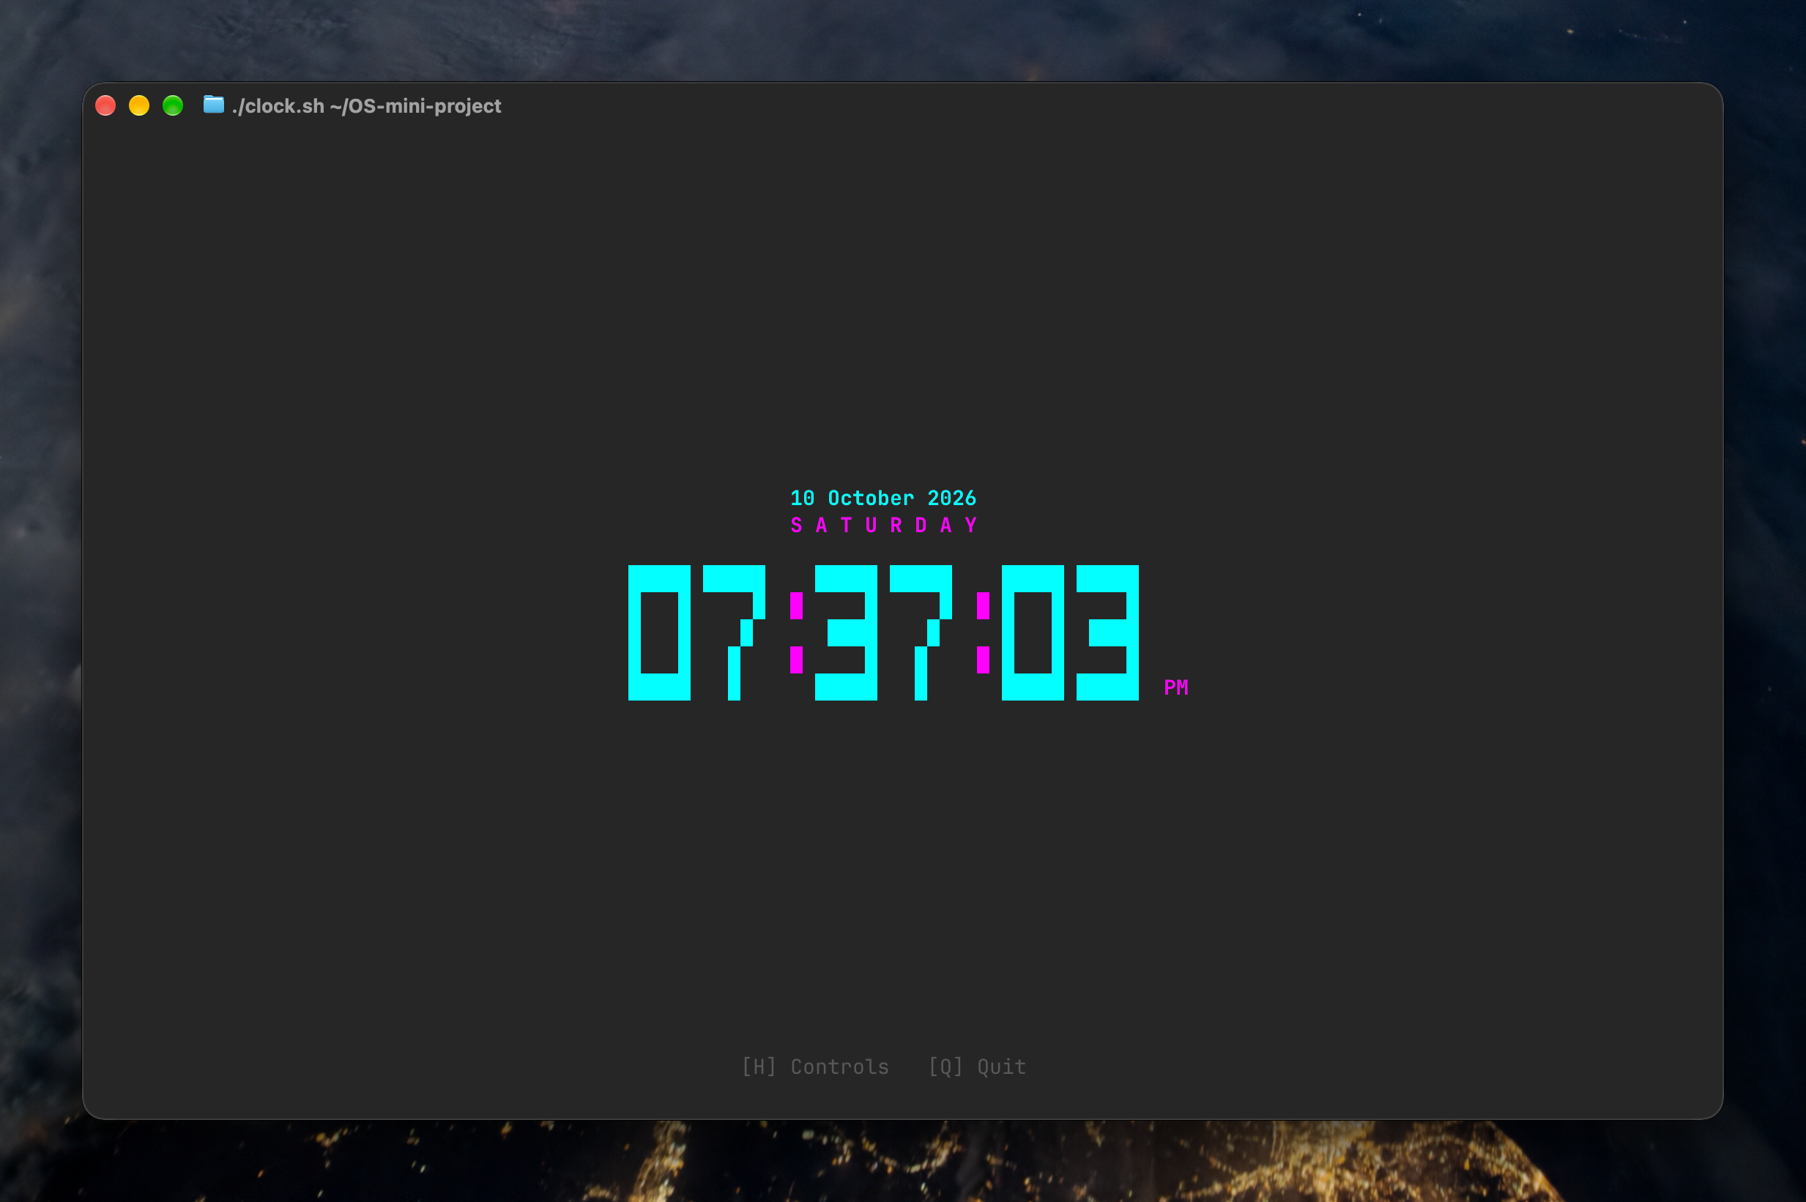
The following screenshot was captured from the clock script while it was running in an interactive terminal instance. The large ASCII digits show the live time, with the date above and controls at the bottom.
Figure 4. Terminal output of Project 2, running ASCII clock.

Project 2 Source Code: clock.sh
#!/usr/bin/env bash

# Ensure UTF-8 locale for character handling across platforms
export LC_ALL="${LC_ALL:-en_US.UTF-8}"
export LANG="${LANG:-en_US.UTF-8}"

# Single-byte ASCII Escape code for ANSI terminal formatting (compatible with all shells and printf %s)
ESC=$(printf '\033')

# Ensure clean exit and terminal restoration
cleanup() {
printf "%s[?25h" "$ESC" # Show cursor
printf "%s[0m" "$ESC" # Reset colors
printf "%s[2J%s[H" "$ESC" "$ESC" # Clear screen and move home
if [ -n "$ORIG_STTY" ]; then
stty "$ORIG_STTY" 2>/dev/null || true
fi
exit 0
}

trap cleanup INT TERM EXIT

# Save original terminal settings and configure non-blocking input
ORIG_STTY=$(stty -g 2>/dev/null || true)
stty -echo -icanon min 0 time 0 2>/dev/null || true

# Hide cursor
printf "%s[?25l" "$ESC"

# Options and state
FORMAT_12H=1 # 1 = 12-hour with AM/PM, 0 = 24-hour (no 24H text)
SHOW_SECONDS=1 # 1 = Show HH:MM:SS, 0 = Show HH:MM
SHOW_DATE=1 # 1 = Large 2-Line Day & Date, 2 = Compact, 0 = Hidden
BLINK_COLON=1 # 1 = Blink colons every interval
FONT_STYLE=1 # 1 = Modern Bold Block (Default), 0 = Classic 7-Segment, 2 = Tech Slender
COLOR_THEME=1 # 1 = Cyberpunk Neon (Default), 0 = Emerald, 2 = Amber, 3 = Solar, 4 = Violet, 5 = Mono
BORDER_STYLE=0 # 0 = No border (Clean Modern Default), 1 = Double (╔═══╗), 2 = Rounded (╭───╮), 3 = Dashed (+---+), 4 = Solid (┌───┐)
SHOW_HELP=0 # 0 = Hidden, 1 = Show hotkey bar at bottom

# Parse command line options
while [ $# -gt 0 ]; do
case "$1" in
-h|--help)
echo "Usage: ./clock.sh [OPTIONS]"
echo ""
echo "Modern ASCII Running Digital Clock in Bash"
echo ""
echo "Options:"
echo " -12, --12h Use 12-hour format with AM/PM (default)"
echo " -24, --24h Use 24-hour format (clean without 24H label)"
echo " -s, --no-seconds Hide seconds"
echo " -d, --no-date Hide date header"
echo " -b, --border <0-4> Border style (0=None, 1=Double, 2=Rounded, 3=Dashed, 4=Solid)"
echo " --no-blink Disable blinking colons"
echo " -c, --theme <0-5> Color theme (1=Cyberpunk, 0=Emerald, 2=Amber, 3=Solar, 4=Violet, 5=Mono)"
echo " -f, --font <0-2> Font style (1=Modern Bold Block, 0=Classic 7-Segment, 2=Tech Slender)"
echo " -h, --help Show this help message and exit"
echo ""
echo "Keyboard Controls while running:"
echo " q, ESC : Quit clock"
echo " h, ? : Toggle controls / Return to homescreen"
echo " t : Toggle 12h / 24h mode"
echo " s : Toggle seconds display"
echo " d : Toggle date display (Large / Compact / Off)"
echo " c : Cycle color themes"
echo " f : Cycle font styles"
echo " b : Cycle border styles (None / Double / Rounded / Dashed / Solid)"
exit 0
;;
-12|--12h) FORMAT_12H=1 ;;
-24|--24h) FORMAT_12H=0 ;;
-s|--no-seconds) SHOW_SECONDS=0 ;;
-d|--no-date) SHOW_DATE=0 ;;
-b|--border)
shift
if [ -n "${1:-}" ]; then BORDER_STYLE="$1"; fi
;;
--no-blink) BLINK_COLON=0 ;;
-c|--theme)
shift
if [ -n "${1:-}" ]; then COLOR_THEME="$1"; fi
;;
-f|--font)
shift
if [ -n "${1:-}" ]; then FONT_STYLE="$1"; fi
;;
esac
shift
done

update_term_size() {
local size
size=$(stty size 2>/dev/null || echo "24 80")
read -r TERM_ROWS TERM_COLS <<< "$size"
[ -z "$TERM_ROWS" ] || [ "$TERM_ROWS" -le 0 ] && TERM_ROWS=24
[ -z "$TERM_COLS" ] || [ "$TERM_COLS" -le 0 ] && TERM_COLS=80
printf "%s[2J" "$ESC" # Clear screen on resize
}

trap update_term_size WINCH

# ------------------------------------------------------------------------------
# Color Palettes
# ------------------------------------------------------------------------------
get_theme_colors() {
case "$COLOR_THEME" in
0) # Emerald Matrix Green
COLOR_BORDER="${ESC}[38;5;46m"
COLOR_DIGIT="${ESC}[1;38;5;48m"
COLOR_COLON="${ESC}[1;38;5;120m"
COLOR_DATE="${ESC}[1;38;5;46m"
COLOR_DATE_SUB="${ESC}[1;38;5;157m"
COLOR_AMPM="${ESC}[1;38;5;119m"
THEME_NAME="Emerald Matrix"
;;
1) # Cyberpunk Neon
COLOR_BORDER="${ESC}[38;5;51m"
COLOR_DIGIT="${ESC}[1;38;5;51m"
COLOR_COLON="${ESC}[1;38;5;201m"
COLOR_DATE="${ESC}[1;38;5;201m"
COLOR_DATE_SUB="${ESC}[1;38;5;51m"
COLOR_AMPM="${ESC}[1;38;5;201m"
THEME_NAME="Cyberpunk Neon"
;;
2) # Amber CRT Terminal
COLOR_BORDER="${ESC}[38;5;214m"
COLOR_DIGIT="${ESC}[1;38;5;220m"
COLOR_COLON="${ESC}[1;38;5;208m"
COLOR_DATE="${ESC}[1;38;5;214m"
COLOR_DATE_SUB="${ESC}[1;38;5;222m"
COLOR_AMPM="${ESC}[1;38;5;214m"
THEME_NAME="Amber CRT"
;;
3) # Solarized Gold
COLOR_BORDER="${ESC}[38;5;178m"
COLOR_DIGIT="${ESC}[1;38;5;221m"
COLOR_COLON="${ESC}[1;38;5;166m"
COLOR_DATE="${ESC}[1;38;5;220m"
COLOR_DATE_SUB="${ESC}[1;38;5;229m"
COLOR_AMPM="${ESC}[1;38;5;178m"
THEME_NAME="Solar Gold"
;;
4) # Electric Violet
COLOR_BORDER="${ESC}[38;5;141m"
COLOR_DIGIT="${ESC}[1;38;5;183m"
COLOR_COLON="${ESC}[1;38;5;199m"
COLOR_DATE="${ESC}[1;38;5;199m"
COLOR_DATE_SUB="${ESC}[1;38;5;141m"
COLOR_AMPM="${ESC}[1;38;5;141m"
THEME_NAME="Electric Violet"
;;
5) # Sleek Monochrome
COLOR_BORDER="${ESC}[38;5;248m"
COLOR_DIGIT="${ESC}[1;38;5;255m"
COLOR_COLON="${ESC}[1;38;5;250m"
COLOR_DATE="${ESC}[1;38;5;255m"
COLOR_DATE_SUB="${ESC}[1;38;5;248m"
COLOR_AMPM="${ESC}[1;38;5;245m"
THEME_NAME="Pure Monochrome"
;;
esac
COLOR_RESET="${ESC}[0m"
COLOR_DIM="${ESC}[38;5;240m"
}

# ------------------------------------------------------------------------------
# ASCII Glyphs Definition
# ------------------------------------------------------------------------------

# Style 0: Classic 3-Line 7-Segment (True to Assignment Reference)
# Digits are 3 chars wide, 3 lines tall
get_classic_glyph() {
local char="$1"
local line="$2"
local show_colon="$3"
case "$char" in
0) [ "$line" -eq 1 ] && echo " _ " || { [ "$line" -eq 2 ] && echo "| |" || echo "|_|"; } ;;
1) [ "$line" -eq 1 ] && echo " " || { [ "$line" -eq 2 ] && echo " |" || echo " |"; } ;;
2) [ "$line" -eq 1 ] && echo " _ " || { [ "$line" -eq 2 ] && echo " _|" || echo "|_ "; } ;;
3) [ "$line" -eq 1 ] && echo " _ " || { [ "$line" -eq 2 ] && echo " _|" || echo " _|"; } ;;
4) [ "$line" -eq 1 ] && echo " " || { [ "$line" -eq 2 ] && echo "|_|" || echo " |"; } ;;
5) [ "$line" -eq 1 ] && echo " _ " || { [ "$line" -eq 2 ] && echo "|_ " || echo " _|"; } ;;
6) [ "$line" -eq 1 ] && echo " _ " || { [ "$line" -eq 2 ] && echo "|_ " || echo "|_|"; } ;;
7) [ "$line" -eq 1 ] && echo " _ " || { [ "$line" -eq 2 ] && echo " |" || echo " |"; } ;;
8) [ "$line" -eq 1 ] && echo " _ " || { [ "$line" -eq 2 ] && echo "|_|" || echo "|_|"; } ;;
9) [ "$line" -eq 1 ] && echo " _ " || { [ "$line" -eq 2 ] && echo "|_|" || echo " _|"; } ;;
:)
if [ "$show_colon" -eq 1 ]; then
[ "$line" -eq 1 ] && echo " " || { [ "$line" -eq 2 ] && echo ":" || echo "."; }
else
echo " "
fi
;;
" ") echo " " ;;
*) echo " " ;;
esac
}

# Style 1: Modern Bold Block (5 lines tall)
get_block_glyph() {
local char="$1"
local line="$2"
local show_colon="$3"
case "$char" in
0)
case "$line" in
1) echo "█████" ;;
2) echo "█ █" ;;
3) echo "█ █" ;;
4) echo "█ █" ;;
5) echo "█████" ;;
esac ;;
1)
case "$line" in
1) echo " ██ " ;;
2) echo " ███ " ;;
3) echo " ██ " ;;
4) echo " ██ " ;;
5) echo "█████" ;;
esac ;;
2)
case "$line" in
1) echo "█████" ;;
2) echo " █" ;;
3) echo "█████" ;;
4) echo "█ " ;;
5) echo "█████" ;;
esac ;;
3)
case "$line" in
1) echo "█████" ;;
2) echo " █" ;;
3) echo " ████" ;;
4) echo " █" ;;
5) echo "█████" ;;
esac ;;
4)
case "$line" in
1) echo "█ █" ;;
2) echo "█ █" ;;
3) echo "█████" ;;
4) echo " █" ;;
5) echo " █" ;;
esac ;;
5)
case "$line" in
1) echo "█████" ;;
2) echo "█ " ;;
3) echo "█████" ;;
4) echo " █" ;;
5) echo "█████" ;;
esac ;;
6)
case "$line" in
1) echo "█████" ;;
2) echo "█ " ;;
3) echo "█████" ;;
4) echo "█ █" ;;
5) echo "█████" ;;
esac ;;
7)
case "$line" in
1) echo "█████" ;;
2) echo " █" ;;
3) echo " █ " ;;
4) echo " █ " ;;
5) echo " █ " ;;
esac ;;
8)
case "$line" in
1) echo "█████" ;;
2) echo "█ █" ;;
3) echo "█████" ;;
4) echo "█ █" ;;
5) echo "█████" ;;
esac ;;
9)
case "$line" in
1) echo "█████" ;;
2) echo "█ █" ;;
3) echo "█████" ;;
4) echo " █" ;;
5) echo "█████" ;;
esac ;;
:)
if [ "$show_colon" -eq 1 ]; then
case "$line" in
1|3|5) echo " " ;;
2|4) echo "█" ;;
esac
else
echo " "
fi ;;
" ") echo " " ;;
*) echo " " ;;
esac
}

# Style 2: Tech Slender (3 lines tall)
get_tech_glyph() {
local char="$1"
local line="$2"
local show_colon="$3"
case "$char" in
0) [ "$line" -eq 1 ] && echo "┌─┐" || { [ "$line" -eq 2 ] && echo "│ │" || echo "└─┘"; } ;;
1) [ "$line" -eq 1 ] && echo " ┐ " || { [ "$line" -eq 2 ] && echo " │ " || echo " ┴ "; } ;;
2) [ "$line" -eq 1 ] && echo "┌─┐" || { [ "$line" -eq 2 ] && echo "┌─┘" || echo "└──"; } ;;
3) [ "$line" -eq 1 ] && echo "┌─┐" || { [ "$line" -eq 2 ] && echo " ─┤" || echo "└─┘"; } ;;
4) [ "$line" -eq 1 ] && echo "│ │" || { [ "$line" -eq 2 ] && echo "└─┤" || echo " │"; } ;;
5) [ "$line" -eq 1 ] && echo "┌──" || { [ "$line" -eq 2 ] && echo "└─┐" || echo "──┘"; } ;;
6) [ "$line" -eq 1 ] && echo "┌──" || { [ "$line" -eq 2 ] && echo "├─┐" || echo "└─┘"; } ;;
7) [ "$line" -eq 1 ] && echo "──┐" || { [ "$line" -eq 2 ] && echo " │" || echo " │"; } ;;
8) [ "$line" -eq 1 ] && echo "┌─┐" || { [ "$line" -eq 2 ] && echo "├─┤" || echo "└─┘"; } ;;
9) [ "$line" -eq 1 ] && echo "┌─┐" || { [ "$line" -eq 2 ] && echo "└─┤" || echo "──┘"; } ;;
:)
if [ "$show_colon" -eq 1 ]; then
[ "$line" -eq 1 ] && echo " " || { [ "$line" -eq 2 ] && echo "•" || echo "•"; }
else
echo " "
fi ;;
" ") echo " " ;;
*) echo " " ;;
esac
}

# Get line of glyph based on current font style
get_glyph_line() {
local char="$1"
local line="$2"
local show_colon="$3"
case "$FONT_STYLE" in
0) get_classic_glyph "$char" "$line" "$show_colon" ;;
1) get_block_glyph "$char" "$line" "$show_colon" ;;
2) get_tech_glyph "$char" "$line" "$show_colon" ;;
esac
}

get_glyph_height() {
case "$FONT_STYLE" in
0) echo 3 ;;
1) echo 5 ;;
2) echo 3 ;;
esac
}

# ------------------------------------------------------------------------------
# Render Frame
# ------------------------------------------------------------------------------
render_clock() {
local blink_state="$1"

get_theme_colors
local height
height=$(get_glyph_height)

# 1. Fetch current time and date in a single Unix date call
local time_24 time_12 ampm_val day_name date_val
IFS="|" read -r time_24 time_12 ampm_val day_name date_val <<< "$(date "+%H:%M:%S|%I:%M:%S|%p|%A|%d %B %Y")"

local time_str ampm_str=""
if [ "$FORMAT_12H" -eq 1 ]; then
if [ "$SHOW_SECONDS" -eq 1 ]; then
time_str="$time_12"
else
time_str="${time_12:0:5}"
fi
ampm_str="$ampm_val"
else
if [ "$SHOW_SECONDS" -eq 1 ]; then
time_str="$time_24"
else
time_str="${time_24:0:5}"
fi
fi

# 2. Build multi-line ASCII output
local lines=()
local colon_visible=1
if [ "$BLINK_COLON" -eq 1 ] && [ "$blink_state" -eq 0 ]; then
colon_visible=0
fi

for ((l=1; l<=height; l++)); do
local current_row=""
local len=${#time_str}
for ((i=0; i<len; i++)); do
local ch="${time_str:$i:1}"
local g
g=$(get_glyph_line "$ch" "$l" "$colon_visible")
if [ "$ch" = ":" ]; then
current_row="${current_row} ${COLOR_COLON}${g}${COLOR_DIGIT} "
else
current_row="${current_row}${g} "
fi
done
lines[l]="${current_row% }"
done

# Calculate exact display column width of clock digits/colons
local glyph_w=3
[ "$FONT_STYLE" -eq 1 ] && glyph_w=5

local inner_width=0
for ((i=0; i<${#time_str}; i++)); do
local ch="${time_str:$i:1}"
if [ "$ch" = ":" ]; then
inner_width=$(( inner_width + 3 ))
elif [ "$ch" = " " ]; then
[ "$FONT_STYLE" -eq 1 ] && inner_width=$(( inner_width + 3 )) || inner_width=$(( inner_width + 2 ))
else
inner_width=$(( inner_width + glyph_w + 1 ))
fi
done
inner_width=$(( inner_width - 1 ))

# Determine border characters
local b_tl="" b_tr="" b_bl="" b_br="" b_h="" b_v=""
case "$BORDER_STYLE" in
1) # Double Lined
b_tl="╔" b_tr="╗" b_bl="╚" b_br="╝" b_h="═" b_v="║"
;;
2) # Modern Rounded
b_tl="╭" b_tr="╮" b_bl="╰" b_br="╯" b_h="─" b_v="│"
;;
3) # Dashed
b_tl="+" b_tr="+" b_bl="+" b_br="+" b_h="-" b_v="|"
;;
4) # Sharp Solid
b_tl="┌" b_tr="┐" b_bl="└" b_br="┘" b_h="─" b_v="│"
;;
esac

local total_content_width total_box_width total_box_height box_start_col
local border_pad=5
if [ "$BORDER_STYLE" -gt 0 ]; then
total_content_width=$(( inner_width + border_pad + border_pad ))
total_box_width=$(( total_content_width + 2 ))
total_box_height=$(( height + 2 ))
box_start_col=$(( (TERM_COLS - total_box_width) / 2 ))
else
total_content_width=$inner_width
total_box_width=$inner_width
total_box_height=$height
box_start_col=$(( (TERM_COLS - inner_width) / 2 ))
fi

# Calculate vertical spacing
local date_rows=0
if [ "$SHOW_DATE" -eq 1 ]; then
date_rows=3
elif [ "$SHOW_DATE" -eq 2 ]; then
date_rows=2
fi

local total_full_height=$(( total_box_height + date_rows ))
local start_row=$(( (TERM_ROWS - total_full_height) / 2 ))
[ "$start_row" -lt 1 ] && start_row=1
[ "$box_start_col" -lt 1 ] && box_start_col=1

local current_cursor_row=$start_row

# 3. Draw Date (if enabled)
if [ "$SHOW_DATE" -eq 1 ]; then
local date_col=$(( (TERM_COLS - ${#date_val}) / 2 ))
[ "$date_col" -lt 1 ] && date_col=1
printf "%s[%d;%dH%s[2K%s%s%s" "$ESC" "$current_cursor_row" "$date_col" "$ESC" "$COLOR_DATE_SUB" "$date_val" "$COLOR_RESET"
current_cursor_row=$((current_cursor_row + 1))

local day_name_upper
day_name_upper=$(echo "$day_name" | tr "[:lower:]" "[:upper:]")
local spaced_day=""
for ((i=0; i<${#day_name_upper}; i++)); do
spaced_day="${spaced_day}${day_name_upper:$i:1} "
done
spaced_day="${spaced_day% }"
local day_col=$(( (TERM_COLS - ${#spaced_day}) / 2 ))
[ "$day_col" -lt 1 ] && day_col=1
printf "%s[%d;%dH%s[2K%s%s%s" "$ESC" "$current_cursor_row" "$day_col" "$ESC" "$COLOR_DATE" "$spaced_day" "$COLOR_RESET"
current_cursor_row=$((current_cursor_row + 2))
elif [ "$SHOW_DATE" -eq 2 ]; then
local compact_str="${day_name}, ${date_val}"
local date_col=$(( (TERM_COLS - ${#compact_str}) / 2 ))
[ "$date_col" -lt 1 ] && date_col=1
printf "%s[%d;%dH%s[2K%s%s%s" "$ESC" "$current_cursor_row" "$date_col" "$ESC" "$COLOR_DATE" "$compact_str" "$COLOR_RESET"
current_cursor_row=$((current_cursor_row + 2))
fi

# 4. Draw Top Border (if border enabled)
if [ "$BORDER_STYLE" -gt 0 ]; then
local border_line=""
for ((b=0; b<total_content_width; b++)); do
border_line="${border_line}${b_h}"
done
local top_border="${b_tl}${border_line}${b_tr}"
local bot_border="${b_bl}${border_line}${b_br}"

printf "%s[%d;%dH%s[2K%s%s%s" "$ESC" "$current_cursor_row" "$box_start_col" "$ESC" "$COLOR_BORDER" "$top_border" "$COLOR_RESET"
current_cursor_row=$((current_cursor_row + 1))
fi

# 5. Draw Clock Rows
for ((l=1; l<=height; l++)); do
local row_content="${lines[l]}"
local side_text=""

if [ "$FORMAT_12H" -eq 1 ] && [ "$l" -eq "$height" ]; then
side_text=" ${COLOR_AMPM}${ampm_str}${COLOR_RESET}"
fi

if [ "$BORDER_STYLE" -gt 0 ]; then
local border_side_pad=" "
if [ "$FORMAT_12H" -eq 1 ] && [ "$l" -eq "$height" ]; then
border_side_pad=" ${COLOR_AMPM}${ampm_str}${COLOR_RESET} "
fi

printf "%s[%d;%dH%s[2K%s%s%s %s%s%s%s%s" \
"$ESC" "$current_cursor_row" "$box_start_col" "$ESC" \
"$COLOR_BORDER" "$b_v" "$COLOR_RESET" \
"${COLOR_DIGIT}${row_content}${COLOR_RESET}" \
"$border_side_pad" \
"$COLOR_BORDER" "$b_v" "$COLOR_RESET"
else
printf "%s[%d;%dH%s[2K%s%s" \
"$ESC" "$current_cursor_row" "$box_start_col" "$ESC" \
"${COLOR_DIGIT}${row_content}${COLOR_RESET}" \
"$side_text"
fi
current_cursor_row=$((current_cursor_row + 1))
done

# 6. Draw Bottom Border (if border enabled)
if [ "$BORDER_STYLE" -gt 0 ]; then
printf "%s[%d;%dH%s[2K%s%s%s" "$ESC" "$current_cursor_row" "$box_start_col" "$ESC" "$COLOR_BORDER" "$bot_border" "$COLOR_RESET"
current_cursor_row=$((current_cursor_row + 1))
fi

# 7. Clean Muted Grey Controls Bar
if [ "$SHOW_HELP" -eq 1 ]; then
local help_msg="[T] 12/24H [S] Sec [C] Color: $THEME_NAME [F] Font [B] Border [D] Date [H] Close [Q] Quit"
local help_col=$(( (TERM_COLS - ${#help_msg}) / 2 ))
[ "$help_col" -lt 1 ] && help_col=1
printf "%s[%d;%dH%s[2K%s%s%s" "$ESC" "$((TERM_ROWS - 1))" "$help_col" "$ESC" "$COLOR_DIM" "$help_msg" "$COLOR_RESET"
else
local hint="[H] Controls [Q] Quit"
local hint_col=$(( (TERM_COLS - ${#hint}) / 2 ))
[ "$hint_col" -lt 1 ] && hint_col=1
printf "%s[%d;%dH%s[2K%s%s%s" "$ESC" "$((TERM_ROWS - 1))" "$hint_col" "$ESC" "$COLOR_DIM" "$hint" "$COLOR_RESET"
fi
}

# ------------------------------------------------------------------------------
# Input Processing
# ------------------------------------------------------------------------------
process_key() {
local key="$1"
[ -z "$key" ] && return 1

if [ "$SHOW_HELP" -eq 1 ]; then
case "$key" in
h|H|$'\e'|" "|$'\n')
SHOW_HELP=0
printf "%s[2J" "$ESC"
return 0
;;
esac
fi

case "$key" in
q|Q) cleanup ;;
$'\e') cleanup ;;
t|T) FORMAT_12H=$(( 1 - FORMAT_12H )); printf "%s[2J" "$ESC" ;;
s|S) SHOW_SECONDS=$(( 1 - SHOW_SECONDS )); printf "%s[2J" "$ESC" ;;
d|D) SHOW_DATE=$(( (SHOW_DATE + 1) % 3 )); printf "%s[2J" "$ESC" ;;
c|C) COLOR_THEME=$(( (COLOR_THEME + 1) % 6 )) ;; # Instant recolor without screen clear
f|F) FONT_STYLE=$(( (FONT_STYLE + 1) % 3 )); printf "%s[2J" "$ESC" ;;
b|B) BORDER_STYLE=$(( (BORDER_STYLE + 1) % 5 )); printf "%s[2J" "$ESC" ;;
h|H|\?) SHOW_HELP=$(( 1 - SHOW_HELP )); printf "%s[2J" "$ESC" ;;
*) return 1 ;;
esac
return 0
}

# ------------------------------------------------------------------------------
# Main Event Loop
# ------------------------------------------------------------------------------
update_term_size
printf "%s[2J" "$ESC"

blink=1
tick=0
render_clock "$blink"

while true; do
raw_in=$(dd bs=10 count=1 2>/dev/null || true)
if [ -n "$raw_in" ]; then
if process_key "$raw_in"; then
render_clock "$blink"
tick=0
fi
fi

sleep 0.05
tick=$((tick + 1))

# Every 10 ticks (0.5 seconds), update time and blink
if [ "$tick" -ge 10 ]; then
tick=0
blink=$(( 1 - blink ))
render_clock "$blink"
fi
done

