**Text Classification with Linear Models and BERT**

**1. INTRODUCTION**

Text classification is one of many Natural Language Processing (NLP) applications that’s gaining traction in the past decades. Online news and social media, which has been considered as one of the most powerful forces, often able to shift general population’s political view and spark a manifestation of real-world phenomenon, presents itself not only as a gigantic source of text data but also as a domain where text classification can find important uses. Two of the most popular use cases that this project is focusing on, are classification of fake and real news as well as identification of toxic social media comments.

The challenges of building a robust NLP model starts with constructing a numerical representation of a text, termed vectorization.

Perhaps the most primitive embedding method is Bag of Words1 (BoW) in which a document is represented by a vector $x = \left[x_{1} x_{2}…x_{d}\right]$ with $x_{i}$ corresponding to the count of the word $V_{i}$, the $i$-th word in vocabulary V, in the document. The vocabulary $V=\left[V_{1} V_{2}…V_{d}\right]$ encompasses a subset or the entirety of words present in the dataset of many documents.

TF-IDF method2 weighs each term based on its importance in the dataset. Term Frequency (TF) $tf_{i,j}$ is a frequency of occurrence of term $i$ in document $j$, defined as follows:

$$tf_{i,j}=\frac{n_{i,j}}{\text{number of terms in document j}}$$

Inverse Document Frequency (IDF) $idf_{i}$ is a measure of term $i$’s importance in the dataset and is defined as

$$idf_{i}=log\frac{\text{number of documents}}{\text{number of documents with term i}}$$

TF-IDF score for each term can then be calculated as $tf_{i}df_{i,j}=tf_{i,j}*idf_{i}$. High score is assigned to terms with high frequency only in a few documents.

Once vector representations of documents are obtained, standard classification algorithms can be applied.

**BERT (Bidirectional Encoder Representations from Transformers)**

BERT is considered as the state-of-the-art in text classification. BERT is essentially a specifically designed neural network that is derived from transformers architecture. The full explanation of how transformers work can be found in the original paper3. Transformer was created to do sequence-to-sequence modelling, for instance to perform machine translation. While transformers consist of 2 parts: encoder and decoder, BERT is developed to generate a language model and hence only the encoder part is necessary.

BERT typically comes with models pre-trained with different corpuses for a problem termed Masked Language Model (MLM). In MLM, 80% of input words are replaced with [MASK] tokens, 10% with random words and the remaining 10% with the original words.

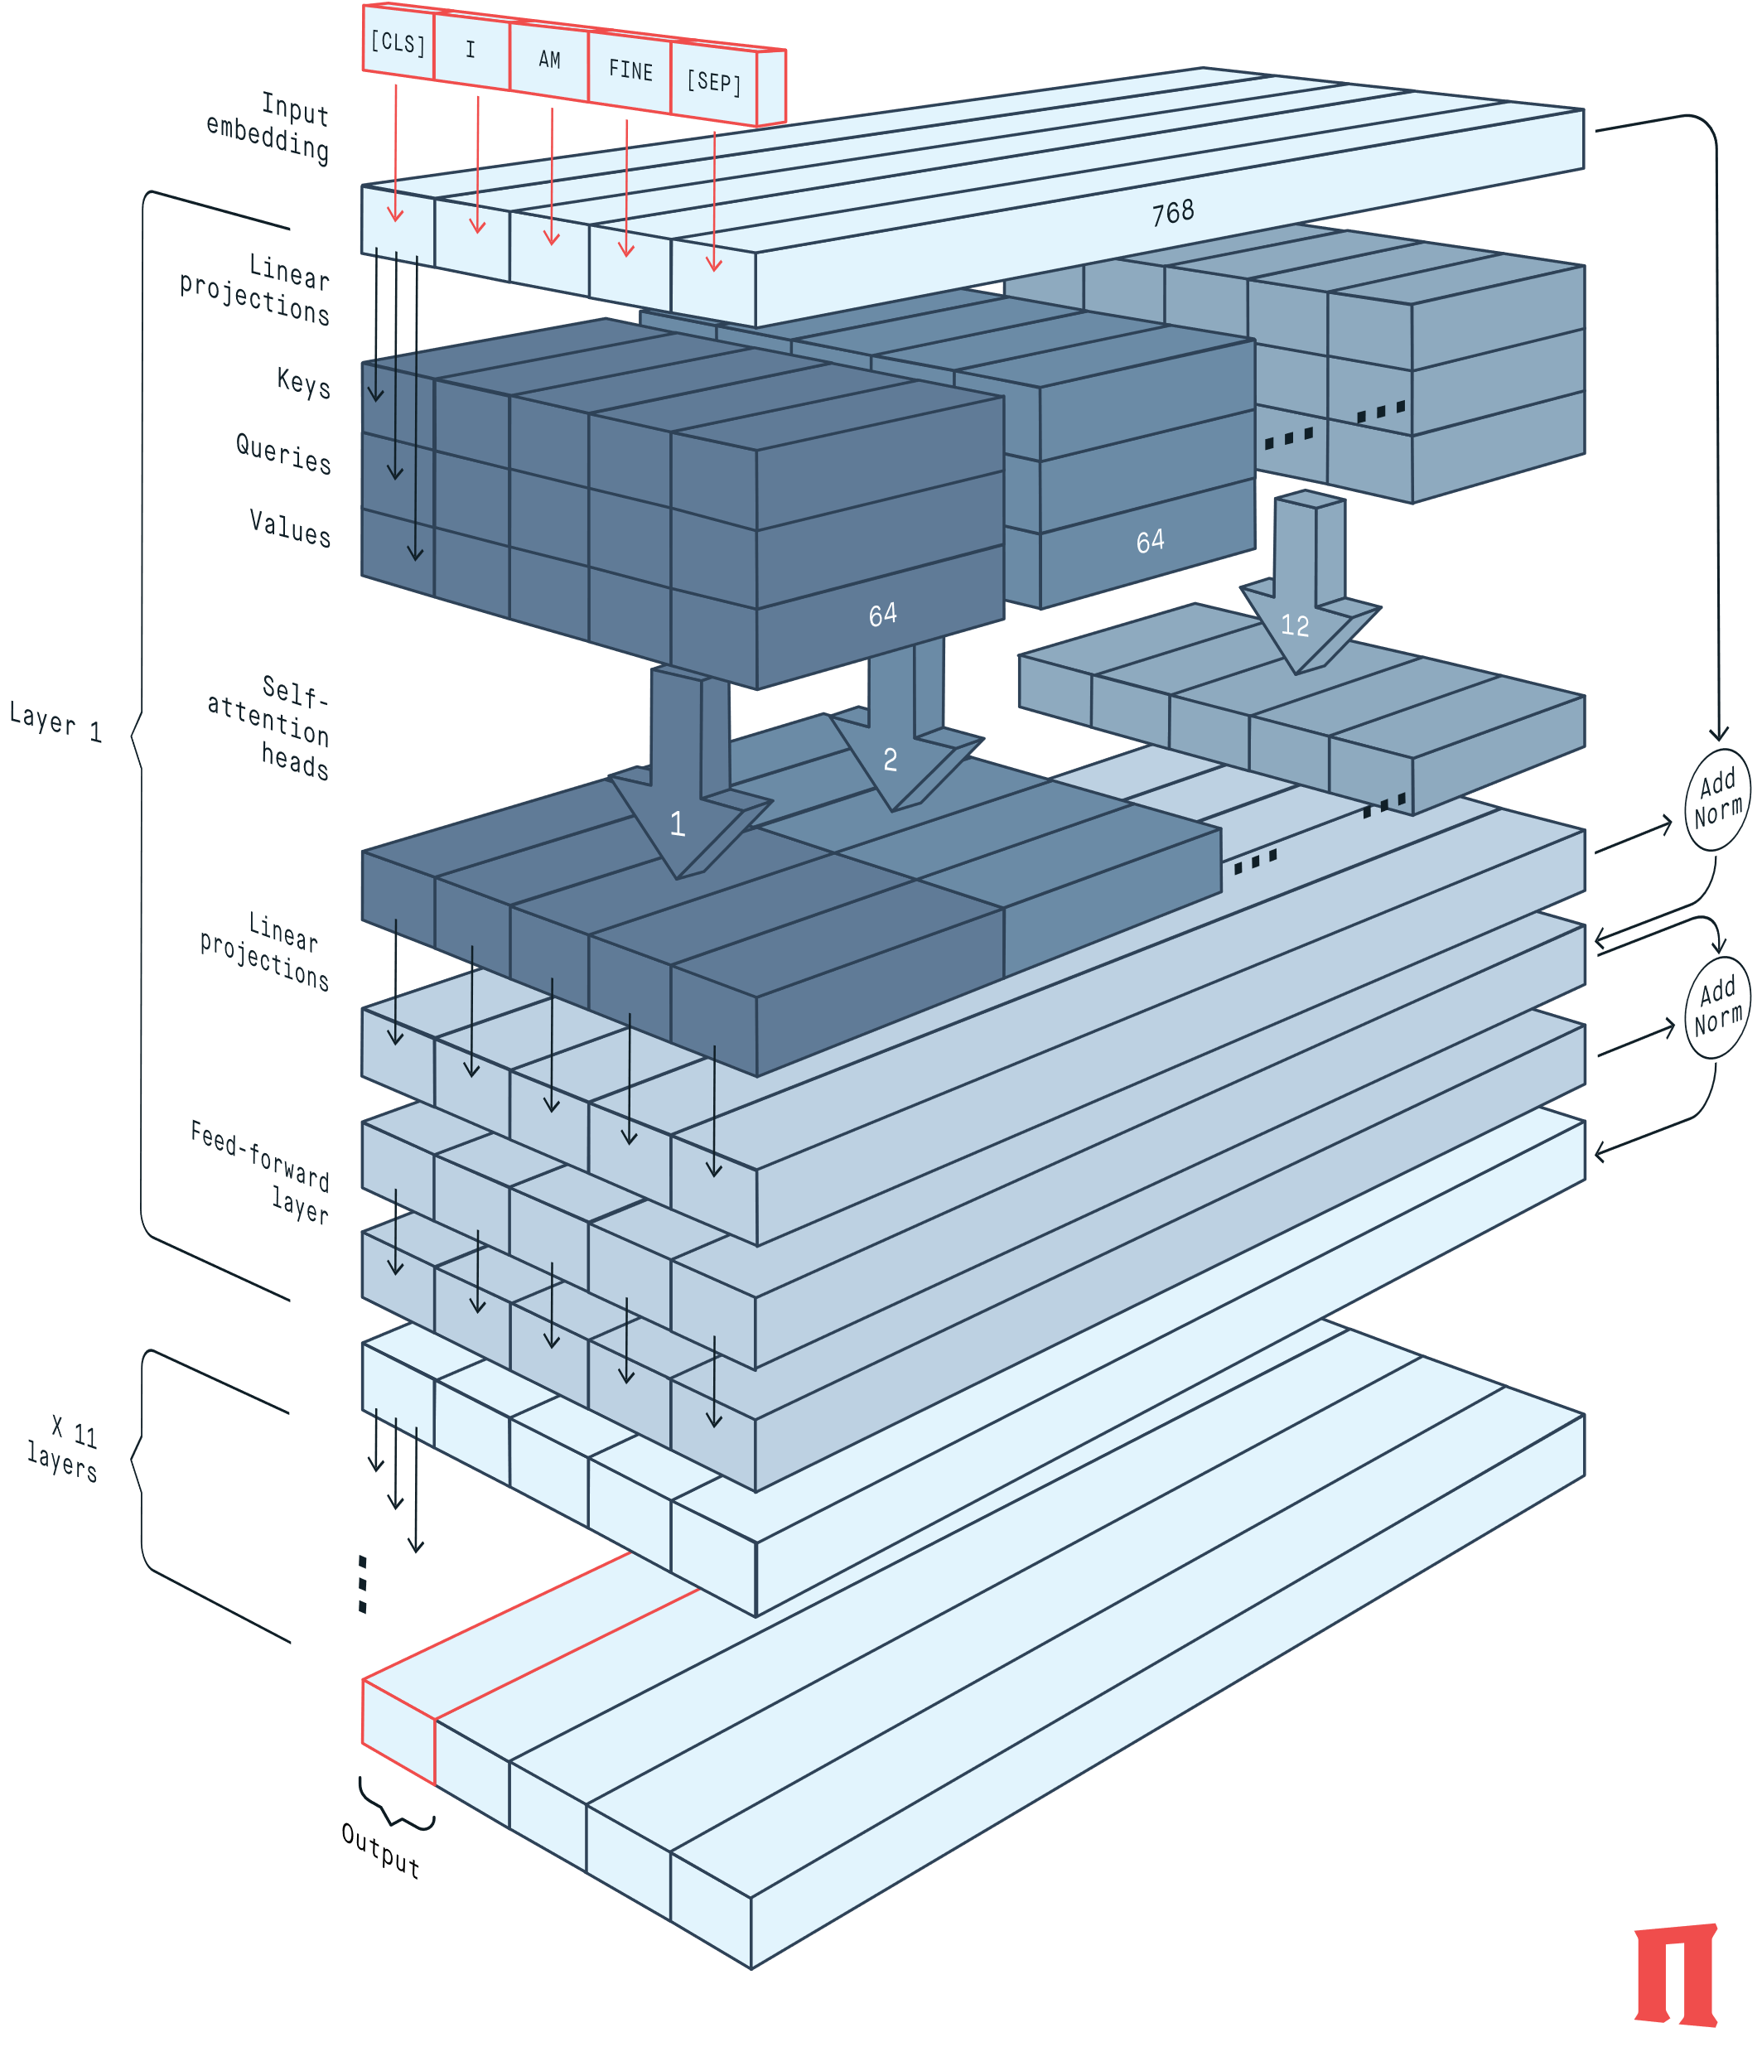

*Figure 1. BERT English architecture*4

**BERT architecture**

The full BERT architecture is shown in Figure 1. This section breaks down each layer of BERT and the intuition behind the mathematical operations involved.

**Input encoding** layer tokenizes input text and vectorizes each word into a $R^{768}$ vector. BERT introduces [CLS] and [SEP] token to mark the beginning and end of sentences. Since the number of tokens must be fixed, input sequence is truncated or padded (with a specific padding token) to a fixed length specified during model training. The resulting $A∈R^{768×n}$ matrix, where $n$ is the number of tokens in an input sequence, is then passed to the next layer.

**Keys, Queries and Values (KQV)** layer performs 3 linear projections on the input encoding. The linear projections typically reduce the dimensionality from 768 to 64. This procedure is duplicated 12 times referred to as heads.

For $i$-th head, keys $K_{i}$, queries $Q_{i}$, and values $V_{i}$ are defined as follows.

$$K_{i}=W_{i,K}A, Q_{i}=W_{i,Q}A, V_{i}=W_{i,V}A$$

Where $K_{i},Q_{i},V_{i}∈R^{64×n}$ and $W_{i,K},W_{i,Q},W_{i,V}∈R^{64×768}$.

The keys and queries specifically can be thought of as projections focusing on different directions of vector space corresponding to different semantic aspects. Values are yet another $R^{64×n}$ projection performed similarly to keys and queries focusing on different semantic direction.

**Self-attention heads** are where keys, queries and values are combined to form contextual embeddings. First, for $i$-th head, a product of keys and queries are computed to produce an $R^{n×n}$ matrix

$$M_{i}={K_{i}}^{T}Q_{i}$$

Where $M_{i}∈R^{n×n}$ and $K_{i},Q_{i}∈R^{64×n}$. Then column-based softmax is applied to this matrix to produce $M_{i,softmax}$ where the sum of each column is $1$. Finally, contextual embedding matrix $B_{i}$ is produced from values matrix $V_{i}$ in the following expression.

$$B_{i}={V_{i}}^{T}M_{i,softmax}$$

Where $B_{i},V_{i}∈R^{64×n}$. There are 12 self-attention heads each with its own keys, queries and values and the resulting matrices $B_{i},…,B_{12}$ are concatenated to form $B$, an $R^{768×n}$ matrix.

**Linear projections** layer, as the name suggests, produces $C$, a linear projection of $B$

$$C=W_{BC}B$$

Where $C∈R^{768×n}$ and $W_{BC}∈R^{n×n}$. Addition followed by normalization was then performed on $C$ to produce $D$.

$$D=norm\left(C+A\right)$$

**Feed-forward layer** then passes D through a hidden layer with dropout, maintaining the same dimensionality, following which $D$ is added to the output of this hidden layer, termed $E$ and finally normalized to produce $F$ as described in the following expressions

$$D\underset{→}{feed-forward}E$$

$$F=norm\left(E+D\right)$$

Where $D, E, F∈R^{768×n}. F$ then goes into the second transformer layer starting with linear projections in the KQV layer. There are in total 12 transformers layers in BERT architecture.

To perform classification task additional 512-neuron hidden layers were attached to the end of BERT block as illustrated below:

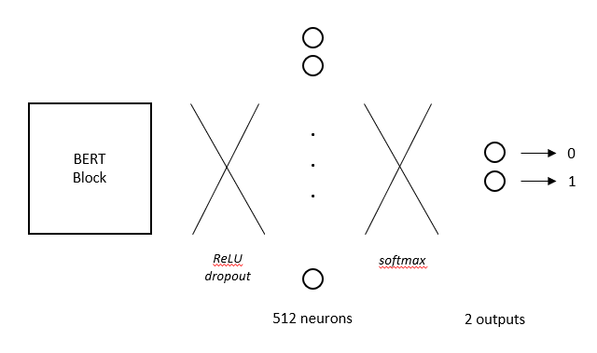

*Figure 2. BERT Classification layer architecture*

**2. DATA**

Two datasets are analyzed in this project, both are taken from Kaggle:

* News dataset, containing 17903 fake and 20826 real news articles (https://www.kaggle.com/clmentbisaillon/fake-and-real-news-dataset)
* Comments dataset from Jigsaw, containing 144277 non-toxic and 15294 toxic comments (https://www.kaggle.com/c/jigsaw-toxic-comment-classification-challenge/data). The full version of dataset contains other categories which are not used in this project: severe toxic, obscene, threat, insult, and identity hate.

**3. METHODOLOGY**

**3.1. News dataset**

**3.1.1 Preprocessing**

Preprocessing of the text data is summarized in steps listed in order as follows:

1. Expansion of contractions using “contractions” package (https://pypi.org/project/contractions/)
2. Splitting of each document into sentences using NLTK’s Punkt Sentence Tokenizer
3. Conversion to lower case
4. Tokenization using NLTK’s word_tokenize
5. Lemmatization according to each word’s Part Of Speech (POS) tag, which consists of 4 categories: adjective, adverb, verb and noun.

Additionally, removal of the source of the article needs to be done as real news articles in the dataset starts with it, for example “Washington (Reuters) - ”. This is done with regular expression to remove everything up until the first ‘-‘ (dash) encountered.

**3.1.2**. **Non-deep learning classification**

The News dataset was split 80:20 into train and test set. BoW and TF-IDF vectorization were performed using Scikit-Learn with default parameters (i.e. unigram and consisting of the entire vocabulary found in the corpus). For each vectorization technique, logistic regression, linear SVM and SVM with RBF kernel classification models were built also using default parameters specified in Scikit-Learn. No elaborate optimization of hyperparameters was done, in favor of attempting a more challenging dataset as well as exploring BERT, which is considered as the current best standard for text classification.

**3.2. Comments dataset**

**3.2.1. Preprocessing**

Preprocessing of text data was done using the same procedure as News dataset in section 3.1.

**3.2.2.** **Non-deep learning classification**

Similar to News dataset Bow and TF-ID vectorization were performed in combination with logistic regression, linear SVM and SVM with RBF. Comments dataset contains only ~9.4% toxic comments therefore comparison between uniform class weight and ‘balanced’ class weight is drawn. Due to time constraint, only the best model had the hyperparameter(s) optimized.

The dataset is split 80:20 into train and test set, after which the train set is again split 80:20 to perform validation. Random state for each splitting is fixed to ensure comparability between models. The performance on validation set, particularly precision, recall, f1-score and ROC-AUC score, are used to select the best non-deep learning classification model.

**3.2.3. BERT**

BERT comes with its own tokenizer which can process raw text, therefore it was used instead of the preprocessing steps described for the non-deep learning classification. Huggingface’s “transformers” package was used, specifically “bert-base-uncased” which was pre-trained on lower-case English corpus. Three models were trained with parameters listed below:

|  |  |  |  |
| --- | --- | --- | --- |
| **Parameters** | **BERT v1** | **BERT v2** | **BERT v3** |
| Loss function | Cross entropy | Cross entropy | Cross entropy |
| Class weight | Balanced | Balanced | Balanced |
| Optimizer | AdamW | AdamW | AdamW |
| Number of tokens | 128 | 256 | 128 |
| Learning rate | 10-5 | 10-5 | 10-7 |
| Batch size | 32 | 32 | 32 |
| Number of epochs | 10 | 10 | 10 |
| Classification layer | (768, 512) | (768, 512) | (768, 512) |
| BERT parameters frozen | Yes | Yes | No |

*Table 1. BERT model parameters*

Train, validation, and test split were done exactly as described for non-deep learning classification in the previous section. Within each training, model with lowest validation loss is saved to prevent overtraining. Validation losses were compared to select the best BERT model.

**4. EVALUATION AND RESULTS**

**4.1. News dataset**

Preprocessing step is illustrated below:

Before:

WASHINGTON (Reuters) - The head of a conservative Republican faction in the U.S. Congress, who voted this month for a huge expansion of the national debt to pay for tax cuts, called himself a “fiscal conservative” on Sunday and urged budget restraint in 2018. In keeping with…

After:

the head of a conservative republican faction in the you.s . congress , who vote this month for a huge expansion of the national debt to pay for tax cut , call himself a “ fiscal conservative ” on sunday and urge budget restraint in 2018 . in keep with…

Lower casing and lemmatization seems to work properly in general apart from the fact that “U.S” is transformed into “you.s”. Unfortunately, there does not seem to be a simple workaround, therefore, it is kept as it is for further analysis.

Below is the summary of quick exploration of BoW and TF-IDF vectorizer combined with logistic regression, linear SVM and SVM with RBF kernel. Normal threshold of 0.5 probability is used for all models.

|  |  |  |  |  |
| --- | --- | --- | --- | --- |
| **Model** | **Accuracy** | **Precision** | **Recall** | **F1-score** |
| Logistic regression, BoW | 0.985 | 0.984 | 0.982 | 0.983 |
| Logistic regression, TF-IDF | 0.982 | 0.985 | 0.974 | 0.980 |
| Linear SVM, BoW | 0.982 | 0.981 | 0.990 | 0.980 |
| Linear SVM, TF-IDF | 0.989 | 0.990 | 0.985 | 0.988 |
| RBF-SVM, BoW | 0.979 | 0.983 | 0.971 | 0.977 |
| RBF-SVM, TF-IDF | 0.987 | 0.990 | 0.982 | 0.986 |

*Table 2. Test results of linear models with default parameters on News dataset*

There is not enough differentiation between vectorization methods and classification algorithms since all of them appear to have no problems distinguishing between fake and real news with high accuracy. This warrants a closer look at the text data from both classes.

Sample real news:

…japan be prepare to acquire precision air-launched missile that for the first time would give it the capability to strike north korean missile site , two source with direct knowledge of the matter say . japan plan to put money…

Sample fake news:

… decide to literally beg his many fan on twitter for money to fund his campaign . invoke his crooked hillary theme , he tweet out to all the neo-nazis , klan member , misogynist, …

It seems that there might be a difference in writing style and topics between real and fake news. This correlation is generally not straight-forward to visualize, however, some indication can be observed from a comparison of TF-IDF feature means between real and fake news.

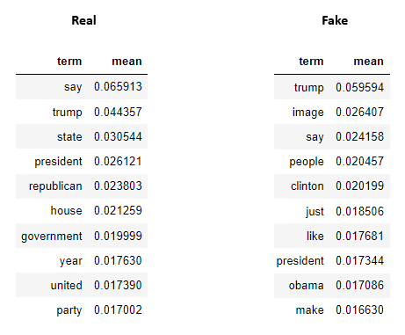

*Table 3. 10 terms highest mean TF-IDF score in real news and fake news*

It can be seen that there is a difference in the nature of words appearing in real news and fake news. For instance, the word “clinton” and “obama” which correspond to political opponents of Trump have higher TF-IDF frequency in fake news. The word “trump” itself appears more frequently in fake news. The author recognizes the possible bias existing in the acquisition of real and fake news articles and does not attempt to make any political statement or conclusion.

**4.2. Comments dataset**

In order to obtain better comparison between algorithms, a harder classification problem is required. Therefore a second dataset is included in this project.

Comments dataset is tougher to classify for two reasons:

1. There is a severe imbalance in the dataset. Only ~9.4% of comments are considered toxic.

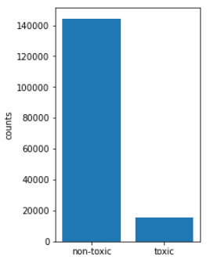

*Figure 3. Distribution of toxic and non-toxic comments*

1. Similar conversational language style in both toxic and non-toxic comments.

**4.2.1. Non-deep learning classification**

Baseline performance was established using BoW and TF-IDF with logistic regression. Linear SVM and RBF-SVM. BoW and TF-IDF vectors are generated with all words found in the corpus after stop-words removal, totalling 179429 features. The following are the validation results:

|  |  |  |  |  |
| --- | --- | --- | --- | --- |
| **Model** | **Accuracy** | **Precision** | **Recall** | **F1-score** |
| Logistic regression, BoW | 0.958 | 0.851 | 0.680 | 0.756 |
| Logistic regression, TF-IDF | 0.954 | 0.923 | 0.571 | 0.706 |
| Linear SVM, BoW | 0.954 | 0.769 | 0.740 | 0.754 |
| Linear SVM, TF-IDF | 0.959 | 0.872 | 0.670 | 0.758 |
| RBF-SVM, BoW | 0.935 | 0.968 | 0.336 | 0.499 |
| RBF-SVM, TF-IDF | 0.957 | 0.923 | 0.601 | 0.728 |

*Table 4. Validation results of baseline linear models*

The models prioritize accuracy and tend to predict non-toxic more as evident from much lower recall compared to precision score. It might be desired to sacrifice precision for higher recall, particularly in the context of comments gatekeeping, especially if there is a manual moderation somewhere in the filtering pipeline. One way to do this is to introduce ‘balanced’ class weight where the weight of a particular class is set to be inversely proportional to its frequency in the dataset. The balanced class weights are 0.553 for non-toxic comments and 5.217 for toxic comments.

|  |  |  |  |  |
| --- | --- | --- | --- | --- |
| **Model (balanced)** | **Accuracy** | **Precision** | **Recall** | **F1-score** |
| Logistic regression, BoW | 0.945 | 0.677 | 0.822 | 0.742 |
| Logistic regression, TF-IDF | 0.943 | 0.662 | 0.838 | 0.739 |
| Linear SVM, BoW | 0.942 | 0.670 | 0.782 | 0.722 |
| Linear SVM, TF-IDF | 0.947 | 0.696 | 0.798 | 0.744 |
| RBF-SVM, BoW | 0.938 | 0.639 | 0.805 | 0.713 |
| RBF-SVM, TF-IDF | 0.959 | 0.839 | 0.714 | 0.771 |

*Table 5. Validation results of models with balanced class weight*

The obvious trend is balanced weight produces higher recall and lower precision. Interestingly, RBF-SVM sees a major F1-score improvement from using TF-IDF and balanced class weight. For further analysis, balanced class weight is focused on.

Analysis of the unigram BoW and TF-IDF terms shows a distinction between non-toxic and toxic comments as shown below. The author apologizes for inappropriate terms displayed.

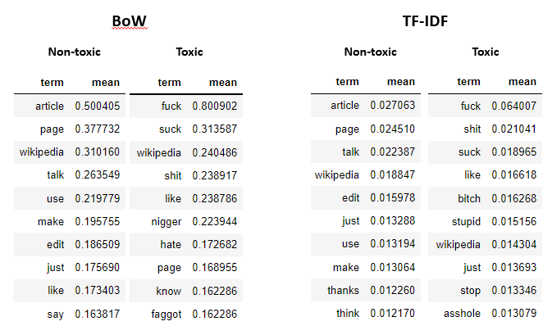

*Table 6. 10 terms highest mean BoW and TF-IDF score in real news and fake news*

Another parameter to look at is the number of features generated by the vectorizer. CountVectorizer and TfidfVectorizer support selection of n features with the highest term frequency across the corpus.

|  |  |  |  |  |
| --- | --- | --- | --- | --- |
| **Model (balanced)** | **Accuracy** | **Precision** | **Recall** | **F1-score** |
| Logistic regression, n=100000 | 0.942 | 0.651 | 0.843 | 0.735 |
| Logistic regression, n=50000 | 0.941 | 0.645 | 0.847 | 0.733 |
| Logistic regression, n=25000 | 0.939 | 0.635 | 0.854 | 0.728 |
| Logistic regression, n=10000 | 0.934 | 0.610 | 0.859 | 0.713 |
| Logistic regression, n=5000 | 0.928 | 0.583 | 0.865 | 0.697 |

|  |  |  |  |  |
| --- | --- | --- | --- | --- |
| **Model (balanced)** | **Accuracy** | **Precision** | **Recall** | **F1-score** |
| Linear SVM, n=100000 | 0.944 | 0.672 | 0.809 | 0.735 |
| Linear SVM, n=50000 | 0.941 | 0.653 | 0.814 | 0.725 |
| Linear SVM, n=25000 | 0.938 | 0.634 | 0.833 | 0.720 |
| Linear SVM, n=10000 | 0.930 | 0.595 | 0.845 | 0.698 |
| Linear SVM, n=5000 | 0.923 | 0.565 | 0.852 | 0.679 |

|  |  |  |  |  |
| --- | --- | --- | --- | --- |
| **Model (balanced)** | **Accuracy** | **Precision** | **Recall** | **F1-score** |
| RBF-SVM, n=100000 | 0.959 | 0.829 | 0.723 | 0.773 |
| RBF-SVM, n=50000 | 0.959 | 0.821 | 0.737 | 0.777 |
| RBF-SVM, n=25000 | 0.959 | 0.806 | 0.749 | 0.776 |
| RBF-SVM, n=10000 | 0.956 | 0.779 | 0.762 | 0.770 |
| RBF-SVM, n=5000 | 0.953 | 0.747 | 0.767 | 0.757 |

*Table 7. Validation results with different number of features generated by TfidfVectorizer*

Recall seems to increase for all algorithms with decreasing number of features, however since the evaluation is not done with cross-validation this trend might be specific for the current training and validation split. RBF-SVM seems to experience lower decay in F1-score as number of features decreases compared to the other two algorithms which is in line with the intuition that RBF-SVM typically suffers from overfitting problem and lowering variance while increasing bias in the model typically affects the model in a positive way.

Since RBF-SVM takes > 50000 iterations to converge, regularization parameters optimization is only done for logistic regression and Linear SVM.

**Regularization parameter optimization**

Logistic regression and Linear SVM were optimized with 5-fold cross validation.

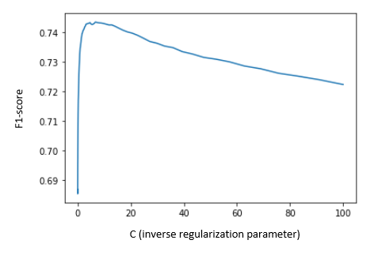

*Figure 4. F-1 score against C for logistic regression*

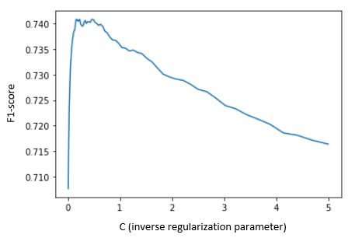

*Figure 5. F-1 score against C for linear SVM*

Optimum C of 6.734 and 0.231 were obtained for logistic regression and linear SVM, respectively. The results of the optimized algorithms on validation set (for comparability with the other models so far) are summarized in the following table.

|  |  |  |  |  |
| --- | --- | --- | --- | --- |
| **Model (balanced)** | **Accuracy** | **Precision** | **Recall** | **F1-score** |
| Logistic regression, optimized | 0.944 | 0.672 | 0.809 | 0.735 |
| Linear SVM, optimized | 0.948 | 0.699 | 0.810 | 0.750 |

*Table 8. Validation results of optimized logistic regression and linear SVM*

Even though the validation F1-scores of optimized algorithms are lower than those of many other algorithms so far, they might generalize better to the test set since they are obtained with cross validation as opposed to just one version of validation set. However, for illustration purpose RBF-SVM with n=50000, which corresponds to the highest F1-score obtained on validation set, is picked as the best model to be compared with BERT (in section 4.2.3).

**4.2.2. BERT**

Three BERT models were trained according to the parameters listed in the methodology section. Token lengths of 128 and 256 were chosen as they seem to be appropriate considering the word count distribution in the training set. The training of each model took >14 hours.

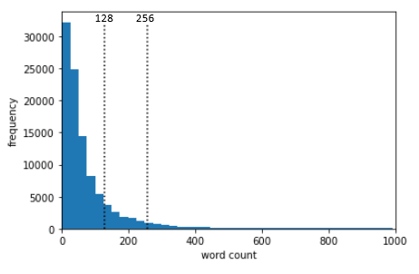

*Figure 4. Word count distribution in the Comments training set*

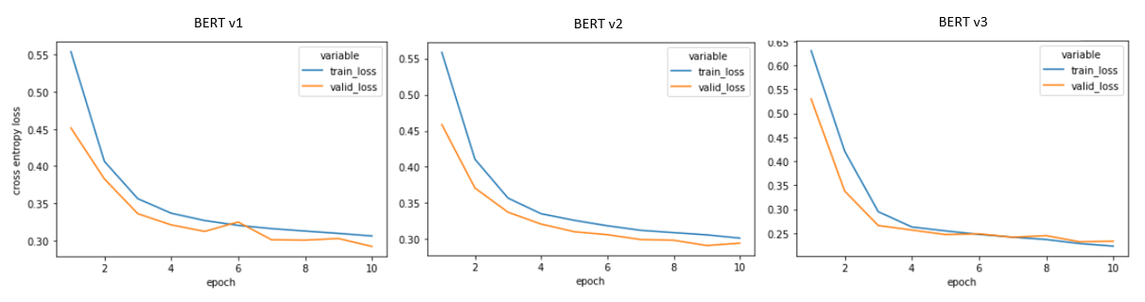Validation losses of the three models are plotted.

*Figure 5. Training and validation losses of three BERT models*

Increasing the number of tokens does not seem to have any significant impact on validation loss. This is possibly due to most comments having fewer than 128 words and hence 256-token features consist of mostly padding tokens which do not add any information to the model.

Unfreezing BERT parameters, however, significantly improves validation loss at the cost of longer training time and the risk of overfitting. Learning rate had to be reduced by a factor of 100 otherwise validation loss shoots back up immediately after the first epoch. This is because backpropagation updates all the weights that are not frozen.

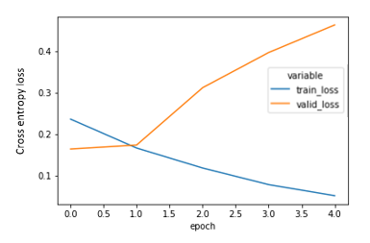

*Figure 6. Preliminary BERT trial with 200 tokens and learning rate of 10-5*

Validation results are summarized in the following table:

|  |  |  |  |  |
| --- | --- | --- | --- | --- |
| **Model** | **Accuracy** | **Precision** | **Recall** | **F1-score** |
| BERT v1 | 0.884 | 0.441 | 0.805 | 0.570 |
| BERT v2 | 0.886 | 0.449 | 0.850 | 0.587 |
| BERT v3 | 0.957 | 0.738 | 0.856 | 0.793 |

*Table 9. Validation results of BERT models*

BERT v3 with parameters (weights) unfrozen and jointly trained together with classification layer produces much better validation results.

**4.2.3. Threshold optimization**

Threshold can be adjusted to yield different classification result. Up until this point default threshold of 0.5 was used. In this section two additional thresholds are explored for the best model, BERT v3:

* Threshold to produce 2447 comments predicted as toxic (2447 is the actual number of toxic comments in validation set)
* Threshold to produce best validation F1-score

To produce 2247 toxic predictions, threshold needs to be shifted to 0.845 as shown in the following plot.

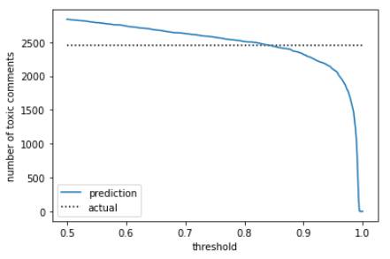

*Figure 7. Number of toxic comments (predicted and actual) with different probability thresholds*

F1-score can also be optimized for the validation set by plotting it against different thresholds.

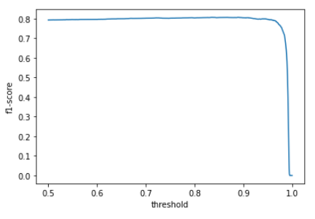

*Figure 8. F1-score with different probability thresholds*

Threshold of 0.891 produced maximum F1-score. BERT v3 validation results with different results are shown below.

|  |  |  |  |  |
| --- | --- | --- | --- | --- |
| **Model** | **Accuracy** | **Precision** | **Recall** | **F1-score** |
| BERT v3, default threshold | 0.957 | 0.738 | 0.856 | 0.793 |
| BERT v3, threshold=0.845 | 0.963 | 0.805 | 0.805 | 0.805 |
| BERT v3, threshold=0.891 | 0.964 | 0.822 | 0.791 | 0.806 |

*Table 9. BERT v3 validation results with different thresholds*

**4.2.4. Test results**

Performance metrics of BERT v3 with different thresholds on test set are summarized in the following table.

|  |  |  |  |  |
| --- | --- | --- | --- | --- |
| **Model** | **Accuracy** | **Precision** | **Recall** | **F1-score** |
| BERT v3, default threshold | 0.955 | 0.732 | 0.836 | 0.780 |
| BERT v3, threshold=0.845 | 0.961 | 0.802 | 0.784 | 0.793 |
| BERT v3, threshold=0.891 | 0.961 | 0.817 | 0.765 | 0.790 |

*Table 10. BERT v3 test results with different thresholds*

**5. CONCLUSION**

BoW or TF-IDF vectorization combined with linear models such as logistic regression, linear SVM and RBF-SVM is sufficient to classify News dataset with test F1-score >0.98.

For Comments dataset, BERT model with unfrozen parameters outperforms logistic regression, linear SVM and RBF-SVMwith F1-score of ~0.8 on validation set and ~0.79 on test set.

There are several other methods that might improve the model’s accuracy. The use of “large” BERT instead of the “base” model used in this project sometimes yield better performance at the expense of longer training time (BERT-large has 24 encoding layers with 336M parameters, while BERT-base has 12 encoding layers with 110M parameters). It has also been reported that introducing additional layers (called adapter) after each transformer block can improve BERT’s predictive power5.

**6. REFERENCES**

1. Harris, Zellig (1954). "Distributional Structure". *Word*. 10 (2/3): 146–62.
2. Spärck Jones, K. (1972). "A Statistical Interpretation of Term Specificity and Its Application in Retrieval". *Journal of Documentation*. 28: 11–21.
3. Ashish Vaswani, Noam Shazeer, Niki Parmar, Jakob Uszkoreit, Llion Jones, Aidan N. Gomez, Lukasz Kaiser, Illia Polosukhin. *Attention Is All You Need.* <https://arxiv.org/abs/1706.03762>
4. BERT English architecture. <https://peltarion.com/knowledge-center/documentation/modeling-view/build-an-ai-model/blocks/english-bert>
5. Sina J. Semnani, Kaushik Ram Sadagopan, Fatma Tlili. BERT-A: Fine-tuning BERT with Adapters and Data Augmentation. <https://web.stanford.edu/class/archive/cs/cs224n/cs224n.1194/reports/default/15848417.pdf>