**To director of {{our_name}}**

**{{our_director}}**

**from Limited Liability Company «Elit Logistic»**

**presented by the General**

**Director Janysh uulu Kalybek**

**Transport request**

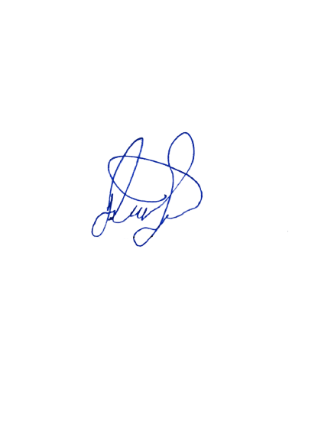On the basis of our Agreement No. {{contract_ip_ozar_number}} dated {{contract_ip_ozar_date}}, which was concluded between us, we ask you to deliver the goods to the address: TURKEY, ISTANBUL, Ikitelli Osb Mah.Isteks Sosyal Tesis Sk.Isteks Sanayi Sosyal Tesis No:1 S Ic Kapi No:27 Basaksehir, since this vehicle is purchased in favor of OZBUHARA DIS TICARETSANAYI LIMITED SIRKETI under agreement No.{{our_contract}} from {{our_date}}.



**Best regards**

**general director of**

|  |  |
| --- | --- |
| **Elite Logistic LLC** | **Janysh uulu Kalybek** |