**Test 1**

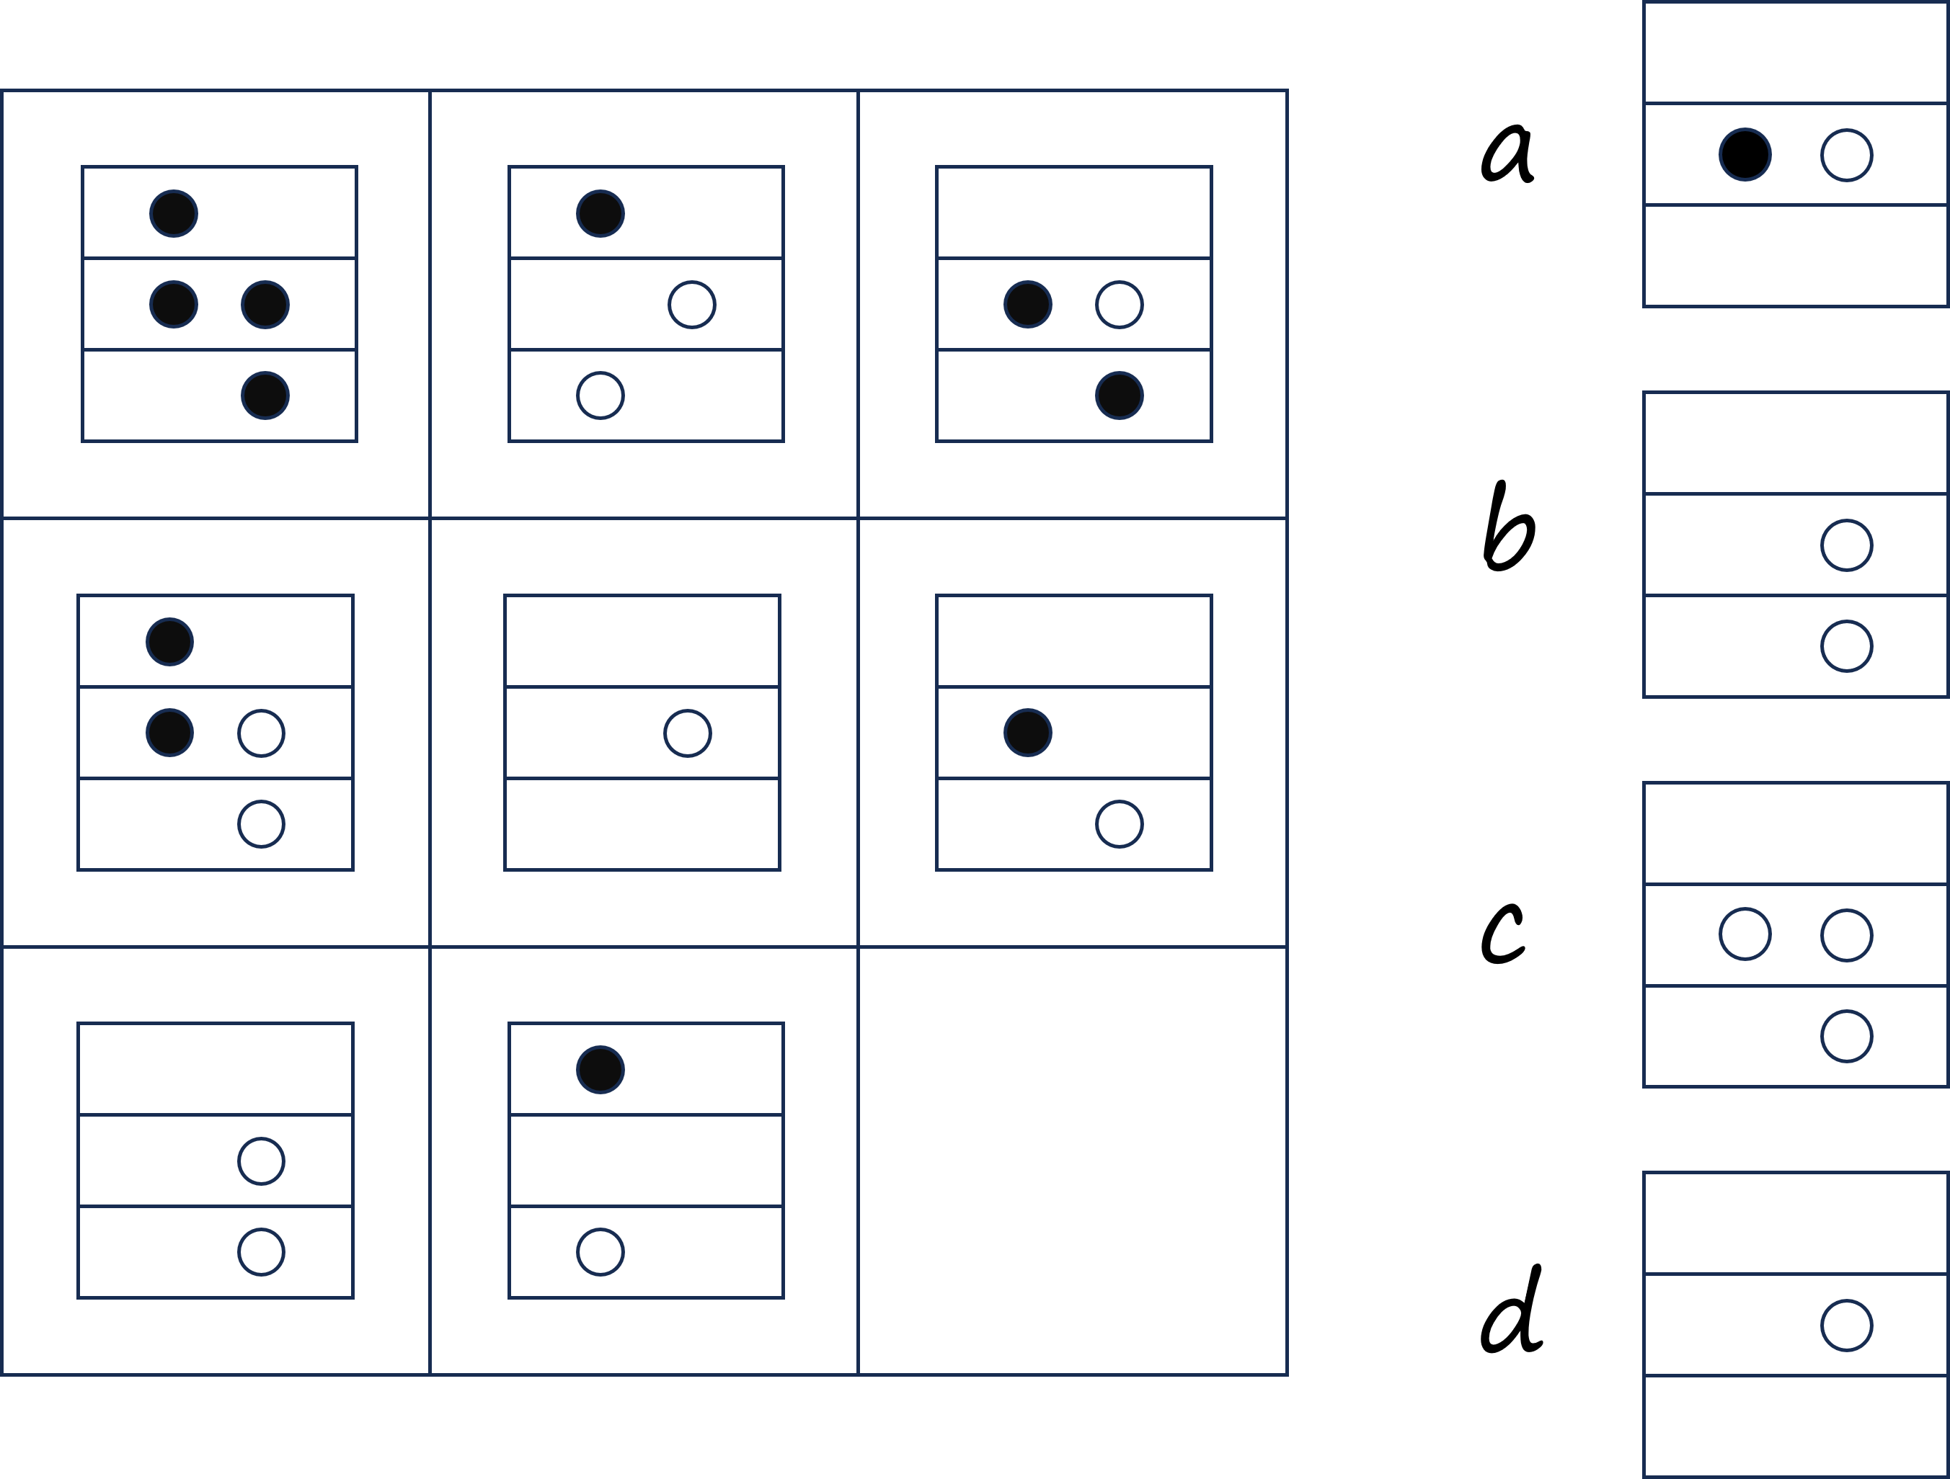Rule: the fulfilled circle equals to 2, the empty circle equals to 1, and the 3rd row equals to the 1st row minus the 2nd row

**Test 2**

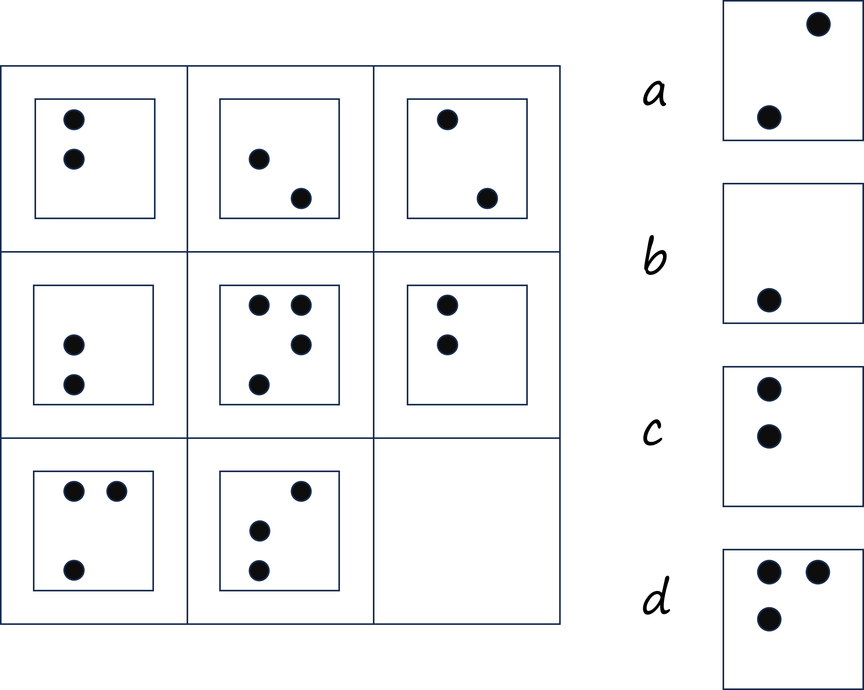Rule: Every fulfilled circle is equal to 1. The matrix is partitioned by row, and the logical computation rules are different for the left and right columns in each element of the matrix. In the left column, 1+1=0+0=0, 1+0=0+1=1. In the right column, 1+1=1, 0+0=1+0=0+1=0.