Homework

A researcher seeks to examine the data from a questionnaire to uncover its underlying structure. The questionnaire consists of 20 questions, completed by 200 participants. The assignment requires you to carry out the following tasks and provide explanations for each:

1. **Perform an exploratory factor analysis (EFA) in SPSS/JASP to determine how many factors can be derived from the 20 items and identify which items correspond to each factor.**

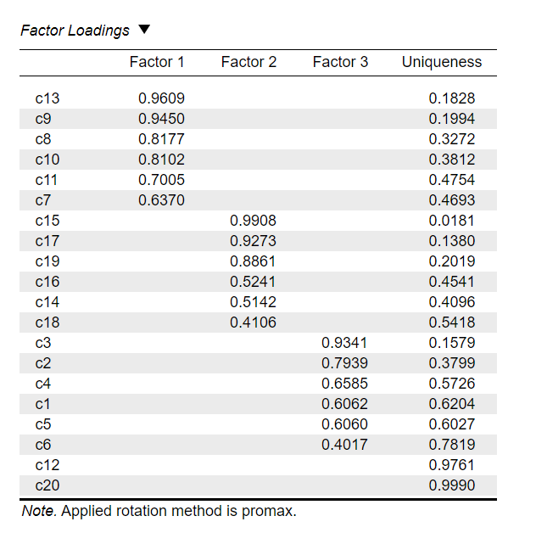Principle Axis Factoring was used to perform an EFA, the number of factors extracted is based on Parallel analysis, rotation method is Promax. 3 factors were derived from the 20 items. C13/9/8/10/11/7 corresponded to Factor 1, C15/17/19/16/14/18 corresponded to Factor 2, C23/2/4/1/5/6 corresponded to Factor 3. However, C12 and C20 had no positive correlation with any of the three factors.

1. **Assess which items are not suitable for the inclusion in the questionnaire and suggest ways to improve it.**

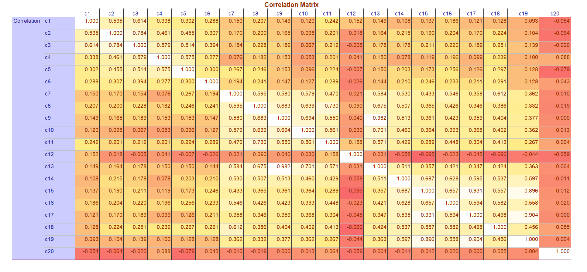Check correlation matrix below, and easily C12 and C20 were identified to have low correlation with other items.

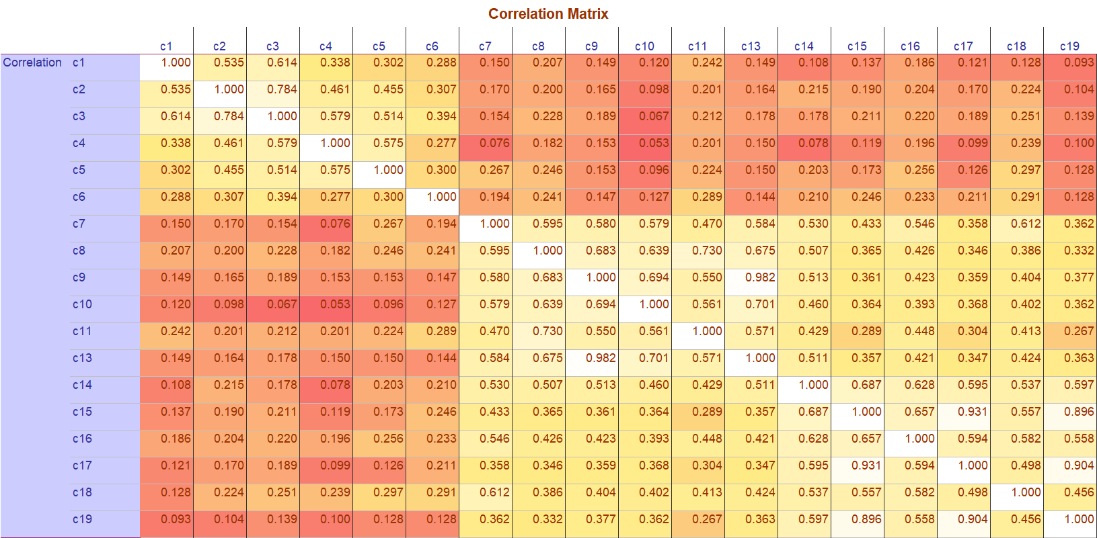Having excluded C12 and C20, the correlation matrix seemed acceptable(see below).

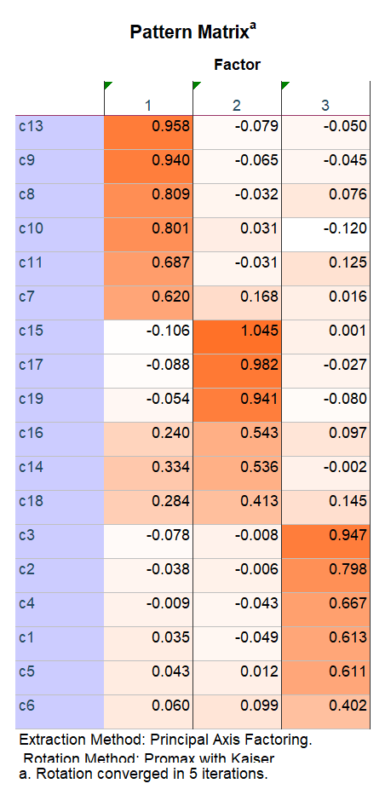Factor analysis(Principle Axis Factoring) was performed on the remaining 18 items, and it was noted that the difference in cross loadings of C18 and C14 (see right) was less than 0.2, so they were deleted. The remaining 16 items passed the KMO test, Bartlett's test, and the MSA values also met the requirements, with the difference of cross loadings greater than 0.2 and the maximum factor loading of each item greater than 0.4.

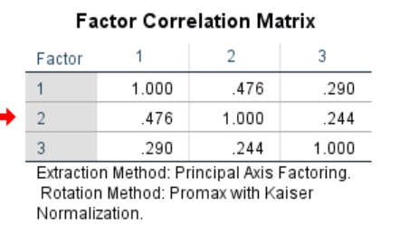Check the Factor correlations matrix, and the result showed that using promax to rotate the axis is appropriate.

1. **Conduct the factor analysis again, excluding the items that were deemed inadequate.**

Exclude C12/C20/C14/C18 and conduct the factor analysis again. The correlation matrix has been shown above, overall MSA is 0.833, each item’s MSA was larger than 0.5, and the result of Bartlett’s Test and Chi-squared Tess were significant.

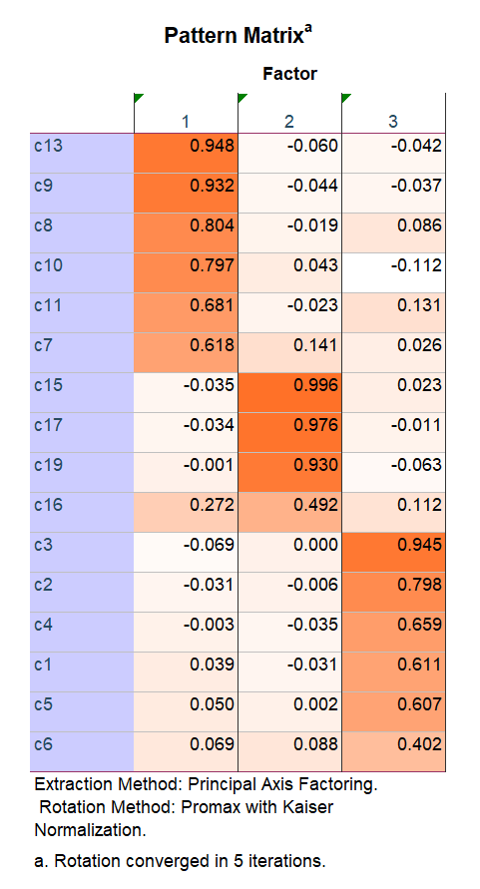Factor loadings are represented below, which clearly shows that 16 items were divided into three groups, each of them corresponding to a latent factor.

1. **Use the regression method to compute factor scores and check their correlations.**

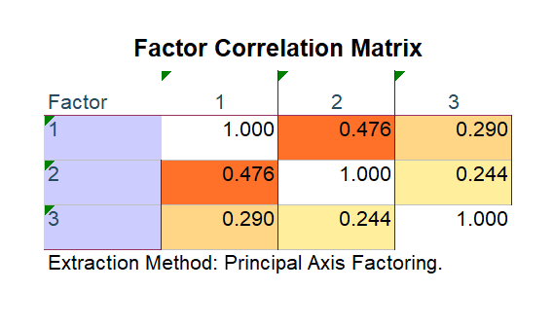The factor correlation matrix which was calculated by SPSS is shown below. So the promax method is appropriate in this case.