**Question 1:**

a) Create a table according to the schema given below. Choose the appropriate data types while creating the table. Insert the records given in Table 1 into the Employee table. And, write SQL queries to satisfy the questions given below.

Employee (Emp_ID, Emp_Name, DoB, Department, Designation, DoJ, Salary)

Here, DoB means Date of Birth, DoJ means Date of Joining.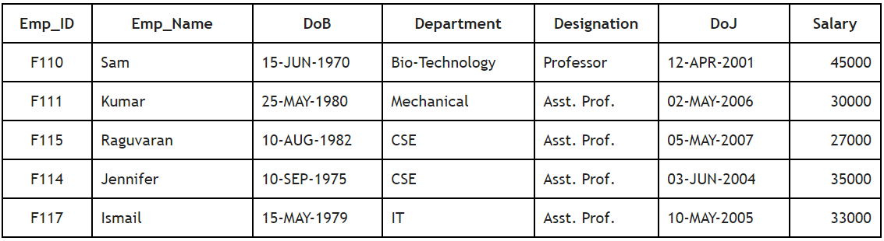

**b) Queries**

1. Display all the records from table Employee.

2. Find all the employees who are working for CSE department.

3. Get the details about the employees who have joined after ’10-JUN-2005’.

4. Find all the employees who earn more than 30000.

5. Get the details of employees who are not ‘Professor’.

6. Find the name, date of birth, and designation of all the employees who work for ‘IT’ department.

7. Find all the departments which are offering a salary above 25000.

8. Get the DoB of the employee named ‘Kumar’.

9. Find the names and departments of employees who earn the salary in the range 20000 to 40000.

10. Find the employee details of any employee who works for ‘CSE’ and earns more than 30000.

**Question 2:**

Consider the relation schemas of a selling database given below. Primary keys of all the tables are underlined.

PART(Part_Number, Part_Description, Quantity_On_Hand, Class, Warehouse, Price)

ORDERLINE(Order_Number, Part_Number_Ordered, Quantity_Ordered, Quoted_Price)

ORDERS(Order_Number, Order_Date, Customer_Number)

CUSTOMER(Customer_Number, Last_Name, First_Name, Street, City, State, Pincode, Balance, Credit_Limit, Sales_Representative_Number)

SALESREP(Sales_Representative_Number, Last_Name, First_Name, Street, City, State, Pincode, Commission, Rate)

**Write SQL Queries to achieve the following;**

1. Display the Part_Number, Part_Description, Quantity_On_Hand, and Price of all the parts in ascending order of Part_Description.

2. List down the Pincode, Last_name, Street, City, and State of every customer in the ascending order of the Pincode.

3. Produce a list showing Part_Number, Part_Description, Quantity_On_Hand, and Price sorted by both Warehouse and Class.

4. List all the records of ORDERLINE by selecting only rows where the Quantity_Ordered is greater than or equal to 2.

5. List all customers’ Last_Name and First_Name whose Credit_Limit is less than or equal to 10000.

6. List the Last_Name and First_Name of customers whose Credit_Limit is greater than or equal to 10000 and Pincode is 649219.

7. Display all the parts that have a Part_Number that begins with ‘B’

8. Find the part number, part description, number of parts ordered and the quoted price for every part that are ordered.

9. List the Part_Number, Part_Description, Quantity_Ordered and Quoted_Price of all the parts whose Part_Number begins with ‘C’

10. Find the order number, date of order, of every order made by customer along with the part numbers, part description, number of parts ordered and the quoted price of the part.

11. List the Order_Number, Order_Date, Part_Number, Part_Description, Quantity_Ordered and Quoted_Price of all the orders where the minimum quantity ordered is at least 10.

12.Find the Customer’s Last_Name and First_Name followed by the Order_Number, Part_Description and Quantity_Ordered for all of his orders.

**Question 3:**

## Consider a relation REPAYMENT with the following schema;

## 

## REPAYMENT(BORROWER_ID, NAME, ADDRESS, LOANAMOUNT, REQUESTDATE, REPAYMENT_DATE, REPAYMENT_AMOUNT)

## 

## Assume that this table records the repayment of loans by the borrowers. A borrower may have multiple entries if he/she has paid multiple installments. Write SQL statements (queries) to achieve the following;

## 

## Question (a)

## Find all the records with information on repayments from the borrower with id equal to 42, and where the lent amount exceeds 1000.

Question (b)

Find the total amount repaid for every address in the repayment table.

Question (c)

Delete all information on the completed loans. (Note: you can find the status of the loan by summing the total repaid amount. If the total repaid amount is equal to the loan amount, then you would say that the loan is ended.)

Question (d)

Find all the borrower names who have a unique address. (ie., you should not count the borrowers who are from the same address)

Question (e)

Find the total number of repayments made by every borrower.

**Question 4:**

Consider the following relations; primary key attributes are underlined.

Product(productCode, productName, productCategory, productDescription)

Manufacturer(manuCode, manufacturerName, city, Phone)

Supply(manuCode, productCode, storeID, wholesaleUnitPrice, quantity)

Store(storeID, storeName, phoneNumber , city)

Write the SQL queries to answer the following questions. You can assume appropriate data types for the columns. Note: do not use the aggregation functions in SQL for these questions.

a) Find names of all stores that are in the city of “Pittsburgh”.

b) Find the name of the manufacturer that supplies the largest quantity of any product.

c) Find the names and the cities of all manufacturers that supply any product of more than 100 units whose wholesale unit price is greater than 50.

d) Find the names of store-manufacturer pairs where the store and the manufacturer in each pair is located in the same city and there is a supply record of the manufacturer whose total cost (i.e. unit price multiplied by quantity) is greater than 10,000.

e) Find the store name, city, and product name of all the products whose wholesale unit price is less than 100 and the city is not “Allentown”.