Quantization基础
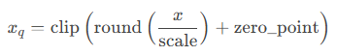
Weight and Activation
Per-tensor, Per-channel, Per-tensor
W8A16
Weight 8 Bit
Activation 16 bit
这里activation怎么理解？不是Activation函数，而是指的output
比如，input x BF16，Wx, 矩阵乘法int8 x int8，而后output dequant成BF16

CLE
Bias Correction

Quantization schemes for LLM/LVM Transformers
1.1. Language model quantization scheme
In general, we apply w4a16kv8 quantization with several mixed precision (MP) for language Transformer model in LLM/LVM:
- (w4) Decoder linear layers weights: 4-bits per-channel for all decoder linear layers.
- (a16) Output activations: 16-bits per-tensor for all activations except the KV cache activations.
- (kv8) KV cache activations (blue background in table): 8-bits per-tensor, required for Genie on-target execution.
- (MP) lm-head weights: 8-bits for accuracy purpose (reducing to 4-bits leads to large accuracy drop, need further study for accuracy recovery).
- (MP) Embedding weights: 16-bits by default, can reduce to 8-bits if accuracy still preserves.
- (MP) Layer/RMSNorm weights: 16-bits by default, can reduce to 8-bits if accuracy still preserves.
1.2. Vision model quantization scheme
In general, we apply w8a16 quantization for vision Transformer model in LVM, with the following notes:
- Linear layer weights: We found w4 quantization leads to large accuracy drop on ViT in LVM, so w8 is applied as default. But it is possible to reduce to 4-bits with LiteMP/AMP, or algorithms like SeqMSE (further study required).
- Layer/RMSNorm weights: 8-bits by default following the w8 scheme, but can move to 16-bits if 8-bits is not sufficient to preserve accuracy.
- MatMul input activations: ViT does not have KV cache so 16x8 bits for MatMul inputs (note that the 8-bits 2nd input also leads to 8-bits output of k/v-proj) is not necessary. But currently we still use 16x8 in our ViT notebooks since using 16x16 requires “use_dynamic_16_bit_weights“ flag duringqairt-quantizer step, which currently has bugs/issues when applying it (any documentation on this issue in GR00T?).

Types | Layers | Bitwidth | Symmetric | Granularity | Reason
Weights | Linear layers | 4 / 8 | Symmetric | Per-channel
Weights | Layer/RMS Norm | 16 / 8 | Asymmetric | Per-tensor | Accuracy: output goes to residual, escalate
Weights | Embedding | 16 / 8 | Asymmetric | Per-tensor | Non-zero mean, reduce memory
Weights | LM-head | 8 | Symmetric | Per-channel | Linear MatMul/Conv faster
Activation | Output activations | 16 | Asymmetric | Per-tensor | Accuracy
Activation | KV cache | 8 | Symmetric | Per-tensor | Save Memory
Activation | MatMul input 1 | 16 | Asymmetric | Per-tensor | 要过Softmax
Activation | MatMul input 2 (kv) | 8 | Symmetric | Per-tensor | 在和V Cache点乘时INT8 * INT8 Hardware Path
 | self_attn_Concat | 8 | Symmetric |  | Not reused, Enables INT8 × INT8 GEMM in output projection

Exceptions
Propagate_output_encodings:
Wherever the graph has a Concat op (e.g. joining new K/V with cached K/V, or joining rotary cos/sin halves), this forces all of that Concat's input quantizers to share the exact same scale/offset as its output quantizer. Without this, each input to a Concat could get its own independently-calibrated encoding, and concatenating tensors with different scales mid-graph introduces representational mismatch (effectively wasted precision, since the concat output has to be re-quantized to a single scale anyway). This keeps the KV-cache concatenation numerically consistent across cache steps.

Embedding
Asym A16, later modify to 8 bit

RMSNorm
Per-tensor, per-channel is over-kill, asym A16

RMSNorm quantization
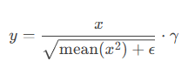
- x: residual stream activation (FP16)
- γ (gamma): learned scale vector (one value per hidden dim)
RMSNorm is a global normalization followed by a uniform rescaling.
RMSNorm assumes:
- The normalization term is shared across all channels
- The scale γ only adjusts relative feature importance, not the normalization structure
If per-channel quantization: γ[0], γ[1], γ[2], ..., γ[H−1] each get their own scale
Per‑channel quantization introduces:
- Different quantization noise per channel
- Implicit re‑normalization after RMSNorm
- Channel‑dependent distortion of residual stream
This causes:
- Residual imbalance
- Layer‑to‑layer drift
- Accumulating error across transformer depth
RMSNorm takes Per-tensor.

Gate_up MLP in MLP
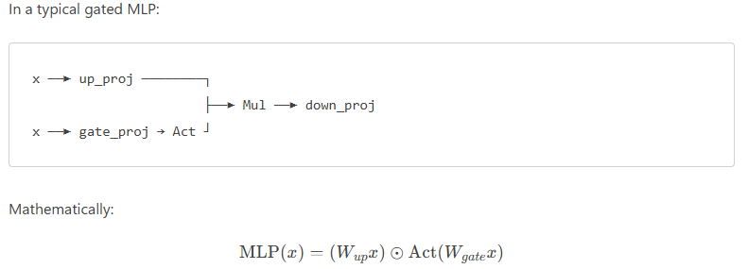
SiLU / GELU / SwiGLU的Act会造成Heavy tails，生成outlier，INT8的精度不够，如果整体的Act精度INT8，MLP的Mul要手动调成16

Quantization Recipe for Qwen3 Embedding Model

Base precision (QuantizationSimModel, QuantScheme.post_training_tf, config htp_quantsim_config_v81.json):W8A16

Layer-specific overrides on top of that base:
Component Setting
K/V matmul second input (8-bit symmetric trick) disabled (commented out)
Concat op encoding unification enabled (propagate_output_encodings)
Mixed precision config exceptions_mlp4_16x16.json
Embedding table 8-bit (EMBEDDING_TABLE_BITWIDTH=8)
RMSNorm weight quantizer forced to per-tensor, 16-bit asymmetric
LPBQ block quantization enabled (APPLY_DECODER_LPBQ=True) — took decoder Conv2d weights that were 8-bit and re-quantized them to 4-bit, block_size=32, decompressed_bw=8, symmetric
SeqMSE enabled — 40 batches, 20 candidates, symqt, MSE loss
Calibration 100 batches from T2Retrieval
Weight clipping (clip_weights_to_7f7f) always applied
Global activation clipping disabled
AdaScale pre-quantization tuning skipped (SKIP_ADASCALE=True)

Net effect: this was already an effectively W4A16 mixed-precision recipe in practice — the "8-bit" default_param_bw was just the starting point that LPBQ then overrode down to 4-bit for most decoder weights, while embedding stayed 8-bit and everything else 16-bit. It wasn't a clean, uniform W4A16 test.

SeqMSE
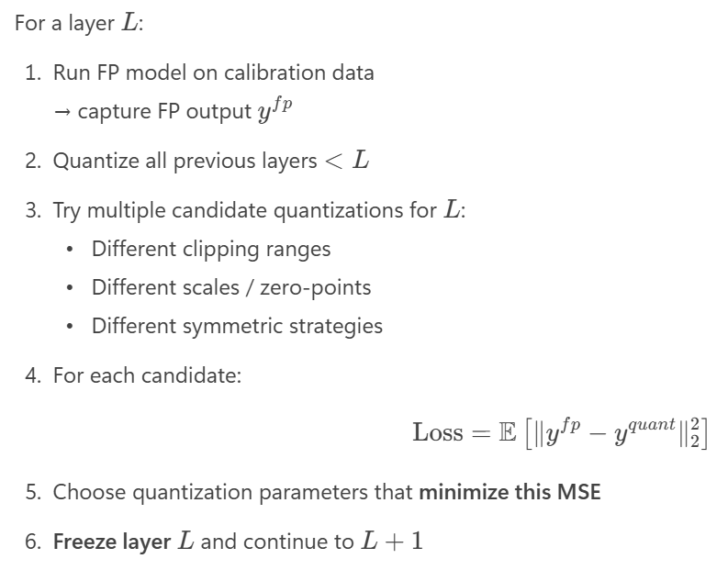
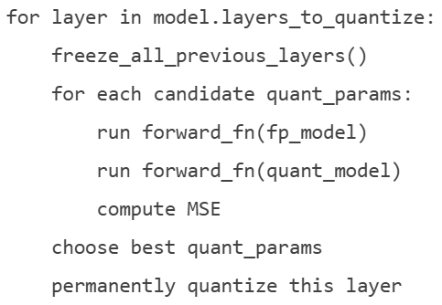

LPBQ
Low‑Precision Blockwise Quantization
hybrid quantization scheme where Weights are stored in very low precision (INT4) But decompressed or accumulated at higher precision (INT8). Also, it splits weights into small contiguous blocks like 64 in channel dimension
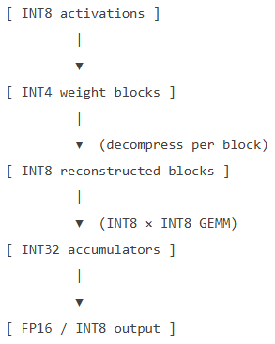
相比每个输出channel一组scale，分成64的block，每个block一组scale（根据block内最大的magnitude range）。但是这样多储存了很多block自己的scale，因此可以用一个channel scale配合每个block一个multiplier，multiplier就可以以很低的精度储存。
高通LPBQ：
Apply LPBQ if:
- It’s a quantized Conv2d (Linear layer)
- It is already INT4
- It is not a hadamard / rotation / special mixing layer
通常不对lm_head做LPBQ或者SeqMSE

AdaScale
Quantization often preserve direction (cosine similarity high) but distort length/magnitude (L2 Norm)
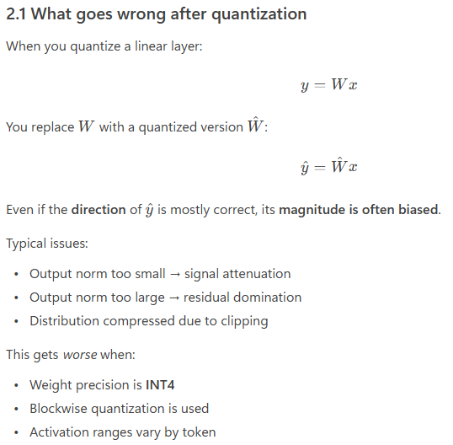
Adascale在quantized output上，额外乘上训练得到的scale，调整可能的magnitude偏差。Adascale fixes aggressive quantization, for example int4 quantization.
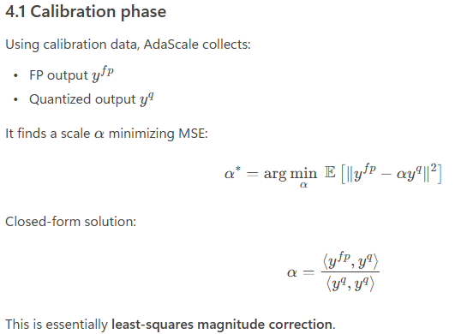

OmniQuant

SpinQuant

PrefixQuant

TurboQuant

Hadamard

SmoothQuant

AWQ: Activation-aware Weight Quantization
W4A16 only, A remain 16b; requires on-the-fly dequant int4 -> fp16 for activations

