Qwen2.5 Omni

Video实例
一个11分30秒的video
Audio部分
Temporal_patch_size = 2, sampling rate 16k, hop_size = 160
实际token数量 11.31秒 * 16k / 160 = 1131, [128, 1131], pad成[129, 30000]
这里sampling rate和hop_size的滑动窗口保证了一秒100个token。
之后，进行下采样audio_len = ((audio_seqlens[audio_idx] - 1) // 2 + 1 - 2) // 2 + 1
这样实际1秒tokens数量25，对应论文中的1个token 40ms，固定！
[128, 1131]进入Encoder
Chunk [6, 200, 128] 最后一个是remainder+padding 200的chunk size乃是 2* n_window (100)
两层Conv padded_embed = nn.functional.gelu(self.conv1(padded_feature)) * padded_mask
padded_embed = nn.functional.gelu(self.conv2(padded_embed)).transpose(1, 2)
self.conv1 = nn.Conv1d(self.num_mel_bins=128, embed_dim=1280, kernel_size=3, padding=1, stride=1)
self.conv2 = nn.Conv1d(embed_dim, embed_dim, kernel_size=3, stride=2, padding=1)
Conv1之后 [6, 1280, 200]
Conv2之后[6, 1280, 100] transpose [6, 100, 1280]
remove padding，实际得到[566, 1280]，放到Transformer Encoder中
再次Chunk, [6, 100, 1280] 最后一个chunk remainder 66
Average Pooling [6, 50, 1280] nn.AvgPool1d(2, stride=2) 合并chunks 实际得到[283, 1280]
Projection [283， 2048]
Encoder之后[283, 2048]

Video部分，preprocess就会抽样成1 FPS，2FPS除以temporal_patch_size = 1 FPS，故此Video本身数据就抽成了1FPS
Patch 14, spacial_merge 2, 1120x2016 / 28 = 40x72, temporal按照秒为单位, video_grid_thw = [11, 40, 72]
Preprocess后pixel_values_video = [31680 x 1176], 31680 = 11x 40 x 72, 1176 patch dim = 14 x 14 x3 x 2
Tokens_per_seconds固定25, matching 1 t / 40 ms
T_index = [0, 25, .. 250], 11 counts
Audio [0,1,2,...283], 25 tokens 1 s
接下来，video的position id按照THW三个维度各自create然后stack
这里h w再次用spatial_merge_size 缩放，h=20，w=36
T[0, 0, 0…… 0, 0, 0…25] 0-25 720个tokens
H[0, 0, 0…… 0, 1, 1… ]
W[0, 1, 2……35, 0, 1… ]
接下来chunk 2S
Audio 0-50, 50-100 + start_idx
Video 0-1440 + start_idx, 1440 = 20x36x2, 2是因为两秒

TMRoPE
def get_rope_index(
self,
input_ids: Optional[torch.LongTensor] = None,
image_grid_thw: Optional[torch.LongTensor] = None,
video_grid_thw: Optional[torch.LongTensor] = None,
attention_mask: Optional[torch.Tensor] = None,
use_audio_in_video: bool = False,
audio_seqlens: Optional[torch.LongTensor] = None,
second_per_grids: Optional[torch.Tensor] = None,
) -> tuple[torch.Tensor, torch.Tensor]:
"""
Calculate the 3D rope index based on image and video's temporal, height and width in LLM.

Explanation:
Each embedding sequence contains vision embedding and text embedding or just contains text embedding.

For pure text embedding sequence, the rotary position embedding has no difference with modern LLMs.
Examples:
input_ids: [T T T T T], here T is for text.
temporal position_ids: [0, 1, 2, 3, 4]
height position_ids: [0, 1, 2, 3, 4]
width position_ids: [0, 1, 2, 3, 4]

For vision and text embedding sequence, we calculate 3D rotary position embedding for vision part
and 1D rotary position embedding for text part.
Examples:
Temporal (Time): 3 patches, representing different segments of the video in time.
Height: 2 patches, dividing each frame vertically.
Width: 2 patches, dividing each frame horizontally.
We also have some important parameters:
fps (Frames Per Second): The video's frame rate, set to 1. This means one frame is processed each second.
tokens_per_second: This is a crucial parameter. It dictates how many "time-steps" or "temporal tokens" are conceptually packed into a one-second interval of the video. In this case, we have 25 tokens per second. So each second of the video will be represented with 25 separate time points. It essentially defines the temporal granularity.
temporal_patch_size: The number of frames that compose one temporal patch. Here, it's 2 frames.
interval: The step size for the temporal position IDs, calculated as tokens_per_second * temporal_patch_size / fps. In this case, 25 * 2 / 1 = 50. This means that each temporal patch will be have a difference of 50 in the temporal position IDs.
input_ids: [V V V V V V V V V V V V T T T T T], here V is for vision.
vision temporal position_ids: [0, 0, 0, 0, 50, 50, 50, 50, 100, 100, 100, 100]
vision height position_ids: [0, 0, 1, 1, 0, 0, 1, 1, 0, 0, 1, 1]
vision width position_ids: [0, 1, 0, 1, 0, 1, 0, 1, 0, 1, 0, 1]
text temporal position_ids: [101, 102, 103, 104, 105]
text height position_ids: [101, 102, 103, 104, 105]
text width position_ids: [101, 102, 103, 104, 105]
Here we calculate the text start position_ids as the max vision position_ids plus 1.

Args:
input_ids (`torch.LongTensor` of shape `(batch_size, sequence_length)`):
Indices of input sequence tokens in the vocabulary. Padding will be ignored by default should you provide
it.
image_grid_thw (`torch.LongTensor` of shape `(num_images, 3)`, *optional*):
The temporal, height and width of feature shape of each image in LLM.
video_grid_thw (`torch.LongTensor` of shape `(num_videos, 3)`, *optional*):
The temporal, height and width of feature shape of each video in LLM.
attention_mask (`torch.Tensor` of shape `(batch_size, sequence_length)`, *optional*):
Mask to avoid performing attention on padding token indices. Mask values selected in `[0, 1]`:

- 1 for tokens that are **not masked**,
- 0 for tokens that are **masked**.
use_audio_in_video (`bool`, *optional*):
If set to `True`, use the audio in video.
audio_seqlens (`torch.LongTensor` of shape `(num_audios)`, *optional*):
The length of feature shape of each audio in LLM.
second_per_grids (`torch.LongTensor` of shape `(num_videos)`, *optional*):
The time interval (in seconds) for each grid along the temporal dimension in the 3D position IDs.

Returns:
position_ids (`torch.LongTensor` of shape `(3, batch_size, sequence_length)`)
mrope_position_deltas (`torch.Tensor` of shape `(batch_size)`)
"""
spatial_merge_size = self.spatial_merge_size
image_token_id = self.config.image_token_id
video_token_id = self.config.video_token_id
audio_token_id = self.config.audio_token_id
vision_start_token_id = self.config.vision_start_token_id
audio_start_token_id = self.config.audio_start_token_id
position_id_per_seconds = self.config.position_id_per_seconds
seconds_per_chunk = self.config.seconds_per_chunk

mrope_position_deltas = []
if input_ids is not None and (image_grid_thw is not None or video_grid_thw is not None):
total_input_ids = input_ids
if attention_mask is not None:
attention_mask = attention_mask == 1
position_ids = torch.ones(
3,
input_ids.shape[0],
input_ids.shape[1],
dtype=input_ids.dtype,
device=input_ids.device,
)
image_idx, video_idx, audio_idx = 0, 0, 0
for i, input_ids in enumerate(total_input_ids):
if attention_mask is not None:
input_ids = input_ids[attention_mask[i]]
image_nums, video_nums, audio_nums = 0, 0, 0
vision_start_indices = torch.argwhere(input_ids == vision_start_token_id).squeeze(1)
vision_tokens = input_ids[vision_start_indices + 1]
audio_nums = torch.sum(input_ids == audio_start_token_id)
image_nums = (vision_tokens == image_token_id).sum()
video_nums = (
(vision_tokens == audio_start_token_id).sum()
if use_audio_in_video
else (vision_tokens == video_token_id).sum()
)
input_tokens = input_ids.tolist()
llm_pos_ids_list: list = []
st = 0
remain_images, remain_videos, remain_audios = image_nums, video_nums, audio_nums
multimodal_nums = (
image_nums + audio_nums if use_audio_in_video else image_nums + video_nums + audio_nums
)
for _ in range(multimodal_nums):
st_idx = llm_pos_ids_list[-1].max() + 1 if len(llm_pos_ids_list) > 0 else 0
if image_token_id in input_tokens and remain_images > 0:
#haoren 按照token_id定位
ed_image = input_tokens.index(image_token_id, st)
else:
ed_image = len(input_tokens) + 1
if video_token_id in input_tokens and remain_videos > 0:
ed_video = input_tokens.index(video_token_id, st)
else:
ed_video = len(input_tokens) + 1
if audio_token_id in input_tokens and remain_audios > 0:
ed_audio = input_tokens.index(audio_token_id, st)
else:
ed_audio = len(input_tokens) + 1
#haoren 定位先开始的
min_ed = min(ed_image, ed_video, ed_audio)
if min_ed == ed_audio:
text_len = min_ed - st - 1
if text_len != 0: #haoren 前有text，先appendtext
st_idx = llm_pos_ids_list[-1].max() + 1 if len(llm_pos_ids_list) > 0 else 0
#haoren 这里要 text psoition id + st_idx
llm_pos_ids_list.append(torch.arange(text_len).view(1, -1).expand(3, -1) + st_idx)

st_idx = llm_pos_ids_list[-1].max() + 1 if len(llm_pos_ids_list) > 0 else 0
bos_len = 1
llm_pos_ids_list.append(torch.arange(bos_len).view(1, -1).expand(3, -1) + st_idx)

st_idx = llm_pos_ids_list[-1].max() + 1 if len(llm_pos_ids_list) > 0 else 0
#这一步是down sampling
audio_len = ((audio_seqlens[audio_idx] - 1) // 2 + 1 - 2) // 2 + 1
llm_pos_ids = torch.arange(audio_len).view(1, -1).expand(3, -1) + st_idx
llm_pos_ids_list.append(llm_pos_ids)

st_idx = llm_pos_ids_list[-1].max() + 1 if len(llm_pos_ids_list) > 0 else 0
eos_len = 1
llm_pos_ids_list.append(torch.arange(eos_len).view(1, -1).expand(3, -1) + st_idx)

st += text_len + bos_len + audio_len + eos_len
audio_idx += 1
remain_audios -= 1

elif min_ed == ed_image:
text_len = min_ed - st - 1
if text_len != 0:
st_idx = llm_pos_ids_list[-1].max() + 1 if len(llm_pos_ids_list) > 0 else 0
llm_pos_ids_list.append(torch.arange(text_len).view(1, -1).expand(3, -1) + st_idx)

st_idx = llm_pos_ids_list[-1].max() + 1 if len(llm_pos_ids_list) > 0 else 0
bos_len = 1
llm_pos_ids_list.append(torch.arange(bos_len).view(1, -1).expand(3, -1) + st_idx)

st_idx = llm_pos_ids_list[-1].max() + 1 if len(llm_pos_ids_list) > 0 else 0
#haoren image_grid_thw=[t,h,w], 图片的t可以当作1
grid_t = image_grid_thw[image_idx][0]
grid_hs = image_grid_thw[:, 1]
grid_ws = image_grid_thw[:, 2]
#haoren 对于图片grid_t = 1的情况，t_index = 0
t_index = (torch.arange(grid_t) * 1 * position_id_per_seconds).long()
llm_pos_ids = self.get_llm_pos_ids_for_vision(
st_idx, image_idx, spatial_merge_size, t_index, grid_hs, grid_ws
)
image_len = image_grid_thw[image_idx].prod() // (spatial_merge_size**2)
llm_pos_ids_list.append(llm_pos_ids)

st_idx = llm_pos_ids_list[-1].max() + 1 if len(llm_pos_ids_list) > 0 else 0
eos_len = 1
llm_pos_ids_list.append(torch.arange(eos_len).view(1, -1).expand(3, -1) + st_idx)

st += text_len + bos_len + image_len + eos_len
image_idx += 1
remain_images -= 1

elif min_ed == ed_video and not use_audio_in_video:
text_len = min_ed - st - 1
if text_len != 0:
st_idx = llm_pos_ids_list[-1].max() + 1 if len(llm_pos_ids_list) > 0 else 0
llm_pos_ids_list.append(torch.arange(text_len).view(1, -1).expand(3, -1) + st_idx)

st_idx = llm_pos_ids_list[-1].max() + 1 if len(llm_pos_ids_list) > 0 else 0
bos_len = 1
llm_pos_ids_list.append(torch.arange(bos_len).view(1, -1).expand(3, -1) + st_idx)

st_idx = llm_pos_ids_list[-1].max() + 1 if len(llm_pos_ids_list) > 0 else 0
grid_t = video_grid_thw[video_idx][0]
grid_hs = video_grid_thw[:, 1]
grid_ws = video_grid_thw[:, 2]
t_index = (
torch.arange(grid_t) * second_per_grids[video_idx].cpu().float() * position_id_per_seconds
).long()
llm_pos_ids = self.get_llm_pos_ids_for_vision(
st_idx, video_idx, spatial_merge_size, t_index, grid_hs, grid_ws
)
video_len = video_grid_thw[video_idx].prod() // (spatial_merge_size**2)
llm_pos_ids_list.append(llm_pos_ids)

st_idx = llm_pos_ids_list[-1].max() + 1 if len(llm_pos_ids_list) > 0 else 0
eos_len = 1
llm_pos_ids_list.append(torch.arange(eos_len).view(1, -1).expand(3, -1) + st_idx)

st += text_len + bos_len + video_len + eos_len
video_idx += 1
remain_videos -= 1

elif min_ed == ed_video and use_audio_in_video:
#haoren [TEXT] [BOS_v] [BOS_a] → interleaved (video chunks + audio chunks) → [EOS_v] [EOS_a]
text_len = min_ed - st - 2
if text_len != 0:
st_idx = llm_pos_ids_list[-1].max() + 1 if len(llm_pos_ids_list) > 0 else 0
llm_pos_ids_list.append(torch.arange(text_len).view(1, -1).expand(3, -1) + st_idx)

st_idx = llm_pos_ids_list[-1].max() + 1 if len(llm_pos_ids_list) > 0 else 0
bos_len = 1
llm_pos_ids_list.append(torch.arange(bos_len).view(1, -1).expand(3, -1) + st_idx)
llm_pos_ids_list.append(torch.arange(bos_len).view(1, -1).expand(3, -1) + st_idx)
#haoren 得到audio pos ids和audio部分相同
st_idx = llm_pos_ids_list[-1].max() + 1 if len(llm_pos_ids_list) > 0 else 0
audio_len = ((audio_seqlens[audio_idx] - 1) // 2 + 1 - 2) // 2 + 1
audio_llm_pos_ids = torch.arange(audio_len).view(1, -1).expand(3, -1) + st_idx
grid_t = video_grid_thw[video_idx][0]
grid_hs = video_grid_thw[:, 1]
grid_ws = video_grid_thw[:, 2]
#haoren 得到video pos ids，其中one temporal ID corresponds to 40ms，所以position_id_per_seconds=25, second_per_grid = 1，3个frames这样t_index[0,25,50]
t_index = (
torch.arange(grid_t) * second_per_grids[video_idx].cpu().float() * position_id_per_seconds
).long()
video_llm_pos_ids = self.get_llm_pos_ids_for_vision(
st_idx, video_idx, spatial_merge_size, t_index, grid_hs, grid_ws
)
#haoren TMRoPE在Audio in Video的处理，切成2秒的chunk, t_ntoken_per_chunk是每个chunk span多少token, 假设25*2=50
t_ntoken_per_chunk = int(position_id_per_seconds * seconds_per_chunk)
#切割成2秒的chunk
video_chunk_indexes = self.get_chunked_index(video_llm_pos_ids[0], t_ntoken_per_chunk, st_idx)
audio_chunk_indexes = self.get_chunked_index(audio_llm_pos_ids[0], t_ntoken_per_chunk, st_idx)
sub_len = 0
#haoren [video_chunk_0][audio_chunk_0] [video_chunk_1][audio_chunk_1]
for j in range(max(len(video_chunk_indexes), len(audio_chunk_indexes))):
video_chunk_index = video_chunk_indexes[j] if j < len(video_chunk_indexes) else None
audio_chunk_index = audio_chunk_indexes[j] if j < len(audio_chunk_indexes) else None
if video_chunk_index is not None:
sub_len += video_chunk_index[1] - video_chunk_index[0]

llm_pos_ids_list.append(
video_llm_pos_ids[:, video_chunk_index[0] : video_chunk_index[1]]
)
if audio_chunk_index is not None:
sub_len += audio_chunk_index[1] - audio_chunk_index[0]

llm_pos_ids_list.append(
audio_llm_pos_ids[:, audio_chunk_index[0] : audio_chunk_index[1]]
)
video_len = video_grid_thw[video_idx].prod() // (spatial_merge_size**2)

st_idx = llm_pos_ids_list[-1].max() + 1 if len(llm_pos_ids_list) > 0 else 0
eos_len = 1
llm_pos_ids_list.append(torch.arange(eos_len).view(1, -1).expand(3, -1) + st_idx)
llm_pos_ids_list.append(torch.arange(eos_len).view(1, -1).expand(3, -1) + st_idx)

st += text_len + bos_len * 2 + audio_len + video_len + eos_len * 2

audio_idx += 1
video_idx += 1
remain_videos -= 1
remain_audios -= 1

if st < len(input_tokens):
st_idx = llm_pos_ids_list[-1].max() + 1 if len(llm_pos_ids_list) > 0 else 0
text_len = len(input_tokens) - st
llm_pos_ids_list.append(torch.arange(text_len).view(1, -1).expand(3, -1) + st_idx)

llm_positions = torch.cat(llm_pos_ids_list, dim=1).reshape(3, -1)

if attention_mask is not None:
position_ids[..., i, attention_mask[i]] = llm_positions.to(position_ids.device)
else:
position_ids[..., i, :] = llm_positions.to(position_ids.device)
mrope_position_deltas.append(llm_positions.max() + 1 - len(input_ids))
mrope_position_deltas = torch.tensor(mrope_position_deltas).unsqueeze(1).to(device=input_ids.device)

return position_ids, mrope_position_deltas
else:
position_ids = attention_mask.long().cumsum(-1) - 1
position_ids.masked_fill_(attention_mask == 0, 1)
position_ids = position_ids.unsqueeze(0).expand(3, -1, -1).to(attention_mask.device)
max_position_ids = position_ids.max(0, keepdim=False)[0].max(-1, keepdim=True)[0]
mrope_position_deltas = max_position_ids + 1 - torch.sum(attention_mask, dim=-1, keepdim=True)

return position_ids, mrope_position_deltas

def get_llm_pos_ids_for_vision(
self,
start_idx: int,
vision_idx: int,
spatial_merge_size: int,
t_index: list[int],
grid_hs: list[int],
grid_ws: list[int],
):
llm_pos_ids_list = []
#haoren spatial merging/downsampling 每一个token代表一个block的patches
llm_grid_h = grid_hs[vision_idx] // spatial_merge_size
llm_grid_w = grid_ws[vision_idx] // spatial_merge_size
#haoren [0,1,2,...,llm_grid_h] -> [0,0,0,... (llm_grid_h+1 times), 1,1,1,..., ... 11,11,...]
h_index = torch.arange(llm_grid_h).view(1, -1, 1).expand(len(t_index), -1, llm_grid_w).flatten()
w_index = torch.arange(llm_grid_w).view(1, 1, -1).expand(len(t_index), llm_grid_h, -1).flatten()
#haoren [0,0,0,... (llm_grid_h * llm_grid_w times)]
t_index = torch.Tensor(t_index).view(-1, 1).expand(-1, llm_grid_h * llm_grid_w).flatten().long()
#haoren 这一步是stack，所以之后mrope才会用index分开再取
_llm_pos_ids = torch.stack([t_index, h_index, w_index])
llm_pos_ids_list.append(_llm_pos_ids + start_idx) # + 1 ) # 12.09 by malinhan
llm_pos_ids = torch.cat(llm_pos_ids_list, dim=1)
return llm_pos_ids
def get_chunked_index(
self, token_indices: torch.Tensor, tokens_per_chunk: int, remove_index: int
) -> list[tuple[int, int]]:
"""
Splits token index list into chunks based on token value ranges.

Given a list of token indices, returns a list of (start, end) index tuples representing
slices of the list where the token values fall within successive ranges of `t_ntoken_per_chunk`.

For example, if `t_ntoken_per_chunk` is 1000, the function will create chunks such that:
- the first chunk contains token values < 1000,
- the second chunk contains values >= 1000 and < 2000, and so on.

Parameters:
token_indices (`torch.Tensor` of shape `(seq_len, )`): A monotonically increasing list of
token index values.
t_ntoken_per_chunk (`int`): Number of tokens per chunk (used as the chunk size threshold).
remove_index (`int`) An index id to subtract from `token_indices` before chunking

Returns:
`list[tuple[int, int]]`: A list of tuples, each representing the start (inclusive)
and end (exclusive) indices of a chunk in `token_indices`.
"""

def _iter():
i, start_idx = 0, 0 # skip bos token
current_chunk = 1
while i < len(token_indices): # skip eos token
if token_indices[i] - remove_index >= current_chunk * tokens_per_chunk:
yield (start_idx, i)
start_idx = i
current_chunk += 1
i += 1
yield (start_idx, len(token_indices))

return list(_iter())

Audio Tower
input_features.shape = (B, T, C)
# Example:
B = 1 # 1 audio
T = 300 # 300 time frames
C = 128 # 128-dim mel features

#haoren attention mask mask out padded part in audio input features
if feature_attention_mask is not None:
audio_feature_lengths = torch.sum(feature_attention_mask, dim=1)
input_features = input_features.permute(0, 2, 1)[feature_attention_mask.bool()].permute(1, 0)
else:
audio_feature_lengths = None
#haoren subsampling，上一步的feature attention mask如果没有，audio_feature_length就是正常的所有
audio_feat_lengths, audio_output_lengths = self.audio_tower._get_feat_extract_output_lengths(
audio_feature_lengths if audio_feature_lengths is not None else feature_attention_mask.sum(-1)
)

这个下采样和TMRoPE当中audio token的处理是一样的，实际上是Conv公式的简化
def _get_feat_extract_output_lengths(self, input_lengths: torch.LongTensor):
"""
Computes the output length of the convolutional layers and the output length of the audio encoder
"""
input_lengths = (input_lengths - 1) // 2 + 1
output_lengths = (input_lengths - 2) // 2 + 1
return input_lengths, output_lengths
推理，这里aftercnn lens就是第一次conv的shape, feature lens则是去除padded之后
def forward(
self,
input_features,
feature_lens=None,
aftercnn_lens=None,
**kwargs,
):
r"""
feature_lens (`torch.LongTensor` of shape `(batch_size,)`):
mel length
aftercnn_lens (`torch.LongTensor` of shape `(batch_size,)`):
mel length after cnn
"""
#haoren切割成100*2的chunk，先准备[100,100,..]
chunk_num = torch.ceil(feature_lens / (self.n_window * 2)).long()

chunk_lengths = torch.tensor(
[self.n_window * 2] * chunk_num.sum(),
dtype=torch.long,
device=feature_lens.device,
)
#haoren 找到最后一个chunk，把remainder也加入进去
tail_chunk_index = F.pad(chunk_num, (1, 0), value=-1).cumsum(0)[1:]
chunk_lengths[tail_chunk_index] = feature_lens % (self.n_window * 2)
#如果有整除的情况，则最后一个chunk就会误被写成0，这里fix
chunk_lengths = torch.where(chunk_lengths == 0, self.n_window * 2, chunk_lengths)

#haoren 切割chunk
chunk_list = input_features.split(chunk_lengths.tolist(), dim=1)
padded_feature, padded_mask, padded_mask_after_cnn = self.padded_and_mask_function(
chunk_list, chunk_lengths, padding_value=0, padding_side="right"
)
padded_embed = nn.functional.gelu(self.conv1(padded_feature)) * padded_mask
padded_embed = nn.functional.gelu(self.conv2(padded_embed)).transpose(1, 2)
#haoren 两层卷积后，[num_chunks, after_cnn_dim, hidden_dim]

padded_embed = padded_embed + self.positional_embedding.positional_embedding[
: padded_embed.shape[1], :
].unsqueeze(0).to(padded_embed.dtype)
#haoren 去除padding
hidden_states = padded_embed[padded_mask_after_cnn]
#haoren 计算每个chunk开始的index
cu_seqlens = torch.cat(
(
torch.zeros(1, device=padded_mask_after_cnn.device, dtype=torch.int32),
padded_mask_after_cnn.sum(1).cumsum(0),
)
).to(torch.int32)
attention_mask = self._prepare_attention_mask(hidden_states, cu_seqlens)

for encoder_layer in self.layers:
layer_outputs = encoder_layer(
hidden_states,
cu_seqlens=cu_seqlens,
attention_mask=attention_mask,
**kwargs,
)
hidden_states = layer_outputs[0]

hidden_states_list = hidden_states.split(aftercnn_lens.tolist(), dim=0)
token_audio_list = []
for each_audio_states in hidden_states_list:
each_audio_states = self.avg_pooler(each_audio_states.transpose(0, 1)).transpose_(0, 1)
each_audio_states = self.ln_post(each_audio_states)
each_audio_states = self.proj(each_audio_states)
token_audio_list.append(each_audio_states)
token_audio = torch.cat(token_audio_list, dim=0)
return BaseModelOutput(last_hidden_state=token_audio)

Padded_and_mask function
def padded_and_mask_function(self, tensor_list, tensor_len, padding_value=0, padding_side="right"):
"""
Pads a sequence of tensors to their maximum length on indicated `padding_side`.
Then prepares a mask so that pad tokens are not attended to.
"""
max_len = tensor_len.max() #haoren实际上得到最大chunk size
dim = tensor_list[0].shape[0] #haoren实际得到mel dim
#先建立为0的完整padded tensor，[num_chunks, mel_dim, chunk size]
padded_tensor = torch.full(
size=(len(tensor_list), dim, max_len),
fill_value=padding_value,
dtype=self.dtype,
device=tensor_list[0].device,
)

batch_mask = torch.zeros(
(len(tensor_len), max_len),
dtype=torch.long,
device=padded_tensor.device,
)
#pad实际上通过覆写得到，remainder chunk的剩余size会被pad
for i, length in enumerate(tensor_len):
batch_mask[i, :length] = 1
padded_tensor[i, :, :length] = tensor_list[i]
#haoren 同样的pad过程，这一次对cnn过后的feature
feature_lens_after_cnn = (tensor_len - 1) // 2 + 1
max_len_after_cnn = feature_lens_after_cnn.max()
batch_mask_after_cnn = torch.zeros(
(len(tensor_len), max_len_after_cnn),
dtype=torch.long,
device=padded_tensor.device,
)
for i, length in enumerate(feature_lens_after_cnn):
batch_mask_after_cnn[i, :length] = 1
return (
padded_tensor,
batch_mask.unsqueeze(1),
batch_mask_after_cnn.bool(),
)

AIMET quantized onnx graph

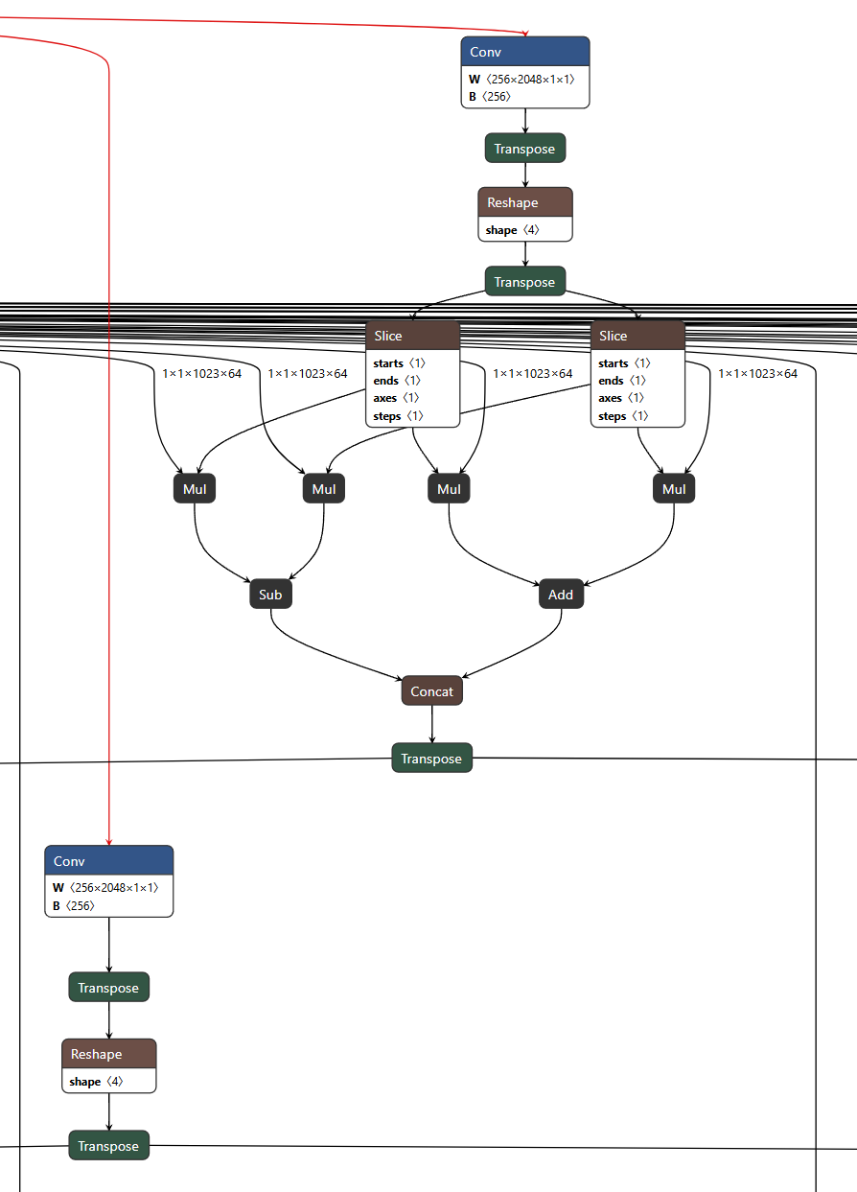
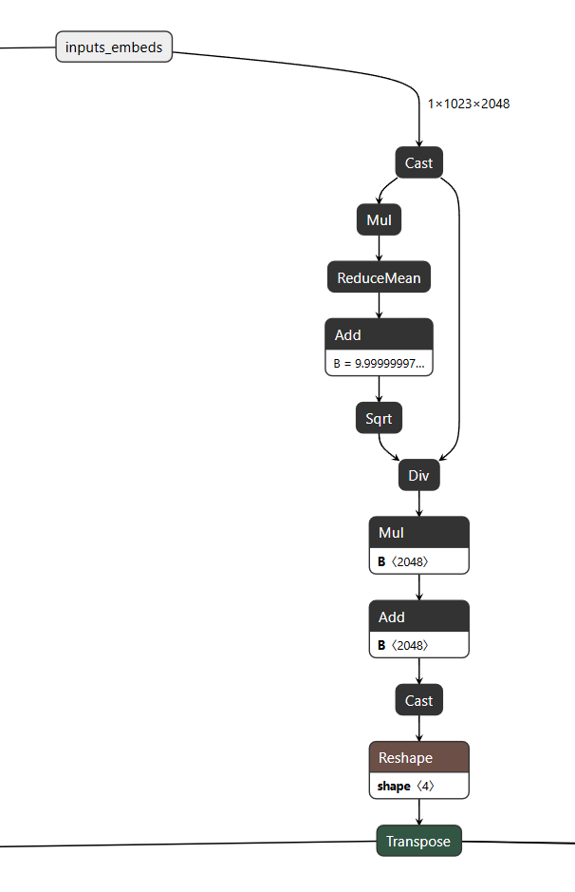
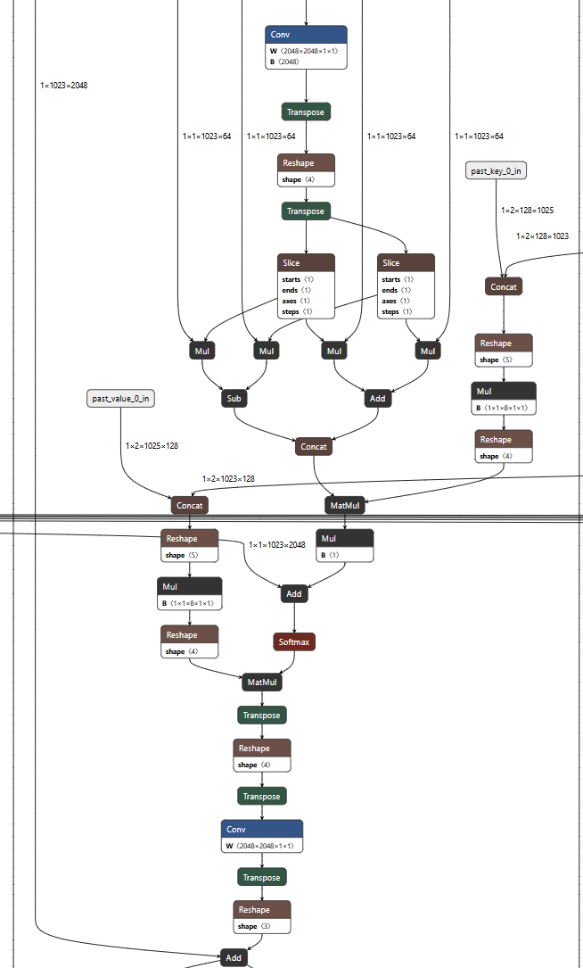

Qwen3-Embedding
GPT style Decoder only
Left padding，因为右侧总是有意义的内容，配合last_hidden_states[:, -1] ，就是Encoder only的架构BERT的CLS Pooling，只不过它取最右边的

结构完全等同Qwen3Model, Check adaptation
为什么关掉set_matmul_second_input_producer_to_8bit_symmetric？没有KV Cache的需求，因为没有AR部分, second input producer to matmul doesn’t come from kv cache
Config是否需要per_channel
LPBQ vs PrefixQuant? -> 没有KV Cache的需求，因为没有AR部分

QcQwen3Model(
(embed_tokens): Embedding(151669, 1024)
(layers): ModuleList(
(0-27): 28 x Qwen3DecoderLayer(
(self_attn): QcQwen3Attention(
(q_proj): Linear(in_features=1024, out_features=2048, bias=False)
(k_proj): Linear(in_features=1024, out_features=1024, bias=False)
(v_proj): Linear(in_features=1024, out_features=1024, bias=False)
(o_proj): Linear(in_features=2048, out_features=1024, bias=False)
(q_norm): Qwen3RMSNorm((128,), eps=1e-06)
(k_norm): Qwen3RMSNorm((128,), eps=1e-06)
)
(mlp): Qwen3MLP(
(gate_proj): Linear(in_features=1024, out_features=3072, bias=False)
(up_proj): Linear(in_features=1024, out_features=3072, bias=False)
(down_proj): Linear(in_features=3072, out_features=1024, bias=False)
(act_fn): SiLU()
)
(input_layernorm): Qwen3RMSNorm((1024,), eps=1e-06)
(post_attention_layernorm): Qwen3RMSNorm((1024,), eps=1e-06)
)
)
(norm): Qwen3RMSNorm((1024,), eps=1e-06)
(rotary_emb): Qwen3RotaryEmbedding()
)

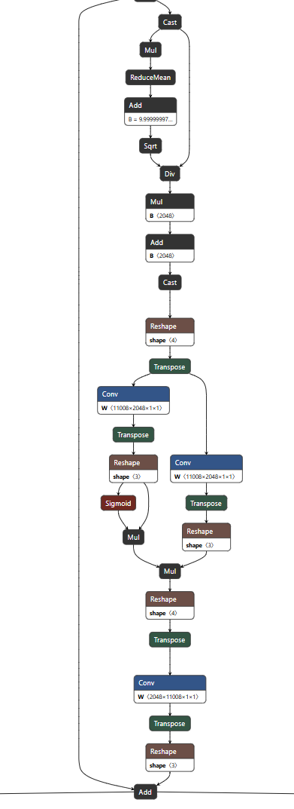

Qwen3.5 4B
Linear Attention
正常Attention Q K转置这一步就NxN的计算和内存复杂度
如果可以先KV，再Q(KV)，K是[D, N], V是[N, Dv]，这一步是固定D x D
但是中间隔着Softmax操作，无法直接近似
把操作拆开到一对ij，i为当前Q的token，j为其他token
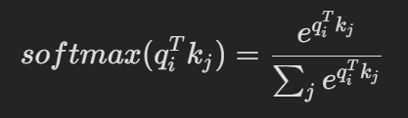
E的指数将其变成了非线性操作，这是关键的不可以直接拿掉
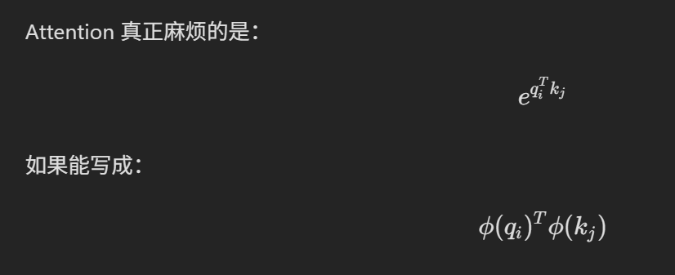
Phi是一个特征变换函数。先做特征变换再做内积，总而近似e指数值。下方先不考虑softmax分母：
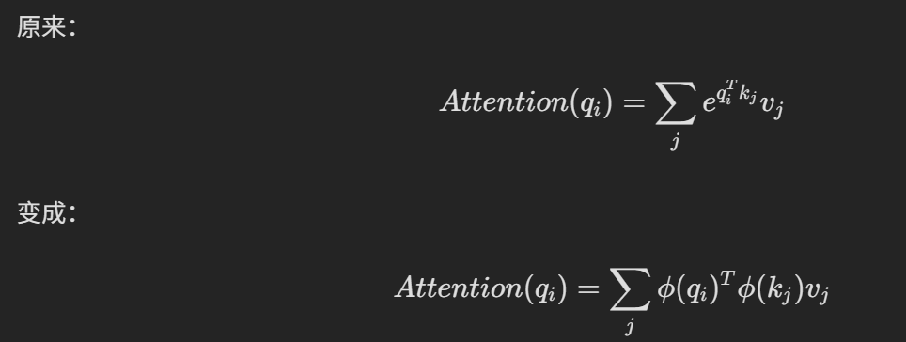
此时Phi(qi)转置提出来，右边剩下的便和query无关了，可以用交换律先算，而且固定size。
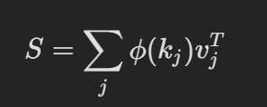
分母是一样的处理方式：
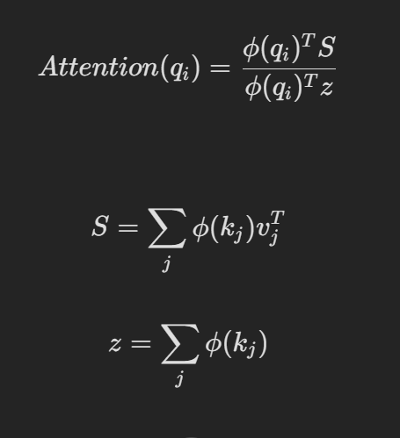
初代的Phi函数，可以看到非负性的模拟方式：
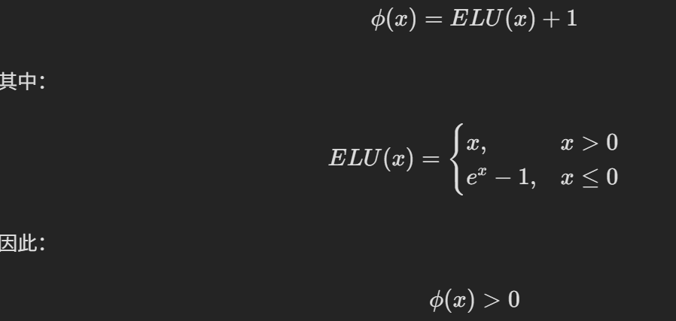
Performer的Phi函数是一个核函数：
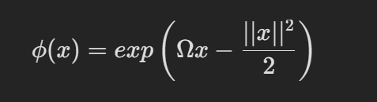
来自泰勒展开。
而Kimi的Linear attention则加入了类似Gate （类似LSTM），可以决定历史状态中多少部分可以遗忘那个。
