**BGT-ChaloIS DB Configuration Tool**

**User Manual**

**Connect to database server:**

On running the tool, the following window will appear (Fig. 1).

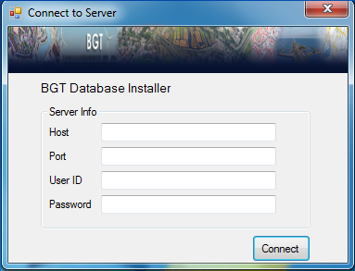

Fig. 1

Fill all the fields (Host, Port, User ID and Password) and click on ‘Connect’ button. If the given input is right then the ‘Database Installation’ window will appear.

**Database Installation:**

As stated above, this window will appear after successful connection to database server.

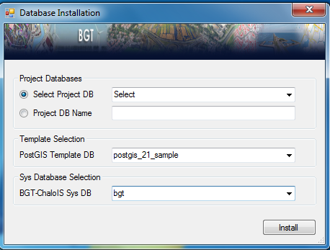

Fig. 2

**Project Database:**

Select the project database from dropdown list you want to install and also the ‘Select Project DB’ radio button has to be checked.

If you don’t find the desired database in dropdown list then input new database name in text field. In this case, ‘Project DB Name’ radio button has to be checked.

**Database Template Selection:**

Select ‘postgis_21_sample’ from dropdown list.

**System Database Selection:**

Select ‘bgt’ from dropdown list.

Now, click on Install button. A message will appear saying whether the installation is successful or not.