

**FULL NAME:**

Diego Monroy Minero

**STUDENT ID:**

2109110

**QUARTER:**

Second (May– August)

**Group:**

2-A

**Major:**

Data

**Unit:**

1st Unit

Unit 1 Project

Since we are studying an engineering where we must develop algorithms that can solve problems, it occurred to me to make a calculator that can convert from radians to sexagesimal degrees and vice versa, so in the following code it does that conversion by asking the user for two arguments, the number to convert and the conversion to perform.

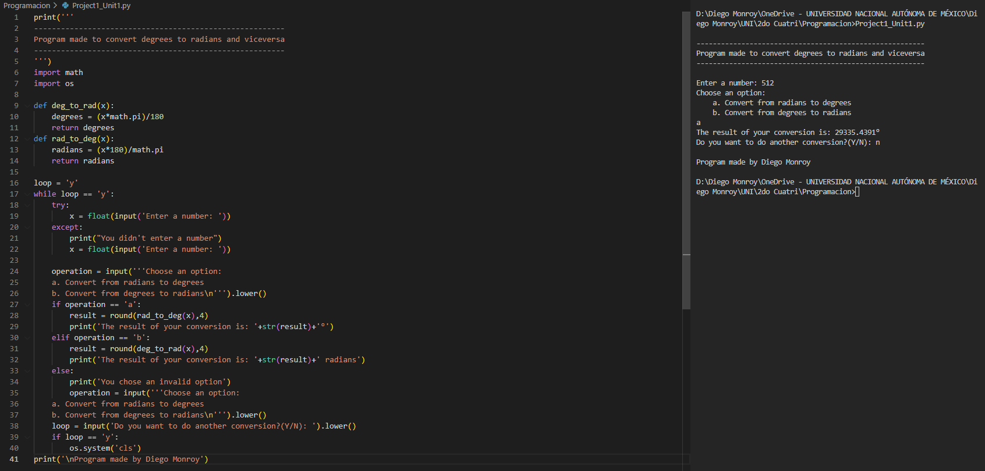The programming paradigm used in this project was structured programming.

As a conclusion of this project, I can emphasize that the handling of conditionals is fundamental in this type of algorithms where the user chooses what he wants to do, since we cannot predict what each user is going to choose.

It is also important to mention that handling a "Try / Except" and the "If / Else" is essential to avoid misuse of my algorithm.