Login → Dashboard → Side Menu → Cash Transactions (Cash In, Cash Out, New Account Deposit, Batch BBLS Deposit) → Customer Services (Loan Inquiry, Account Balance, Account Statement, New Savings Account) → Loan Repayment → Group Loan Repayment → Reports → Settings → Offline Data
14 navigable screens:
Login — Staff ID + Password with show/hide toggle, sign in button with your brand color.
Cash Transactions tab — Cash In (with Account Name + Book Balance + Usable Balance appearing after search), Cash Out, New Account Deposit/Posting (First Name, Surname, Gender, BVN, Product 1 & 2 with payments), Batch BBLS Deposit (Payee Name, Select Branch, Select Group modal with search, Group Code, Group Name, Total, customer-amount table, Send SMS checkbox), and Card Transactions.
Services tab — cleanly sectioned into Inquiries (Loan Inquiry, Account Balance, Account Statement), Account Opening (New Savings — 3 steps), and Repayments (Loan Repayment with full loan details, Group Loan Repayment with group selector modal).
Reports tab — Loans Booked, E-Ledger, LO PAR, Transaction Reports, LO Performance.
Menu/More tab — Officer card, Offline Data (Unposted Transactions with actual list, Better Life Records, Loan Portfolio, Offline Groups, Loan Records), Settings, and Sign Out which returns to the Login screen.
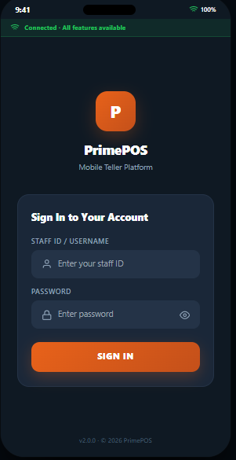
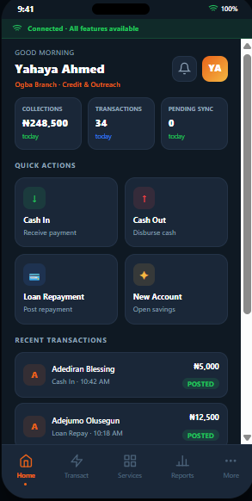
Cash-in (from dashboard)
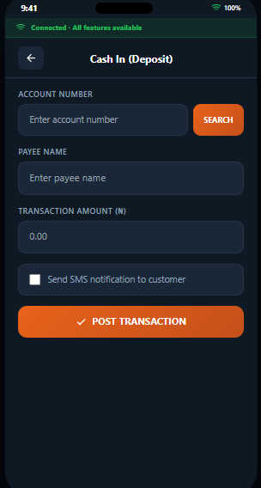
If you enter account number and search it fetches the customer detail
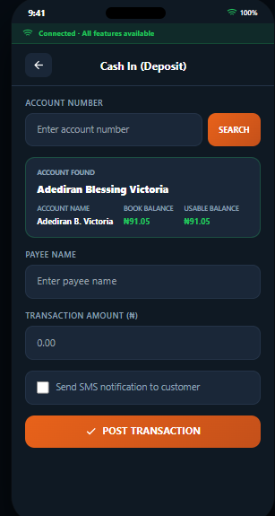

Cashout
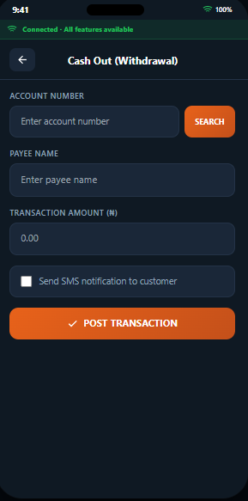
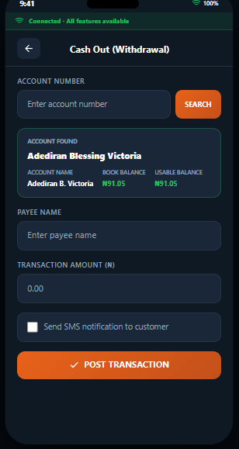
Loan Repayment
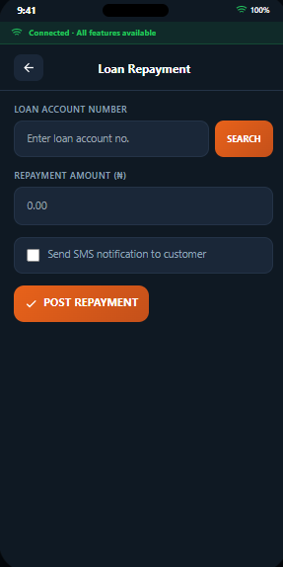
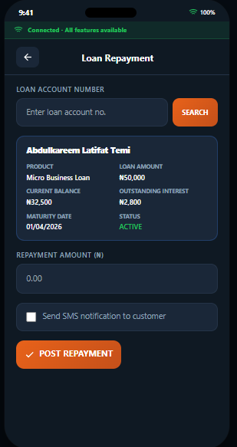

New saving account
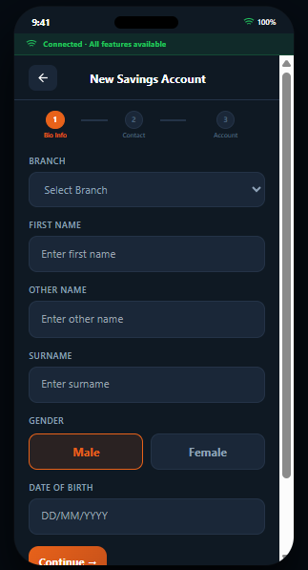
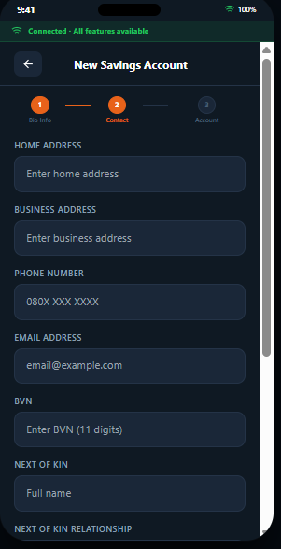
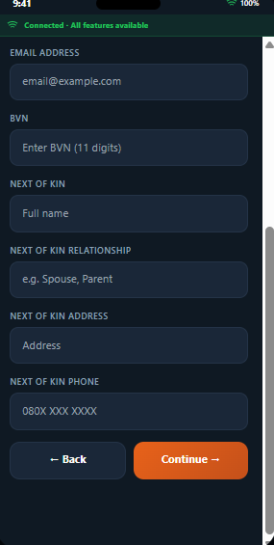
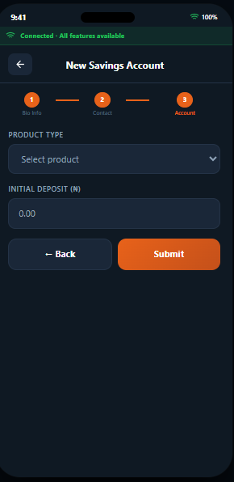

Transact
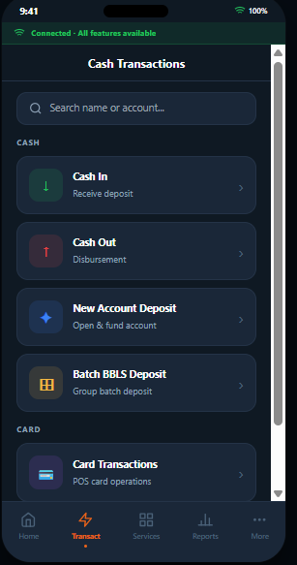
BBLS DEPOSIT
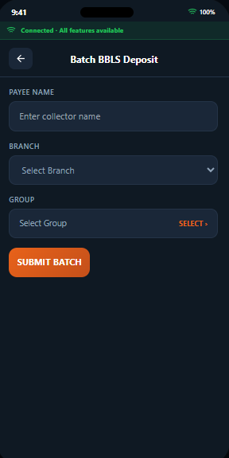
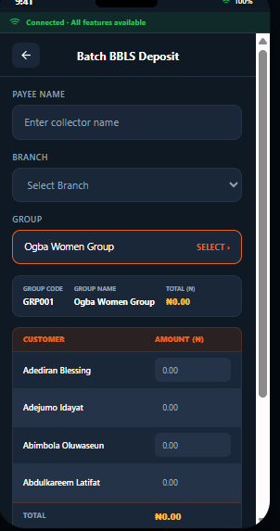
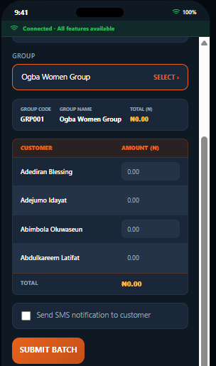

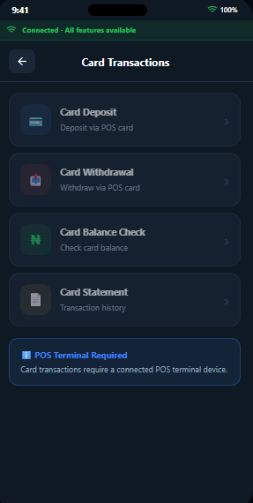

Service
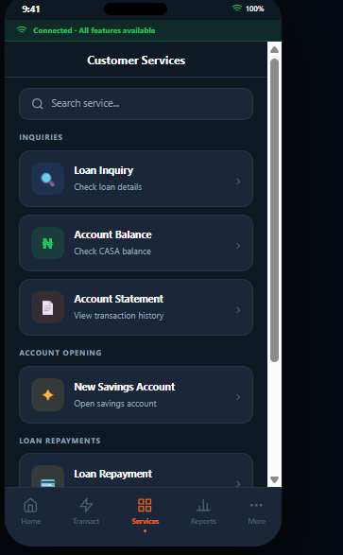
Loan inquiry

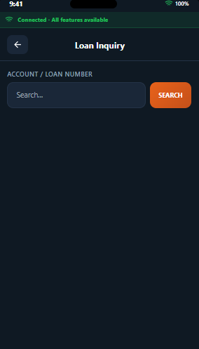
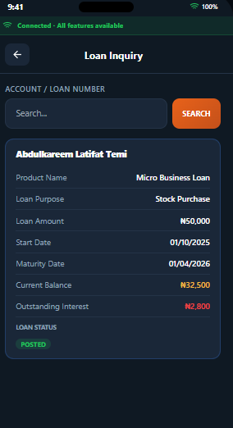

Balance inquiry
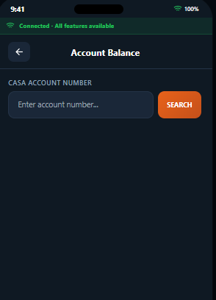
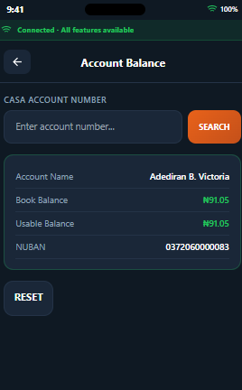
Account statement
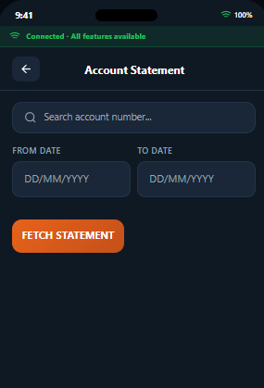
Report
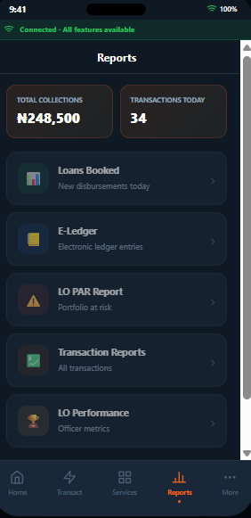
More-Offline Data
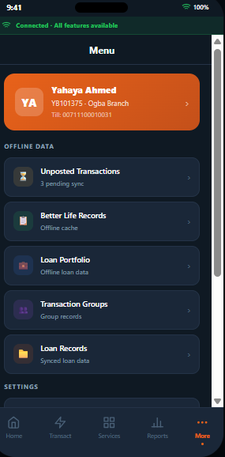
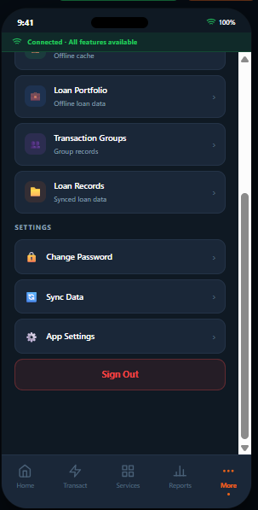

Profile
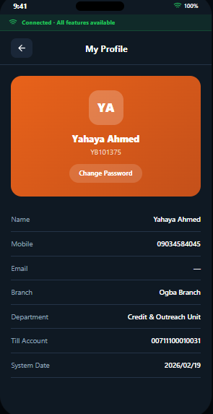

Unposted transaction
