Kentlake Falcons Basketball
Team Order Form

ITEM SIZE PRICE

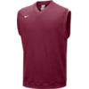

Nike Dri-Fit Vest with Embroidered logo _____ $40.00

PRICE INCLUDE SALES TAX AND SHIPPING
PLEASE MAKE CHECKS PAYABLE TO EASTBAY

NAME:_____________________________PHONE:__________________

