my-fullstack-app/
├── backend/ <-- Spring Boot Project(spring security , jpa , spring web , spring boot devtools, lombok , actuater , slf4j, mysql driver)
│
│
├── frontend/ <-- React Project (javascript , tailwind)
│
│
└── README.md

- I want all the code in this file structure
- We have users with three roles (employee , manager, admin). Each has a separate dashboard.
- First is the login and register page with usename and password , and forgot password. (change the UI accordingly, this ia s dempo UI)
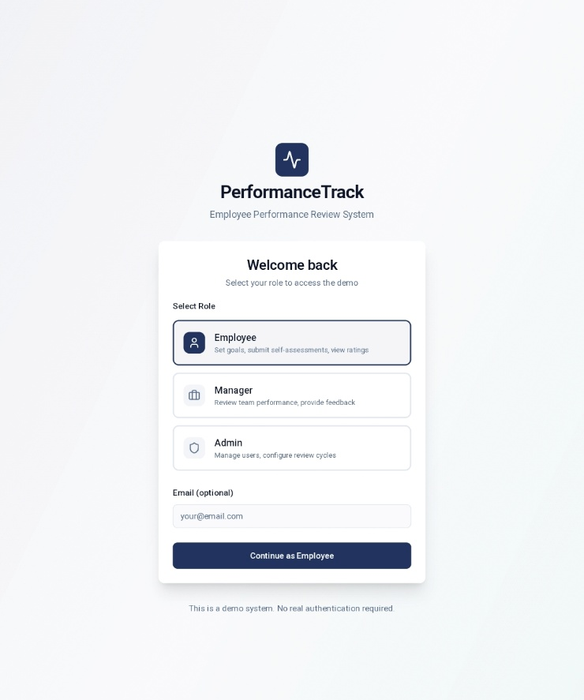

4. amin : we have 7 screen
4.1 dashboard.(admin)
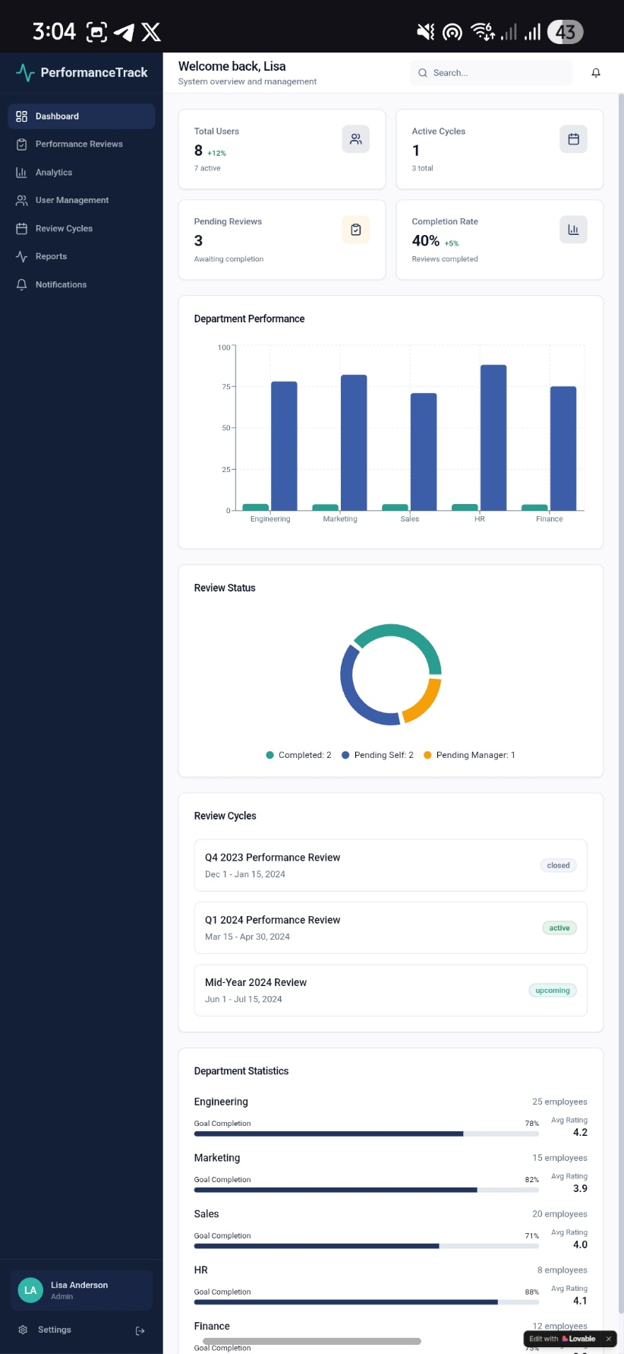

- It shows total users (employee , managers). Also shows active users at the bottom of the, remove the 12% things (it is not relevent)

- Active cycle tab :shows 1 for active cycle or can show 0 for no active cycle , at the bottom it show total no. of cycle

- Pending reviews tab: show no. of reviews pending

- Cpmpletion rate tab: how much percentage of people have completed the reviews.

- Then we have graphs on department performance , review status, review cycles , department statistics.

