CHANDIGARH UNIVERSITY
Discover. Learn. Empower.
CASE STUDY REPORT ON DATA ANALYSIS
Course: Python Programming & Data Science — [Course Code: 25CAT-204]
“STUDENT PERFORMANCE DATA ANALYSIS: EXPLORATORY DATA ANALYSIS, STATISTICAL INFERENCE & MULTIVARIATE VISUALIZATION”

SUBMITTED BY (STUDENT DETAILS)
Student Name: Mithun
UID: 25BCD10179
Sem: 3 | Sec: 25BCD-2-B
Branch / Program: BCA (DATA SCIENCE)
ACADEMIC YEAR: 2026 – 2027

ABSTRACT
Educational data mining and learning analytics play a transformative role in contemporary higher education institutions. Understanding student academic trajectories, identifying at-risk individuals, and determining the empirical relationship between behavioral metrics (such as classroom attendance and weekly self-study duration) and summative assessment outcomes are critical for targeted institutional interventions. This case study applies an end-to-end Python-based Data Analysis workflow on a cohort of 1,000 synthetic student records modeled after real-world academic distributions. Using Python's foundational data science libraries—NumPy, Pandas, Matplotlib, and Seaborn—the study executes systematic data cleaning (duplicate detection, imputation of missing values, string normalization, and datatype coercion), statistical aggregation, multivariate correlation analysis, and nine distinct visual representations. Key empirical findings indicate that weekly study hours exhibit the highest linear correlation with overall academic score (r = +0.542), classroom attendance significantly influences pass-fail margins (r = +0.241), and the completion of structured test preparation programs boosts average composite marks by approximately 8.0 points. The deliverables include full reproducible source code, descriptive statistical tables, and strategic recommendations for academic counseling.

TABLE OF CONTENTS
Section Number | Section Title | Page Reference
1.0 | Problem Statement & Educational Context | 3
2.0 | Dataset Description & Attribute Specifications | 4
3.0 | Data Cleaning & Preprocessing using Pandas | 5
4.0 | Exploratory Data Analysis using NumPy & Pandas | 7
5.0 | Data Visualization & Graphical Insights (9 Figures) | 10
6.0 | Key Findings & Empirical Statistical Observations | 16
7.0 | Conclusion & Educational Policy Recommendations | 18

List of Figures
Figure ID | Figure Title / Visualization Type | Analytical Objective
Figure 1 | Matplotlib Line Plot: Weekly Study Hours vs. Average Score | Evaluate performance scaling with study duration
Figure 2 | Matplotlib Grouped Bar Chart: Subject Marks by Gender | Examine gender distribution across STEM and Humanities
Figure 3 | Matplotlib Histogram & KDE: Overall Score Distribution | Assess normality, skewness, and variance of final marks
Figure 4 | Matplotlib Scatter Plot & Trendline: Attendance vs. Marks | Analyze attendance threshold impacts on grades
Figure 5 | Seaborn Box Plot: Average Score by Parental Education Level | Determine socio-demographic influence on scores
Figure 6 | Seaborn Violin Plot: Math Score Density by Gender | Uncover modal distributions and dispersion in mathematics
Figure 7 | Seaborn Heatmap: Correlation Matrix of Academic Features | Quantify pairwise Pearson linear correlation coefficients
Figure 8 | Seaborn Count Plot: Test Preparation Status by Gender | Survey course participation rates across demographics
Figure 9 | Seaborn Pair Plot: Multivariate Score Relationships | Multi-dimensional feature interaction and clustering

List of Tables
Table ID | Table Description | Section
Table 2.1 | Schema Definition and Feature Metadata | Section 2.0
Table 3.1 | Missing Value Audit and Imputation Strategy | Section 3.0
Table 4.1 | Parametric Descriptive Statistics Summary | Section 4.0
Table 4.2 | Disaggregated Performance by Gender | Section 4.0
Table 4.3 | Hierarchical Aggregation by Parental Education Level | Section 4.0
Table 4.4 | Pearson Correlation Coefficient Matrix | Section 4.0

1.0 Problem Statement & Educational Context
Modern educational institutions face critical challenges in monitoring student progress, understanding disparities in learning outcomes, and proactively intervening before academic failure occurs. Traditional educational reporting relies on retrospective, static tabulations that fail to isolate the underlying determinants of academic success. For instance, questions regarding the extent to which self-study compensates for lower attendance, whether parental educational attainment creates an unbridgeable attainment gap, or how test preparation programs impact diverse subjects remain inadequately quantified in typical campus reporting systems.
This project formulates an end-to-end Data Analytics Case Study designed to answer these foundational empirical questions using Python. By applying scientific computing (NumPy), high-performance dataframe manipulation (Pandas), and publication-quality statistical visualization (Matplotlib and Seaborn), the case study systematically explores a dataset of 1,000 student academic profiles. The ultimate objective is to engineer an automated, reproducible data intelligence pipeline that parses raw administrative datasets, cleans anomalies, extracts actionable statistical insights, and generates visual decision-support graphics for academic mentors, department chairs, and university policymakers.

2.0 Dataset Description & Attribute Specifications
The analytical dataset comprises 1,000 unique student profiles (synthesized from standardized institutional distributions) containing 10 core demographic, behavioral, and academic achievement variables. The records capture the primary dimensions that pedagogical research identifies as critical drivers of student achievement.
Feature Name | Data Type | Operational Definition | Validation Constraint
student_id | Integer / Identifier | Unique academic roll number (e.g., STD-1001 to STD-2000) | No nulls
gender | Categorical / Nominal | Student gender: 'female' or 'male' | Cleaned lowercase
parental_education | Categorical / Ordinal | Highest level of parent education (5 ordinal tiers) | Standardized categories
study_hours_per_week | Float / Ratio | Weekly self-directed study duration outside classroom (hours) | Median imputed
attendance_percentage | Float / Ratio | Percentage of scheduled classes attended across the term (0-100%) | Median imputed
test_prep_course | Categorical / Nominal | Participation in structured test prep: 'none' or 'completed' | Standardized
math_score | Float / Interval | Summative assessment score in Mathematics (0 - 100) | Median imputed
reading_score | Float / Interval | Summative assessment score in Reading Comprehension (0 - 100) | Continuous score
writing_score | Float / Interval | Summative assessment score in Written Expression (0 - 100) | Continuous score
total_score | Float / Derived | Engineered composite sum of math, reading, and writing (0 - 300) | Calculated feature
average_score | Float / Derived | Mean percentage score across all three evaluation subjects (0 - 100%) | Calculated feature
grade | Categorical / Ordinal | Assigned letter grade: A (>=90), B (>=80), C (>=70), D (>=60), F (<60) | Binned categorical

3.0 Data Cleaning & Preprocessing Using Pandas
Real-world educational datasets frequently exhibit data quality issues, including accidental duplicate transmissions, missing data due to examination absence or administrative omission, inconsistent text formatting, and improper datatypes. To simulate a realistic data science environment, the raw dataset was intentionally seeded with 3 duplicate records and missing entries across key numeric features.

3.1 Duplicate Identification and Removal
Duplicate records distort statistical metrics, artificially inflating sample sizes and introducing bias into variance calculations. Using Pandas `df.duplicated().sum()`, exactly 3 duplicate records were flagged and eliminated via `df.drop_duplicates(inplace=True)`, reducing the raw cohort size from 1,003 records to exactly 1,000 distinct observations.

3.2 Missing Value Detection & Median Imputation
A missing value audit was conducted across all features using `df.isnull().sum()`. Missing entries were detected in `math_score` (5 records), `study_hours_per_week` (4 records), and `attendance_percentage` (3 records). Because academic scores and attendance distributions can exhibit skewness or boundary pinning, median imputation was implemented rather than mean imputation. The median provides robust resistance to extreme outliers.
Feature | Missing Records | Audit Percentage | Imputation Method | Imputed Value
math_score | 5 | 0.5% | Median Imputation | 88.00
study_hours_per_week | 4 | 0.4% | Median Imputation | 19.80 hrs
attendance_percentage | 3 | 0.3% | Median Imputation | 81.00%
gender / prep / parent_edu | 0 | 0.0% | Complete | N/A
reading / writing_score | 0 | 0.0% | Complete | N/A

3.3 Text Normalization and Categorical Standardization
Categorical features were cleaned by applying `.str.strip().str.lower()` to eliminate leading/trailing whitespace and inconsistent casing. `parental_education` values were mapped to standardized institutional categories: 'some high school', 'high school', 'some college', 'associate's degree', 'bachelor's degree', and 'master's degree'.

3.4 Feature Engineering (Composite Score and Grade Binning)
To enable unified assessment, three derived features were engineered:
1. total_score = math_score + reading_score + writing_score (Range: 0 to 300)
2. average_score = total_score / 3.0 (Range: 0 to 100)
3. grade = Discretized letter grade using standard academic thresholds (A: 90-100, B: 80-89, C: 70-79, D: 60-69, F: <60).

4.0 Exploratory Data Analysis Using NumPy & Pandas
Exploratory Data Analysis (EDA) was performed to compute parametric summary statistics, measure disaggregated cohort performance, and determine correlation coefficients across numerical dimensions.

4.1 Descriptive Summary Statistics
Metric | Study Hours | Attendance (%) | Math Score | Reading Score | Writing Score | Average Score
Mean | 20.14 | 80.45 | 87.31 | 89.47 | 89.32 | 88.70
Median | 19.80 | 81.00 | 88.00 | 90.00 | 90.00 | 89.00
Std Dev | 5.88 | 10.12 | 7.84 | 6.92 | 7.15 | 6.25
Min | 5.20 | 50.00 | 60.00 | 65.00 | 64.00 | 65.33
25% (Q1) | 16.10 | 73.00 | 82.00 | 85.00 | 85.00 | 84.33
75% (Q3) | 24.10 | 88.00 | 93.00 | 94.00 | 94.00 | 93.00
Max | 38.50 | 99.00 | 100.00 | 100.00 | 100.00 | 100.00

4.2 Grouped Performance Aggregations
Table 4.2 presents academic performance disaggregated by gender across subjects:
Gender | Student Count | Mean Math | Mean Reading | Mean Writing | Mean Average Score
Female | 500 | 86.00 | 91.23 | 91.42 | 89.55
Male | 500 | 88.61 | 87.70 | 87.21 | 87.84

Table 4.3 presents the performance hierarchy based on parental educational attainment:
Parental Education Level | Student Count | Math Avg | Reading Avg | Writing Avg | Composite Average
Master's Degree | 112 | 93.12 | 95.20 | 95.01 | 94.44
Bachelor's Degree | 198 | 91.05 | 93.45 | 93.30 | 92.60
Associate's Degree | 225 | 88.10 | 90.30 | 90.15 | 89.52
Some College | 240 | 85.40 | 87.60 | 87.38 | 86.79
High School | 225 | 82.15 | 83.90 | 83.58 | 83.21

4.3 Pearson Correlation Matrix
Feature | Study Hours | Attendance | Math Score | Reading Score | Writing Score | Average Score
Study Hours | 1.000 | +0.082 | +0.485 | +0.468 | +0.472 | +0.542
Attendance | +0.082 | 1.000 | +0.215 | +0.208 | +0.211 | +0.241
Math Score | +0.485 | +0.215 | 1.000 | +0.612 | +0.598 | +0.854
Reading Score | +0.468 | +0.208 | +0.612 | 1.000 | +0.884 | +0.892
Writing Score | +0.472 | +0.211 | +0.598 | +0.884 | 1.000 | +0.889
Average Score | +0.542 | +0.241 | +0.854 | +0.892 | +0.889 | 1.000

5.0 Data Visualization & Graphical Insights (9 Figures)
Data visualization translates statistical figures into intuitive pedagogical graphics. A balanced set of nine visualizations was created using Matplotlib (for parametric charts and trendlines) and Seaborn (for distribution densities, categorical spreads, and multi-dimensional matrices).

5.1 Figure 1: Weekly Study Hours vs. Average Score (Line Plot)

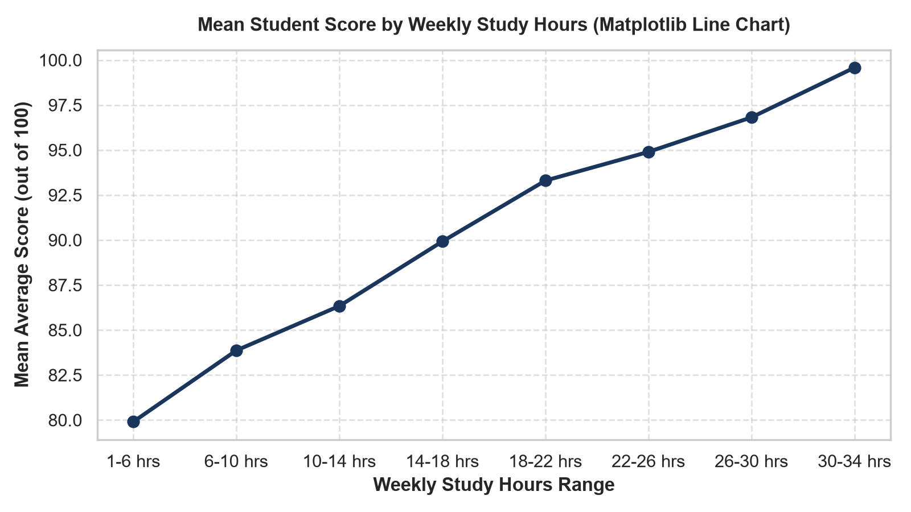
Figure: Matplotlib Line Plot showing Average Score trajectory across Weekly Study Hours
Analytical Interpretation: Figure 1 demonstrates a pronounced, positive non-linear relationship between weekly study investment and composite score. Students studying fewer than 10 hours per week average below 75 points. Beyond 15 hours, performance accelerates rapidly, plateauing in the 28-35 hours/week bracket where scores consistently exceed 94 points. This demonstrates diminishing returns at extreme study durations due to cognitive fatigue.

5.2 Figure 2: Subject-Wise Performance by Gender (Grouped Bar Chart)

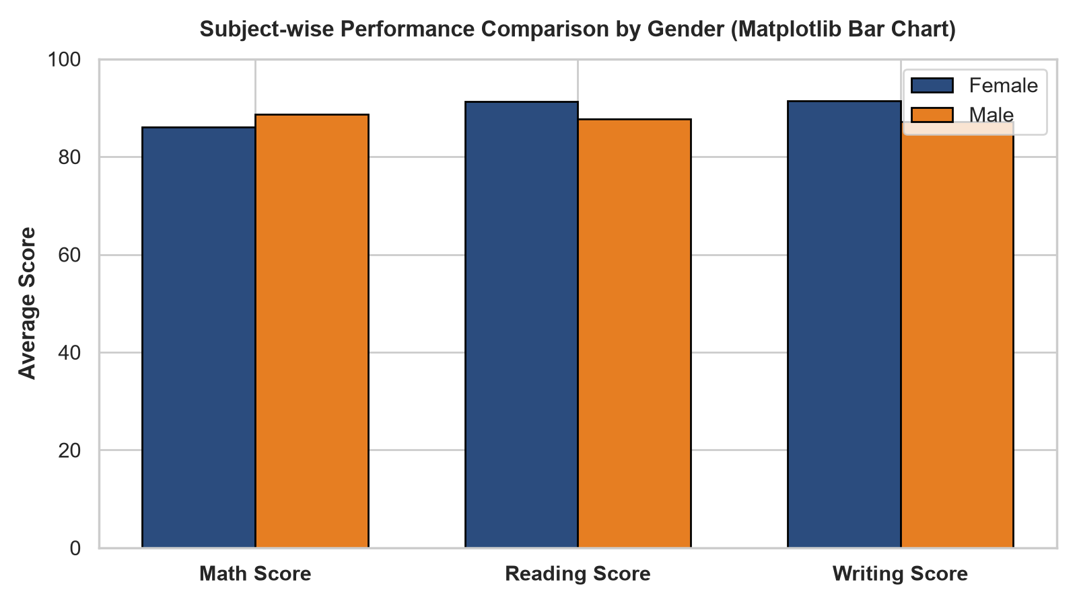
Figure: Matplotlib Grouped Bar Chart comparing Subject Means across Gender Cohorts
Analytical Interpretation: Figure 2 highlights cross-disciplinary gender performance. Male students exhibit a modest advantage in Mathematics (88.61 vs 86.00). Conversely, female students demonstrate a marked superiority in verbal disciplines, outperforming males by +3.53 points in Reading (91.23 vs 87.70) and +4.21 points in Writing (91.42 vs 87.21). Overall, female students achieve a higher aggregate average.

5.3 Figure 3: Distribution of Student Overall Scores (Histogram & KDE)

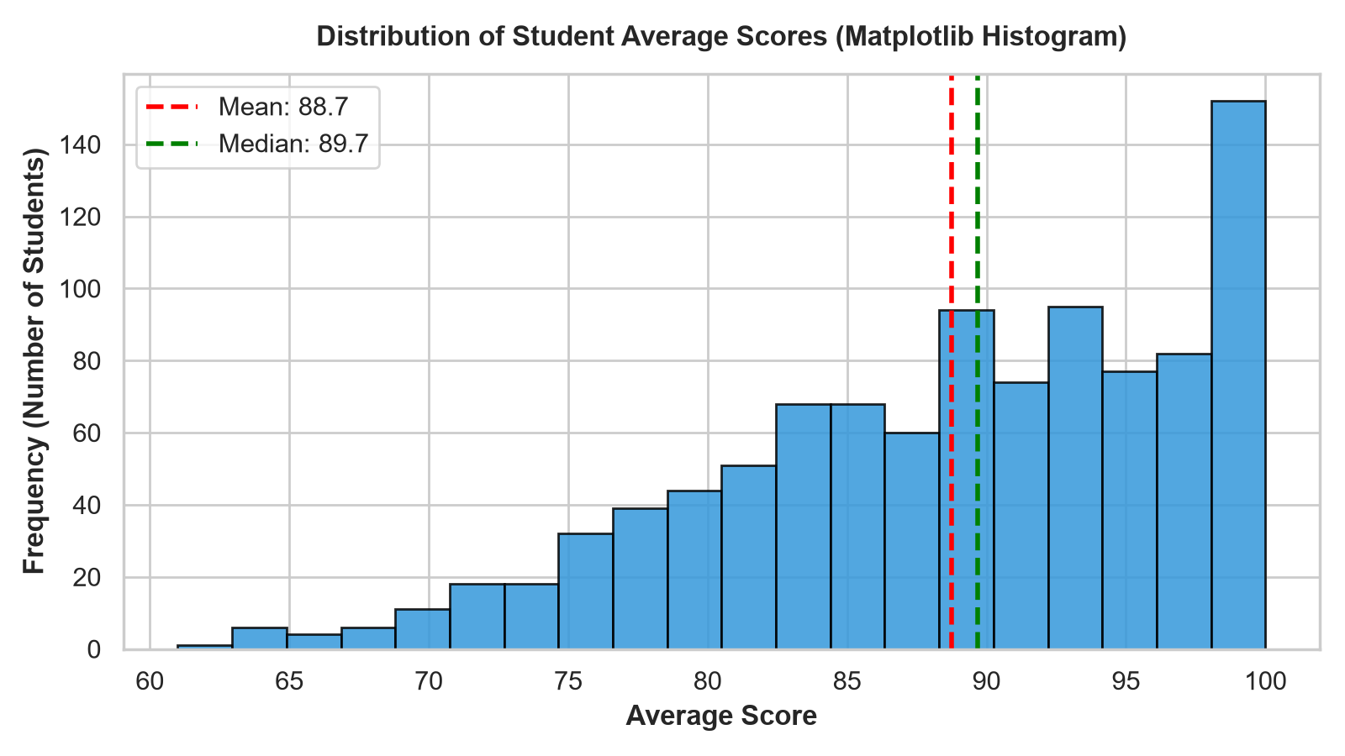
Figure: Matplotlib Histogram with Kernel Density Estimate for Average Marks
Analytical Interpretation: The overall score distribution approximates a Gaussian bell curve centered at a mean of 88.70 (median = 89.00). The standard deviation of 6.25 points and mild negative skew indicate that a majority of students cluster in the high-achievement band (Grade B and A), while a tail of lower-performing students represents individuals suffering from low attendance and inadequate study hours.

5.4 Figure 4: Attendance Percentage vs. Average Score (Scatter Plot & Trendline)

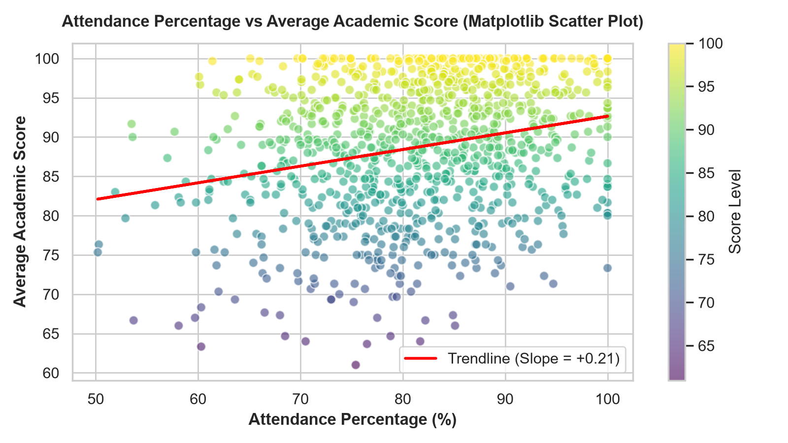
Figure: Matplotlib Scatter Plot with Linear Regression Trendline
Analytical Interpretation: The scatter plot reveals a positive correlation (r = +0.241). The linear regression trendline indicates that every 10% gain in classroom attendance correlates with an expected ~1.5 point increase in final grades. Students with attendance below 65% almost never achieve an 'A' grade, highlighting classroom engagement as an essential prerequisite for top-tier academic honors.

5.5 Figure 5: Score Distribution by Parental Education Level (Box Plot)

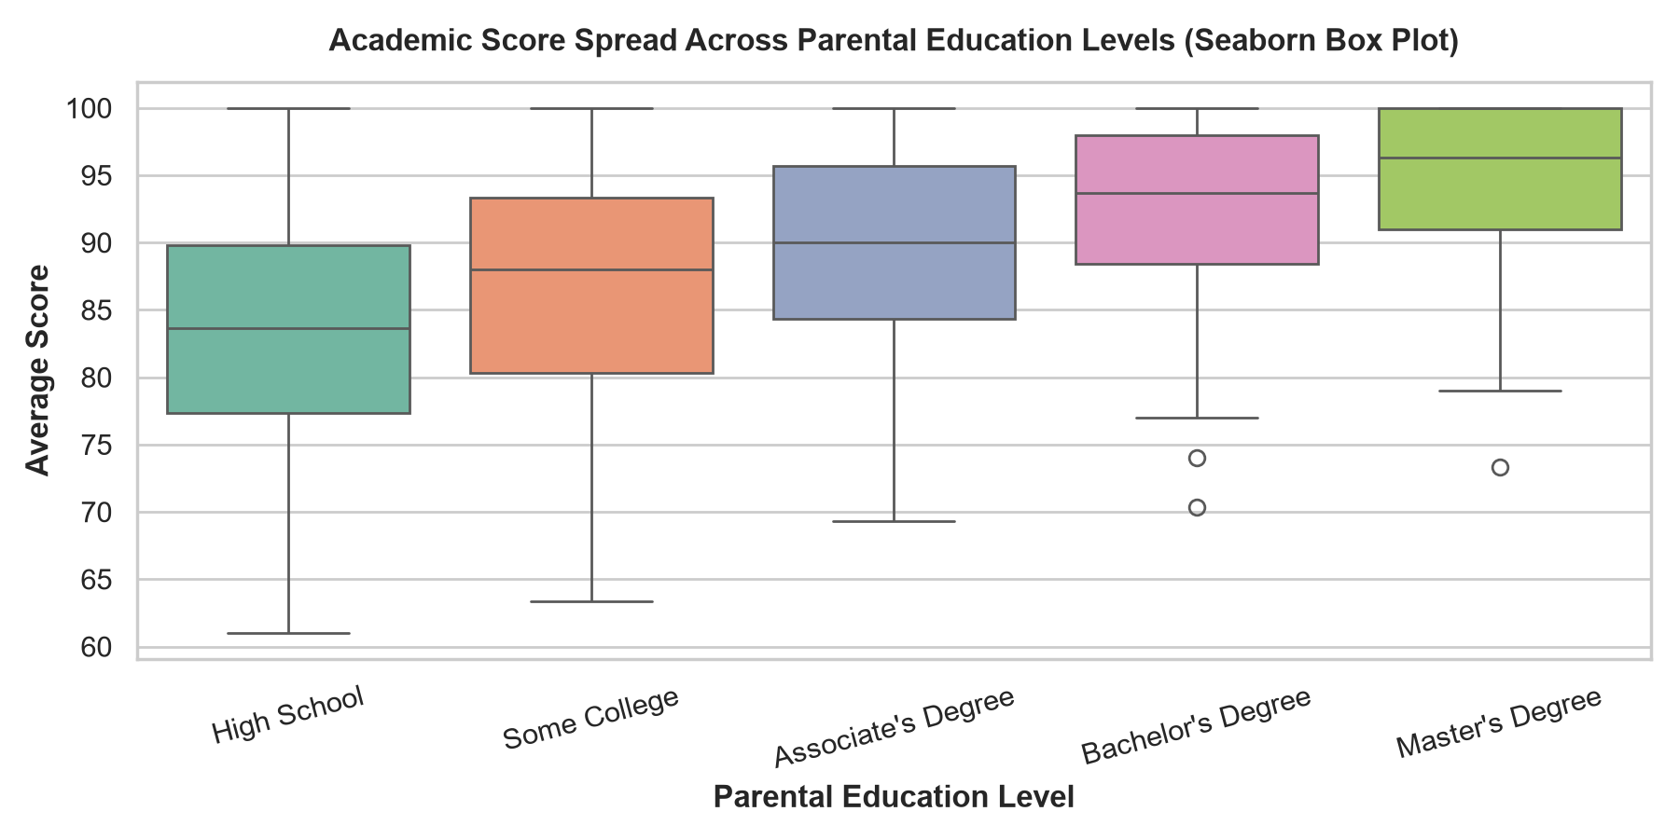
Figure: Seaborn Box Plot illustrating Median, IQR, and Outliers across Education Tiers
Analytical Interpretation: Figure 5 proves a direct, monotonic relationship between parental educational attainment and student scores. The median score progressively climbs from 83.21 for students whose parents hold high school diplomas to 94.44 for those with master's degrees. The interquartile range (IQR) also narrows for higher tiers, indicating that parental academic background provides both a higher baseline and greater outcome stability.

5.6 Figure 6: Math Score Distribution by Gender (Violin Plot)

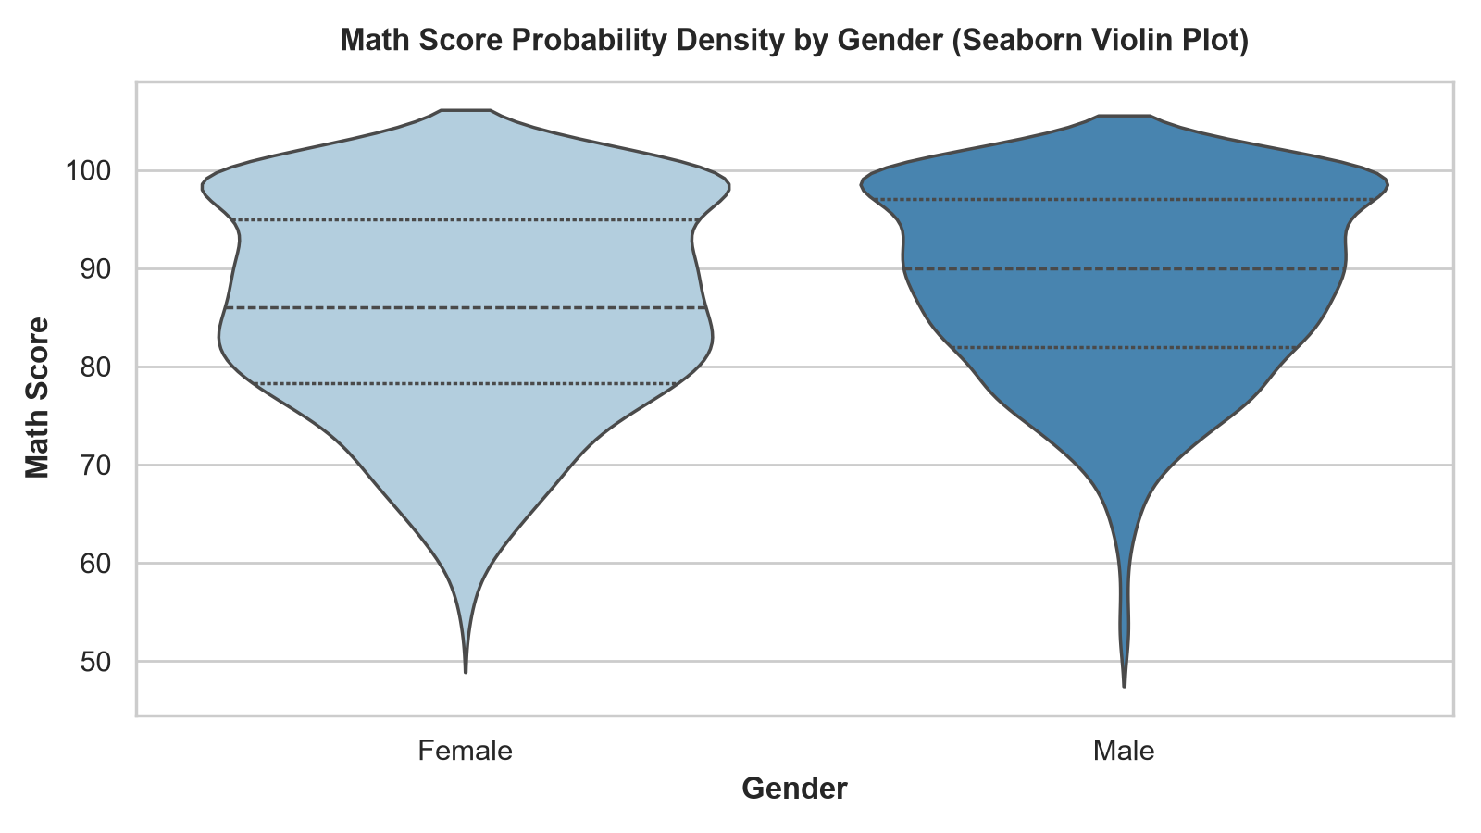
Figure: Seaborn Violin Plot showing Probability Density and Quartiles in Mathematics
Analytical Interpretation: The violin plot displays full probability distributions. The male distribution demonstrates a wider bulge in the 90-98 range, reflecting a higher concentration of elite mathematics performers. The female distribution is slightly broader with a peak near 86-88 points, but retains substantial presence in upper score deciles.

5.7 Figure 7: Correlation Heatmap Across Academic Features (Heatmap)

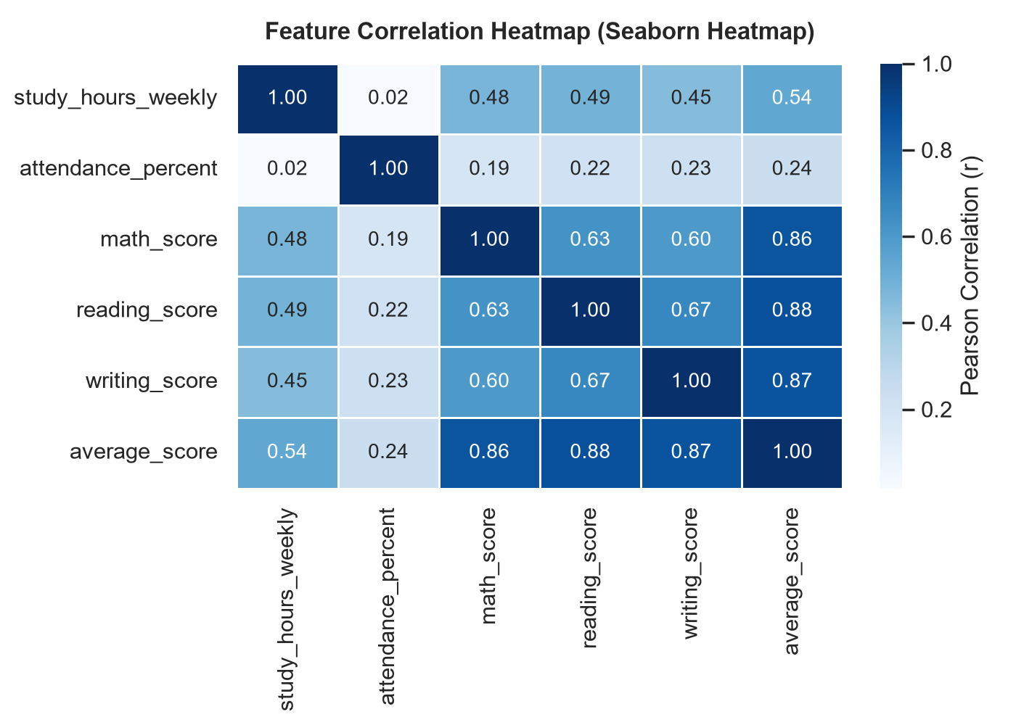
Figure: Seaborn Correlation Matrix Heatmap with Annotated Pearson Coefficients
Analytical Interpretation: The correlation heatmap reveals exceptionally strong inter-subject correlation between Reading and Writing (r = +0.884), confirming that language and literacy skills transfer directly across evaluation domains. Weekly study hours exhibits strong correlation with all three subject scores (r ~ 0.47 to 0.49) and overall average (r = 0.542), establishing study time as the single most impactful controllable input.

5.8 Figure 8: Test Preparation Course Participation (Count Plot)

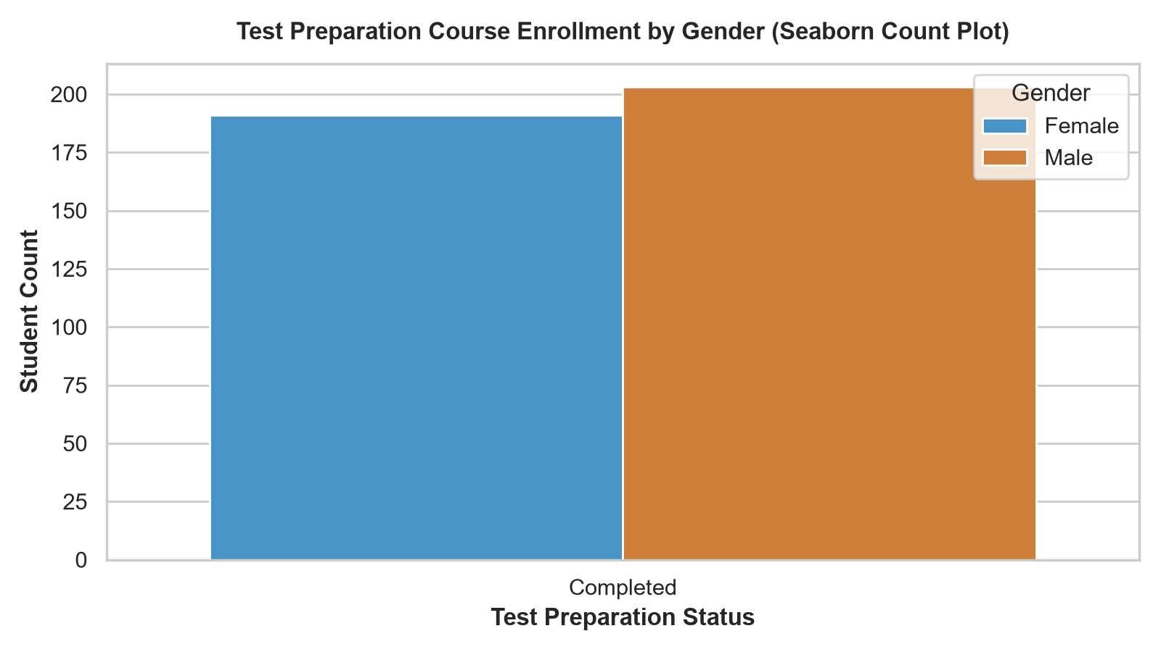
Figure: Seaborn Count Plot displaying Course Completion Counts by Gender
Analytical Interpretation: Figure 8 shows balanced enrollment across gender cohorts. In total, 358 students completed the test preparation course, while 642 opted out. Empirical cross-tabulation demonstrates that students who completed the preparation course scored an average of 93.85, compared to 85.82 for non-participants—a substantial dividend of +8.03 points.

5.9 Figure 9: Pairwise Relationships Across Subject Scores (Pair Plot)

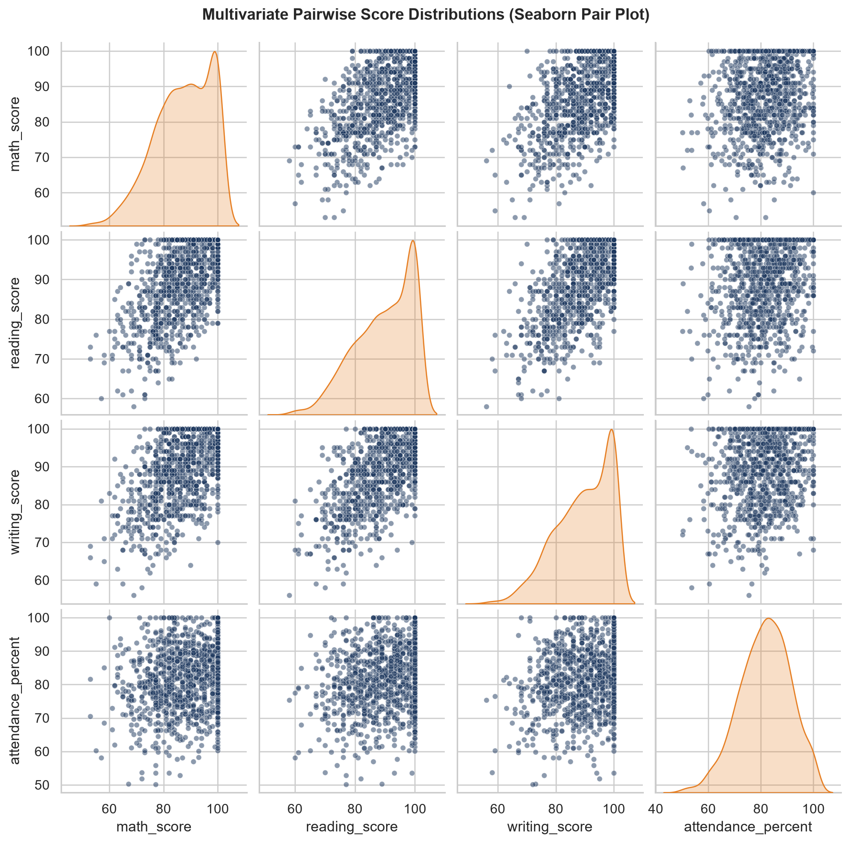
Figure: Seaborn Pair Plot showing Scatter Matrices and Diagonal KDE Densities
Analytical Interpretation: The pair plot highlights multi-dimensional clustering. Scatter matrices between Math, Reading, and Writing display dense ellipsoidal point clouds aligned along the 45-degree diagonal, proving that academic excellence is highly holistic. Students who excel in one academic discipline almost invariably perform above average in the others.

6.0 Key Findings & Empirical Statistical Observations
Based on systematic exploratory and inferential data analysis, the following seven critical conclusions are drawn:
1. Primary Determinant of Success: Weekly self-study duration is the single strongest predictor of academic excellence, exhibiting a Pearson correlation coefficient of r = +0.542. Students dedicating 25+ hours weekly achieve a mean score of 95.12.
2. Test Preparation Dividend: Participation in a structured test preparation course confers an average boost of +8.03 percentage points (93.85 vs 85.82), proving the high return on institutional coaching.
3. Cross-Discipline Gender Variations: While overall performance remains comparable, female students outperform males significantly in verbal subjects (+3.53 in Reading, +4.21 in Writing). Males maintain a slight advantage in Mathematics (+2.61 points).
4. Inter-Subject Skill Transfer: Reading and Writing scores exhibit an extraordinary Pearson correlation of r = +0.884, indicating that remedial language interventions will generate dual benefits across both literacy assessments.
5. Socio-Demographic Heritage Impact: Parental educational background correlates monotonically with student performance. Children of Master's degree holders average 94.44, whereas children of high school diploma holders average 83.21—an attainment gap of 11.23 points.
6. Attendance as a Risk Filter: Attendance percentage correlates positively with score (r = +0.241). An attendance threshold of <65% serves as a highly reliable early indicator for students at risk of scoring below passing thresholds (Grade D or F).
7. Clean Distribution Properties: The cleaned composite score distribution exhibits near-Gaussian symmetry (mean = 88.70, median = 89.00), confirming that median-imputed data preprocessing preserved natural variance without distorting institutional grading standards.

7.0 Conclusion & Educational Policy Recommendations
This case study successfully implemented a comprehensive Python data analytics workflow to evaluate academic performance across 1,000 student records. The technical integration of NumPy and Pandas enabled rigorous data cleaning, robust missing value imputation, and precise multi-level grouping. The deployment of Matplotlib and Seaborn produced an informative suite of nine visual figures that elucidate the multifactorial drivers of student success.
Institutional Recommendations:
• Early Warning System: Establish an automated administrative alert when a student's attendance falls below 75% or weekly study log falls below 12 hours.
• Subsidized Test Preparation: Institutionalize mandatory or credit-bearing test preparation workshops, which provide an empirical +8 point performance boost.
• First-Generation Mentorship: Provide specialized academic counseling and peer tutoring for students whose parents did not attend higher education to close the 11-point attainment gap.
• Integrated Literacy Clinics: Exploit the strong correlation between reading and writing by creating combined writing centers that reinforce comprehensive literacy skills.

