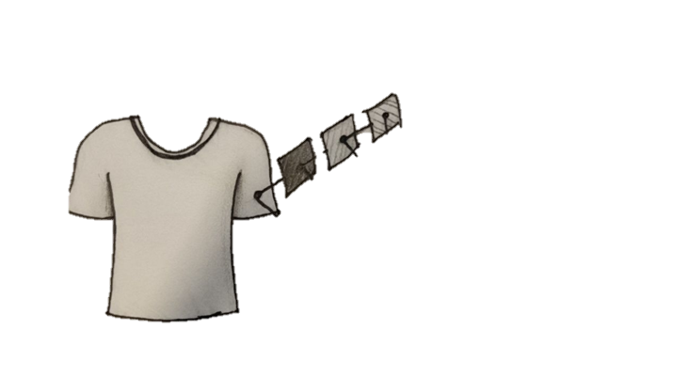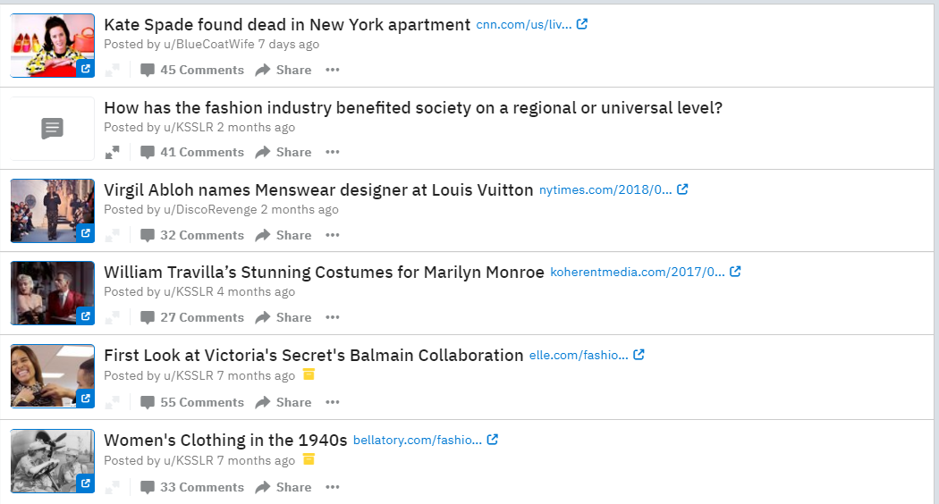

|  |
| --- |
| **Adam&Aoki show improved design for t-shirts!**  Last Friday, the founders of Adam&Aoki have shown their new and improved design for their t-shirts, and we’re loving it!  *by: Shelly123 on: 6-7-2018* |
| Image result for sunscreen**Children sunscreen proven to cause rashes…**  Hello everybody, I was watching the news last night and it showed that this sunscreen (see photo) is proven to cause rashes on children!!! :O  *by: friendlyneighbor on: 13-6-2018* ***Waarschuwing*** |
| Image result for cap**Have you seen the new clothing line of A&A?**  We proudly introduce our new clothing line, made especially for our young, but hip, children. Come get it while it’s hot!  *by: Adam&Aoki on: 18-6-2018 Spreker* |
| See more … |

|  |
| --- |
| **Image result for white mom@Shelly123**  *The fear of my grandchildren getting sunburned really has declined since my daughter let me buy a t-shirt from A&A, so yes, I recommend that you buy it. It really works!*  *2 min ago - Received* |
| Image result for nik penhale smith**@NikSmith**  Hey, thank you for joining our community! If you have any questions relating our product, just let me know and I’ll come back to you!  *3 days ago - Seen* |
| Image result for black dad**@proudpaps**  Appreciate you responding to my question, thanks! So yeah I’ve been struggling with what sunscreen to buy for my baby, since there are so many bad revieuws out there. The sunscreen you recommended seems really good, so I’ll give it a shot!  *4 days ago - Sent* |

