ATTENTION
- 1、Definition of attention; Selective attention
- Attention is … the taking into possesion of the mind, in clear and vivid form, of one out of what seem several simultaneously possible objects or trains of thought. Focalisation, concentration, of consciousness are of its essence.
- Cognitive processes that process relevant inputs, thought, or actions while ignoring irrelevant or distracting ones.
- 2、Type of attention
- Voluntary attention vs. reflexive attention
- Voluntary: top-down, goal-directed
- Reflexive: bottom-up way, stimulus-driven
- 3、Attention theory
- Early selection model
- Late selection model
- Methods to study attention
- Cuing tasks
- Inhibition of return (IOR)
- Spatial, feature, object-based attention
- LIMITED CAPACITY

- Bottlenecks in processing
P1, N1, N2pc
Neuroimaging studies: attention related brain area (e.g. middle occipital gyrus, visual cortex, FFA, PPA)
Level of single neuron: Visual cortex, SC, LIP, IPS
Attention network: LIP + FEF + PFC
EMOTION
1、Definition：Emotions are our body’s adaptive response，include physiological arousal、expressive behaviors、conscious experience.( 情绪是我们身体的适应反应，包括生理唤起、表达行为和意识体验)
2、Theories：
James-Lange Theory： physiological activity precedes the emotional experience (生理反应发生在情绪体验之前) 杰姆斯兰格理论
Cannon-Bard Theory: an emotion-triggering stimulus and the body's arousal take place simultaneously. （情绪触发刺激和身体的觉醒同时发生）
Schachter-Singer two-factor theory: our physiology and cognitions create emotions. Emotions have two factors–physical arousal and cognitive label.(情绪是由生理和认知共同作用产生的，情绪有两个因素：生理唤醒和认知标签)
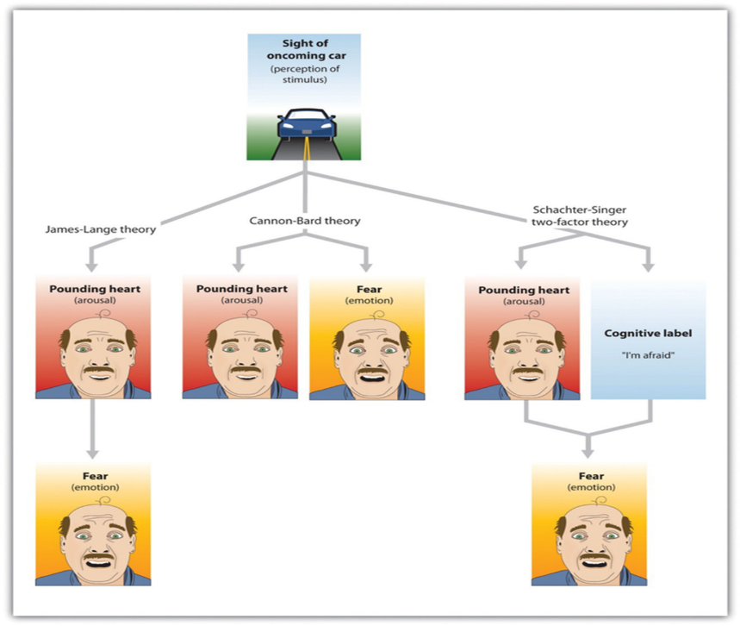
3、Fear：Fear can torment us, rob us of sleep, and preoccupy our thinking. However, fear can be adaptive – it makes us run away from danger, it brings us closer as groups, and it protects us from injury and harm.(恐惧会折磨我们，夺去我们的睡眠，占据我们的思想。然而，恐惧是可以适应的，它使我们远离危险，它使我们更接近群体，它保护我们免受伤害。）We learn fear in two ways, either through conditioning and/or through observation（我们学习恐惧有两种方式，一种是通过条件作用，另一种是通过观察）
Fear conditioning paradigm：A form of classical conditioning in which the unconditioned stimulus is aversive. 恐惧条件作用:经典条件作用的一种形式,其中无条件刺激是厌恶性的
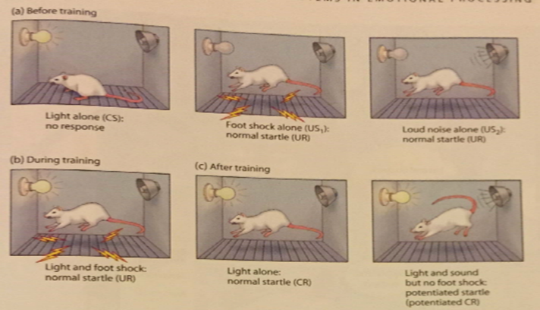
4、Two pathways to amygdala：杏仁核的两条途径
Low road: fast, crude info analysis (快速、粗略的分析)
High road: slower, but more thorough and complete info analysis（更慢，但更全面和完整的信息分析）
5、Fear learning: implicit, explicit learning (amygdala & hippocampus)
Implicit learning 内隐学习：The role of amygdala in learning to respond to stimuli that represent aversive events through fear conditioning. 杏仁核在学习通过恐惧条件作用对代表厌恶事件的刺激作出反应中的作用
Patient S.P. - Bilateral amygdala damage（杏仁核受损）
Normal cognitive functions ; Unable to identify fear face expression whereas other more subtle emotions’ perception were intact.（认知能力正常，其他微妙情绪感知完好无损，但无法识别恐惧表情）
Fear conditioning paradigm（恐惧条件范式）: 10s of blue square (CS), A mild electrical shock to the wrist (US) after the CS（10秒条件刺激，CS后温和的手腕电刺激UC）

No change in skin conductance response was found after the CS.条件刺激之后皮肤电反应没有变化
Patients who had bilateral damage to the hippocampus but an intact amygdala:（双侧海马受损但杏仁核完好无损）
1. Normal skin conductance response（皮肤电反应正常）
2. Unable to report that the presentations of the blue square were paired with shock
Explicit knowledge and conditioned responses are dissociated.
Amygdala is necessary for the implicit expression of emotional learning （杏仁核在内隐情绪学习表达中很重要）
Hippocampus is necessary for the acquisition of explicit emotional learning（海马在外显情绪学习中很重要）.
Explicit emotional learning（外显情绪学习）
Example: A dog once have bitten a person, you are scared of it.
Instructed fear experiment
Normal: （正常人）
1, potentiated startle response to the blue square（对蓝色方框恐惧增强）
2, increase in skin conductance response to the blue square which was correlated with amygdala activities（皮肤电对蓝色方框的反应增强，与杏仁核活动相关）
Patients with amygdala damage: （杏仁核损伤的病人）
1, Able to learn and report that the blue square might be paired with shock）（能够学习并报告蓝色方块可能与电击配对）
2, no potentiated startle response to the blue square（对蓝色方框没有增加的恐惧反应）
Amygdala is sometimes critical for the indirect expression of a fear response with explicit emotional learning （杏仁核有时对于外显情绪学习间接表达恐惧反应至关重要）
1. Hippocampal-dependent representation of the emotional properties of events can affect amygdala activity and certain indirect fear responses.
2. James McGaugh (1992) and Ferry & McGaugh (2000) found the amygdala modulates the strength of declarative memories for emotional events.
3. Amygdala seems unimportant for most of explicit evaluation. Ability of conscious labeling a stimulus as good, bad, or arousing does not depend on the amygdala. However, amygdala is important for facial expression.
6、Emotion and cognition
1）Cognition Can Define Emotion（认知可以定义情绪）：an arousal response to one event spills over into our response to the next event.( 对一个事件的唤起反应会影响到我们对下一个事件的反应)
2）Cognition Does Not Always Precede Emotion（对一个事件的唤起反应会影响到我们对下一个事件的反应。认知并不总是先于情感）
3) Brain areas related to emotion: Activity of the left hemisphere (happy) is different from the right (depressed) for emotions.(左脑半球(快乐)的活动与右脑半球(沮丧)的情绪活动是不同的)

Problem solving
- Types of problems：
- Well defined problem: All aspects of the problem are clearly laid out. We know the initial state, the rules, and the goal state（定义良好的问题:问题的所有方面都清楚地列出。我们知道初始状态，规则和目标状态）
- ILL defined problem: None of these things are as clear（定义不清的问题）
2、Gestalt Psychology
1）Concerned with entities/experience as a whole rather than consisting of parts. They drew a distinction between reproductive thinking：, involving re-use of previous experience, and productive thinking ：involving a novel restructuring of the problem（格式塔心理学:关注实体/经验作为一个整体，而不是由部分组成。他们在再造思维(涉及重复利用以前的经验)和创造性思维(涉及对问题进行新的调整)之间作了区分）
2）Insight occurs during productive thinking when the problem is suddenly restructured and the solution becomes clear.（当问题突然被重构，解决方案变得清晰时，顿悟就会出现在有效思考的过程中。）Conscious cue speed up solution times（有意识的提示可以加快解决问题的时间）
3、Representational Change Theory（表征改变理论）：attempt to incorporate some Gestalt ideas into a working theory（试图融入格式塔理论）
1）A problem is represented in a certain way in the person’s mind and this serves as a probe for information from long-term memory问题在人的头脑中以某种方式表现出来，这是对来自长期记忆的信息的一种探索
2）The retrieval process spreads activation over ‘relevant’ long term memory items检索过程将激活扩展到“相关的”长期记忆项目
3）A block occurs if the way a problem is represented does not lead to a helpful memory search如果表示问题的方式不能导致有用的内存搜索，就会出现块
4）The way the problem is represented changes and the memory search is extended, making new information available问题的表示方式发生了变化，内存搜索得到了扩展，从而提供了新的信息
5）Representational change can occur due to ‘elaboration’ (addition of new information) ‘constraint relaxation’ (rules are reinterpreted) or ‘re-encoding’ (functional fixedness is removed) 由于“精化”(添加新信息)、“约束松弛”(重新解释规则)或“重新编码”(去掉功能性固定)，可能导致表征性变化
6）Insight occurs when a block is broken and retrieved knowledge results in solution当块被破坏并检索到的知识导致解决方案时，就会出现顿悟
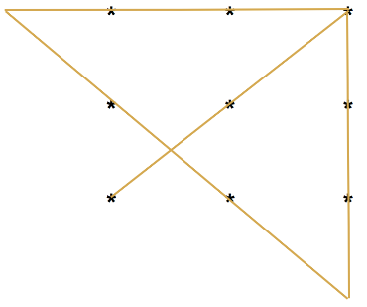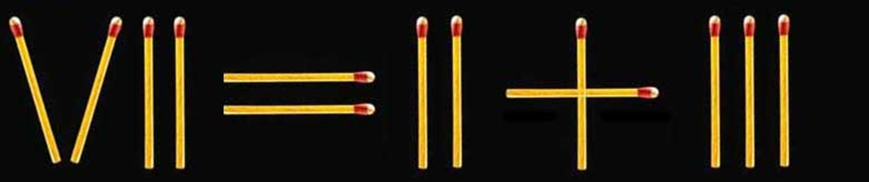
4、Progress Monitoring Theory（进程监控理论）：MacGregor et al (2001) have put forward this theory. There are two main features.
1）Maximisation heuristic: Each move or decision is an attempt to make as much headway as possible towards the goal（最大化启发式:每一步或每一个决定都是为了朝着目标取得尽可能多的进展）
2）Progress monitoring: The rate of progress is assessed constantly, and if it is deemed to be slow and inefficient criterion failure occurs. An alternative strategy is then sought.（进度监控:不断对进度进行评估，如果认为进度缓慢且效率低下，则发生标准故障。然后寻求另一种策略。）
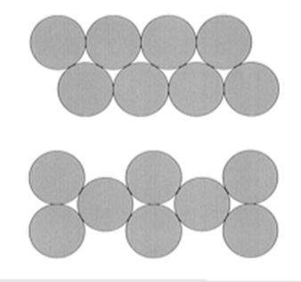
5、Transfer of Training（练习迁移）：Refers to how our experience of past problems influences our ability to solve new ones（过去知识经验影响当前问题解决）
Positive transfer: Previous experience allow to solve the current problem faster and more easily（过去知识经验使当前问题解决更快更容易）
Negative transfer: Solving a problem in the past disrupts to solve a similar current problem （过去的知识经验扰乱当前问题的解决）
Reasoning
1、Definition：Mental processes by which people derive conclusions from a given set of premises（从给定前提中得到结论的心理过程）
- Types of reasoning：
1）Inductive reasoning（归纳推理）：Inductive reasoning results in a hypothesis. Testing a hypothesis will result in either confirmation or falsification. Confirmation involves finding evidence is support of the hypothesis . Falsification involves finding evidence that does not support the conclusions. 归纳推理产生假设。检验一个假设将导致证实或证伪。证实包括寻找证据来支持假设。证伪包括寻找不支持结论的证据。
2）Deductive reasoning：Deductive reasoning allows us to draw conclusions that are definitely valid provided that the other statements are assumed to be true. 演绎推理使我们能够在假设其他命题为真的前提下得出肯定有效的结论。
Conditional Reasoning involves deciding something based on knowledge about something else. 条件推理包括基于对其他事物的认识来决定某事物。
Reasoning based on if and then：If it is raining, then the ground outside will be wet
Abstract Rule Theory：Following processes occur when someone encounters a deductive reasoning problem（当某人遇到演绎推理问题时，就会发生以下过程）
- The premises are comprehended and encoded into a mental representation in working memory( 前提被理解并编码成工作记忆中的心理表征。)
- Abstract-rule schema’s are applied to these premises in order to derive a conclusion (e.g. modus ponens ( 将抽象规则图式应用于这些前提，以得出结论(如推理方法))
- Feeder schemas are applied to produce intermediate conclusions (中间性结论)
- Incompatibility rules examine the contents of working memory for any incompatible references (e.g. inferring both ‘A’ and ‘not A’) 不兼容规则检查任何不兼容引用的工作内存内容(例如推断A和非A)
why people make errors in reasoning:
- Comprehension errors: The premises are interpreted incorrectly （错误:前提解释错误）
- Heuristic inadequacy: The participants reasoning processes fail to locate the correct line of reasoning（启发式不足:参与者的推理过程没有找到正确的推理线。）
- Processing errors: The participant fails to attend fully to the task at hand or suffers from memory overload（处理错误:参与者不能完全处理手头的任务，或者内存过载。）
Mental Model Approach：A mental model is a possibility for the way things are in the world
Assumptions:
A mental model describing the given situation is constructed, and the conclusions following from this are generated. 建立了描述给定情况的心理模型，并由此得出结论。
An attempt is made to construct alternative models that will falsify the conclusion. 试图建立可替代的模型，以证伪结论。
If a satisfactory alternative model is not found, the conclusion is assumed to be valid. 如果没有找到满意的替代模型，则假定结论是有效的。
The construction of mental models taxes the Working Memory system.理模型的构建加重了工作记忆系统的负担.
To save Working Memory resources, people tend to construct models that represent explicitly what is true and not what is false. 为了节省工作内存资源，人们倾向于构建模型来明确表示什么是正确的，什么是错误的。
Problems requiring the construction of mental models are harder to solve than those requiring only one mental model, because of the demands on Working Memory由于工作记忆的需要，需要构建心理模型的问题比只需要一个心理模型的问题更难解决.
Limitations:
More details needed as to how mental models are formed and which knowledge we bring forth and use(我们需要更多的细节来说明心智模式是如何形成的，以及我们提出和使用哪些知识)
Neither…could be said to provide evidence of developing mental models that are structural analogues of the world(这两种说法都不能提供证据证明正在发展的心理模型是世界的结构类似物)

