Monsterma314
Audio Equalizer PCB + Power Supply
18 January, 2021
Audio Equalizer Analysis
Power Supply Analysis
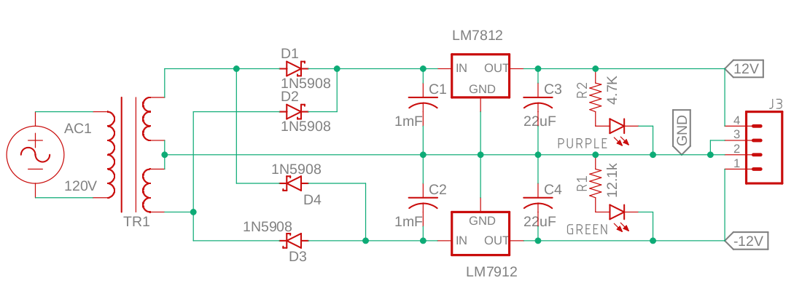
Figure 2.1 The figure above shows the circuit that effectively drives the audio equalizer.

The turns ratio of the transformer was about 4.6:1 across the entire primary and secondary. This finds about at 9V RMS voltage across each of side of the center tap with 120V AC. Since the AC RMS for a sinusoid is related to the maximum in Equation 2.1, the maximum voltage is found to be right around 13.3V above and below the center tap ground. This is unloaded.

Equation 2.1

Since the full bridge rectifier (with a center tap) will create the full wave 13.3V amplitude signal above and below ground, these can be smoothed by large capacitors (not too large to cause unnecessary inrush currents but enough to smooth the voltage supplies). For this, 1mF electrolytic capacitors rated for 16V (or 25V) would be ideal. The ESR should sufficiently limit the inrush current for initial charging. To get a smooth supply for the audio equalizer, a 12V positive and negative voltage regulator are used. LDO (low dropout) regulators are better, but the LM7812 will get very close to a ±12V output unloaded. This will drop to about ±11V when loaded. By using the LM7812, this smooths the output Vdd and Vss rails. These are called 12V and -12V respectively. The simulation below shows this output.

