Class Design

1. Class ListDockView

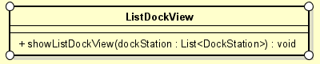

* 1. Attribute
  2. Operation

|  |  |  |  |
| --- | --- | --- | --- |
| # | Name | Return type | Description |
| 1 | showListDockView | void | Display the list dock station view |

* 1. Parameter

DockStation: List<DockStation> - a list of all dock stations

* 1. Exception
  2. Method
  3. State

1. Class BikeInDockView

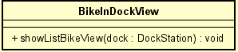

* 1. Attribute
  2. Operation

|  |  |  |  |
| --- | --- | --- | --- |
| # | Name | Return type | Description |
| 1 | ShowListBikeView | void | Show the list Bike in dock view |

* 1. Parameter

Dock: dockStation – information of the dock

* 1. Exception
  2. Method
  3. State

1. Class DockController

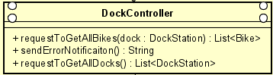

* 1. Attribute
  2. Operation

|  |  |  |  |
| --- | --- | --- | --- |
| # | Name | Return type | Description |
| 1 | requestToGetAllBikes | List<Bike> | Get all bikes from a dock station |
| 2 | requestToGetAllDocks | List<DockStation> | Update the cart information |
| 3 | sendErrorNotification | String | Send error notification |

* 1. Parameter

Dock: dockStation

* 1. Exception
  2. Method
  3. State

1. Class DockStation

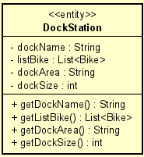

* 1. Attribute

dockName – name of the dock

listBike – list bike in the dock

dockArea – example: 120x100 (m2)

dockSize – total number of

* 1. Operation

|  |  |  |  |
| --- | --- | --- | --- |
| # | Name | Return type | Description |
| 1 | getDockName | String | Get name of the dock station |
| 2 | getListBike | List<Bike> | Get list bike in the dock station |
| 3 | getDockArea | String | Get dock area |
| 4 | getDockSize | Int | Get total number of bikes in the dock |

* 1. Parameter
  2. Exception
  3. Method
  4. State