1. **Class relation**

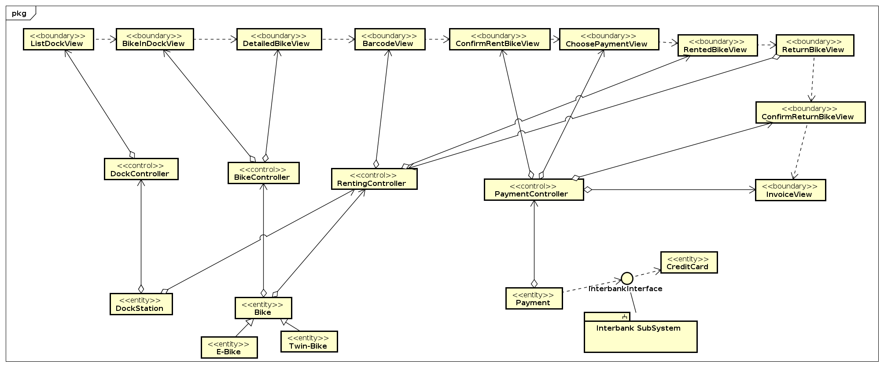

1. **Class design**
   1. **Class “ListDockView”**

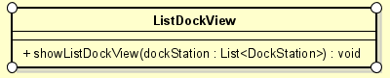

**Attributes**

None

**Operation**

|  |  |  |  |
| --- | --- | --- | --- |
| # | Name | Return type | Description |
| 1 | showListDockView | void | Display the list dock station view |

**Parameters**

DockStation: List<DockStation> - a list of all dock stations

**Exception**

**Method**

**State**

* 1. **Class “BikeInDockView”**

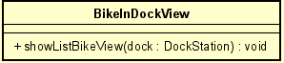

**Attributes**

None

**Operation**

|  |  |  |  |
| --- | --- | --- | --- |
| # | Name | Return type | Description |
| 1 | ShowListBikeView | void | Show the list Bike in dock view |

**Parameters**

Dock: dockStation – information of the dock

**Exception**

**Method**

**State**

* 1. **Class “DockController”**

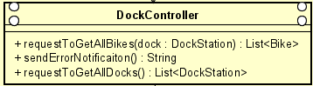

**Attributes**

None

**Operation**

|  |  |  |  |
| --- | --- | --- | --- |
| # | Name | Return type | Description |
| 1 | requestToGetAllBikes | List<Bike> | Get all bikes from a dock station |
| 2 | requestToGetAllDocks | List<DockStation> | Update the cart information |
| 3 | sendErrorNotification | String | Send error notification |

**Parameters**

Dock: dockStation – information of the dock

**Exception**

**Method**

**State**

* 1. **Class “DockStation”**

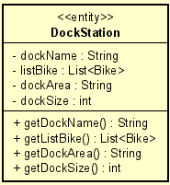

**Attributes**

dockName – name of the dock

listBike – list bike in the dock

dockArea – example: 120x100 (m2)

dockSize – total number of bike can be fit in dock

**Operation**

|  |  |  |  |
| --- | --- | --- | --- |
| # | Name | Return type | Description |
| 1 | getDockName | String | Get name of the dock station |
| 2 | getListBike | List<Bike> | Get list bike in the dock station |
| 3 | getDockArea | String | Get dock area |

**Parameters**

**Exception**

**Method**

**State**

* 1. **Class “PaymentView”**

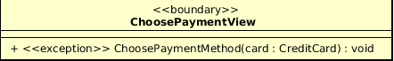

**Attributes**

None

**Operation**

|  |  |  |  |
| --- | --- | --- | --- |
| # | Name | Return type | Description |
| 1 | ChoosePaymentMethod | Void | Choose Payment method for payment/refund |

**Parameters**

card – credit card used for payment/refund

**Exception**

PaymentException - If responded with a pre-defined error code

UnrecognizedException – If responded with unknown error code or something goes wrong

**Method**

None

**State**

None

* 1. **Class “PaymentController”**

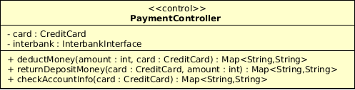

**Attributes**

Card: CreditCard - Represent the card used for payment

Interbank:InterbankInterface - Represent the Interbank system

**Operation**

|  |  |  |  |
| --- | --- | --- | --- |
| # | Name | Return type | Description |
| 1 | DeductMoney | Map<String,String> | Deduct money for renting and return the result with a message |
| 2 | ReturnDepositMoney | Map<String,String> | Return deposit money when user return bike |
| 3 | CheckAccountInfo | Map<String,String> | Check credit card information and return result with a message |

**Parameters**

card – credit card used for payment/refund

amount – the amount to pay

**Exception**

None

**Method**

None

**State**

None

* 1. **Class “Payment”**

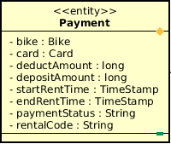

**Attributes**

|  |  |  |  |  |
| --- | --- | --- | --- | --- |
| # | Name | Data type | Default value | Description |
| 1 | Bike | Bike | NULL | Represent the bike which user rented |
| 2 | card | Card | NULL | Represent the card used for payment |
| 3 | DeductAmount | Long | NULL | Amount of deduct money |
| 4 | DepositeAmount | Long | NULL | Amount of deposit money |
| 5 | StartRentTime | TimeStamp | NULL | Time when user start renting |
| 6 | EndRentTime | TimeStamp | NULL | Time when user end renting |
| 7 | paymentStatus | String | NULL | Status of the payment |
| 8 | RentalCode | String | NULL | Unique code of every rental |

**Operation**

None

**Parameters**

card – credit card used for payment/refund

amount – the amount to pay

**Exception**

None

**Method**

None

**State**

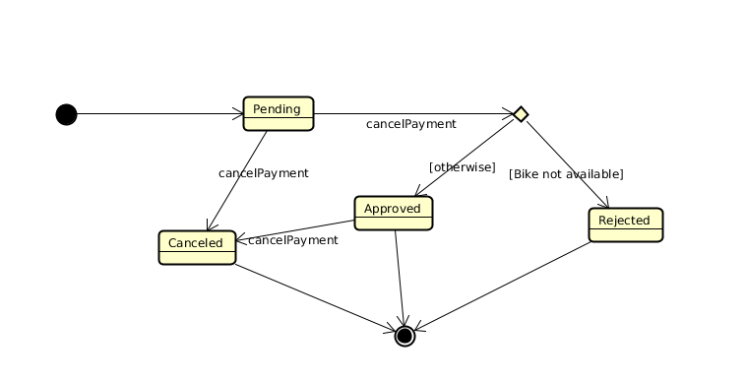

* 1. **Class “Payment”**



**Attributes**

None

**Operation**

|  |  |  |  |
| --- | --- | --- | --- |
| # | Name | Return type | Description |
| 1 | showDetailedBikeInfo | Void | Display the detailed bike information view |

**Parameters**

bike – the bike selected

**Exception**

None

**Method**

None

**State**

None

* 1. **Class “RentedBikeView”**



**Attributes**

None

**Operation**

|  |  |  |  |
| --- | --- | --- | --- |
| # | Name | Return type | Description |
| 1 | showRentedBikeInfo | Void | Display the rented bike information view |

**Parameters**

bike – the bike selected

**Exception**

None

**Method**

None

**State**

None

* 1. **Class “BikeController”**

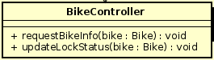

**Attributes**

None

**Operation**

|  |  |  |  |
| --- | --- | --- | --- |
| # | Name | Return type | Description |
| 1 | requestBikeInfo | Void | Request all related information for selected bike from database |
| 2 | updateLockStatus | Void | Change rented bike’s lock status |

**Parameters**

bike – the bike selected

**Exception**

None

**Method**

None

**State**

None

* 1. **Class “Bike”**

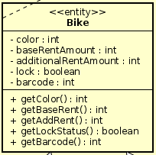

**Attributes**

|  |  |  |  |  |
| --- | --- | --- | --- | --- |
| # | Name | Data type | Default value | Description |
| 1 | color | int | NULL | Color of the bike |
| 2 | baseRentAmount | int | NULL | Base amount of rent for the bike |
| 3 | additionalRentAmount | int | NULL | Additional amount of rent for the bike |
| 4 | lock | boolean | NULL | Lock status for rented bike |
| 5 | barcode | int | NULL | Barcode of the bike |

**Operation**

|  |  |  |  |
| --- | --- | --- | --- |
| # | Name | Return type | Description |
| 1 | getColor | int | Request selected bike’s color |
| 2 | getBaseRent | int | Request selected bike’s base rent amount |
| 3 | getAddRent | int | Request selected bike’s additional rent amount |
| 4 | getLockStatus | boolean | Request selected bike’s lock status |
| 5 | getBarcode | int | Request selected bike’s barcode |

**Parameters**

bike – the bike selected

**Exception**

None

**Method**

None

**State**

None

* 1. **Class “RentingController”**

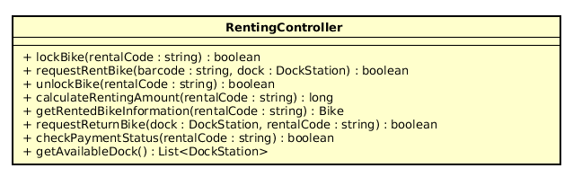

**Attributes**

None

**Operation**

|  |  |  |  |
| --- | --- | --- | --- |
| # | Name | Return type | Description |
| 1 | lockBike | boolean | Lock the rented bike |
| 2 | unlockBike | boolean | Unlock the rented bike |
| 3 | requestRentBike | boolean | Request to rent a bike in dock |
| 4 | calculateRentingAmount | Long | Calculate the renting amount of the rented bike |
| 5 | getRentedBikeInformation | Bike | Get the information of the rented bike |
| 6 | requestReturnBike | Boolean | Request to return a bike to a dock |
| 7 | checkPaymentStatus | Boolean | Check whether the transaction has been paid or not |
| 8 | getAvailableDock | List<DockStation> | Get available dock for returning bike |

**Parameters**

rentalCode:string – the rental code of the rented bike

Barcode:string - barcode of the bike

Dock:DockStation - dock station model

**Exception**

None

**Method**

None

**State**

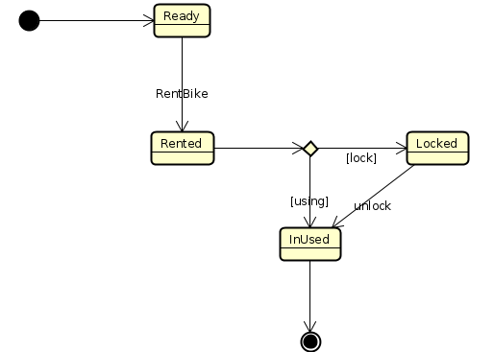

* 1. **Class “BarcodeView”**

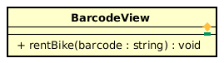

**Attributes**

None

**Operation**

|  |  |  |  |
| --- | --- | --- | --- |
| # | Name | Return type | Description |
| 1 | rentBike | void | Request to rent bike from user |

**Parameters**

Barcode:string - barcode of the bike

**Exception**

None

**Method**

None

**State**

None

* 1. **Class “ReturnBikeView”**

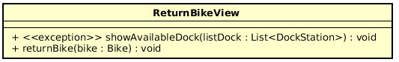

**Attributes**

None

**Operation**

|  |  |  |  |
| --- | --- | --- | --- |
| # | Name | Return type | Description |
| 1 | showAvailableDock | void | Show available dock to user to return bike |
| 2 | returnBike | void | Button to request to return bike |

**Parameters**

listDock: List<DockStation> - list of DockStation model

bike:Bike – the bike selected

**Exception**

dockException - show exception if retrieve dock information failed

**Method**

None

**State**

None

* 1. **Class “RentedBikeView”**

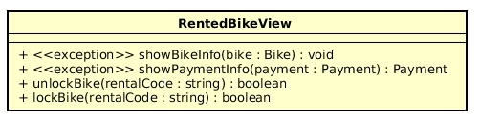

**Attributes**

None

**Operation**

|  |  |  |  |
| --- | --- | --- | --- |
| # | Name | Return type | Description |
| 1 | showBikeInfo | void | Show Information of rented bike |
| 2 | showPaymentInfo | Void | Show information about rented bike fee |
| 3 | unlockBike | Void | Lock the rented bike from user |
| 4 | lockBike | Void | Unlock the rented bike from user |

**Parameters**

listDock: List<DockStation> - list of DockStation model

bike:Bike – the bike selected

**Exception**

rentedBikeException - exception raise if the rented bike is not eligible

paymentException - exception raise if there is no payment with the bike

**Method**

None

**State**

None

1. **Class diagram**

