**Lab07 – Data Modeling**

1. **Conceptual Data Model**

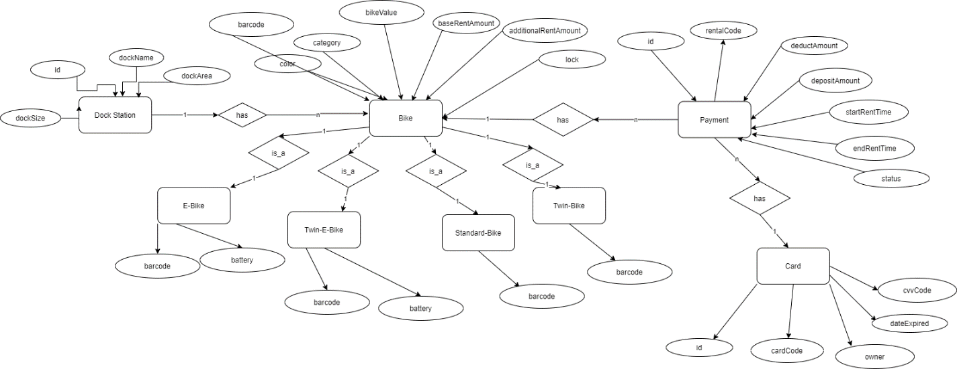

1. **Physical Data Model**

|  |  |  |  |  |  |  |
| --- | --- | --- | --- | --- | --- | --- |
|  |  |  |  | Payment |  |  |
| *#* | *PK* | *FK* | *Column Name* | *Data Type* | *Mandatory* | *Description* |
| 1 | x |  | id | serial | yes | Payment id |
| 2 |  |  | rentalCode | Integer | yes | Rental code |
| 3 |  |  | deductAmount | float | Yes | Deduct amount |
| 4 |  |  | DepositAmount | Float | yes | Deposit amount |
| 5 |  |  | startRentTime | TIMESTAMP | yes | Starting rent time |
| 6 |  |  | endRentTime | TIMESTAMP | yes | Ending rent time |
| 7 |  |  | Status | integer | yes | Status of transaction |
|  |  |  |  |  |  |  |
|  |  |  |  | **Payment Bike** |  |  |
| 1 |  | x | PaymentId | Serial | Yes | Payment id |
| 2 |  | x | BikeId | Serial | Yes | Bike id |

1. **Script**

create table "ecoBikeSystem"."Payment"

(

id serial not null,

"rentalCode" VARCHAR not null,

"deductAmount" float not null,

"depositAmount" float not null,

"startRentTime" TIMESTAMP not null,

"endRentTime" TIMESTAMP not null,

status int not null

);

create unique index payment_id_uindex

on "ecoBikeSystem"."Payment" (id);

create unique index payment_rentalcode_uindex

on "ecoBikeSystem"."Payment" ("rentalCode");

alter table "ecoBikeSystem"."Payment"

add constraint payment_pk

primary key (id);

create table "ecoBikeSystem"."PaymentBike"

(

"PaymentId" int not null

constraint paymentbike_payment_id_fk

references "ecoBikeSystem"."Payment"

on update cascade on delete cascade,

"BikeId" int not null

constraint paymentbike_bike_id_fk

references "ecoBikeSystem"."Bike"

on update cascade on delete cascade,

constraint paymentbike_pk

primary key ("PaymentId", "BikeId")

);