Screen specification

View Bike Screen

Eco Bike Rental |  | Date of creation | Person in charge
Screen specification | View Bike Screen | 07/11/2020 | Nguyễn Ngọc Quý
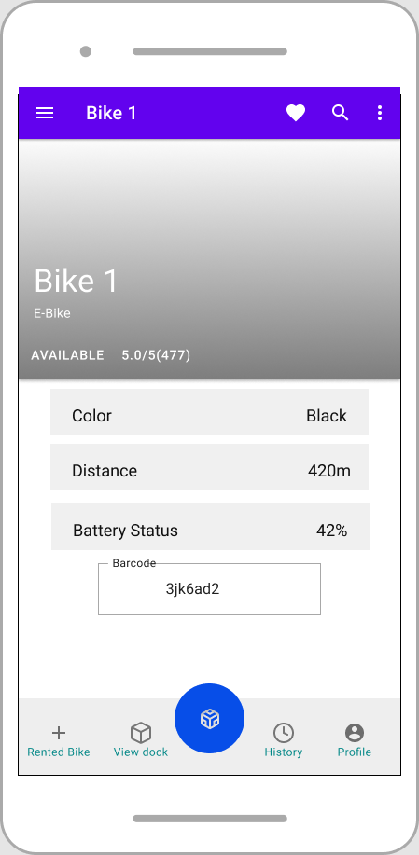 |  | Control | Operation | Function
 |  | Area for viewing bike | Initial | Display bike Information
 |  | Area for bike barcode | Initial | Display bike barcode

Defining the field attributes

Screen name | Rent Bike Screen
Item name | Number of digits | Type | Field attribute | Remarks
Barcode | 8 | String | Black | center-justified
Bike Name | 10 | String | Black | Left-justified
Bike Type | 10 | String | Black | Left-justified
Bike Availability | 10 | String | Black | Left-justified
Bike Rating | 10 | Float | Black | Left-justified
Bike Color | 10 | String | Black | Right-justified
Bike Distance | 10 | Float | Black | Right-justified
Bike Battery Status | 10 | Float | Black | Right-justified

View Rented Bike Screen

Eco Bike Rental |  | Date of creation | Person in charge
Screen specification | View Rented Bike Screen | 07/11/2020 | Nguyễn Ngọc Quý
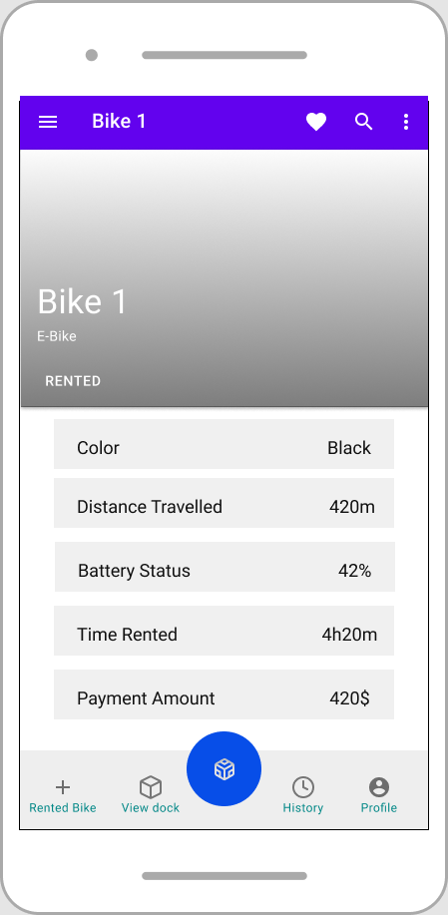 |  | Control | Operation | Function
 |  | Area for viewing Rented Bike | Initial | View rented bike

Defining the field attributes

Screen name | Rent Bike Screen
Item name | Number of digits | Type | Field attribute | Remarks
Bike Name | 10 | String | Black | Left-justified
Bike Type | 10 | String | Black | Left-justified
Bike Color | 10 | String | Black | Right-justified
Bike Distance Traveled | 10 | Float | Black | Right-justified
Bike Remaining Battery Status | 10 | Float | Black | Right-justified
Bike Rented Time | 10 | Float | Black | Right-justified
Payment Amount Estimated | 10 | Float | Black | Right-justified

