Class Design
- Initial Design Classes

- Define Relationships between classes
- Class Design
  - Class “PaymentView”:

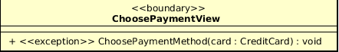

Attribute
None
Operation
# | Name | Return type | Description (purpose)
1 | ChoosePaymentMethod | Void | Choose Payment method for payment/refund
Parameter
- card – credit card used for payment/refund
Exception
- PaymentException - If responded with a pre-defined error code
- UnrecognizedException – If responded with unknown error code or something goes wrong
Method
None
State
None
  - Class “PaymentController”

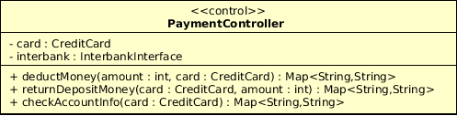
Attribute
# | Name | Data type | Default value | Description
1 | Card | CreditCard | NULL | Represent the card used for payment
2 | Interbank | InterbankInterface | NULL | Represent the Interbank system

Operation
# | Name | Return type | Description (purpose)
1 | DeductMoney | Map<String,String> | Deduct money for renting and return the result with a message
2 | ReturnDepositMoney | Map<String,String> | Return deposit money when user return bike
3 | CheckAccountInfo | Map<String,String> | Check credit card information and return result with a message
Parameter
- card – credit card used for payment/refund
- amount – the amount to pay
Exception
None
Method
None
State
None
  - Class “Payment”

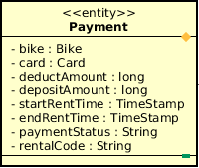

Attribute
# | Name | Data type | Default value | Description
1 | Bike | Bike | NULL | Represent the bike which user rented
2 | card | Card | NULL | Represent the card used for payment
3 | DeductAmount | Long | NULL | Amount of deduct money
4 | DepositeAmount | Long | NULL | Amount of deposit money
5 | StartRentTime | TimeStamp | NULL | Time when user start renting
6 | EndRentTime | TimeStamp | NULL | Time when user end renting
7 | paymentStatus | String | NULL | Status of the payment
8 | RentalCode | String | NULL | Unique code of every rental

Operation
None
Parameter
- card – credit card used for payment/refund
- amount – the amount to pay
Exception
None
Method
None
State
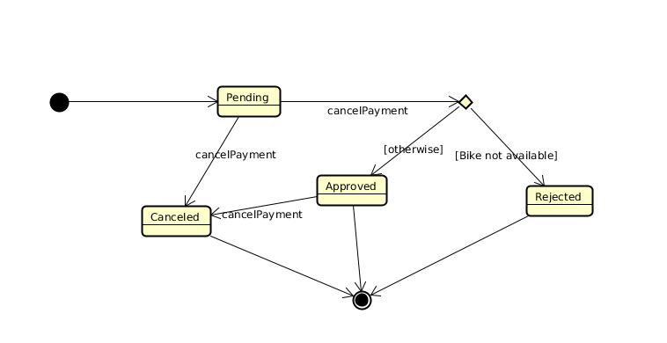

- Class Diagram

