Screen specification

Home Menu Bar

Eco Bike Rental |  | Date of creation | Person in charge
Screen specification | Home Menu Bar | 07/11/2020 | Nguyễn Xuân Hoàng
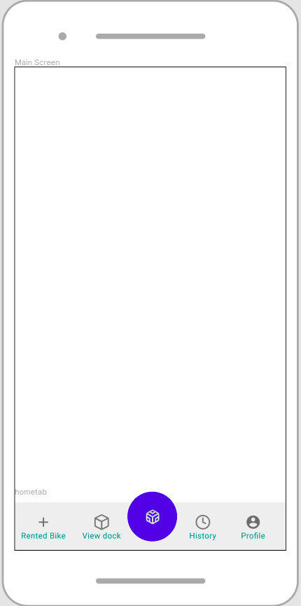 |  | Control | Operation | Function
 |  | Area for viewing Rented Bike | Click | View rented Bike
 |  | Area for viewing dock | Click | View docks
 |  | Area for viewing renting history | Click | View History
 |  | Area for viewing profile | Click | View Profile
 |  | Area for displaying Renting Bike Screen | Click | Request to rent a Bike

Rent Bike Screen

Eco Bike Rental |  | Date of creation | Person in charge
Screen specification | Rent Bike Screen | 07/11/2020 | Nguyễn Xuân Hoàng
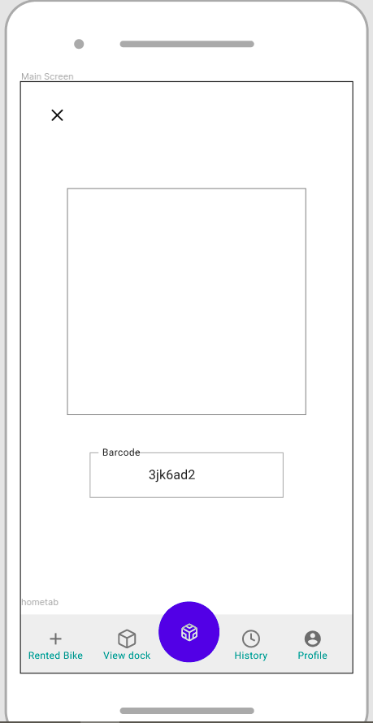 |  | Control | Operation | Function
 |  | Area for Scanning Barcode | Initial | Scanning Bike’s Barcode
 |  | Area for inputting barcode | Focus | Getting barcode if scanning not working
 |  | Area for Escape Screen | Click | Escape the screen

Defining the field attributes

Screen name | Rent Bike Screen
Item name | Number of digits | Type | Field attribute | Remarks
Barcode | 8 | String | Black | center-justified

Confirm Return Bike Screen

Eco Bike Rental |  | Date of creation | Person in charge
Screen specification | Confirm Return Bike Screen | 07/11/2020 | Nguyễn Xuân Hoàng
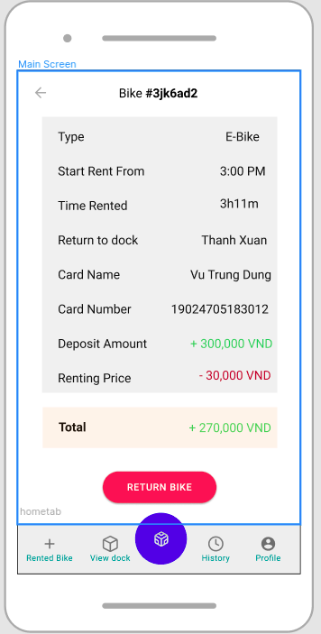 |  | Control | Operation | Function
 |  | Area for displaying Bike barcode | Initial | Displaying Bike barcode
 |  | Area for displaying Renting Information | Initial | Displaying Reting Information
 |  | Area for displaying total price for renting | Initial | Calculating amount of money for renting
 |  | Return Bike button | Click | Displaying Invoice Screen
 |  | Escape Button | Click | Cancel the Return Bike Screen

Defining the field attributes

Screen name | Confirm Return Bike Screen
Item name | Number of digits | Type | Field attribute | Remarks
Bike’s Barcode | 8 | String | Black, bold | center-justified
Bike’s Type | 10 | String | Black | Right-justified
Start Renting Time | 10 | Time | Black | Right-justified
Time Rented | 10 | Time | Black | Right-justified
Return to Dock | 50 | String | Black | Right-justified
Card name | 50 | String | Black | Right-justified
Card Number | 16 | Number | Black | Right-justified
Deposit Amount | 50 | String | Green | Right-justified
Renting Bike | 50 | String | Red | Right-justified
Total | 50 | String | Green | Right-justified

Invoice Screen

Eco Bike Rental |  | Date of creation | Person in charge
Screen specification | Invoice Screen | 07/11/2020 | Nguyễn Xuân Hoàng
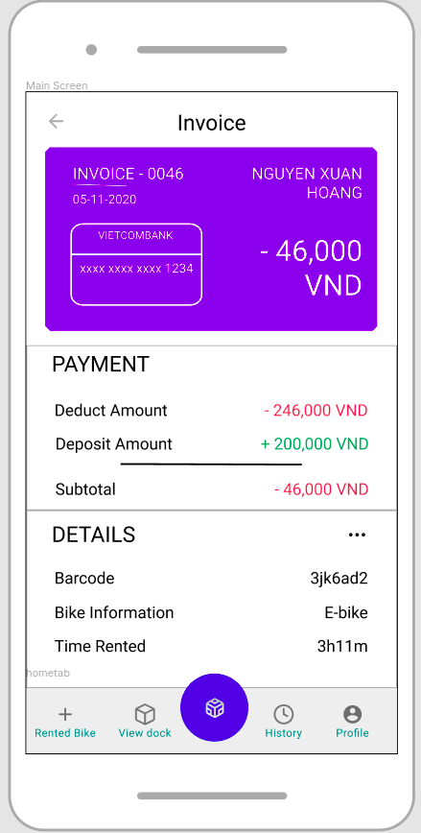 |  | Control | Operation | Function
 |  | Area for displaying customer Information | Initial | Displaying customer Information
 |  | Area for payment Information | Initial | Displaying payment Information
 |  | Area for displaying rented bike | Initial | Displaying details information about rented bike
 |  | Escape Button | Click | Cancel the Return Bike Screen
Defining the field attributes

Screen name | Invoice Screen
Item name | Number of digits | Type | Field attribute | Remarks
Bike’s Barcode | 8 | String | Black, bold | center-justified
Bike’s Type | 10 | String | Black | Right-justified
Card name | 50 | String | White | Left-justified
Card Number | 16 | Number | White | Left-justified
Deposit Amount | 50 | String | Green | Right-justified
Renting Bike | 50 | String | Red | Right-justified
Subtotal | 50 | String | Green | Right-justified
Customer’s Name | 50 | String | White | Left-justified
Created Date | 20 | Date | White | Left-justified

