Screen specification

Choose payment method screen

Eco Bike Rental |  | Date of creation | Person in charge
Screen specification | Home Menu Bar | 07/11/2020 | Nguyễn Trung Nghĩa
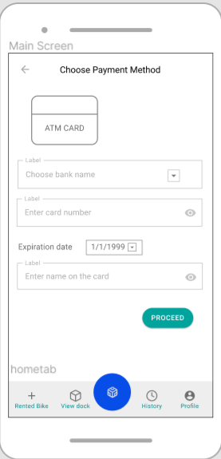 |  | Control | Operation | Function
 |  | Area for choosing bank name | Click – choose from a list | View list bank
 |  | Area for entering card number | Click | Fill in card number
 |  | Area for choosing date | Click – choose from lists | Fill in expiration date
 |  | Area for entering name on the card | Click | Fill in name on the card
 |  | Area for sending the form | click | Send the form

List dock stations screen

Eco Bike Rental |  | Date of creation | Person in charge
Screen specification | Rent Bike Screen | 07/11/2020 | Nguyễn Trung Nghĩa
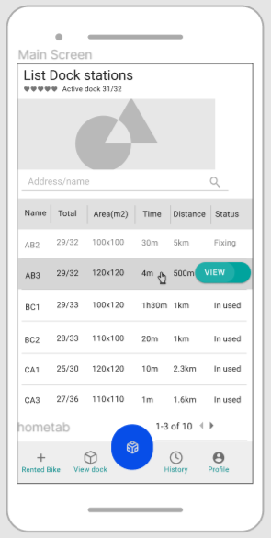 |  | Control | Operation | Function
 |  | Area for search dock station | Click | Find dock by address or name
 |  | Area for view bike detail | Click | View detail information of bike in station
 |  | Area for viewing next or previous page of table | Click | View table
 |  | Area for displaying the name of dock | Initial | displaying the name of dock
 |  | Area for displaying number of bike in dock | Initial | displaying number of bike in dock
 |  | Area for displaying area of the dock | Initial | displaying area of the dock
 |  | Area for displaying min time to walk to the dock | Initial | displaying min time to walk to the dock
 |  | Area for displaying distance from current position to the dock | Initial | displaying distance from current position to the dock
 |  | Area for displaying status of the dock | Initial | displaying status of the dock

Defining the field attributes

Screen name | Rent Bike Screen
Item name | Number of digits | Type | Field attribute | Remarks
Search bar | many | String | Black | Left-justified

View bike in dock station screen

Eco Bike Rental |  | Date of creation | Person in charge
Screen specification | Confirm Return Bike Screen | 07/11/2020 | Nguyễn Trung Nghĩa
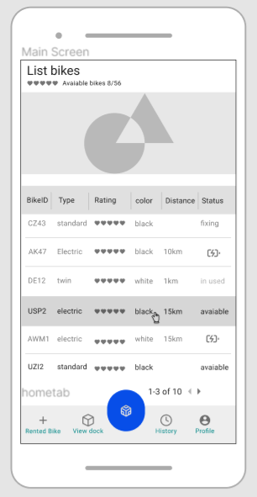 |  | Control | Operation | Function
 |  | Area for displaying the bikeID or bike code | Initial | displaying the bikeID or bike code
 |  | Area for displaying bike type | Initial | displaying bike type
 |  | Area for displaying rating for that bike | Initial | displaying rating for that bike
 |  | Area for displaying color of the bike | Initial | displaying color of the bike
 |  | Area for displaying battery status of the bike | Initial | displaying battery status of the bike
 |  | Area for viewing pages of tables | Click | viewing pages of tables
 |  | Area for displaying maximum distance the bike can go (e-bike) | Initial | displaying maximum distance the bike can go (e-bike

Defining the field attributes

Screen name | Confirm Return Bike Screen
Item name | Number of digits | Type | Field attribute | Remarks
Bike’s ID | 8(max) | String | Black | Left-justified
Bike’s Type | 10(max) | String | Black | Left-justified
Bike’s rating | 10(max) | String | Black | Left-justified
Bike’s status |  | String or image | Black | Left-justified
Distance | 10(max) | String | Black | Left-justified

